AlexNet - Original

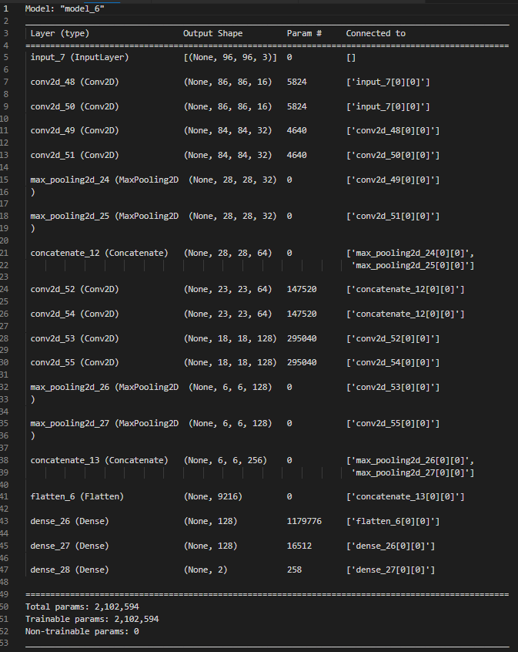

Reduced parameters

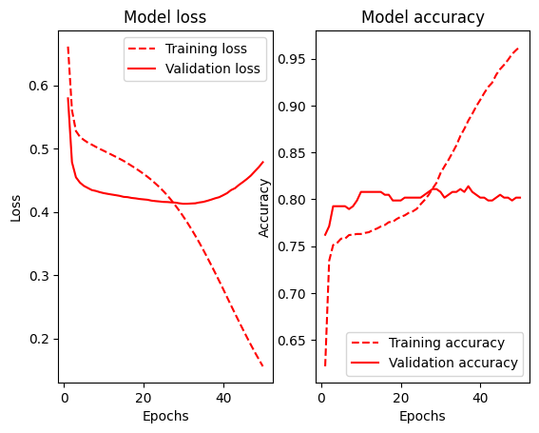

Bottleneck 1

Bottleneck 2

