**4. Exercise 1: Data Mining: Tasks and Methods, Sets and Relations**

**5. Exercise 1-1 Data mining tasks**

Which data mining tasks (association rule mining, clustering, outlier detection, classification, etc.) are hiding in the following use cases? Are the tasks supervised or unsupervised?

**6. Suggested solution:**

The point of this exercise is not so much one or the other solution, but to discuss the applications and possible questions. The purpose is to trigger interactive discussion of the different kind of data mining or machine learning tasks and to become more familiar with the group. Take it easy and feel free to diverge into various variants of the listed problems!

**7. (a) Optical character recognition/OCR:**

When crossing the alps using the Brenner Autobahn, there is the option to pay electronically in advance. When approaching the toll station, the barrier automatically opens when the number plate was recognized. The recognition happens fully automatically by a digital camera system.

**8. Suggested solution:**

Classification

**9. (b) Computer Aided Diagnosis:**

Patients that suffer from blood cancer can be characterized in two categories (ALL and AML). The therapies for these two types partially differ, and the therapy for AML can sometimes be detrimental to patients suffering from ALL and the other way around. To avoid these complications, special gene expression data are used to differentiate between these two types by comparing them to the data from patients where the cancer type is already known.

**10. Suggested solution:**

Classification

**11. (c) Cheat Detection**

The operator of a multi player online game wants to protect his system against various violations of the terms of service. Particular problems are the use of game bot programs, the manipulation of timestamps in the communication protocol, and attempts to predict random numbers used. To prevent this misuse, data mining is used on the available user data.

**12. Suggested solution:**

Outlier detection, sometimes classification (for known bots), clustering (to recognize strategies)

**13. (d) Recommendation Systems**

An online shopping portal wants to determine products that are automatically offered to registered customers upon login. The available data in particular include products previously bought by the customers to predict their interests. For example a user that bought the book "Lord of the rings" might be offered the DVDs of the movie trilogy. A related task might be suggesting additional products for already chosen products as a bundled offer.

**14. Suggested solution:**

Market basket analysis, association rules

**15. (e) News Aggregation**

A news summary web site automatically collects current news from various sites to keep the visitor informed. However, news reports about the same subject are common and should be grouped by subject. This happens at multiple levels: there are obviously broad categories like politics and sports, and subcategories such as soccer. But even on a single soccer game, there will likely be different news sites reporting. Some articles will be identical to the report of a major agency, some will only be slightly modified, others will be original works.

**16. Suggested solution:**

Clustering and Classification (for categories)

**17. (f) Extraction of Data / Web Scraping**

From some movie database a list of movies and a list of actors is to be extracted (ignoring licensing problems).

**18. Suggested solution:**

Data selection - according to our definitions not "Data Mining", but the first step of the KDD process. Not a focus of this course, though.

**19. (g) Identification of the most important suppliers**

A big online seller would like to know which suppliers are most important to his business, i.e., which suppliers contribute most to his revenue. The plan is to tighten the relationship to those, to take over the company, or to place a new logistic center close to the locations of such suppliers.

**20. Suggested solution:**

Data selection and simple aggregation.

We can answer this with a simple database query, e.g.:

SELECT SUM(Revenue) FROM data GROUP BY supplier

This is not KDD or data mining, but "trivial" knowledge.

**21. Exercise 1-2 Set operations**

An algebra is defined over a base set $Ω$, all sets involved in the algebra are subsets of $Ω$.

basic operations for $S,T⊆Ω$:

$$\begin{matrix} & \text{union} S∪T≡\{x∣x∈S∨x∈T\} \\ & \text{intersection} S∩T≡\{x∣x∈S∧x∈T\} \\ & \text{complement} \overset{‾}{S}≡S^{C}≡\{x∣x∉S\} \\ & \text{difference} S∖T≡\{x∣x∈S∧x∉T\} \\ & \text{product} S×T≡\{(x,y)∣x∈S∧y∈T\}\end{matrix}$$

Powerset $P(S)≡℘(S)≡2^{S}≡\{T∣T⊆S\}$

Now let $Ω$ be the English alphabet lowercase letters, i.e., $\{a,b,c,d,…,x,y,z\}$, and let $S=\{a,b,c\}$ and $T=\{c,d\}$.

What are the values of the following expressions:

(a) $S∪T$

**22. Suggested solution:**

$$\{a,b,c,d\}$$

(b) $S∩T$

**23. Suggested solution:**

$$\{c\}$$

(c) $\overset{‾}{S}$

**24. Suggested solution:**

$$\{d,e,f,g,h,…,x,y,z\}$$

(d) $S∖T$

**25. Suggested solution:**

$$\{a,b\}$$

(e) $S×T$

**26. Suggested solution:**

$$\{(a,c),(a,d),(b,c),(b,d),(c,c),(c,d)\}$$

(f) $P(S)$

**27. Suggested solution:**

$$\{\{a,b,c\},\{a,b\},\{a,c\},\{b,c\},\{a\},\{b\},\{c\},\{\}\}$$

(g) $S∩\overset{‾}{T}$

**28. Suggested solution:**

$$\{a,b\}$$

**29. Exercise 1-3 Sets, Relations, Functions - Visualization**

Consider the sets $A=\{a,b,c\}$ and $Z=\{1,2,3,4\}$ and some binary relation over them.

If for example the elements $a∈A$ and $2∈Z$ are in relation $R$ could we write: $aR2$ or $(a,2)∈R$.

As a graphical visualization we can draw the two sets and a line connecting $a$ and 2 :

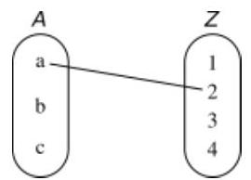

Given such a visualization, the mathematical definitions basically tell us which lines to draw.

Give such a visualization for:

(a) The Cartesian product $A×Z$

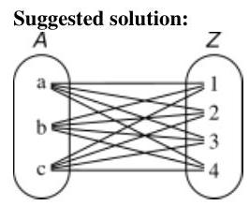

Each element in $A$ is partner to

each element in $Z$.

(b) A binary relation over $A$ and $Z$, that is not a function.

Suggested solution:

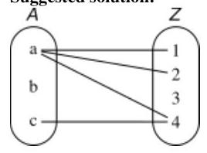

Elements in $A$ may have none, one, or several partners in $Z$.

Elements in $Z$ may have none, one, or several partners in $A$

(c) A non-total function $A→Z$

**30. Suggested solution:**

Each element in $A$

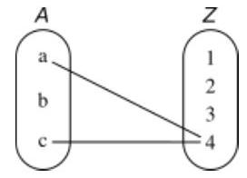

has none or one partner in $Z$, but not several.

At least one element in $A$ does not have a partner (non-total).

Elements in $Z$ may have none, one, or several partners in $A$.

(d) A total function $A→Z$ Suggested solution:

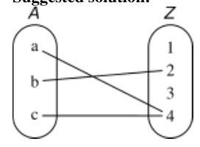

Each element in $A$ has one partner in $Z$, but not several.

Elements in $Z$ may have none, one, or several partners in $A$.

(e) We called the case c) non-total. Could we have called it partial, or would that make a difference?

**31. Suggested solution:**

Intuitively we would expect that a function is either partial or total, but not both.

The condition for a partial function is however, that each element in $A$ has none or one partner in $Z$.

This condition is given for non-total functions as well as for total functions.

Given the definition, partial is therefore a generalization of total, not the opposite of total.

**32. Exercise 1-4 Tools and Data**

(a) Install WEKA (stable version) on your computer. It comes with a manual and with datasets.

(b) What kind of formats should a dataset have in order to be analyzed with WEKA? What could be done with other formats?

(c) Check out the "iris" dataset. Read about it (e.g, wikipedia) to understand its properties (e.g., how many attributes, meaning of attributes, classes).

(d) Start the WEKA explorer.

(e) Loadiris. arff.

(f) Go to the "Cluster"-tab and run "SimpleKMeans". Make sure to set the parameter for the number of clusters to the known number of classes in the dataset. Also use the button "IgnoreAttributes" to ignore the class attribute.

**33. Suggested solution:**

Note that we introduce k-means to a later point in the course. For this exercise, this is just some black box clustering algorithm. Don't get into any discussions of how it works.

(g) Right-click on the result allows you to visualize the cluster assignments. Explore the possibilities. Compare colors by cluster and colors by class. Are the clusters similar to the classes?

(h) You can visualize different combinations (pairs) of attributes. In some attribute combinations, the clusters are better separated. Why?

(i) Try some preprocessing (e.g., use filter "Normalize", or select additional attributes to ignore) and repeat the clustering. What do you observe?

**34. Suggested solution:**

Interactive demo and discussion in the tutorial.