**3. Exercise 6**

Exercise 6-1 Conditional Probability

(1 point)

Suppose that of all individuals buying a certain digital camera, $60\%$ include an optional memory card in their purchase, $40\%$ include an extra battery, and $30\%$ include both a card and a battery. Consider randomly selecting a buyer and let $A=\{$ memory card purchased $\}$ and $B=$ $\{$ battery purchased $\}$. Then $Pr⁡(A)=0.6,Pr⁡(B)=0.4$, and $Pr⁡(A∩B)=0.3$.

1. Given that the selected individual purchased an extra battery, what is the probability that an optional card was also purchased?

**4. Suggested solution:**

$$Pr⁡(A∣B)=\frac{Pr⁡(A∩B)}{Pr⁡(B)}=\frac{0.3}{0.4}=0.75$$

1. Given that the selected individual purchased a memory card, what is the probability that an optional extra battery was also purchased?

**5. Suggested solution:**

$$Pr⁡(B∣A)=\frac{Pr⁡(A∩B)}{Pr⁡(A)}=\frac{0.3}{0.6}=0.5$$

Exercise 6-2 Bayes' Theorem

(1 point)

Only 1 in 1000 adults is afflicted with a rare disease for which a diagnostic test has been developed. The test is such that when an individual actually has the disease, a positive result will occur $99\%$ of the time, whereas an individual without the disease will show a positive test result only $2\%$ of the time.

If a randomly selected individual is tested and the result is positive, what is the probability that the individual has the disease?

Suggested solution:

Bayes' Theorem:

$$Pr⁡(A∣B)=\frac{Pr⁡(B∣A)Pr⁡(A)}{Pr⁡(B)}$$

We have the following events:

- Actual positive / has disease

- Actual negative / healthy

$T^{+}-$ Test is positive

- Test is negative

We are given the following probabilities:

$$\begin{matrix} & Pr⁡\left(A^{+}\right)=\frac{1}{1000} \\ & Pr⁡\left(A^{-}\right)=\frac{999}{1000} \\ & Pr⁡\left(T^{+}∣A^{+}\right)=0.99 \\ & Pr⁡\left(T^{+}∣A^{-}\right)=0.02\end{matrix}$$

Total probability of positive test:

$$\begin{matrix}Pr⁡\left(T^{+}\right) & =Pr⁡\left(T^{+}∣A^{+}\right)Pr⁡\left(A^{+}\right)+Pr⁡\left(T^{+}∣A^{-}\right)Pr⁡\left(A^{-}\right) \\ & =0.99⋅0.001+0.02⋅0.999 \\ & =0.02097\end{matrix}$$

We want to calculate $Pr⁡\left(A^{+}∣T^{+}\right)$:

$$\begin{matrix}Pr⁡\left(A^{+}∣T^{+}\right) & =\frac{Pr⁡\left(T^{+}∣A^{+}\right)Pr⁡\left(A^{+}\right)}{Pr⁡\left(T^{+}\right)} \\ & =\frac{0.00099}{0.02097} \\ & =0.0472\end{matrix}$$

Exercise 6-3 Nearest Neighbour Classification

(1 point)

The $2D$ feature vectors in the figure below belong to two different classes (circles and rectangles). Classify the object at $(6,6)$- in the image represented using a triangle - using $k$ nearest neighbor classification. Use Manhattan distance $\left(L_{1}\right.$ norm $)$ as distance function, and use the non-weighted class counts in the $k$-nearest-neighbor set, i.e. the object is assigned to the majority class within the $k$ nearest neighbors. Perform $kNN$ classification and compare the results with your own "intuitive" result for the following $k$ values.

$$\begin{matrix} & k=4 \\ & k=7 \\ & k=10\end{matrix}$$

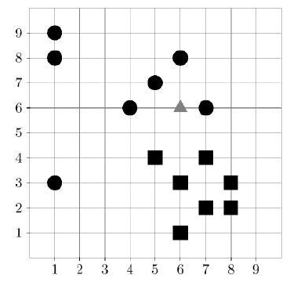

**6. Suggested solution:**

For $k=4$:

Looking at the closest neighbours, we see that all 4 nearest neighbours are circles. The object at $(6,6)$ would be classified as a circle.

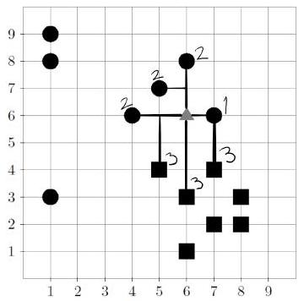

For $k=7:$

Looking at the closest neighbours, we see that $\frac{4}{7}$ of the nearest neighbours are circles. The object at $(6,6)$ would be classified as a circle.

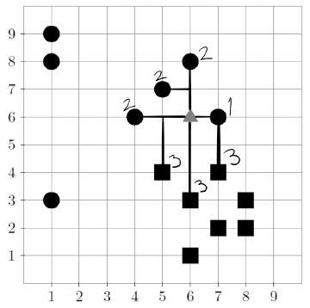

For $k=10$:

Looking at the closest neighbours, we see that $\frac{4}{10}$ of the nearest neighbours are circles. We also see that $\frac{6}{10}$ of the nearest neighbours are squares.

The object at $(6,6)$ would be classified as a square.

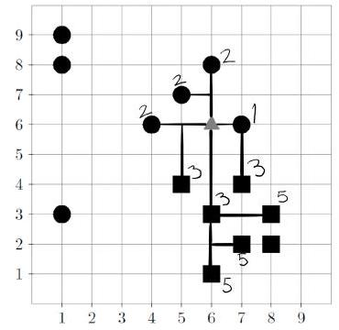

Exercise 6-4 Nearest Neighbour Classification

(1 point)

Find a scenario where we have a set of at least four points in 2 dimensions, such that the Nearest Neighbor classification $(k=1)$ only gives incorrect classification results when using any of these points as query point and the rest as training examples. Use Euclidean distance as distance function.

**7. Suggested solution:**

Various solutions are possible, e.g.:

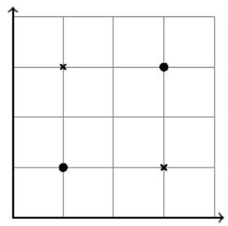

Exercise 6-5 Linearity of Expectation and Variance

(1 point)

Suppose that the two variables $x$ and $y$ are statistically independent. Show that the mean and variance of their sum satisfies:

$$\begin{matrix}E(x+y) & =E(x)+E(y) \\ var⁡(x+y) & =var⁡(x)+var⁡(y)\end{matrix}$$

**8. Suggested solution:**

Proof for Linearity of Expectation:

values of $x$.

$$E(x)=\sum_{i}{ }x_{i}⋅Pr⁡\left(x_{i}\right)$$

Probability of sum of variables:

$$\begin{matrix}E(x+y) & =\sum_{i}{ } \sum_{j}{ } \left[\left(x_{i}+y_{j}\right)⋅Pr⁡\left(x=x_{i},y=y_{j}\right)\right] \\ & =\sum_{i}{ } \sum_{j}{ } \left\{x_{i}⋅Pr⁡\left(x=x_{i},y=y_{j}\right)\right\}+\sum_{i}{ } \sum_{j}{ } \left\{y_{j}⋅P r⁡\left(x=x_{i},y=y_{j}\right.\right. \\ & =\sum_{i}{ } x_{i}\sum_{j}{ } Pr⁡\left(x=x_{i},y=y_{j}\right)+\sum_{j}{ } y_{j}\sum_{i}{ } Pr⁡\left(x=x_{i},y=y_{j}\right) \\ & =\sum_{i}{ } x_{i}Pr⁡\left(x=x_{i}\right)+\sum_{j}{ } y_{j}Pr⁡\left(y=y_{j}\right) \\ & =E(x)+E(y)\end{matrix}$$

We never assume variables are independent, so this proof also works for dependent variables. Note: For continuous random variables, the proof is the same, but with integrals rather than sums. The proof can be extended to an arbitrary number of variables by induction.

Variance follows a similar proof. Recall definition of variance over a random variable:

$$\begin{matrix}Var⁡(x) & =E(X-E(X))^{2} \\ & =E\left(X^{2}\right)-E(X)^{2} \\ & =E\left((x+y)^{2}\right)-E(x+y)^{2}\end{matrix}$$

We use the linearity of expectation for this proof:

$$\begin{matrix}Var⁡(x) & =E\left((x+y)^{2}\right)-E(x+y)^{2} \\ & =E\left(x^{2}+y^{2}+2xy\right)-E(x+y)^{2} \\ & =E\left(x^{2}\right)+E\left(y^{2}\right)+E(2xy)-(E(x)+E(y))^{2} \\ & =E\left(x^{2}\right)+E\left(y^{2}\right)+E(2xy)-\left(E(x)^{2}+E(y)^{2}+2E(x)E(y)\right) \\ & =E\left(x^{2}\right)+E\left(y^{2}\right)-E(x)^{2}-E(y)^{2} \\ & =Var⁡(x)+Var⁡(y)\end{matrix}$$