**3. Exercise 7: Bayes Optimal Classifier, Naïve Bayes, Random Variables and Distributions, EM Clustering**

**4. Exercise 7-1 Bayes Optimal**

(1 point)

We have a classification problem with two classes " $+"$ and " $-"$, three trained classifiers $h_{1}$, $h_{2}$, and $h_{3}$, with the following probabilities of the classifiers, given the training data $D$:

$$\begin{matrix} & Pr⁡\left(h_{1}∣D\right)=0.4 \\ & Pr⁡\left(h_{2}∣D\right)=0.6 \\ & Pr⁡\left(h_{3}∣D\right)=0.3\end{matrix}$$

For the three test instances $o_{1},o_{2},o_{3}$, the classifiers give the following class probabilities:

$$\begin{matrix}Pr⁡\left(+∣h_{1}\right)=0.6 & Pr⁡\left(-∣h_{1}\right)=0.4 \\ Pr⁡\left(+∣h_{2}\right)=1.0 & Pr⁡\left(-∣h_{2}\right)=0.0 \\ Pr⁡\left(+∣h_{3}\right)=0.2 & Pr⁡\left(-∣h_{3}\right)=0.8\end{matrix}$$

$$O_{2}:$$

$$\begin{matrix}Pr⁡\left(+∣h_{1}\right)=0.8 & Pr⁡\left(-∣h_{1}\right)=0.2 \\ Pr⁡\left(+∣h_{2}\right)=0.6 & Pr⁡\left(-∣h_{2}\right)=0.4 \\ Pr⁡\left(+∣h_{3}\right)=0.1 & Pr⁡\left(-∣h_{3}\right)=0.9\end{matrix}$$

$$O_{3}:$$

$$\begin{matrix}Pr⁡\left(+∣h_{1}\right)=0.3 & Pr⁡\left(-∣h_{1}\right)=0.7 \\ Pr⁡\left(+∣h_{2}\right)=0.1 & Pr⁡\left(-∣h_{2}\right)=0.9 \\ Pr⁡\left(+∣h_{3}\right)=1.0 & Pr⁡\left(-∣h_{3}\right)=0.0\end{matrix}$$

We combine the three classifiers to get a Bayes optimal classifier. Which class probabilities will we get from this Bayes optimal classifier for the three test instances?

**5. Suggested solution:**

The Bayes optimal classifier adds the conditional class probabilities given the classifier, weighted with the conditional classifier probabilities given the data:

$$Pr⁡\left(c_{j}∣D\right)=\sum_{h_{i}∈H}{ }Pr⁡\left(c_{j}∣h_{i}\right)Pr⁡\left(h_{i}∣D\right)$$

The resulting probabilities are:

$$\begin{matrix}o_{1}: & Pr⁡(+∣ \text{Bayes optimal} )=(0.6⋅0.4+1⋅0.6+0.2⋅0.3)=0.9 \\ o_{1}: & Pr⁡(-∣ \text{Bayes optimal} )=(0.4⋅0.4+0.0⋅0.6+0.8⋅0.3)=0.4 \\ o_{2}: & Pr⁡(+∣ \text{Bayes optimal} )=(0.8⋅0.4+0.6⋅0.6+0.1⋅0.3)=0.71 \\ o_{2}: & Pr⁡(-∣ \text{Bayes optimal} )=(0.2⋅0.4+0.4⋅0.6+0.9⋅0.3)=0.59 \\ o_{3}: & Pr⁡(+∣ \text{Bayes optimal} )=(0.3⋅0.4+0.1⋅0.6+1⋅0.3)=0.48 \\ & o_{3}: Pr⁡(-∣ \text{Bayes optimal} )=(0.7⋅0.4+0.9⋅0.6+0⋅0.3)=0.82\end{matrix}$$

The predictions are therefore:

$$\begin{matrix} & O_{1}:+ \\ & O_{2}:+ \\ & O_{3}:-\end{matrix}$$

Exercise 7-2 Naive Bayes

(1 point)

The skiing season is open. To reliably decide when to go skiing and when not, you could use a classifier such as Naïve Bayes. The classifier will be trained with your observations from the last year. Your notes include the following attributes:

The weather: The attribute weather can have the following three values: sunny, rainy, and snow. The snow level: The attribute snow level can have the following two values: $≥50$ (There are at least $50 cm$ of snow) and $<50$ (There are less than $50 cm$ of snow).

Assume you went skiing 8 times during the previous year. Here is the table with your decisions:

|  |  |  |
| --- | --- | --- |
| Weather | Snow level | Ski? |
| sunny | $$<50$$ | no |
| rainy | $$<50$$ | no |
| rainy | $$≥50$$ | no |
| snow | $$≥50$$ | yes |
| snow | $$<50$$ | no |
| sunny | $$≥50$$ | yes |
| snow | $$≥50$$ | yes |
| rainy | $$<50$$ | yes |

1. Compute the a priori probabilities for both classes ski $=$ yes and ski $=$ no (on the training set)!

Suggested solution:

$$\begin{matrix}P(ski)=0.5 \\ P(¬ski)=0.5\end{matrix}$$

1. Compute the distribution of the conditional probabilities for the two classes for each attribute.

Suggested solution:

$$\begin{matrix}P( \text{weather} = \text{sunny} ∣ \text{ski} ) & =\frac{1}{4} \\ P( \text{weather} = \text{snow} ∣ \text{ski} ) & =\frac{2}{4} \\ P( \text{weather} = \text{rainy} ∣ \text{ski} ) & =\frac{1}{4} \\ P( \text{weather} =sunny∣¬ski) & =\frac{1}{4} \\ P( \text{weather} =snow∣¬ski) & =\frac{1}{4} \\ P( \text{weather} = \text{rainy} ∣¬ski) & =\frac{2}{4}\end{matrix}$$

$$\begin{matrix}P( \text{snow} ≥50∣ski) & =\frac{3}{4} \\ P( \text{snow} <50∣ski) & =\frac{1}{4} \\ P( \text{snow} ≥50∣¬ski) & =\frac{1}{4} \\ P( \text{snow} <50∣¬ski) & =\frac{3}{4}\end{matrix}$$

1. Decide for the following weather and snow conditions, whether to go skiing or not! Use the Naïve Bayes classifier as trained in the previous steps for your decision.

|  |  |  |
| --- | --- | --- |
|  | Weather | Snow level |
| day A | sunny | $$≥50$$ |
| day B | rainy | $$<50$$ |
| day C | snow | $$<50$$ |

**6. Suggested solution:**

$$\begin{matrix}P\left(C_{i}∣M\right) & =\frac{P\left(M∣C_{i}\right)⋅P\left(C_{i}\right)}{P(M)} \\ & =\frac{P\left(M∣C_{i}\right)⋅P\left(C_{i}\right)}{\sum_{C_{j}∈C}{ } P\left(C_{j}\right)⋅P\left(M∣C_{j}\right)}\end{matrix}$$

**7. Day A:**

$$\begin{matrix}P( \text{ski|weather} = \text{sunny,snow} ≥50) & =\frac{P( \text{weather} = \text{sunny} ∣ \text{ski} )⋅P( \text{snow} ≥50∣ \text{ski} )⋅P(ski)}{P( \text{weather} = \text{sunny,snow} ≥50)} \\ & =\frac{\frac{1}{4}⋅\frac{3}{4}⋅\frac{1}{2}}{P( \text{weather} = \text{sunny,snow} ≥50)} \\ & =\frac{\frac{3}{32}}{P( \text{weather} = \text{sunny,snow} ≥50)} \\ P(¬ski∣ \text{weather} = \text{sunny, snow} ≥50) & =\frac{P( \text{weather} = \text{sunny} ∣¬ \text{ski} )⋅P( \text{snow} ≥50∣¬ski)⋅P(¬ski)}{P( \text{weather} = \text{sunny,snow} ≥50)} \\ & =\frac{\frac{1}{4}⋅\frac{1}{4}⋅\frac{1}{2}}{P( \text{weather} = \text{sunny, snow} ≥50)} \\ & =\frac{\frac{1}{32}}{P( \text{weather} = \text{sunny, snow} ≥50)}\end{matrix}$$

$$\begin{matrix} & ⇒ \text{Ski} \end{matrix}$$

Day B:

$$\begin{matrix}P( \text{ski} ∣ \text{weather} = \text{rainy} , \text{snow} <50) & =\frac{P( \text{weather} = \text{rainy} ∣ \text{ski} )⋅P( \text{snow} <50∣ski)⋅P(ski)}{P( \text{weather} = \text{rainy} , \text{snow} <50)} \\ & =\frac{\frac{1}{4}⋅\frac{1}{4}⋅\frac{1}{2}}{P( \text{weather} = \text{rainy} , \text{snow} <50)} \\ & =\frac{\frac{1}{32}}{P( \text{weather} = \text{rainy,snow} <50)} \\ P(¬ski∣ \text{weather} = \text{rainy,snow} <50) & =\frac{P( \text{weather} = \text{rainy} ¬ski)⋅P( \text{snow} <50∣¬ski)⋅P(¬ski)}{P( \text{weather} = \text{rainy,snow} <50)} \\ & =\frac{\frac{2}{4}⋅\frac{3}{4}⋅\frac{1}{2}}{P( \text{weather} = \text{rainy, snow} <50)} \\ & =\frac{\frac{6}{32}}{P( \text{weather} = \text{rainy, snow} <50)}\end{matrix}$$

$⇒$ Do not ski

Day C:

$$\begin{matrix}P( \text{ski} ∣ \text{weather} = \text{snow, snow} <50) & =\frac{P( \text{weather} = \text{snow} ∣ \text{ski} )⋅P( \text{snow} <50∣ \text{ski} )⋅P( \text{ski} )}{P( \text{weather} = \text{snow, snow} <50)} \\ & =\frac{\frac{2}{4}⋅\frac{1}{4}⋅\frac{1}{2}}{P( \text{weather} = \text{snow, snow} <50)} \\ & =\frac{\frac{2}{32}}{P( \text{weather} = \text{snow, snow} <50)} \\ P(¬ski∣ \text{weather} = \text{snow, snow} <50) & =\frac{P( \text{weather} = \text{snow} ∣¬ski)⋅P( \text{snow} <50∣¬ski)⋅P(¬ski)}{P( \text{weather} = \text{snow} , \text{snow} <50)} \\ & =\frac{\frac{1}{4}⋅\frac{3}{4}⋅\frac{1}{2}}{P( \text{weather} = \text{snow, snow} <50)} \\ & =\frac{\frac{3}{32}}{P( \text{weather} = \text{snow, s}\text{now} <50)}\end{matrix}$$

$⇒$ Do not ski Exercise 7-3 Random Variables and Probability Distributions

(1 point)

We played a lot with dice in the lecture. When we take the sum of $n$ dice (a random variable), we get a probability distribution over the possible values. For just one die, this distribution is discrete with equal probabilities over $\{1,2,3,4,5,6\}$. For two dies, the probabilities are unequally distributed over $\{2,3,4,5,6,7,8,9,10,11,12\}$.

How does the shape of the probability distribution develop with increasing $n$?

Visualize the development of the shape with a little program or script.

Suggested solution:

Can be done with a simple python script, using matplotlib.

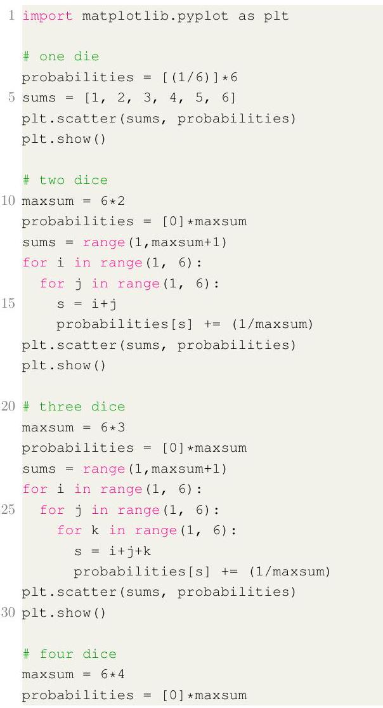

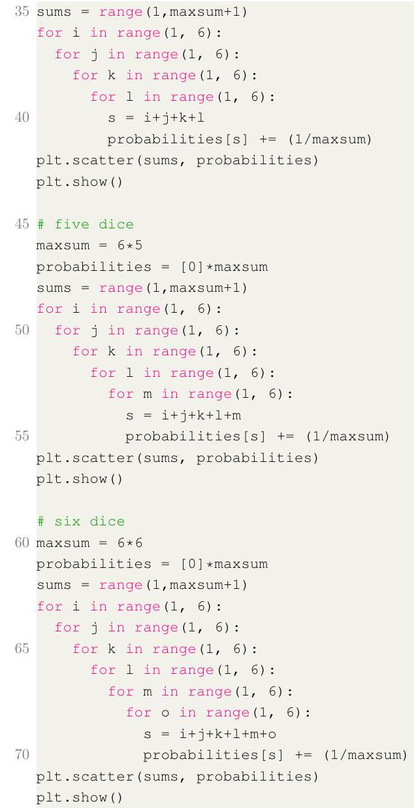

Exercise 7-4 Assignments in the EM-Algorithm

(1 point)

Given a data set with 100 points consisting of three Gaussian clusters $A,B$ and $C$ and the point $p$

The cluster $A$ contains $30\%$ of all objects and is represented using the mean of all its points $μ_{A}=(2,2)$ and the covariance matrix $Σ_{A}=\left(\begin{matrix}3 & 0 \\ 0 & 3\end{matrix}\right)$

You will need the inverse $Σ_{A}^{-1}=\left(\begin{matrix}\frac{1}{3} & 0 \\ 0 & \frac{1}{3}\end{matrix}\right)$.

The cluster $B$ contains $20\%$ of all objects and is represented using the mean of all its points $μ_{B}=(5,3)$ and the covariance matrix $Σ_{B}=\left(\begin{matrix}2 & 1 \\ 1 & 4\end{matrix}\right)⋅Σ_{B}^{-1}≈\left(\begin{matrix}0.571428 & -0.142857 \\ -0.142857 & 0.285714\end{matrix}\right)$

The cluster $C$ contains $50\%$ of all objects and is represented using the mean of all its points $μ_{C}=(1,4)$ and the covariance matrix $Σ_{C}=\left(\begin{matrix}16 & 0 \\ 0 & 4\end{matrix}\right)⋅Σ_{C}^{-1}=\left(\begin{matrix}\frac{1}{16} & 0 \\ 0 & \frac{1}{4}\end{matrix}\right)$

The point $p$ is given by the coordinates $(2.5,3.0)$.

The following sketch is not exact, and only gives a rough idea of the cluster locations:

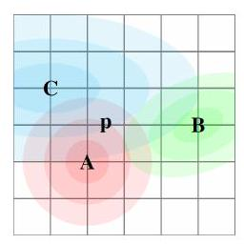

Compute the three probabilities of $p$ belonging to the clusters $A,B$, and $C$. Suggested solution: Cluster A:

$$\begin{matrix}Σ_{A}=\left(\begin{matrix}3 & 0 \\ 0 & 3\end{matrix}\right) Σ_{A}^{-1}=\left(\begin{matrix}\frac{1}{3} & 0 \\ 0 & \frac{1}{3}\end{matrix}\right) μ_{A}=(2,2) \\ p-μ_{A}=(0.5,1) \\ { \text{dist} }^{2}=(p-μ)^{T}Σ^{-1}(p-μ)≈0.41666 \\ { \text{dens} }_{A}≈\frac{1}{\sqrt{(2π)^{2}9}}e^{-\frac{1}{2}0.41666} \\ ≈0.04307456\end{matrix}$$

Cluster B:

$$\begin{matrix}Σ_{B}=\left(\begin{matrix}2 & 1 \\ 1 & 4\end{matrix}\right) Σ_{B}^{-1}≈\left(\begin{matrix}0.571428 & -0.142857 \\ -0.142857 & 0.285714\end{matrix}\right) μ_{B}=(5,3) \\ p-μ_{B}=(-2.5,0) \\ { \text{dist} }^{2}=(p-μ)^{T}Σ^{-1}(p-μ)≈3.5714285 \\ { \text{dens} }_{B}≈\frac{1}{\sqrt{(2π)^{2}7}}e^{-\frac{1}{2}3.5714285} \\ ≈0.01008661\end{matrix}$$

Cluster C:

$$\begin{matrix}Σ_{C}=\left(\begin{matrix}16 & 0 \\ 0 & 4\end{matrix}\right) Σ_{C}^{-1}=\left(\begin{matrix}\frac{1}{16} & 0 \\ 0 & \frac{1}{4}\end{matrix}\right) μ_{C}=(1,4) \\ p-μ_{C}=(1.5,-1) \\ { \text{dist} }^{2}=(p-μ)^{T}Σ^{-1}(p-μ)≈0.390625 \\ {dens}_{C}≈\frac{1}{\sqrt{(2π)^{2}64}}e^{-\frac{1}{2}0.390625} \\ ≈0.01636466\end{matrix}$$

|  |  |  |  |
| --- | --- | --- | --- |
|  | $$A$$ | $$B$$ | $$C$$ |
| Density | $$0.043075$$ | $$0.010087$$ | $$0.016365$$ |
| Size | $$30\%$$ | $$20\%$$ | $$50\%$$ |
| Score | $$0.012922$$ | $$0.002017$$ | $$0.008182$$ |
| Sum | $$\frac{0.012922}{0.023122}$$ | $$\frac{0.002017}{0.023122}$$ | $$\frac{0.008182}{0.023122}$$ |
| Weight | $$55.9\%$$ | $$8.2\%$$ | $$35.4\%$$ |