**3. Exercise 13**

Exercise 13-1 Handwritten digit recognition in PyTorch with neural nets In this exercise session we will be discussing neural networks and develop a handwritten digit classifier from scratch. For this, we will be using PyTorch with nn.Linear, nn.ReLU, (optional) nn.Sequential.

We will be using the popular MNIST database. It is a collection of 70000 handwritten digits split into training and test set of 60000 and 10000 images respectively.

You will need to build a neural net (multilayer perceptron) with

* 0 hidden layers (linear regression)

1 hidden layer of for example 100 neurons

2 hidden layers of 100 hidden neurons

Get it to run on the MNIST data set. Tutorials and other helpful resources can be found on the PyTorch website.

Observe how batch size and learning rate should be changed together, and how adjusting the parameters affects the accuracy. Observe how training set size affects accuracy. Observe how different levels of depth affect accuracy (0-1-2- hidden layers).

**4. Suggested solution:**

Take a look at the three files [linearRegression.py](http://linearRegression.py), [oneHiddenLayer.py](http://oneHiddenLayer.py) and [twoHiddenLayers.py](http://twoHiddenLayers.py) to see the three neural networks.

For the linear regression you should aim for an accuracy of about $91\%$. For the deeper neural nets you should achieve circa $95\%$ accuracy.

We set the batch size to 100 and the learning rate to $0.01$. For the linear regression we get the following output:

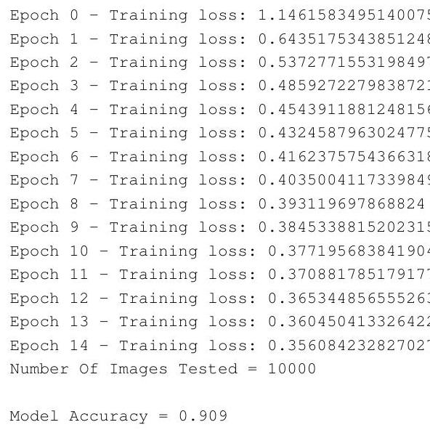

For the one hidden layer we get the following output:

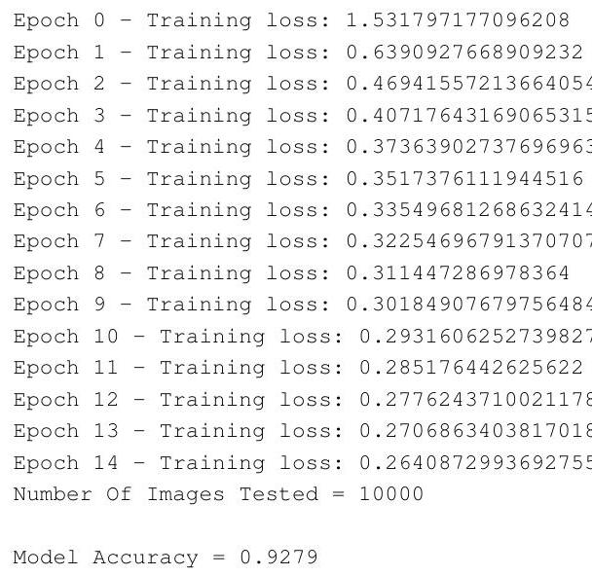

For the two hidden layers we get the following output:

