Deep learning Project 1

**Authors**

Gustav Christensen

Exam nr.

Christoffer Mondrup Kramer

Exam nr. 4102366

**Course**

DS809 / DM873

Deep Learning (Autumn)

University of Southern Denmark

**Date**

11-11-2022

**Table of contents**

1. Data Augmentation 2

2. Network Architecture 5

3. Visualization 8

4. Final Results 10

# 1. Data Augmentation

**Authors:** *Gustav Christensen and Christoffer Kramer*

We decided to use data augmentation to make our model more generalizable. We also shuffled the image order to avoid any potential bias in the image order. We created a function called *generate_data* which returned four *ImageDataGenerators*. We did this, since it would make it a lot easier to implement different models in different files while still ensuring that the input data received the same type of data augmentation.

from tensorflow.keras.preprocessing.image import ImageDataGenerator  
from tensorflow.keras.models import clone_model  
from tensorflow.keras.backend import clear_session  
import matplotlib.pyplot as plt  
from math import ceil  
from os import listdir  
import tensorflow as tf  
from tensorflow.keras import layers  
from tensorflow.keras import models  
from tensorflow.keras import optimizers  
import os  
import numpy as np  
  
  
def generate_data(targ_size, batch_size):  
 """  
 Creates datagenerators with the specified target dimensions and batch sizes  
 """  
 # ------ Training data ------  
 train_datagen = ImageDataGenerator(  
 rescale=1./255,   
 rotation_range = 20,  
 width_shift_range = 0.20,  
 height_shift_range = 0.20,  
 shear_range=0.10,  
 zoom_range=0.20,  
 horizontal_flip=True)  
  
 train_generator = train_datagen.flow_from_directory(  
 directory = r"catdog_data/train",  
 target_size = targ_size,  
 color_mode = "rgb",  
 batch_size = batch_size,  
 class_mode='binary',  
 shuffle = True)   
  
 # ------ Test data ------  
 test_val_datagen = ImageDataGenerator(rescale=1./255)  
 test_generator = test_val_datagen.flow_from_directory(  
 directory= r"catdog_data/test",  
 target_size = targ_size,  
 color_mode="rgb",  
 batch_size = batch_size,  
 class_mode= "binary")  
  
 # ------ Validation data ------  
 val_generator = test_val_datagen.flow_from_directory(   
 directory = r"catdog_data/validation",  
 target_size = targ_size,  
 color_mode = "rgb",  
 batch_size= batch_size,  
 class_mode='binary')  
  
 # Full training data set  
 full_train_generator = train_datagen.flow_from_directory(  
 directory = r"catdog_data/train_val",  
 target_size = targ_size,  
 color_mode = "rgb",  
 batch_size = batch_size,  
 class_mode='binary',  
 shuffle = True)  
  
 return train_generator, val_generator, test_generator, full_train_generator

Since we used augmented data, we needed to make sure that our model wouldn't train indefinitely. We, therefore, created a function for calculating steps per epoch. This caused problems in the beginning of our project since it by mistake returned a step size of 1. This caused our models to fluctuate wildly in their accuracies. However, we fixed this and ended up with some models, which were a lot more stable.

def calc_steps_epoch(n_samples, batch_size, factor):  
 """  
 Return how many steps to go through in each epoch  
 This is neccesarry since we use augmented data  
 """  
 return int(ceil( (factor * n_samples) / batch_size))

For a quick sanity check we loaded an images and inspected how the augmentation looked. We deemed the current augmentation perfect for our taks at hand, since it was comprehensible to us.

# Datagenerator - Example  
datagen = ImageDataGenerator(  
 rotation_range = 20,  
 width_shift_range = 0.20,  
 height_shift_range = 0.20,  
 shear_range = 0.10,  
 zoom_range = 0.20,  
 horizontal_flip = True)  
  
fnames = [os.path.join("catdog_data/train/cats/", fname) for  
 fname in os.listdir("catdog_data/train/cats/")]  
  
img_path = fnames[3]  
  
img = tf.keras.utils.load_img(img_path, target_size=(150, 150))  
  
x = tf.keras.utils.img_to_array(img)  
x = x.reshape((1,) + x.shape)  
  
i = 0  
for batch in datagen.flow(x, batch_size=1):  
 #plt.figure(i)  
 ax = plt.subplot(2, 2, i + 1)  
 imgplot = plt.imshow(tf.keras.utils.img_to_array(batch[0]).astype(np.uint8))  
 i += 1  
 if i % 4 == 0:  
 break  
  
plt.suptitle("Random images generated by data augmentation", fontweight = "bold", y = 0.96)  
plt.show()

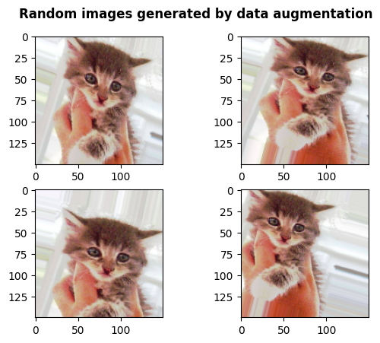

# 2. Network Architecture

**Author:** *Christoffer Kramer*

We experimented with the following model architectures. The number in parenthesis in convolutional layers refers to the filters/channels:

**Model 1:**

* *Hyperparameters*:
  + kernels = (3, 3)
  + Activation = relu
  + Learning Rate = 0.001
* *Architecture*
  + Conv(32) --> MaxPool
  + Conv(64) --> MaxPool
  + Conv(64) --> MaxPool
  + Flatten --> Dense(64)
  + Dropout(0.2) -> Sigmoid

**Model 2:**

* *Hyperparameters*:
  + kernels = (3, 3)
  + Activation = relu
  + Learning Rate = 0.001
* *Architecture*
  + Conv(32) --> MaxPool
  + Conv(64) --> MaxPool
  + Conv(64) --> MaxPool
  + Conv(64) --> MaxPool
  + Flatten --> Dense(248)
  + Dropout(0.2) -> Sigmoid

**Model 3:**

* *Hyperparameters*:
  + kernels = (3, 3)
  + Activation = relu
  + Learning Rate = 0.001
* *Architecture*
  + Conv(32) --> MaxPool
  + Conv(64) --> MaxPool
  + Conv(128) --> MaxPool
  + Flatten --> Dense(128)
  + Dropout(0.2) -> Sigmoid

We started by training each model for 20 epochs. We used a input shape of 112x112 pixels with three (RGB) color channels. We then choose the most promising model for further training and tweaking. We decided to use model 2, since it was computationally inexpensive, didn’t really overfit and had an accuracy of over 70%. We tweaked it by lowering the batch size to 32 to see if we would get a smoother loss function. This didn't work, so we kept a batch size of 64 but lowered the learning rate of the Adam optimizer to 0.0001. This worked surprisingly well and made the loss function decrease more smoothly and the accuracy likewise increased more smoothly. Since the model didn’t appear to be overfitting, we decided to use these parameters for our final model.

INPUT_SHAPE = (112, 112, 3)  
BATCH_SIZE = 64  
  
# Calcualte length of data   
n_train_samples = (len(listdir("catdog_data/train/cats")) + len(listdir("catdog_data/train/dogs")))  
  
n_val_samples = (len(listdir("catdog_data/validation/cats")) + len(listdir("catdog_data/validation/dogs")))  
  
n_test_samples = (len(listdir("catdog_data/test/cats")) + len(listdir("catdog_data/test/dogs")))  
   
n_full_train_samples = n_train_samples + n_val_samples  
  
TEST_STEPS = calc_steps_epoch(n_samples = n_test_samples,  
 batch_size = BATCH_SIZE,  
 factor = 1)  
  
FULL_TRAIN_STEPS = calc_steps_epoch(n_samples = n_full_train_samples,  
 batch_size = BATCH_SIZE,  
 factor = 1)  
train_generator, val_generator, test_generator, full_train_generator = generate_data(targ_size = (INPUT_SHAPE[0], INPUT_SHAPE[1]),  
 batch_size = BATCH_SIZE)  
  
# Model 2  
model = models.Sequential()  
  
# Conv(32) -> MaxPool -->  
model.add(layers.Conv2D(filters = 32,  
 kernel_size = (3, 3),  
 input_shape = INPUT_SHAPE))  
model.add(layers.MaxPooling2D(pool_size = 2))  
  
# Conv(64) -> MaxPool -->  
model.add(layers.Conv2D(filters = 64,  
 kernel_size = (3, 3),  
 activation = 'relu'))  
model.add(layers.MaxPooling2D(pool_size = 2))  
  
# Conv(64) -> MaxPool -->  
model.add(layers.Conv2D(filters = 64,  
 kernel_size = (3, 3),  
 activation = 'relu'))  
model.add(layers.MaxPooling2D(pool_size = 2))  
  
# Conv(64) -> MaxPool -->  
model.add(layers.Conv2D(filters = 64,  
 kernel_size = (3, 3),  
 activation = 'relu'))  
model.add(layers.MaxPooling2D(pool_size = 2))  
  
# Flatten -> Dense(248) -->  
model.add(layers.Flatten())  
model.add(layers.Dense(248, activation='relu'))  
  
# Dropout(0.2) -> Sigmoid  
layers.Dropout(.2)  
model.add(layers.Dense(1, activation='sigmoid'))  
  
  
model.compile(loss = 'binary_crossentropy',  
 optimizer = optimizers.Adam(learning_rate = 0.0001),  
 metrics = ['accuracy'])

Found 2000 images belonging to 2 classes.  
Found 400 images belonging to 2 classes.  
Found 600 images belonging to 2 classes.  
Found 2600 images belonging to 2 classes.

# 3. Visualization

**Author** *Gustav Christensen*

To visualize the training and validation metrics during different epochs, we define a function that takes a fitted model as the only argument.

def plot_hist(history):  
 acc = history.history['accuracy']  
 val_acc = history.history['val_accuracy']  
 loss = history.history['loss']  
 val_loss = history.history['val_loss']  
 epochs = range(1, len(acc) + 1)  
  
 figure, axis = plt.subplots(2, 1)  
  
 axis[0].plot(epochs, acc, label = 'Training accuracy')  
 axis[0].plot(epochs, val_acc, label = 'Validation accuracy')  
 axis[0].set_title('Training and validation accuracy')  
 axis[0].legend(loc = "lower right")  
  
 axis[1].plot(epochs, loss, label = 'Training loss')  
 axis[1].plot(epochs, val_loss, label = 'Training loss')  
 axis[1].set_title('Training and validation loss')  
 axis[1].legend(loc = "upper right")  
  
 plt.subplots_adjust(hspace = 0.4)  
  
 plt.show()

TRAIN_STEPS = calc_steps_epoch(n_samples = n_train_samples,  
 batch_size = BATCH_SIZE,  
 factor = 1)  
  
VAL_STEPS = calc_steps_epoch(n_samples = n_val_samples,  
 batch_size = BATCH_SIZE,  
 factor = 1)  
history = model.fit(  
 train_generator,  
 steps_per_epoch = TRAIN_STEPS, #   
 epochs = 100,  
 validation_data = val_generator,  
 validation_steps = VAL_STEPS,  
 verbose = True  
)

plot_hist(history)

Epoch 1/100  
32/32 [==============================] - 25s 740ms/step - loss: 0.6911 - accuracy: 0.5260 - val_loss: 0.6877 - val_accuracy: 0.6133  
  
…   
  
Epoch 100/100  
32/32 [==============================] - 22s 695ms/step - loss: 0.4172 - accuracy: 0.8090 - val_loss: 0.5023 - val_accuracy: 0.7683

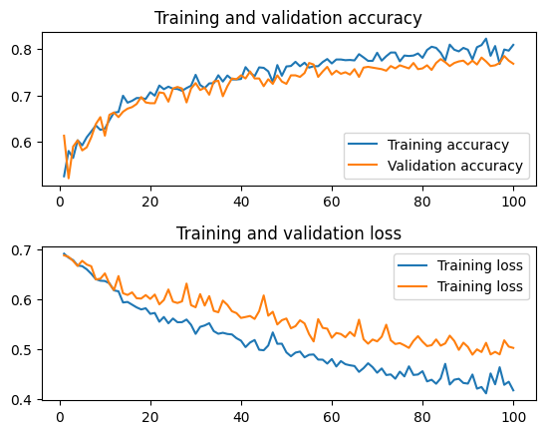

In the figure above, we have plotted the accuracy and loss of both the training and validation set. Here, we observe that both curves for each plot follow the other relatively close which is an indication that the trained neural network is not overfitting. Therefore, the model is ready for training on the full data set.

# 4. Final Results

**Authors:** *Gustav Christensen and Christoffer Kramer*

For the final model we trained on both the training and validation set, we used epoch 100 and early stopping with a patience of 7.

clear_session()  
callback = tf.keras.callbacks.EarlyStopping(monitor='loss', patience=7)  
final_model = clone_model(model)  
final_model.compile(loss = 'binary_crossentropy',  
 optimizer = optimizers.Adam(learning_rate = 0.0001),  
 metrics = ['accuracy'])  
   
final_model.fit(  
 full_train_generator,  
 steps_per_epoch = FULL_TRAIN_STEPS,  
 epochs = 100,  
 verbose = True,  
 callbacks=[callback]  
)

Epoch 1/100  
41/41 [==============================] - 31s 741ms/step - loss: 0.6912 - accuracy: 0.5169

...

Epoch 100/100  
41/41 [==============================] - 28s 680ms/step - loss: 0.4221 - accuracy: 0.8046

We trained the model for 100 epochs and the accuracy on the test data was 77.25 % which we deemed sufficient.

final_model.evaluate(test_generator, steps = TEST_STEPS)  
final_model.save("models/final_model.h5")

7/7 [==============================] - 1s 157ms/step - loss: 0.4238 - accuracy: 0.7725