Exercise 3

Chris Penfold

25 September, 2019

## Embed a plot

Here’s an embedded plot

library(ggplot2)  
ggplot(data = mpg, aes(x = drv,   
 y = hwy,   
 colour = drv)) +   
 geom_boxplot()

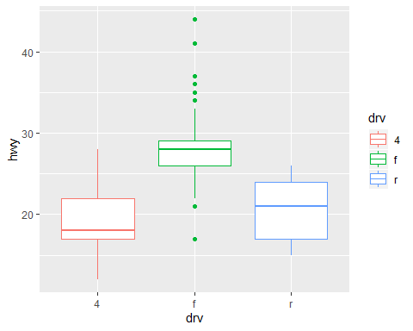

## Embed a table

Here’s an embedded table

library(BristolVis)  
library(arsenal)  
table_one <- tableby(diet ~ bmi + sex,   
 data = bmi,   
 test=TRUE, # include tests of associations between diet and exposures  
 total=TRUE, # include a total column  
 control=tableby.control(digits=1)) # to control how many decimal places are in the table  
summary(table_one)

|  |  |  |  |  |
| --- | --- | --- | --- | --- |
|  | 0 (N=9) | 1 (N=11) | Total (N=20) | p value |
| **bmi** |  |  |  | 0.618 |
| Mean (SD) | 30.7 (3.0) | 30.2 (1.1) | 30.4 (2.1) |  |
| Range | 25.0 - 33.3 | 28.0 - 31.8 | 25.0 - 33.3 |  |
| **sex** |  |  |  | 0.423 |
| F | 5 (55.6%) | 8 (72.7%) | 13 (65.0%) |  |
| M | 4 (44.4%) | 3 (27.3%) | 7 (35.0%) |  |

## Inline R code

We included 20 people from the BMI dataset in our analyses. The mean BMI of people in this study was 30.4kg/m2 (sd = 2.1kg/m2).