Web Programming Project – SMT Movie Rental Testing Report

Term 1 2021

Table of Contents

Pear Code Standard 0

Figure 1. 0

Figure 2. 0

Figure 3. 0

Figure 4. 1

Risk Analysis 1

Test Table 1

Figure 1. 2

Figure 2. 3

Figure 3. 3

Figure 3.5. 3

Figure 4. 4

Figure 4.5. 4

Figure 5. 4

Figure 6. 4

Figure 7. 4

Figure 8. 5

Figure 8.5. 5

Figure 9. 5

Figure 9.5. 6

Browser Tests 6

MS Edge 6

Figure 1. 6

Figure 2. 6

Figure 3. 7

Firefox 7

Figure 1. 7

Figure 2. 7

Figure 3. 8

Adjustments Following All Tests 8

# Pear Code Standard

For the code to be compliant with the Pear standard an extension called “phpcs” has been used within Visual Studio Code to highlight and provide comments about any errors.

## Figure 1.

Line 26 advises me that require is a statement and not a function, the brackets should be removed.

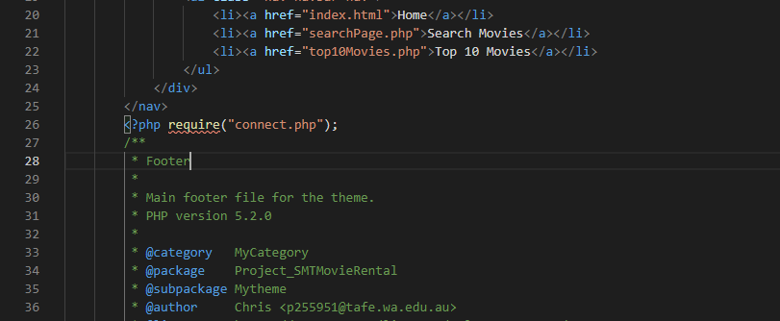

## Figure 2.

Once corrected there is a new error still on line 26 around the below commenting not being quite correct.

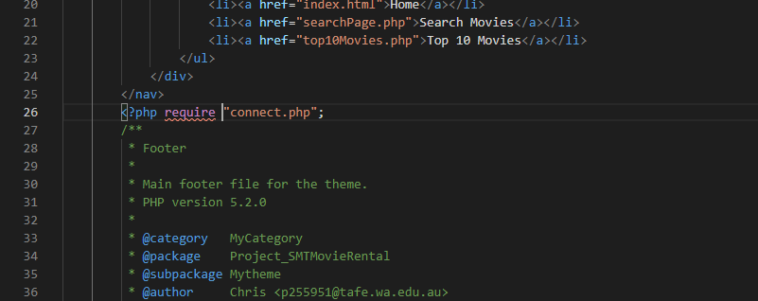

## Figure 3.

Moving down the code after correcting line 26 there is a few errors that appear irrelevant such as expected after {\n; while there is {\n.

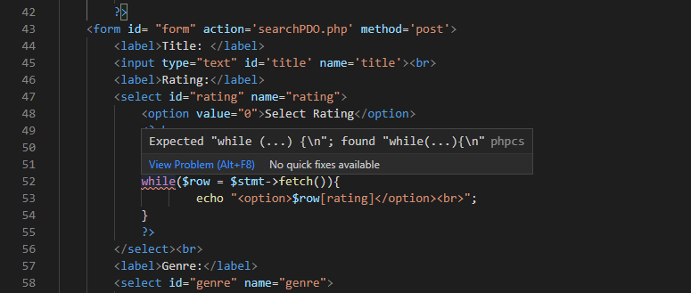

## Figure 4.

The page is left with a simple warning that the characters on this line may be too long however this is not an error.

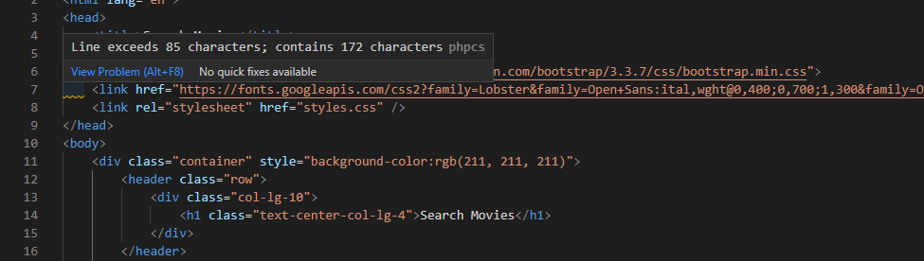

# Risk Analysis

There may have been potential for errors to occur should the user have more input options, but the website has been designed with dropdown boxes in all but one place. The dropdown boxes allow the user to pick one or more columns within the database as a search parameter.

Using a PDO connection rather than SQLi combined with prepared statements assists in preventing the user from injecting malicious SQL to the parameter of the post request. Bad values need escaping and there are additional PDO functions that can be implemented such as PDO::quote().

# Test Table

|  |  |  |  |  |
| --- | --- | --- | --- | --- |
| Test Case | Expected Outcome | Actual Outcome | Comments | Verdict |
| Clicking all links in nav bar from each page | All links are functioning correctly without error | All links are functioning correctly without error |  | Pass |
| Submit button clicked from search page with title only. Never ending story | Table will appear with correct movie details | Table will appear with correct movie details | See figure 1 | Pass |
| Submit button clicked from search page with genre Drama and rating R | Table will appear with correct movie details | Table will appear with correct movie details | See figure 2 | Pass |
| Submit button clicked from search page with genre Drama and rating R and Year 1997 | Table will appear with correct movie details | Table will appear with correct movie details | See figures 3 & 3.5 | Pass |
| Submit button clicked from search page with title Never Ending Story and Year 1997 | Table will appear with correct movie details | Table will appear with correct movie details | See figures 4 & 4.5 | Pass |
| Submit button clicked from search page with no details input to search | Message will appear to the user advising them of an error and to try again | Message will appear to the user advising them of an error and to try again | See figure 5 | Pass |
| Submit button clicked from search page with incorrect title details | Message will appear to the user advising them of an error and to try again | Message will appear to the user advising them of an error and to try again | See figure 6 | Fail |
| Submit button clicked from search page with correct title, rating, genre, and year | Table will appear with correct movie details | Table will appear with correct movie details | See figure 7 | Pass |
| Click Top 10 from nav bar to see chart | Chart with top 10 searched movies appears showing the number of searches with movie titles on opposite axis. Also, a table appears below the chart with the same information. | Chart with top 10 searched movies appears showing the number of searches with movie titles on opposite axis. Also, a table appears below the chart with the same information. | See figure 8 & 8.5 | Pass |
| Submit button clicked from search page with partially correct title details | Message will appear to the user advising them of an error and to try again | Message will appear to the user advising them of an error and to try again | See figure 9 & 9.5 – The error message has been fixed since the last similar test, but further adjustment will made so that a partial title does display results. | Pass |

## Figure 1.

## Figure 2.

## Figure 3.

## Figure 3.5.

## Figure 4.

## Figure 4.5.

## Figure 5.

## Figure 6.

## Figure 7.

## Figure 8.

## Figure 8.5.

## Figure 9.

## Figure 9.5.

# Browser Tests

The above test used in the table where all done using Chrome, below will be Edge and Firefox.

## MS Edge

Edge performs almost identically to Chrome in testing, see below images.

### Figure 1.

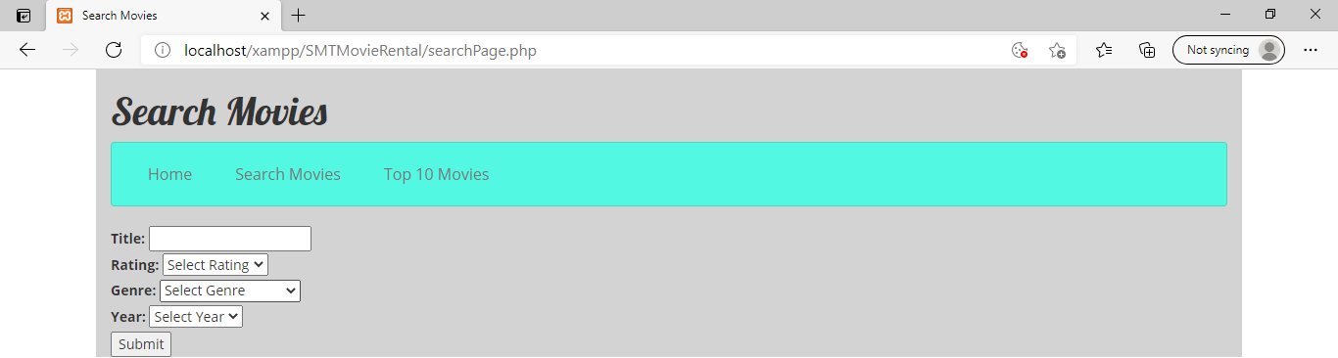

### Figure 2.

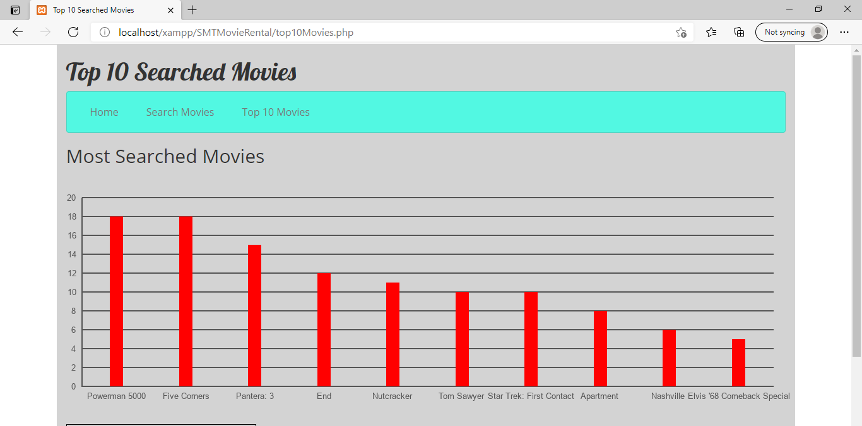

### Figure 3.

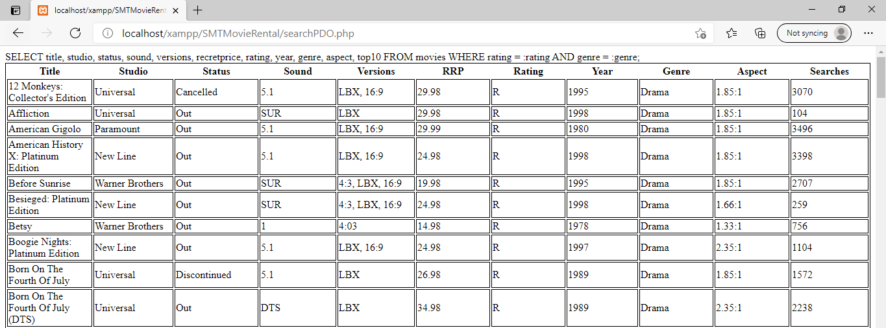

## Firefox

Firefox is still functional and there are no errors however the CSS has been automatically adjusted.

### Figure 1.

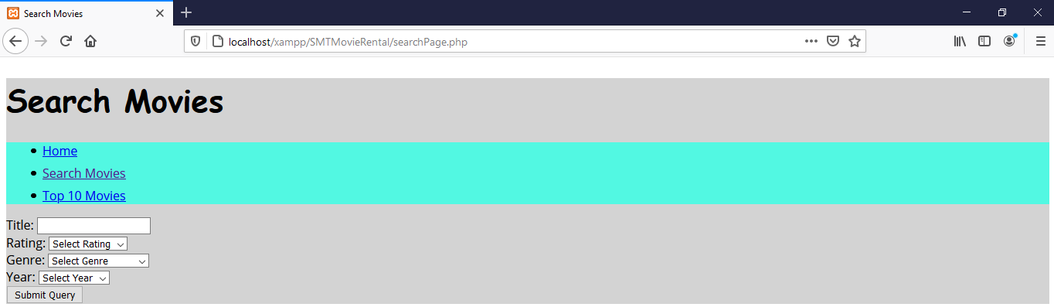

### Figure 2.

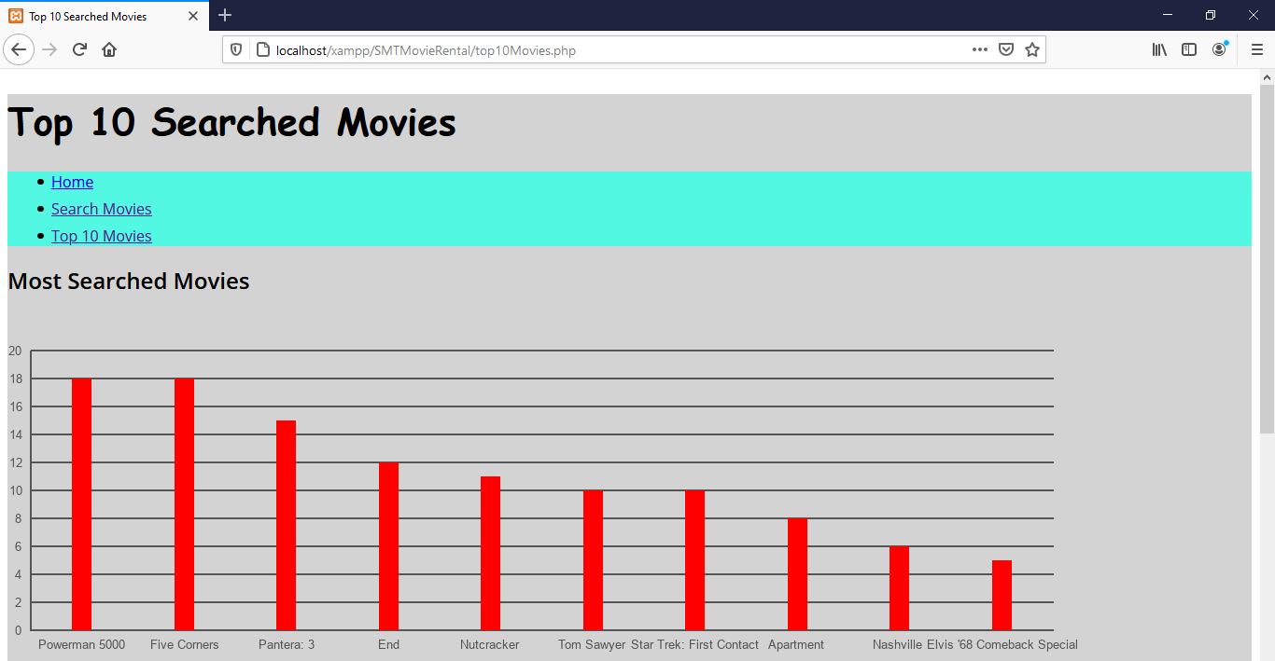

### Figure 3.

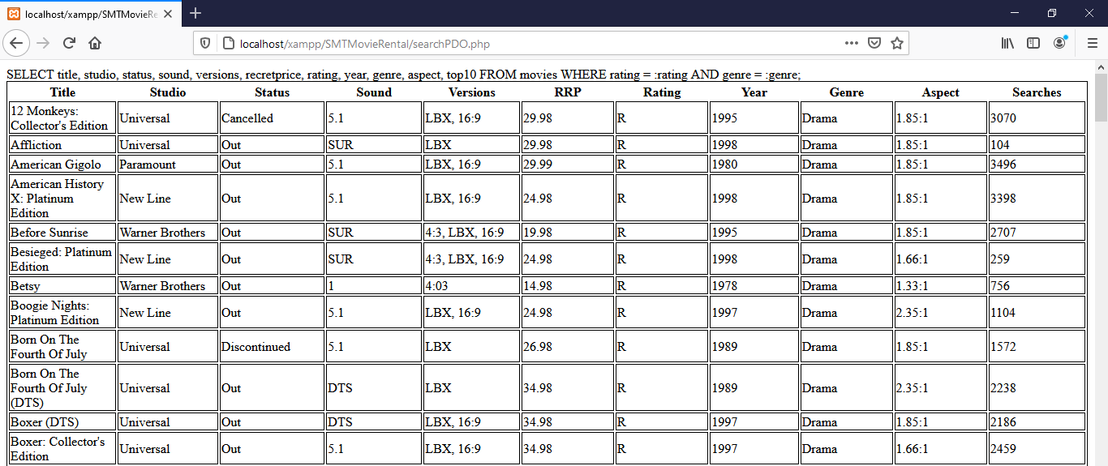

# Adjustments Following All Tests

1. The first change to the code was adding an if/else statement around displaying the table with movies details so that if the result equals null, the user gets a message advising them with a link to click going back to the search page.

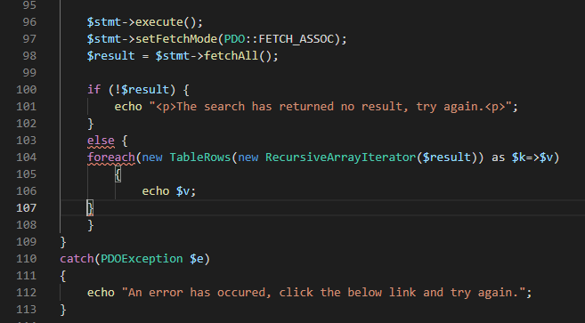

1. The second change to the code is adjusting the SQL around title to add % at the start and end of a movie title combined with LIKE meaning the user can know part of a title name and still see relevant results.

