ASCOM GenericSafety Safety Monitor

This driver will read a file and/or check the Windows PowerLineStatus and use the results to set the ASCOM IsSafe property.

Installation
The normal ASCOM driver installer is used. This file is shown if required.

Setup
This shows the safety setup dialog:
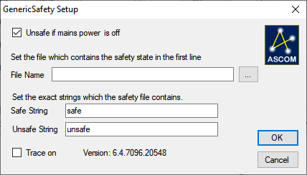

- If ‘Unsafe if mains power is off’ is checked then the Windows PowerLineStatus is checked and if this reports offline then IsSafe is reported as true , i.e. unsafe.
- The File name text box has the path to the file that is checked for safety state in the first line, the button with the ellipsis… is used to select the file.
- The strings in the file used to report the safety state can be specified. All that is required is that the exact text of either string is contained in the first line of the file.
  - Unsafe is checked before Safe so if the safe string is contained in the unsafe string (as in the example) the system will report unsafe.
  - If either string s not present the system will report unsafe
  - If there is an error opening or reading the file then the GSM will report unsafe.
- Check the Trace On button to enable trace logging. The log file is named ASCOM.GenericSafety.<time>.<nnn>.txt and is in the folder Documents\ASCOM\Logs <date>\.
- Click on Cancel to exit without saving the changes.
- Click on OK to save the current setup and close the dialog.
  - If ‘Unsafe if mains power is off’ is unchecked and the file name is empty then no checks will be done. A message will be shown warning you. It’s possible to accept this or you can click on ‘No’ and go back to correct this.

Safety File Format
The file format is a text file with at least one line of text, the first line must be changed as the monitored condition is changed. Two different strings of text are used to set the safety state.

The file can be generated in a script or batch file, for example:

SetSafe.bat could contain
Echo safe > safety.txt

And SetUnsafe.bat could contain
Echo unsafe > safety.txt

The driver has to be set so it knows the path to the safety file and the strings that define the safe and unsafe states.

The file can contain more than the specified text in the first line, so “UPS state safe” will report safe and “UPS state is unsafe” will report unsafe.

Operation
This is intended to signal to an application that the power is failing and so allow the application to do an orderly close down while there is still backup power available.
A typical installation would be running on a laptop, with the laptop powered directly from the mains. All other systems, scope, cameras, observatory roof etc. would be powered from a UPS. When the mains power fails the GSM signals this and the application performs a orderly close down, warming the camera, parking the scope, parking the dome, closing the roof/shutter and finally

