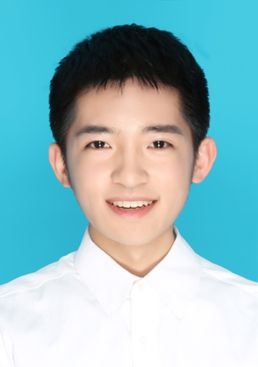**个人简历**

**Personal Resume**

**个人资料 Personal Information**

姓名：袁海 生日：1996.08

邮箱：434743325@163.com 电话：17751126561

毕业院校：西交利物浦大学 学历：本科

**教育背景 Education Background**

**2014.09 – 2018.06** 就读于西交利物浦大学通信工程专业，主修的课程包括C语言，C++语言，线性代数，微积分，数字电子，电子电路设计，工程数学，电磁机电学，连续和离散信号与系统，模拟与数字通信，HDL数字系统设计，电子通信，无线系统，光子学和光通信系统，信号处理与数字滤波。

**2014.09 – 2018.06** I study in Xi’an Jiaotong-Liverpool University and my major is telecommunications engineering. The compulsory modules consist of C and C++ Programming, Linear Algebra, Calculus (Science and Engineering), Digital Electronics, Electronic Circuits, Engineering Mathematics, Electromagnetism and Electromechanics, Continuous and Discrete Time Signals and Systems, Analogue and Digital Communications, Digital System Design with HDL, Electronics for Communications, Wireless systems, Photonics and Optical Communication Systems, Signal Processing and Digital Filtering.

**在校成就 Achievements in School**

曾在一门叫能量转换和电力系统的课程中获得第一名，分别在演讲和报告中取得优异成绩。

通过做必修课程的实验，对MATLAB应用的熟练度大幅度提高，可做数据的分类。

曾参加偏远山区支教活动并得到当地师生好评。

I have gained the highest academic scores in Energy Conversion and Power Systems, and I also achieved pleasant performances in presentation and report. From the experiment of compulsory modules, the proficiency of MATLAB is increased. Besides, I can finish data classification. To be a volunteer teacher who went to rural area to teach, and I obtained compliment from other teachers and students.

**实习经历 Internship Experience**

* **2015年11月，西交利物浦大学IT部门**

帮同学装软件，替同学解决设备上的问题。

* **2016年1月，贵州浩瑞电力科技有限公司**

用CATIA做3D建模和AutoCAD制图，并焊接电路

* **2015. 11 IT department of Xi’an Jiaotong-Liverpool University**

Help students to install software and solve the problems on the device.

* **2016. 1 Guizhou Haorui Electric Power Technology Co., Ltd**

Using CATIA and AutoCAD to achieve 3-D modeling and sketch, respectively. Besides, I also weld circuit.

**自我评价 self-assessment**

性格活泼开朗，对人友好，易与他人交上朋友，而且有较强的团队精神，懂得如何与他人合作。在面对困难时，不会轻易放弃，会想尽一切办法去解决，在没解决之前，会抱着激情一直努力。另一方面，要做重要决定时，会冷静下来考虑各个方面并选择风险最小的一个方案。在学习方面，本人态度认真，虚心请教他人，会努力学习自己不懂的知识。

My personality is extravert, friendly, and I can make friends with others easily. Besides, I have a strong team spirit and know how to cooperate with team members. When I meet problems, I will try my best to solve them and never give up. I will hold passion to make effort until the trouble solved. In addition, I will choose the best one with the lowest risk under careful thinking when I must make an important decision. As for study, I am hard-working and modest. Besides, I attempt to study the knowledge that I do not understand.