HACE: Addressing Viability Failure in Sequential Reinforcement Learning with Homeostatic Auxiliary Rewards
Ziyu Kong, Shihang Gui, Ruth Ukubay, Meiyi Song
Department of Computer Science, Brown University, Providence, RI, USA

1 Introduction
Reinforcement learning agents deployed in continual settings must adapt to changing objectives without losing previously learned capabilities. The dominant research paradigm in continual RL (CRL) frames this challenge almost exclusively as catastrophic forgetting: the tendency for parameters to overwrite old knowledge during new-task training [5,8-9]. A rich toolkit has emerged—Elastic Weight Consolidation (EWC [5]), Experience Replay (ER [6]), progressive architectures [7]—all evaluated on whether old-task performance degrades after training on new ones.
We argue that this focus on forgetting obscures an equally critical failure mode in embodied sequential settings: viability failure. When an environment imposes shared physiological constraints—such as an internal energy variable that depletes with each action—a task transition can be lethal. An agent completing Task $T_{i}$ with minimal remaining energy arrives at Task $T_{i+1}$ without the resources to survive long enough to learn. No amount of weight regularization or replayed transitions can save an agent that dies in its first three steps.
Consider a concrete example. An agent trained on Conservation (high step cost, must be efficient) transitions to Sprint (very short time limit, must be fast). Under carryover boundary conditions—where energy persists between tasks—the agent arrives at Sprint with critically low energy and no time to explore. It dies immediately. EWC preserves the Conservation weights perfectly, but those weights are useless if the agent cannot survive.
This paper makes three contributions. First, we formally identify viability failure as a distinct failure mode in embodied CRL, separate from catastrophic forgetting, and show that traditional CRL methods do not directly target it (Section 3). Second, we propose Hace, a task-invariant auxiliary reward based on homeostatic drive reduction that incentivizes energy management across all tasks without task-specific engineering. Third, we design a 10-task sequential gridworld benchmark with 9 agent variants and a curated task sequence, enabling systematic study of both failure modes (Section 4). Our experiments (Section 5) show that Hace maintains viability across task transitions while traditional CRL methods do not improve survival metrics in our benchmark.

2 Related Work

Continual RL.
EWC [5] constrains important parameters via a Fisher-weighted penalty; ER [6] interleaves old transitions during new-task training; progressive networks [7] freeze old columns and add capacity per task. These methods have been benchmarked on Continual World [9] and CORA [10], where episode termination is unaffected by resource constraints. Our work highlights that this evaluation paradigm does not directly test for viability failure.

Homeostatic RL.
Keramati and Gutkin [1] formalize reward as deviation reduction from an internal setpoint, producing risk-averse and anticipatory behaviors. Yoshida [2-3] extends this to deep RL and connects it to meta-RL. Konidaris and Barto [4] propose adaptive motivational systems. However, much of this prior work studies single or slowly shifting environments and does not test whether homeostatic objectives improve sequential task learning.

Transfer and auxiliary rewards.
Successor features [11] decompose value into reusable dynamics and task-specific weights. Tomov et al. [12] observe that humans reuse policies across tasks and that task descriptions could be grounded in physiological states—an insight Hace operationalizes. Unlike curiosity [14] or pixel control [13], Hace targets viability maintenance rather than exploration or representation learning.

3 Viability Failure and HACE

3.1 Sequential Task Setting
We consider an agent learning a sequence of tasks $T_{1},…,T_{n}$ sharing a common action space, an internal energy variable $E_{t}∈[0,E_{max}]$ with per-step cost $c_{\text{step}}$, and a terminal condition $E_{t}≤0⟹\text{death}$. Tasks differ in grid layout, hazards, food sources, walls, and energy economics (Section 4). At task boundaries, the agent retains its network parameters. Energy is handled by the boundary mode: reset reinitializes energy to each task’s default, while carryover preserves the terminal energy from the previous task. Carryover is the ecologically realistic setting where viability failure is most acute.

3.2 Viability Failure
An agent experiences viability failure at boundary $T_{i}→T_{i+1}$ when its expected terminal energy after Task $T_{i}$ is insufficient to sustain exploration in $T_{i+1}$:
$$E_{π_{i}}​\left[E_{T_{i}}^{\text{terminal}}\right] ​< ​E_{\text{viable}}^{(i+1)}. \text{(1)}$$
The agent then dies in the first few steps of the new task, observing mostly short death trajectories and receiving little informative signal about successful behavior in the new task. This differs fundamentally from catastrophic forgetting: forgetting is a parameter-level problem (old weights are overwritten), while viability failure is a trajectory-level problem (the agent never survives long enough to learn). EWC preserves old weights perfectly but cannot force the agent to conserve energy. ER replays old transitions, but those transitions do not necessarily address the agent’s depleted resource state at the new task boundary. L2 regularization constrains parameter magnitude with no survival signal. Thus, these methods target parameter or data retention, whereas viability failure depends on the agent’s realized resource state at the task boundary.
In our experiments, we operationalize the viability threshold empirically through boundary solvability: whether the policy can complete the next task when initialized from the terminal energy distribution of the previous task.

3.3 Homeostatic Drive Reduction
Following Keramati and Gutkin [1], we define an internal drive as distance from a homeostatic setpoint $H^{*}$: $d_{t}=|H^{*}−E_{t}|$. The Hace auxiliary reward is the one-step drive reduction:
$$r_{t}^{H} = |H^{*}−E_{t}| − |H^{*}−E_{t+1}|. \text{(2)}$$
This signal is positive when actions bring the agent closer to homeostasis (e.g., collecting food when energy is low) and negative when actions increase deviation. Its functional form is task-invariant: across tasks, the agent receives the same drive-reduction signal, with energy normalized by each task’s energy cap. The signal is also dense (per-step feedback) and biologically motivated (mirrors organismal drive reduction [1,4]).
The full Hace reward combines this with the task-specific signal: $r_{t}^{\text{HACE}}=α⋅r_{t}^{\text{task}}+r_{t}^{H}$, where $α=1.0$ by default and $H^{*}=E_{\text{cap}}$. In this benchmark, setting the homeostatic point to the energy cap makes Hace a conservative energy-preservation signal: the agent is rewarded for avoiding depleted boundary states rather than for merely maximizing task reward. We use this instantiation because the central risk in our environments is depletion-induced death; other domains may require intermediate or adaptive setpoints. Because Hace operates at the reward level while EWC/ER operate at the weight/data level, the two are naturally complementary: Agent I (Hace+EWC) combines both to address viability and forgetting simultaneously.

4 Experimental Setup

4.1 Task Benchmark
We design a catalog of 12 structurally diverse gridworld tasks, from which we instantiate curated 10-task sequences for sequential training. All tasks share common energy dynamics but differ in spatial layout, hazards, food placement, walls, gates, step costs, and energy capacities. Table 1 summarizes the catalog. Each task is a Gymnasium environment: the agent moves on a discrete grid, consumes energy per step, collects food to restore energy, avoids hazard cells, and navigates walls and gate mechanisms. Episodes terminate on successful exit or energy depletion.
Table 1 Task catalog. All tasks share 4 movement actions and terminal-on-death. $c_{s}$: step cost. F: food count. H: hazard count.
Task | Grid | $E_{0}$​ | $c_{s}$​ | F | H | Key Challenge
Reach | 5 | 15 | 1 | 1 | 0 | Navigation
Recharge | 5 | 8 | 1 | 1 | 0 | Must eat to survive
Hazard Cross | 5 | 12 | 1 | 1 | 2 | Avoidance
Detour | 5 | 9 | 1 | 1 | 2 | Eat + avoid
Wall Maze | 6 | 14 | 1 | 1 | 0 | Spatial planning
Dual Food | 6 | 10 | 1 | 2 | 1 | Decision under scarcity
Haz. Gauntlet | 6 | 14 | 1 | 1 | 4 | Dense hazards
Conservation | 5 | 20 | 2 | 1 | 1 | High step cost
Endurance | 7 | 16 | 1 | 1 | 2 | Long path
Collect Exit | 6 | 14 | 1 | 1 | 2 | Gate mechanism
Sprint | 5 | 14 | 1 | 1 | 0 | Very short time limit
Gaunt. Refuel | 7 | 16 | 1 | 2 | 4 | All skills combined
We define three curated 10-task orderings: $α$ (Energy-Transfer) where energy management skills build cumulatively, $β$ (Safety-Transfer) where avoidance skills are learned first, and $γ$ (Interference) with deliberately conflicting strategies (e.g., Conservation $→$ Sprint). Full orderings are in Appendix B.

4.2 Agent Catalog
We compare 9 agent variants (Table 2) that systematically vary reward signal, energy observation, CRL method, and training mode. All share the same DQN architecture (2-layer MLP, 128 hidden units, $ε$-greedy; see Appendices A and D for details).
Table 2 Agent catalog. TR: task reward. EO: energy observation. HR: homeostatic reward. Seq: sequential (parameter carryover).
ID | Agent | TR | EO | HR | CRL | Seq
A | Task-only | ✓ | – | – | – | ✓
B | Energy-aware | ✓ | ✓ | – | – | ✓
C | HACE | ✓ | ✓ | ✓ | – | ✓
D | Pure Homeostatic | – | ✓ | ✓ | – | ✓
E | Task Oracle | ✓ | ✓ | – | – | –
F | EWC | ✓ | ✓ | – | EWC | ✓
G | L2 | ✓ | ✓ | – | L2 | ✓
H | Exp. Replay | ✓ | ✓ | – | ER | ✓
I | HACE+EWC | ✓ | ✓ | ✓ | EWC | ✓

4.3 Metrics
We evaluate agents on: current-task success rate (fraction of evaluation episodes reaching exit), an end-of-phase evaluation matrix $R_{i,j}$ (success on task $T_{j}$ after training through $T_{i}$), boundary solvability (whether the current policy can solve $T_{i+1}$ from its actual terminal energy at $T_{i}$), average terminal energy at task boundaries, and standard forgetting $F_{j}=\max_{i≥j}R_{i,j}−R_{n,j}$.

4.4 Protocol
All experiments use the $α$ sequence under carryover boundary mode (the most challenging setting), with 600 episodes per task, 40 evaluation episodes every 50 training episodes, and 10 seeds per agent. Although the benchmark defines three possible orderings, this study focuses on the primary $α$ sequence; the other orderings are included to document the benchmark design and support future work. We report means with standard deviations. Section 5.2 additionally compares reset vs. carryover.

5 Results

5.1 Full 9-Agent Suite (10-Task $α$, Carryover)
Figure 1 shows learning curves for all 9 agents across the 10-task sequence. To reduce visual clutter, we highlight the four primary agents—Task-Only (A), Hace (C), EWC (F), and Hace+EWC (I)—and render the remaining five in the background.
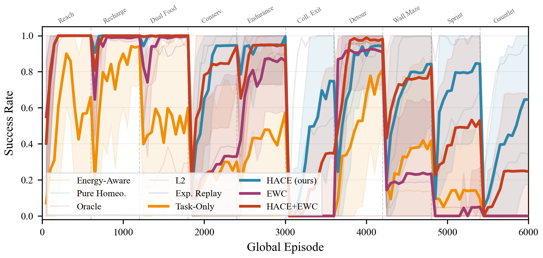
Figure 1 Current-task success rate across the 10-task $α$ sequence (carryover). Task boundaries are marked by dashed lines. Hace (teal) and Hace+EWC (vermillion) consistently recover at task transitions, while Task-Only (amber) and EWC (mauve) collapse on later tasks. Background lines show remaining agents. Mean $± 1σ$ across 10 seeds.
Several patterns are visible in the learning curves. First, traditional CRL methods (EWC, L2, ER) provide no viability advantage over the unprotected Task-Only baseline in the later half of the sequence. On tasks 7–10 (Detour through Gauntlet Refuel), agents without homeostatic reward often approach near-zero success on the hardest later tasks. Second, Hace agents (C and I) consistently recover from initial dips at task boundaries, demonstrating that homeostatic reward provides a persistent survival signal that enables exploration in new tasks. Third, Hace+EWC (I) achieves the most consistent performance across the full sequence, combining the viability benefit of Hace with EWC’s weight-protection on earlier tasks.
Figure 2 quantifies the viability mechanism directly. Panel (a) shows average boundary solvability: Hace and Hace+EWC achieve approximately $3×$ higher boundary solvability than non-homeostatic baselines. This supports viability failure as a major bottleneck—CRL methods that only protect weights do not improve the agent’s ability to survive the next task. Panel (b) reveals the underlying cause: Hace agents retain $3$–$5×$ more energy at task boundaries (11.2 and 9.1 vs. 2–4 for all other agents), directly enabling continued exploration.
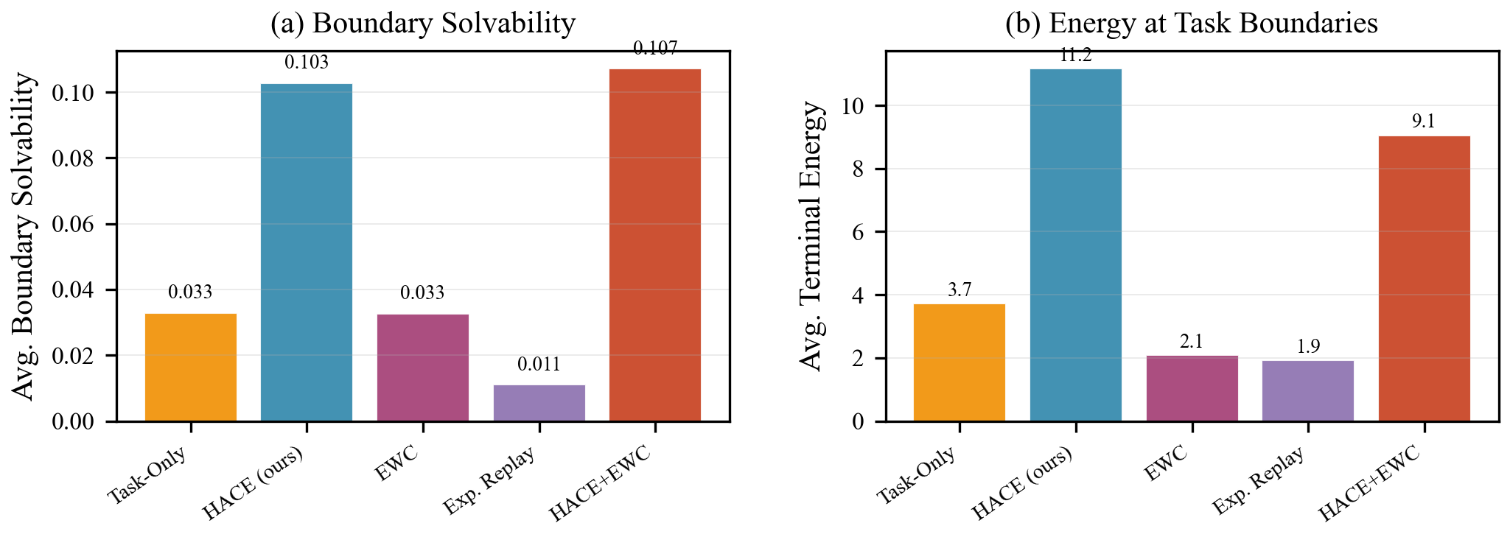
Figure 2 (a) Average boundary solvability across 9 task transitions. (b) Average terminal energy at task boundaries. Hace variants retain $3$–$5×$ more energy than all CRL baselines, directly enabling higher boundary solvability.
Figure 3 presents the end-of-sequence success matrix. The heatmap summarizes the end-of-sequence contrast: Task-Only (A) retains near-zero performance across all 10 tasks after reaching the end of the sequence, while Hace+EWC (I) maintains $>$0.25 success on Gauntlet Refuel—the hardest integrated task—and achieves the highest average success across all tasks (0.335). Even EWC (F) and ER (H), despite protecting earlier-task performance somewhat (Reach: 0.40–0.53), achieve near-zero success on the final task. Hace alone (C) achieves the highest Gauntlet Refuel success among non-oracle agents ($>$0.60), a task demanding all four skills (navigation, food collection, hazard avoidance, efficient energy use).
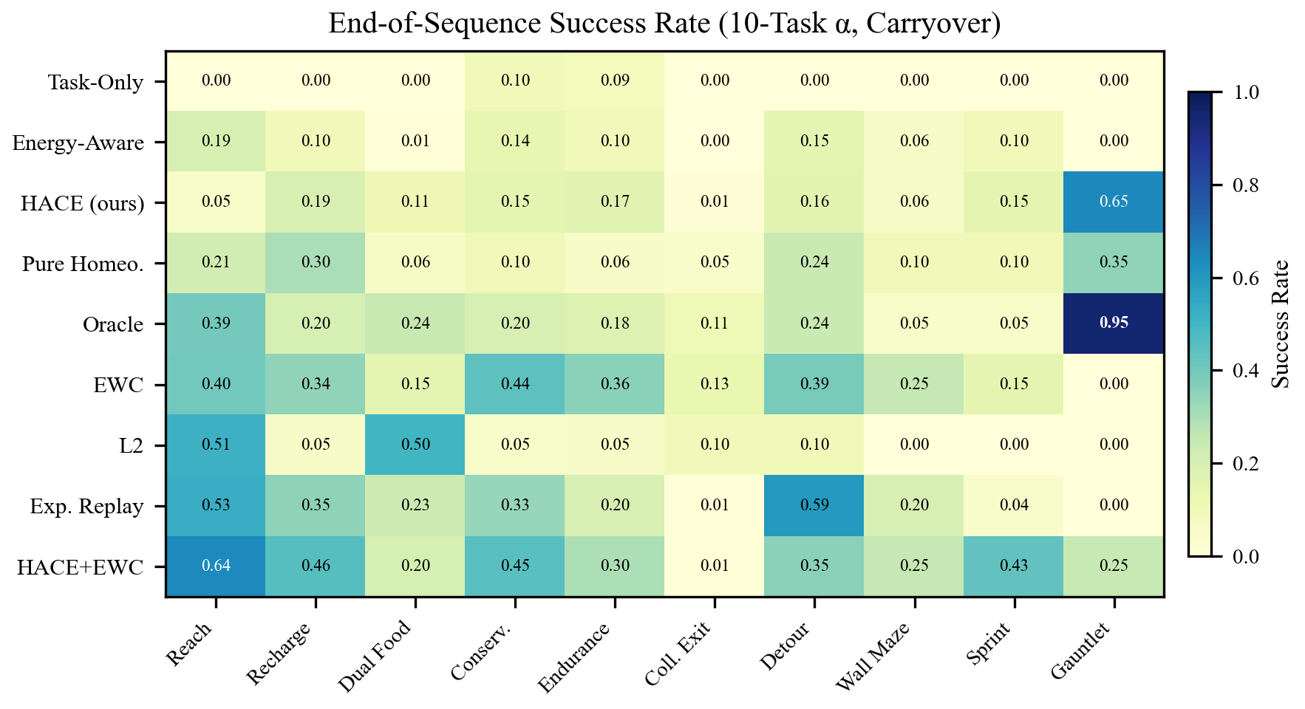
Figure 3 End-of-sequence success rate (agents $×$ tasks) for the 10-task $α$ sequence under carryover. Darker cells indicate higher success. Hace+EWC (bottom row) achieves the highest average performance; Hace (C) achieves the strongest non-oracle performance on Gauntlet Refuel.

5.2 Reset vs. Carryover: Isolating Viability Failure
To confirm that the performance collapse under carryover is due to viability failure rather than forgetting, we ran a $3×2$ factorial experiment (3 reward regimes $×$ 2 boundary modes) on a 5-task pilot sequence, with 10 seeds per condition.
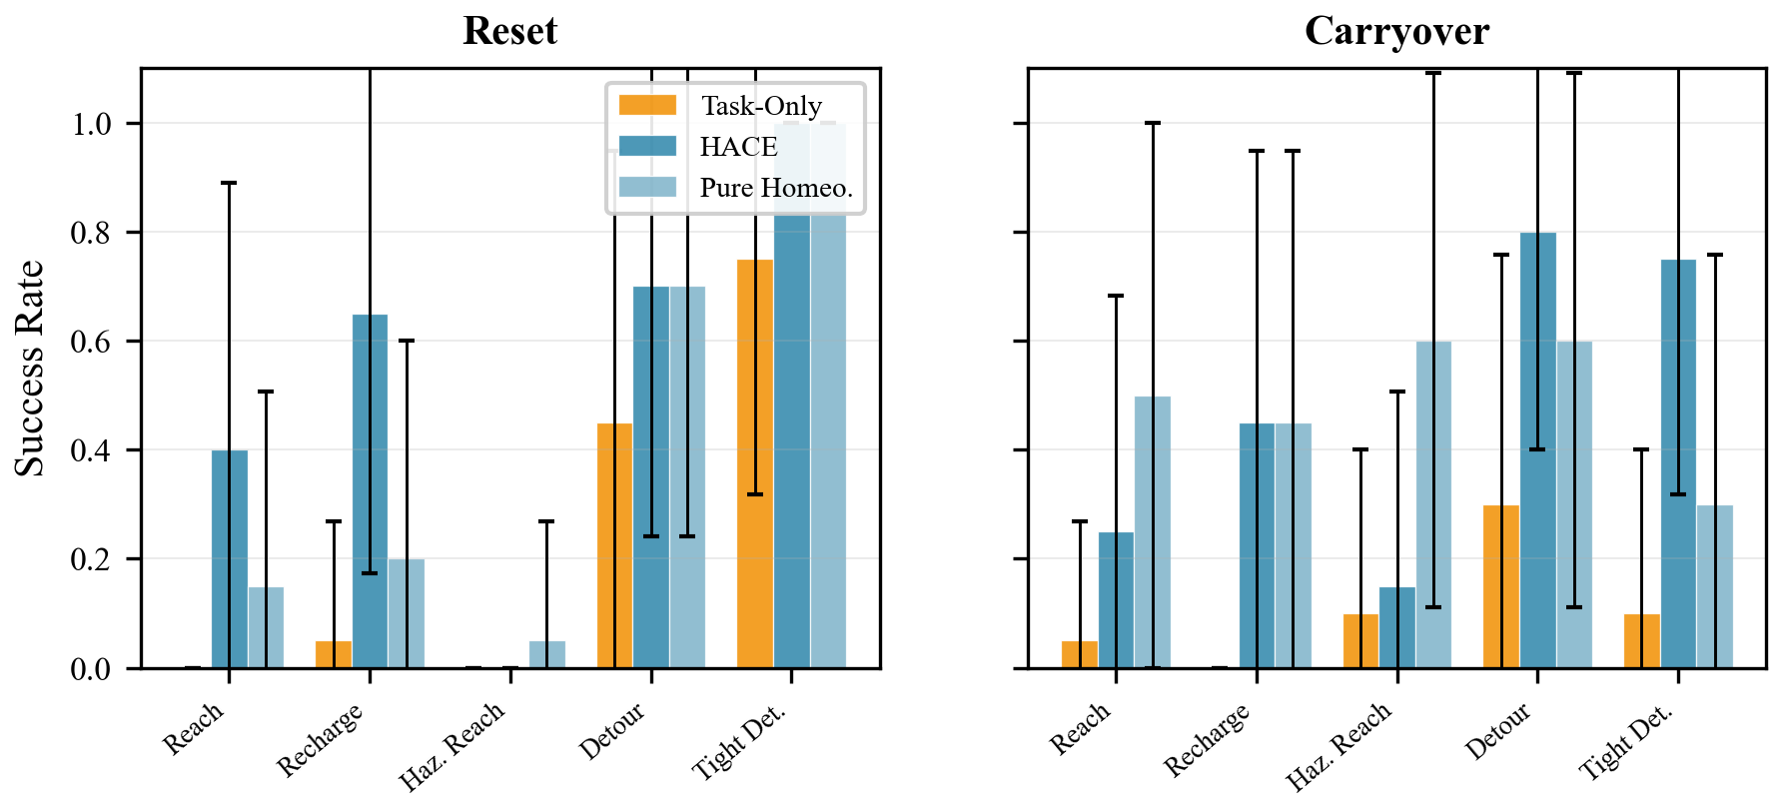
Figure 4 Final evaluation under reset (left) vs. carryover (right). Under reset, all agents perform comparably. Under carryover, Task-Only (amber) degrades while Hace (teal) maintains performance. The discrepancy supports viability failure as the primary explanation: when boundary energy is reset, performance recovers despite the same task sequence and learning setup.
Figure 4 provides direct evidence. Under reset mode, all three reward regimes achieve comparable performance: Task-Only reaches 0.45–0.75 success on Detour. Under carryover, Task-Only drops to 0.30 while Hace maintains 0.80. Crucially, the task definitions, architecture, and training protocol are held fixed; the key manipulation is whether energy is reset or carried across task boundaries. This supports the interpretation that resource-state carryover, rather than forgetting alone, drives the observed collapse. Homeostatic agents maintain higher terminal energy (2.95 vs. 0.35 for Task-Only at sequence end), which directly translates to survival in subsequent tasks.

6 Discussion and Conclusion
Our results establish three findings that have implications for the broader CRL research agenda.

Viability failure is a distinct, overlooked failure mode.
The reset-vs-carryover experiment (Section 5.2) provides evidence that the performance collapse under carryover conditions is not catastrophic forgetting—performance recovers when boundary energy is reset under the same task sequence and training setup. The full 9-agent suite shows that established CRL methods (EWC, L2, ER) improve retention in some cases but do not improve boundary viability metrics. This suggests that standard CRL benchmarks often do not model shared internal resources that carry across task boundaries, potentially overlooking an important failure mode in embodied settings.

HACE is simple, effective, and complementary to CRL methods.
The Hace auxiliary reward (Equation 2) is a single-line modification to any RL training loop. It does not require hand-designed rewards for individual tasks, needs no architectural changes and only a small number of transparent reward hyperparameters—yet it produces approximately $3×$ higher boundary solvability and enables agent C to achieve the strongest non-oracle performance on Gauntlet Refuel (0.65 success). Agent I (Hace+EWC) achieves the best of both worlds: Hace-level viability with EWC’s retention of earlier tasks, achieving the highest overall average success (0.335). This complementarity suggests a principled decomposition of the embodied CRL problem: staying alive (reward level) and remembering how (weight level) are partially separable axes that benefit from independent solutions.

Limitations and future work.
Our benchmark uses tabular gridworlds with vector observations; scaling to visual inputs and richer 3D environments is needed to confirm generality. All results use DQN, and replication with policy-gradient or Transformer-based architectures would further validate the finding. We model a single resource (energy), whereas real agents manage multiple coupled drives. Finally, we fix $H^{*}=E_{\text{cap}}$; learning or adapting the setpoint per task remains unexplored. Although the simplicity of the benchmark limits claims about generality, the results motivate viability failure as a useful lens for studying embodied continual RL, and Hace’s simplicity makes it straightforward to test in other embodied sequential RL settings with shared resource constraints.

References
[1] Mehdi Keramati and Boris Gutkin. Homeostatic reinforcement learning for integrating reward collection and physiological stability. eLife, 3:e04811, 2014.
[2] Naoto Yoshida. Homeostatic Agent for General Environment. Journal of Artificial General Intelligence, 8(1):1–22, 2018.
[3] Naoto Yoshida. Meta-Reinforcement Learning in Homeostatic Regulation. Extended abstract, Computational and Cognitive Neuroscience, 2025.
[4] George Konidaris and Andrew Barto. An Adaptive Robot Motivational System. In Proc. 9th Intl. Conf. Simulation of Adaptive Behavior, pp. 346–356, 2006.
[5] James Kirkpatrick et al. Overcoming catastrophic forgetting in neural networks. PNAS, 114(13):3521–3526, 2017.
[6] David Rolnick, Arun Ahuja, Jonathan Schwarz, Timothy Lillicrap, and Gregory Wayne. Experience replay for continual learning. In NeurIPS 32, 2019.
[7] Andrei A. Rusu et al. Progressive neural networks. arXiv:1606.04671, 2016.
[8] German I. Parisi, Ronald Kemker, Jose L. Part, Christopher Kanan, and Stefan Wermter. Continual lifelong learning with neural networks: A review. Neural Networks, 113:54–71, 2019.
[9] Michal Wolczyk et al. Continual World: A robotic benchmark for continual RL. In NeurIPS 34, 2021.
[10] Sam Powers et al. CORA: Benchmarks, baselines, and metrics as a platform for continual RL agents. In CoLLAs, 2022.
[11] Andre Barreto et al. Successor features for transfer in RL. In NeurIPS 30, 2017.
[12] Momchil S. Tomov, Eric Schulz, and Samuel J. Gershman. Multi-task reinforcement learning in humans. Nature Human Behaviour, 5(6):764–773, 2021.
[13] Max Jaderberg et al. Reinforcement learning with unsupervised auxiliary tasks. In ICLR, 2017.
[14] Deepak Pathak et al. Curiosity-driven exploration by self-supervised prediction. In ICML, pp. 2778–2787, 2017.

Appendix A Hyperparameters
Table 3 lists all hyperparameters shared across agents. Agent-specific parameters (EWC $λ$, ER reservoir size) are also included.
Table 3 Training hyperparameters.
Parameter | Value
Architecture | 2-layer MLP, 128 hidden units
Optimizer | Adam
Learning rate | $5×{10}^{−4}$​
Discount $γ$ | 0.99
Batch size | 64
Replay buffer | 20,000 transitions
Target network update | every 25 episodes
$ε$-greedy | 1.0 $→$ 0.05 over 300 episodes
Episodes per task | 600
Evaluation | 40 episodes every 50 training episodes
EWC $λ$ (F, I) | 400.0
EWC Fisher samples | 1,000
L2 $λ$ (G) | 100.0
ER reservoir (H) | 5,000 transitions, ratio 0.5
Hace setpoint | $E_{\text{cap}}$ per task
Hace coefficient | 1.0
Task reward coefficient $α$ | 1.0

Appendix B Task Sequence Definitions
Table 4 lists the three curated 10-task orderings used in our experiments. Sequence $α$ is the primary ordering used in all main-text experiments; $β$ and $γ$ are reserved for future cross-sequence generalization analyses.
Table 4 Full 10-task sequence orderings.
Seq. | Task Order
$α$​ | Reach $→$ Recharge $→$ Dual Food $→$ Conservation $→$ Endurance $→$ Collect Exit $→$ Detour $→$ Wall Maze $→$ Sprint $→$ Gauntlet Refuel
$β$​ | Reach $→$ Hazard Cross $→$ Haz. Gauntlet $→$ Wall Maze $→$ Detour $→$ Recharge $→$ Sprint $→$ Conservation $→$ Collect Exit $→$ Gauntlet Refuel
$γ$​ | Conservation $→$ Sprint $→$ Haz. Gauntlet $→$ Reach $→$ Endurance $→$ Dual Food $→$ Hazard Cross $→$ Collect Exit $→$ Recharge $→$ Wall Maze

Appendix C Preliminary Experiment: 5-Task Sequential Pilot
Before deploying the full 9-agent suite, we conducted a smaller-scale pilot to validate the core hypothesis. We trained two agents—a task-reward baseline (with energy observation but no homeostatic reward) and a pure homeostatic baseline (comparable to Agent D)—on a 5-task legacy sequence: Reach $→$ Recharge $→$ Hazard Cross $→$ Detour $→$ Sprint, with 600 episodes per task and 10 seeds.
The pilot (Figure 5) revealed a consistent tradeoff: task-specific reward learns early, simple tasks faster (Reach: 0.6 within 200 episodes vs. 400 for homeostatic), but the homeostatic agent matches or exceeds performance on later tasks requiring resource management and hazard avoidance. Final retention on Hazard Cross was 0.90 vs. 0.70, and on Detour 0.80 vs. 0.60. This preliminary finding motivated the full 9-agent experimental suite presented in the main text.
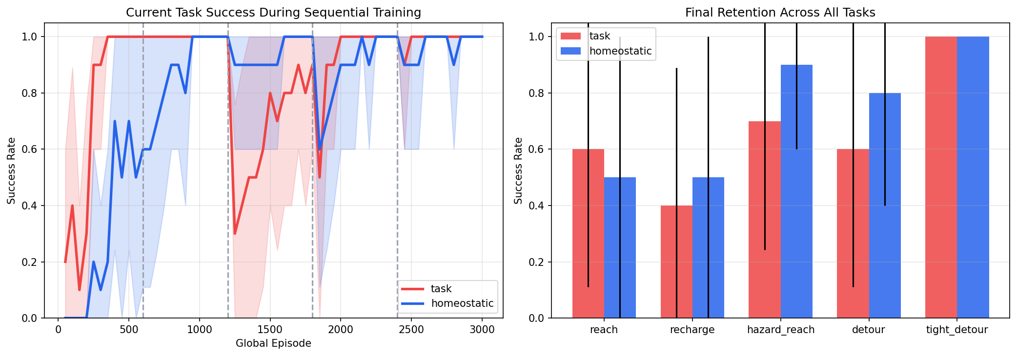
Figure 5 5-task sequential pilot. Left: Current-task success rate during sequential training. The task-specific agent (red) learns early tasks faster; the homeostatic agent (blue) matches or exceeds on later tasks. Right: Final retention across all five tasks. The homeostatic agent shows stronger retention on resource-dependent tasks (Hazard Cross: 0.90 vs. 0.70; Detour: 0.80 vs. 0.60).

Appendix D Observation Space Details
All agents use the same 19-dimensional observation layout (Table 5). For agents without energy observation, the energy coordinate is masked with a sentinel value ($−1$), keeping the input dimensionality fixed across agents. The observation encodes the agent’s position, goal location, food and hazard positions, and—critically—the agent’s current energy level. All spatial features are normalized by grid size; energy is normalized by the task’s energy cap.
Table 5 Observation vector layout. All spatial features are normalized to $[0,1]$. Agent A receives a masked energy value ($−1$) to isolate the effect of reward signal from observation content.
Indices | Content | Normalization
0–1 | Agent position (row, col) | $/$ (grid_size $−$ 1)
2–3 | Exit position (row, col) | $/$ (grid_size $−$ 1)
4–6 | Food 1: row, col, available | $/$ grid; boolean
7–9 | Food 2: row, col, available | $/$ grid; boolean
10 | Energy level | $/$ energy_cap (or $−1$ if masked)
11 | Task index | $/$ (num_tasks $−$ 1)
12–17 | Hazard positions (up to 3) | $/$ grid ($−0.25$ if absent)
18 | Gate locked | Boolean

