InsightED Third Level System
Document Type: Comprehensive End-User Manual
Target Audience: Central Office, Regional Office, and School Division Office HRMOs, and Third Level Officials
Last Updated: June 11, 2026
Welcome to the InsightED Third Level System. This manual provides detailed, step-by-step instructions on accessing the system, navigating its features, managing official profiles, and performing essential administrative workflows securely.

1. System Overview
The Third Level System, accessible via the InsightED Nexus, is a specialized portal designed for the Department of Education. It facilitates the management, profiling, and deployment of "Third Level Officials" (TLOs), including Directors, Superintendents, and Assistant Superintendents.
The system serves two primary functions:
- Records Management & Career Path (Applicant/Official Portal): Allows officials to maintain a 100% complete professional profile, upload necessary documents, and apply for vacant positions in a secure, structured workflow.
- Third Level Dashboard (Administrative Portal): Provides Human Resource Management Officers (HRMOs) and Central Office personnel with the tools to review applications, manage the masterlist of officials, reassign personnel, and monitor incumbency.

2. Account Registration & Authentication
The system features a highly secure authentication portal with a dynamic "sliding window" interface. Access is strictly granted to authorized personnel based on their assigned role and geographic scope.

2.1 Standard Access (Applicants & Officials)
If you are an official aiming to manage your profile or apply for a vacancy:
- Navigate to the InsightED Nexus Gateway (/nexus).
- Click on the Records Management & Career Path portal (indicated by the briefcase icon).
- The navy blue panel will slide open. Select "I have an account" to access the Login page, or "Portal Registration" to create a new profile.
- Fill in your personal information and use your official DepEd email address.
- Upon successful authentication, you will be redirected to the Official Profiling module.

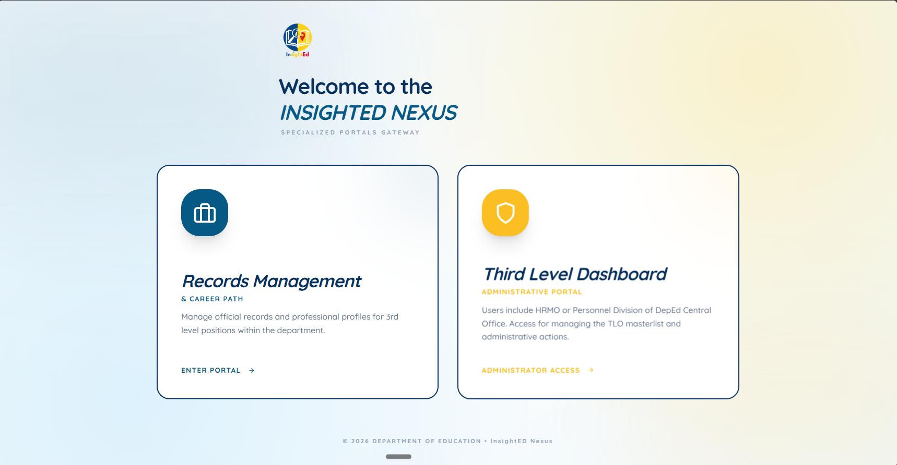

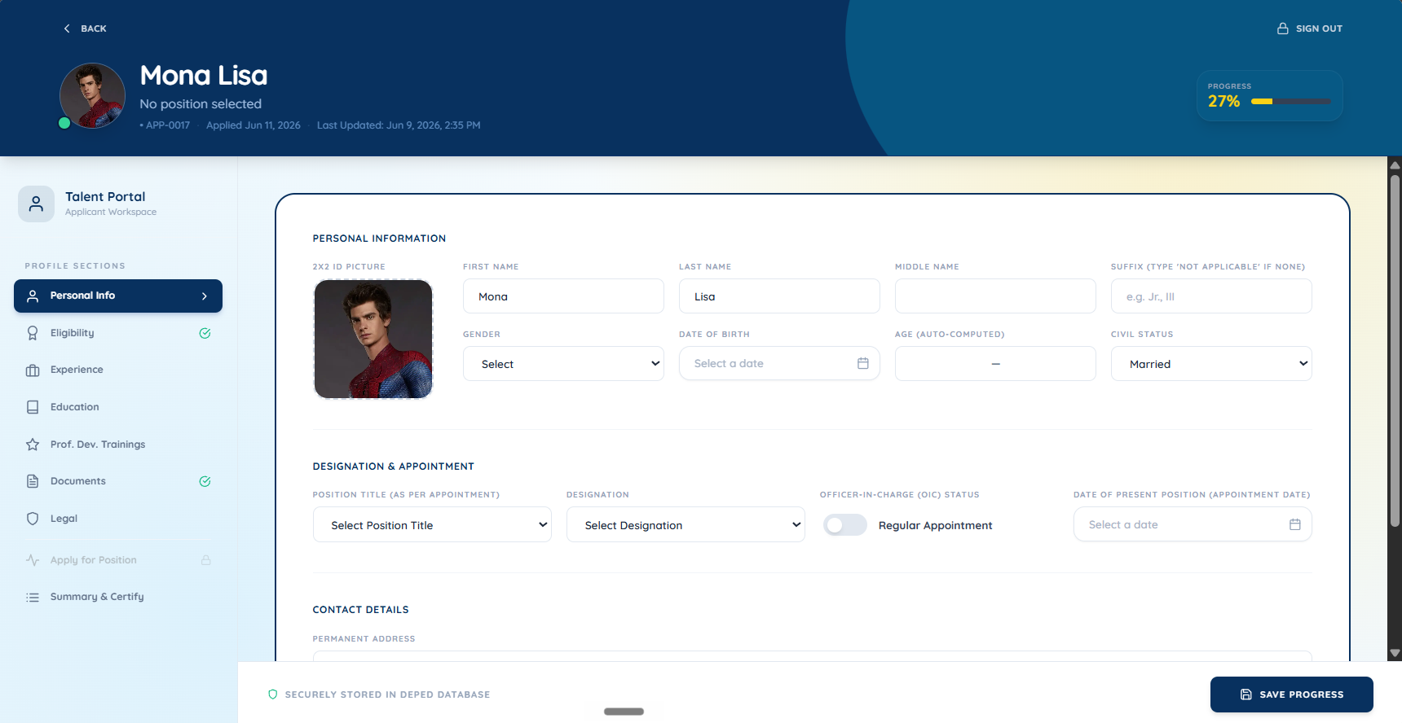

2.2 Administrative Access (Central Office Gate)
If you are an HRMO requiring access to the registry:
- Navigate to the InsightED Nexus Gateway.
- Click on the Third Level Dashboard (Administrative Portal) (indicated by the shield icon).
- Authorization Required: The system will prompt you for an Authorization Code. This code ensures only verified HRMOs can access the administrative backend.
- Enter the valid authorization code provided by your system administrator and click "Verify Access".
- Proceed to Sign In or Register a new Central Office account.
- Upon successful authentication, you will be directed to the Resource Dashboard and Officials Registry.

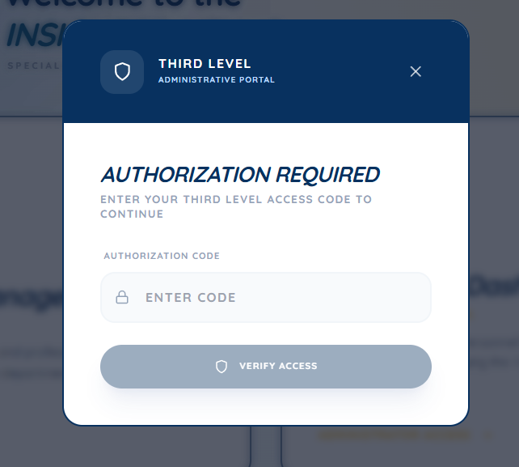

3. Module Guide: Official Profiling (Applicants)
The Official Profiling module is your personal dossier. It tracks your progress toward 100% completeness using a dynamic progress bar at the top of the page.
Critical Business Rule: Your profile must be exactly 100% complete before you can apply for any vacancies.

3.1 Managing Profile Information
Navigate through the tabs located on the left-hand menu to complete your profile. Ensure every required field is filled:
- Personal Info: Enter your basic demographics, name, gender, and civil status. Click "Save & Next" to proceed.
- Eligibility: Log your Career Executive Service (CES) Stage, EMT Passer status, and relevant conferment dates.
- Experience: Detail your current and previous managerial positions. The system automatically computes your "Total Managerial Experience" duration based on your start and end dates.
- Education: Log your highest educational attainment, degree, and the year you graduated.
- Prof. Dev. Trainings: Add relevant training courses. The system automatically sums your total training hours.
- Documents: Upload necessary binaries. You must provide a 2x2 Photo (JPG/PNG), your Personal Data Sheet (PDS), your Word/PPT profiles, and Service Records. A visual indicator will turn green once successfully uploaded.
- Legal: Disclose any pending administrative or Ombudsman cases.
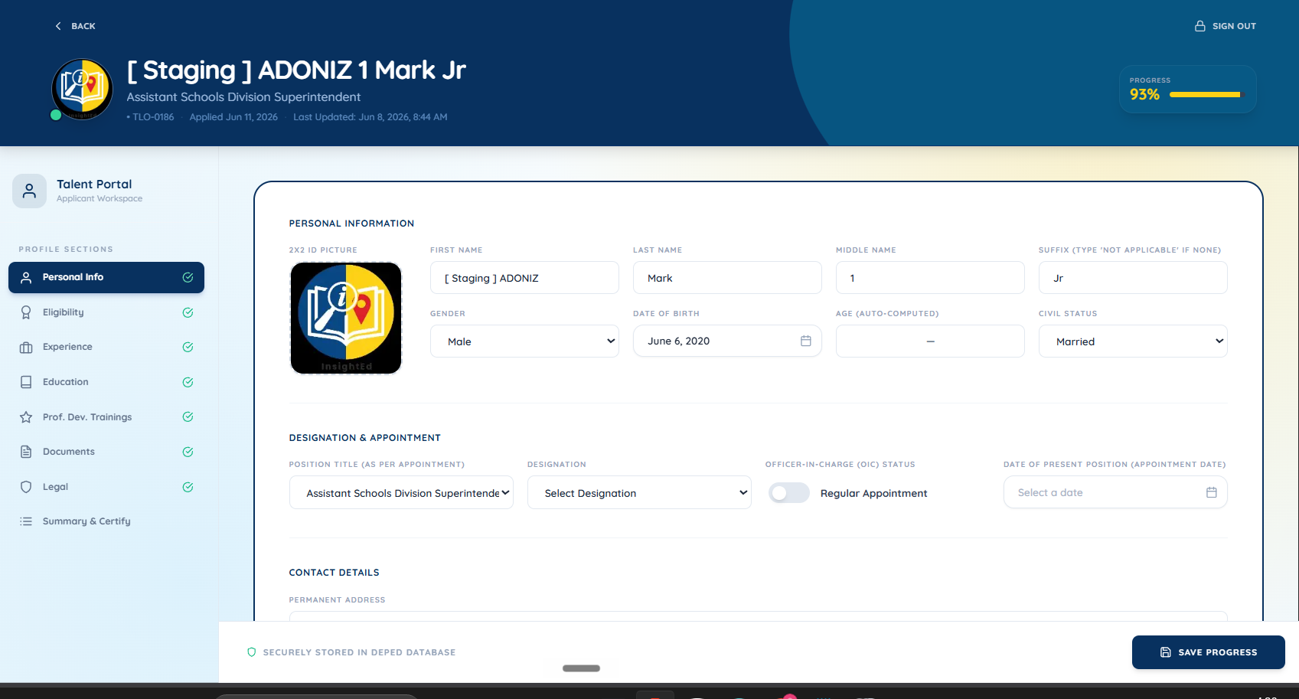

3.2 Applying for Positions and Exporting
- Apply for Position: View current system vacancies. If your profile is at 100%, you can submit a formal application. Note: This tab is locked and inaccessible until the profile progress bar reaches 100%.
- Summary & Certify: Review all data you have entered. You must consent to the Data Privacy Act (DPA) and certify the truthfulness of your submission. From this tab, you can also click the "Export" buttons to generate a PDF dossier or a PowerPoint (PPT) presentation slide of your profile.

4. Module Guide: Officials Registry (Administrators)
The Officials Registry is the central command interface for HRMOs. Access is automatically scoped by your assigned region and division—you will only see data relevant to your geographic jurisdiction.

4.1 Masterlist Management
- Data Grid: View active officials in a detailed Table format or visual Card format using the view toggle at the top right.
- Filters: Search by name or email. Use the dropdown filters to isolate personnel by Status, Strand (e.g., Region IV-A), Position, and Level.
- Incumbency Tracking: Clicking on a specific position title allows you to view the historical timeline of who held that position previously.
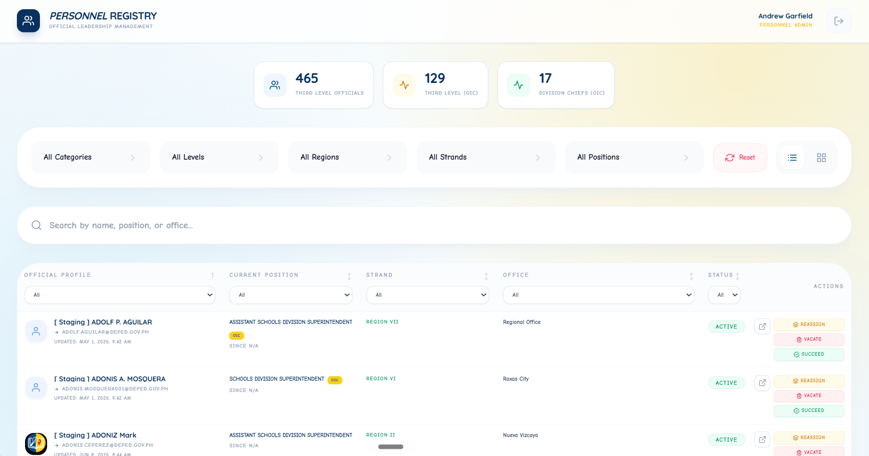

4.2 Application Processing
Review pending applications submitted from the applicant profiling module.
- Approve: Clicking approve migrates the applicant to the active masterlist and permanently upgrades their user role to an Official.
- Reject: Denies the application. The system will prompt you for a mandatory written reason that will be visible to the applicant.

4.3 Administrative Actions
Administrators can manage the deployment of active officials using the "Admin Actions" menu on a personnel card:
- Reassign: Move an official to a new vacant position within their allowed strand. You may also assign currently unassigned personnel to a vacancy.
- Vacate: Mark a position as vacant, moving the official to an "Unassigned" status. A written justification is mandatory for this action to proceed.

5. Resource Dashboard
The Dashboard serves as the National Education Command Center, providing a high-level overview of resources across the entire department.
- KPI Cards: Displays real-time metrics such as "Total Learners", "Priority Schools", "Teachers", and "Critical Alerts".
- Regional Resource Balance Chart: A graphical representation of resource health across different regions, utilizing a specific visual priority signaling system (Blue for stable, Gold for priority review, Red for critical risk).

6. Frequently Asked Questions (FAQ) & Troubleshooting
Q: Why can't I click the "Apply" button?
A: Your profile must reach exactly 100% completeness. Navigate to the "Summary & Certify" tab to identify which mandatory fields are still missing.
Q: I am an OIC, how do I enter my position?
A: Type your position normally (e.g., "OIC - Regional Director"). The system will automatically sanitize the text, standardizing the position title and checking the "Is OIC" flag internally for accurate reporting.
Q: How do I export my profile for a presentation?
A: Go to the "Summary & Certify" tab. Click the "Export" button and choose "PowerPoint (PPTX)". The system will generate a pre-formatted 16:9 slide containing your dossier.
Issue: Endless Loading Screen on Login.
Solution: Clear your browser cache and ensure your internet connection is stable. The system relies on secure session tokens; an expired or corrupted token in local storage might cause loops. Logging out and back in typically resolves this.
Issue: Regional HRMO cannot see certain personnel.
Solution: Verify that the personnel's "Strand" strictly matches the HRMO's assigned region (e.g., "Region IV-A"). The system automatically hides personnel outside of an HRMO's jurisdiction.

