**TRANSITION OUT PLAN**

**TRANSPORT NETWORK VEHICLE SYSTEM  
(ADMINISTRATIVE)**

**TRAILAD.CO**

**MV Campus**

**Quezon City, Philippines, 1118**

**10/3/2025**

**Table of Contents**

1. Executive Summary 1

2. Transition Approach 2

3. Transition Team Organization 3

4. Workforce Transition 4

5. Work Execution During Transition 5

6. Subcontracts 6

7. Property Transition 7

7.1. Government Furnished Equipment (GFE) 7

7.2. Incumbent Owned Equipment 7

7.3. Intellectual Property 7

7.4. User Accounts and Passwords 7

8. Knowledge Transfer 8

9. Schedule 9

10. Handover and Acceptance 10

**Executive Summary**

The purpose of this Transition Out Plan is to document the process for smoothly transferring all project responsibilities, data, and tasks related to the **TNVS Administrative System**. This plan ensures that all system functions, tools, and knowledge are properly handed over from the **current development and testing team** to the **system operations and maintenance team**.

The TNVS Administrative System is designed to help manage transport network vehicle services efficiently — including driver profiles, vehicle registrations, and trip management. This transition will ensure that the system continues to operate effectively once the development phase ends and the administrative operations team fully takes over.

**Transition Approach**

The transition will take place over a **two-week period**, from **October 3 to October 13, 2025**. During this time, the **development team** will work closely with the **administrative and IT maintenance team** to ensure that all files, databases, and documentation are properly handed over.

The team will not add new staff for the transition but will maintain current members until the handover is complete. Knowledge transfer sessions, testing, and final documentation reviews will be conducted to make sure the administrative team fully understands how to operate and maintain the system.

It is also assumed that the **TNVS Project Manager** will coordinate with both teams to schedule activities, monitor progress, and resolve any transition-related issues.

**Transition Team Organization**

|  |  |  |
| --- | --- | --- |
| **Organization** | **Title** | **Roles/Responsibilities** |
| TNVS Project Team | Project Manager | |  | | --- | |  |  |  | | --- | | Oversees all transition activities, monitors progress, and ensures timely completion. | |
| TNVS Project Team | System Developer | Provides technical support during the handover and ensures all system components are documented. |
| TNVS Administrative Staff | IT Officer | Receives full access to the TNVS system and manages day-to-day technical operations after transition. |
| TNVS Administrative Staff | Administrative Head | Ensures that all records, data, and reports are accurate and complete after the handover. |
| TNVS Project Team | Documentation Specialist | Updates and finalizes all manuals, reports, and guides for use by the administrative team. |
| TNVS Quality Assurance | QA and Monitoring Officer | Monitors all transition steps; checks that data transfer, file sharing, and system functions meet quality standards and that no errors occur during the handover. |
| Incoming Team | Incoming Administrator | Receives and learns system processes from the outgoing team; ensures understanding of all administrative functions, reporting formats, and communication procedures. |
| Outgoing Team | Outgoing Administrator | Shares full details about current workflows, data management, and operational tasks; provides guidance and hands-on demonstrations for the incoming team. |

**Workforce Transition**

For the TNVS Administrative transition, the current team members will continue to perform their regular duties while working closely with the incoming team. This setup allows both sides to share knowledge, clarify procedures, and ensure that all administrative, technical, and documentation responsibilities are properly handed over.

During this period, **the outgoing workforce** (the current TNVS administrative staff) will remain active in their assigned roles. They will guide the incoming team by providing system walkthroughs, explaining workflows, and assisting with technical processes such as data entry, reporting, and file organization.

On the other hand, **the incoming workforce** (the new administrative and support members) will undergo continuous training and hands-on familiarization with the TNVS system. They will shadow the outgoing team for several days to understand the responsibilities and challenges of the role.

**Work Execution During Transition**

All ongoing system work will continue based on the approved schedule and development plan. The **development team** will complete pending code refinements, while the **administrative team** will conduct testing and validation to ensure the system’s stability.

Both teams will collaborate daily to make sure all system features, such as user management, reports, and database connections, are fully functional and well-documented. Once confirmed, the administrative team will officially assume responsibility for the TNVS Administrative System.

**Subcontracts**

There are no third-party subcontracts involved in this transition. All work, resources, and tools are developed and managed internally by the TNVS project and administrative teams.

|  |  |  |
| --- | --- | --- |
| **Subcontract #** | **Awarded to** | **Tasks** |
|  |  |  |
|  |  |  |

**Property Transition**

**Government Furnished Equipment (GFE)**

In the TNVS Administrative System, **Government Furnished Equipment (GFE)** refers to equipment and tools provided by the government or the project management office for official use. These items include **laptops, desktop computers, mobile devices, printers, flash drives, and security badges** that are used by the TNVS administrative staff.

Reimaging of all computers and devices will be completed by the TNVS system IT support on or before **October 13, 2025**, ensuring that each piece of equipment is secure and ready for the new administrative staff. Access to system tools, such as the TNVS dashboard and administrative panel, will also be transferred only after verification.

**Incumbent Owned Equipment**

All incumbent-owned equipment will remain under the ownership of the outgoing organization and will not be transferred unless approved. However, if certain devices or software are essential to the continuity of the TNVS Administrative System, the project manager and procurement officer will review them for possible purchase or transfer.

Before the final handover, all incumbent equipment used within the TNVS office must be checked to ensure no project data remains. The outgoing team is responsible for cleaning up files, returning temporary access cards, and submitting a **Property Clearance Form** signed by the Transition Project Manager and IT Lead. This will guarantee transparency and avoid future disputes regarding property ownership.

**Intellectual Property**

All intellectual property that was created under the TNVS project will officially belong to the **TNVS Administrative Office** and will be handed over to the incoming team. This ensures that all project data, knowledge, and procedures remain under the control of the organization, even after the transition.

The outgoing team is responsible for organizing all IP-related files in digital format and uploading them to the official TNVS system storage. Copies of user guides, database setup instructions, and employee workflow documents will also be turned over physically through printed manuals. Both teams will sign a **Confidentiality Agreement** to ensure that sensitive project information remains protected even after the transition.

**User Accounts and Passwords**

Proper handling of user accounts and passwords is a crucial step in protecting the security and confidentiality of the TNVS Administrative System. As part of this transition, all **active accounts, usernames, and passwords** currently used by the outgoing staff will be reviewed and documented by the IT departme

|  |  |  |
| --- | --- | --- |
| **User Account** | **Development Team** | **Administrative Team** |
| System Administrator | Developer/Project Manager | |  | | --- | |  |  |  | | --- | | IT Office | |
| Database Access | |  | | --- | |  |  |  | | --- | | Developer | | |  | | --- | |  |  |  | | --- | | IT Officer | |
| Admin Panel | Developer | |  | | --- | |  |  |  | | --- | | Administrative Head | |

**Knowledge Transfer**

The **Knowledge Transfer** process ensures that all necessary information, skills, and system understanding from the outgoing TNVS Administrative team are properly shared with the incoming team. This is one of the most critical parts of the transition because it guarantees that the new team can operate, maintain, and further develop the TNVS Administrative System without disruption or confusion. The knowledge transfer started on **October 4, 2025**, and will continue until **October 13, 2025**, in time for the final project presentation and turnover.

Knowledge transfer in the TNVS project is not just about handing over documents — it’s about ensuring that the new administrative staff fully understand how to use the system, manage tasks, solve problems, and sustain the project’s success in the long run. This involves multiple sessions of mentoring, training, and documentation sharing that aim to build confidence and competence among the new team members.

**Schedule**

The schedule will be provided by the GANNT chart below:

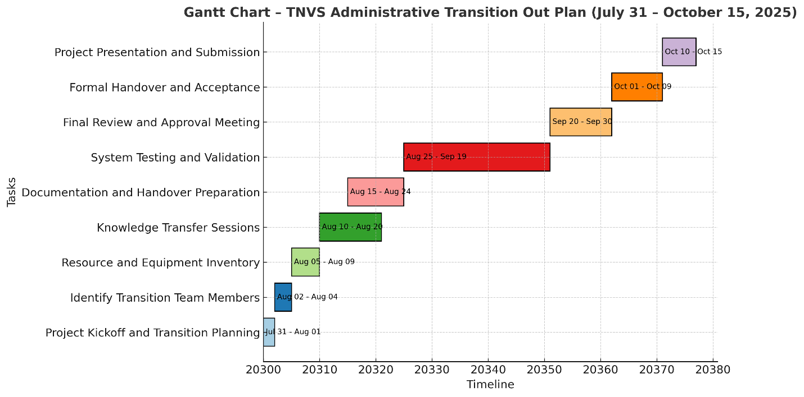

**Handover and Acceptance**

The handover will be formally approved once the **TNVS Administrative Team** confirms that all data, documentation, and accounts have been successfully transferred.

A **handover checklist** will be reviewed and signed by both the Project Manager and the Administrative Head to confirm completion. Once approved, full responsibility for the TNVS Administrative System will be transferred to the administrative team.