Changes to Merge Query
V4.0.5.4 Fix 5

Contents
1 Document Control 3
1.1 Author 3
1.2 Document Summary 3
1.3 Document History 3
1.4 Reference documents 3
1.5 Distribution 3
1.6 Quality Assurance 3
2 Introduction 4
3 Details 5
3.1 Issue #716633 5
3.2 Issue #719893 8
3.3 Issue #719897 8
4 Other Notes 8
5 Future Changes 9
6 Conclusions 9

- Document Control
  - Author
Rob Coupe, Technical Architect

  - Document Summary
This document provides a description of the changes in this minor patch release some of which are subtle but can produce some differences.

  - Document History

Document History
Revision | Date | By | Description
1.0 | 21st May 2009 | R Coupe | First Edition

  - Reference documents
None

  - Distribution
Exor Customers, Partners and Staff

  - Quality Assurance
Document Details
File | Prepared By
Mrg_Query_v4054_fix5.docx | Rob Coupe
Document Name | Reviewed By
Merge Query Changes – post v4.0.5.4
Version | Approved for issue by
1.0
Date of Issue | Support Manager

- Introduction
This document is intended to highlight some significant changes in the merge query in a minor patch to the merge query be issued after v4.0.5.4. It is recommended that this patch is installed on top of existing v4.0.5.4 release although the changes are compatible with version v4.0.5.3 of Core Highways from Exor.
This document is not intended as a user guide or a system description. The fundamentals of the merge query remain unchanged but several critical problems have been fixed and some customers will notice a difference in behaviour, particularly those operating with predominantly non-exclusive group types. These differences are purely in the operation and reliability of the software which is much improved and in the display within the form that displays the results of the merge query relative to linear routes. The results of the merge query relative to the datums are the most important and there are some minor differences where earlier releases missed some data. These occurrences were rare. The main difference in the display of the results is seen in the simplification of the results form.
The merge query is a complex tool and it requires some understanding of its function and the structure of the results in order to understand the differences in behaviour. Here is a brief description and a short glossary of some of the terminology.
The merge query allows the user to configure a set of asset and network predicates such that an area of network is assembled into extents over which the specific predicated data remains homogeneous. This means that the independent linear events of both network and assets may be sliced and diced into homogeneous chunks of the users own design to suit their own specific interest. Hence the results are termed homogeneous chunks. The event data that is considered in the merge query is often referred to as a splitting agent since a change in this agents value over a linear extent will cause a split in the resultant homogeneous chunks. Each chunk is stored as a linear event relative to the network datum over the area that is chosen as the basis of the query. Each homogeneous chunk located over a datum is often referred to as a datum chunk. Neighbouring homogeneous datum chunks may be assembled into larger chunks and expressed as a linear reference relative to a linear group (or route). These are often termed route chunks or merge sections or just sections.
The details that follow will attempt to describe the differences in the way that these chunks are assembled.

- Details
The changes described in this document address ECDM issues numbered 716633, 719893, 719897.
- 716633 - When a route has negative cardinality, the merge query results form displays the mileage erroneously.
- 719893 – Catastrophic failure resulting in ORA-00905: missing keyword, ORA-06512: at 'HIGHWAYS.NM3BULK_MRG', line 1614
- 719897 Missing assets in result set.
The patch contains the usual readme file, the changes to the merge query results form and a change to the main bulk merge query package body. There is also a change to the database design with a new column being added to a table of temporary data. No impact is caused by this data definition change.
  - Issue #716633
The table change is one that allows the system to hold the relative direction of each datum chunk in relation to a linear route. This direction is held as a positive or negative value when the datum direction of increasing measure is either the same or the reverse of the cardinal direction of the route.
This direction indicator allows neighbouring datum homogeneous chunks of merge results to be assembled into the route chunks or merge sections. Without this flag, the assembly of the datum chunks was flawed and the results, when expressed as a linear event relative to the route were incorrect.
It must be stressed that the datum chunks – those that provide the accurate location of each chunk in the linear datum were rarely incorrect, they were just not always assembled correctly and the start and end positions could be incorrect when provided relative to a route.
The NM7051B form displays the merge query resultant homogeneous chunks in two methods in two regions of the form. The datum chunks are assembled into merge sections, each section is displayed in the middle block. Two canvasses are used so that the sections can be shown as a start and end relative to a route and relative to a datum. Note that this middle section of the form produces two single point linear events one for the start and one for the end point. The database holds these point events referenced to both the datum and the route. The lower region of the form contains the linear events for each section and displays the data as route references relative to the preferred LRM and as datum references.
It is the results in the middle region of the form where the greatest change has taken place.
- Firstly, the sections are assembled using correct information about the direction of the datums relative to the route so some difference in the size of the chunks will be noted.
- Differences in the calculated measure of the start and end of the merge section relative to the route will be noted especially when datums have a reversed direction relative to the underlying route.
Also, the merge section is held in the database as a start and end relative to the datum and relative to the route. In the previous releases, the merge section start and ends were expressed as linear references relative to a group of a specific type. On many sites where a single exclusive route type was available the choice of the route was automatic. However on some sites where non exclusive route types are used, the module could randomly pick any one of a number of routes with which to reference the start and end of the merge section. Even in cases where the merge query was executed over a specific linear route, the merge section could have displayed results relative to another linear route. The new version of the module will simplify this. When a linear route or a group of linear routes is used as the extent over which the merge query is executed, it is this linear route that is used as the basis for merge section connectivity and it is this that is now used as the basis for display of the results in the middle block.
Another major benefit of this simplification of the data in the blocks is that the data fields can be used as the basis of a query. This has been of major benefit during the testing phase as the original module forced the user to scroll through the data to find the relevant piece of information.
These changes can be best expressed by reference to the screenshots below.
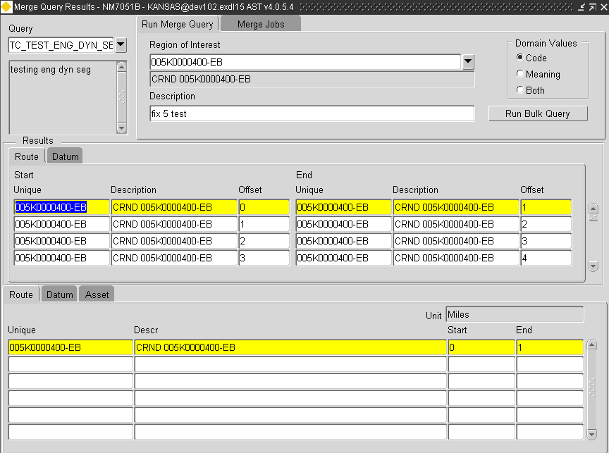
These results are from a specific merge query using a simple asset and attribute pairing over a route that has datums in the reversed direction to the cardinal direction of the route. Each merge section is displayed relative to the route that was chosen as the original extent over which the merge was executed. The bottom block shows the section relative to all routes of the type specified in the users preferred LRM.
By using the enter-query tool in the middle block, the user is now better able to find relevant information instead of scrolling through all records. (note that this may need application server settings to perform this task)

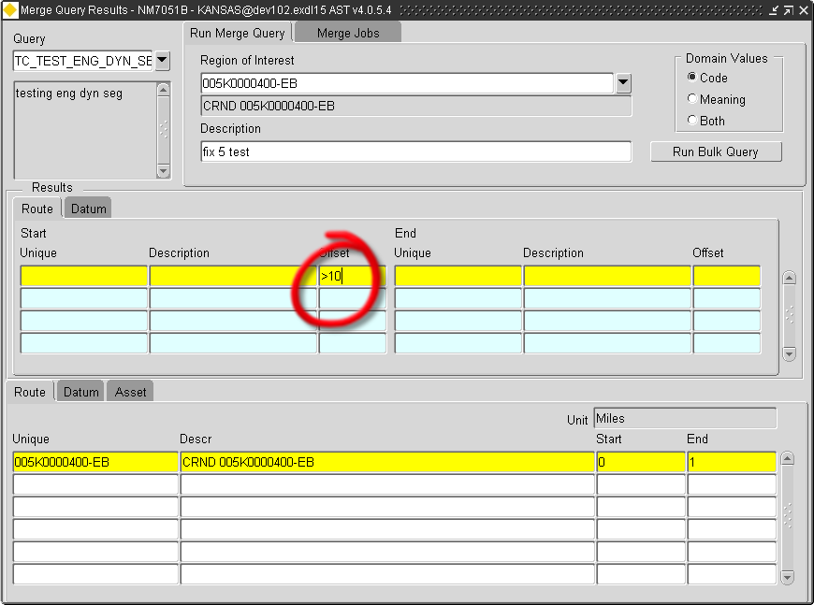
The offsets in the middle block are corrected as the route has datums with reversed direction.

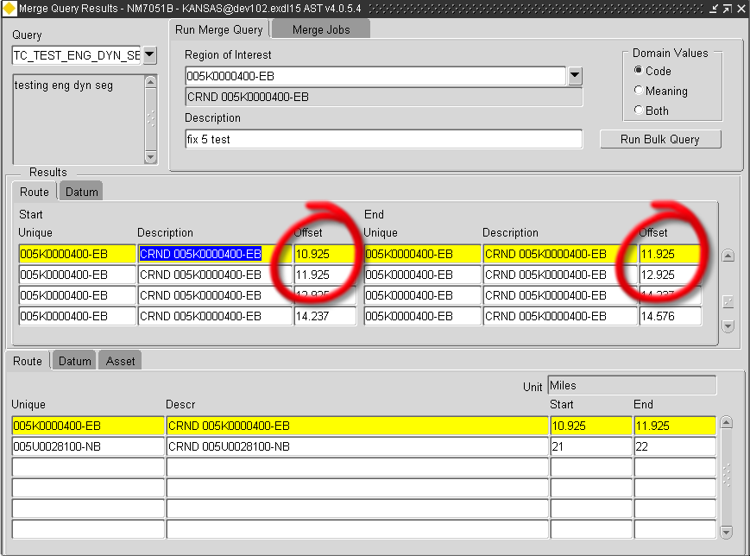

  - Issue #719893
Catastrophic failure resulting in ORA-00905: missing keyword, ORA-06512: at 'HIGHWAYS.NM3BULK_MRG', line 1614.
This issue is fixed by better handling of the dynamic SQL. Other types of query that gave rise to failures have also been fixed under the same banner. The query would fail with an ambiguous column reference in cases where the splitting agent was the primary key of a foreign table. Also there have been fixes to date-based predicates on asset attributes. Justifiable error messages such as those arising from having no declared splitting agents
  - Issue #719897
Missing assets in result set.
This issue has been addressed by the execution of every merge query on two customer database with very dissimilar characteristics. The results of each query across the same area of network were compared with those resulting from execution of the earlier release of merge query and tools were built to flush out any disparities. This release coincides with the successful conclusion that all disparities in a large sample were entirely due to failures in the previous toolset. Further checks on samples of the results were found to be 100% correct.
- Other Notes
Please note that the current version of merge query differs from the version 3 merge query tool in the way that it splits at points at which an asset type may have a different count. The resultant coverage in this case would be the same. This is best illustrated with the aid of a diagram. Below is a schematic of a system of guardrails on each side of the road (blue horizontal lines). The guardrail is handled as a non-exclusive asset type and the merge query is configured to perform an inner join of the guardrail year. Being non-exclusive, the asset type may have overlaps. The vertical lines are the positions along the road where the configuration of the guardrail changes. The red lines show the extent of each
Year = 2002
Year = 2003

Year = 2001
Year = 2003

The configuration of the guardrail gives rise to the merge sections shown above. Note that the merge query tools in version 3 would deliver a single merge section with the resultant guardrail year of 2003 over the two right hand sections at each side of the point indicated. The latest release will deliver a break at this position due to the fact that the number of guardrails changes despite the attribute being the same on each.
- Future Changes
A further patch release of merge query is imminent. This further release will not change the merge query results or the modules that display them. The change is purely in the further option of making a calling interface available that is syntactically equivalent to that which was provided in version 3.2. Many customer who has scheduled dbms-jobs in the previous syntax will be able to use the same nm3mrg package procedure to call the new merge query.
There is also a new and optimised method with which the merge locations and secure attributes are joined in the merge query views. This should offer some performance enhancements in the extraction of results over the previous method.

- Conclusions
A great deal of testing has taken place over several sets of customer data and Exor believe that this current version of merge is more robust and reliable and has significant advantages of speed over the version 3 toolset. It is recommended that this patch is installed on all version 4.0.5.3 and 4.0.5.4 sites.

