

**Fix Release Notes**

4.7.0.x Fix 8

Table of Contents

1. Introduction 2

2. Fix Details 2

3. List of Amended Files 3

4. Enhancement Details 4

4.1 WMS Theme definition in Oracle Map Builder 5

4.2 GIS0030 – GIS WMS Themes form. 14

4.3 Changes to the exor Locator map 18

4.4 Changes to the exor Locator Layer Control Tool 19

5. Log No. Summary 20

# Introduction

This document defines the changes made to the Network Manager product for 4.7.0.x Fix 8 and is specifically targeted at end users.

After reading through this document, should you have any further training or consultancy requirements then please contact your Bentley account manager.

# Fix Details

|  |  |
| --- | --- |
| Fix Details Baseline Release | 4.7.0.x |
| Fix Description | Network Manager 4.7.0.x Fix 8 Patchset.  This patchset will add the ability to define multiple WMS Background Themes to be used with the exor Locator map.  Please refer to Section 4 of this document for details of configure and use this enhancement. |
| Prerequisites | 4.7.0.x Fixes 1 and 3 |
| Implementation Instructions | The staging folder is the location of the folder that exnm04070001en_updt8.zip was extracted to (the folder containing this readme).   * Copy the file gis0030.fmx from the staging folder to the relevant exor\bin on the Oracle Forms Weblogic Server. * Go to the relevant **<ORACLE_HOME>\forms\java** directory on the Oracle Forms WebLogic Server and rename the following file -   **exorMapviewer4700_10_3_6.jar** to **exorMapviewer4700_10_3_6_old.jar**  Then copy in the new version of this file from the staging folder.   * Locate the setDomainEnv.cmd file for the MapViewer Domain on the Weblogic Server, this can be found in the **<MapViewer Domain Home>\**bin folder for example:-C:\bentley\middleware\user_projects\domains\fmmv\bin\setDomainEnv.cmd   Add the following line after the “@REM” comments at the beginning of the file and save the change:-  set JAVA_OPTIONS=%JAVA_OPTIONS% -DUseSunHttpHandler=true     * Log onto SQL*PLUS as the Highways Owner with the staging folder as the working directory.   At the prompt type **START nm_4700_fix8.sql** and press return.  Exit SQL*Plus.   * If the WMS Product Options have previously been used to configure a WMS Background theme for the exor Locator map please follow the instructions given in section 4 of this document to configure the theme using the new functionality as these product options are no longer used and will be removed in a subsequent release.   **Important:**  Restart the Oracle Form WebLogic Server – (e.g. **WLS_FORMS)** – to deploy the newly added jar file.  Restart the MapViewer Weblogic Server – (e.g. **WLS_MAPVR2**) – to apply the change to the setDomainEnd.cmd file. |
| Limitations |  |
| Configuration Information | None |
| How To Test | Recommend full regression test |
| Rollback Strategy | Initially implement on a test environment |

# List of Amended Files

|  |  |
| --- | --- |
| Filename | Version |
| exorMapviewer4700_10_3_6.jar | 1.3 |
| gis0030.fmx | 5.2 |
| nm3sdo_wms.pkh | 3.0 |
| nm3sdo_wms.pkw | 3.0 |
| nm_max_varchar_tbl.tyh | 3.1 |
| v_nm_wms_themes.vw | 3.0 |
| v_sdo_wms_theme_layers.vw | 3.1 |
| v_sdo_wms_theme_params.vw | 3.1 |
| v_sdo_wms_theme_styles.vw | 3.1 |
| v_sdo_wms_themes.vw | 3.1 |
| nm_4700_fix8.sql | 3.1 |
| log_nm_4700_fix8.sql | 3.0 |

# Enhancement Details

This enhancement is intended to replace the WMS Product Options that have previously allowed a single WMS background theme to be configured for the exor Locator map, with a mechanism that allows the definition of multiple WMS Themes for use as background themes within the exor Locator map.

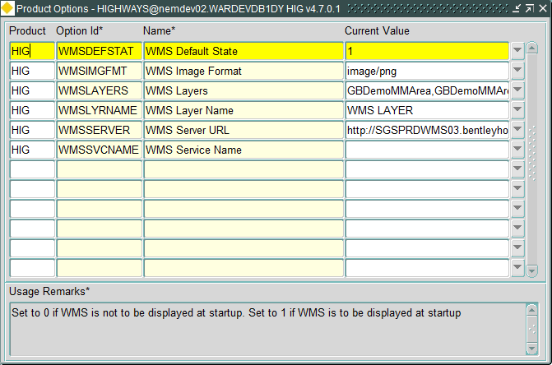

Once this enhancement has been applied the following steps should be taken to define and configure any WMS Themes that are required, including the theme defined in the aforementioned product options as these will no longer be used by the exor Locator map.

## WMS Theme definition in Oracle Map Builder

The first step in configuring a WMS Theme for the exor Locator map is to add a WMS Theme in Oracle Map Builder and add it to the Base Map.

**Note.** For instructions on how to run Oracle Map Builder please refer to the exor “Spatial Server System Admin” document.

### In Map Builder right click on the WMS Themes branch of the “Metadata” tree and select “Create WMS Theme”

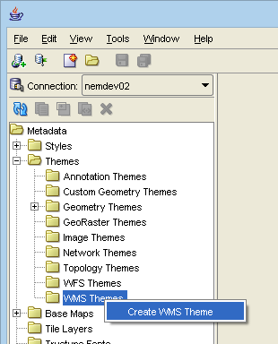

### Click on “Next >”.

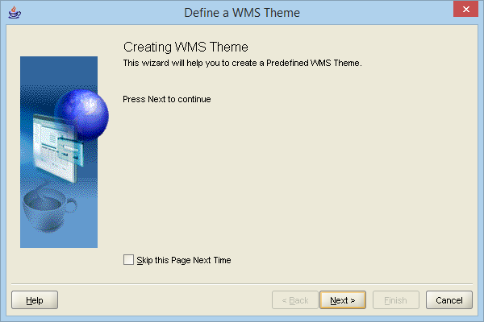

### Enter a Name and Description along with the Capabilities URL and WMS Version for the WMS service to be used.

If Authentication is required by the WMS Service tick the “Authentication” checkbox and enter the user and password required to establish a connection to the service.

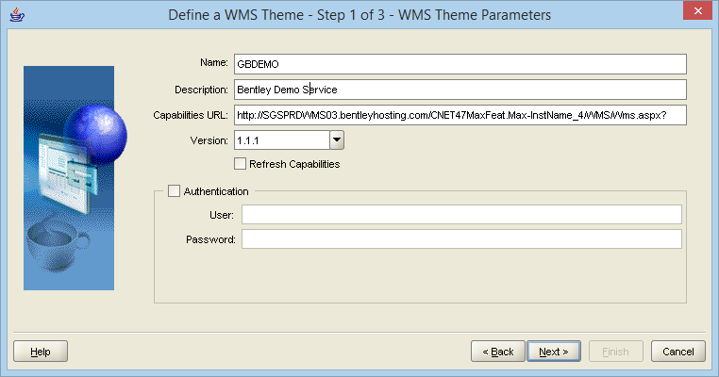

### Click on “Next >”, Map Builder will issue a GetCapabilities request to the service and display the results.

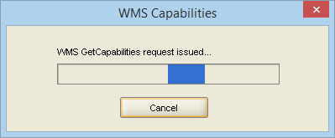

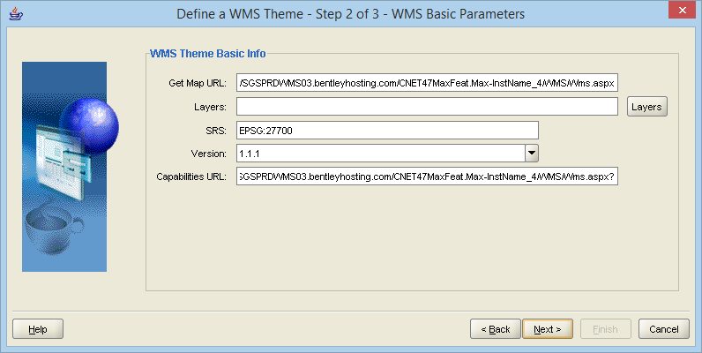

### Check the Get Map URL for parameters i.e. a question mark plus some text in the form “x=y” at the end of the URL. If parameters are present then remove them from the URL and create them as Vendor Parameters (see step **Error! Reference source not found.**).

For example the Get Capabilities URL for the WhereGroup OSM Basic service is:-

<http://mapbender.wheregroup.com/cgi-bin/mapserv?map=/data/umn/osm/osm_basic.map>

Using this URL to create a WMS Theme will result in the following Get Map <URL:->

<http://osm.wheregroup.com/cgi-bin/osm_basic.xml?SERVICE=WMS&>

This should be edited to:-

<http://osm.wheregroup.com/cgi-bin/osm_basic.xml>

and a Vendor Parameter with the name “SERVICE” and value “WMS” should be added.

**NB. If the Get Map URL is not edited to remove any parameters the Theme preview in Map Builder may still work but the Theme will not be displayed in the exor Locator map.**

### Click on the “Layers” button, select the required layers and click on “Ok”.

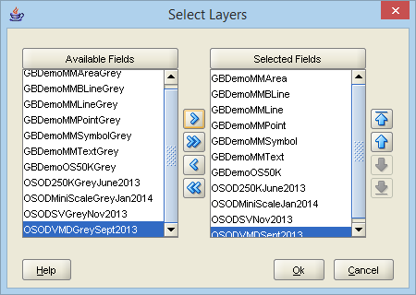

### Check the co-ordinate system (SRS), ideally this should match the co-ordinate system being used to store spatial data in the exor database, and click on “Next >”.

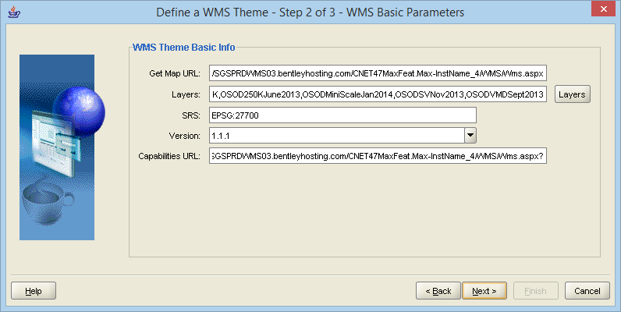

**NB. Oracle MapViewer does not currently fully support reprojection for images so if the co-ordinate system used does not match the spatial data in the exor database or other WMS Themes used the rendered image may not line up correctly.** <https://community.oracle.com/thread/460772?start=0&tstart=0>

### Select the image “Format” to be used (where transparency is required “Image/png” should be used).

Set the required background colour or tick the “Transparent” checkbox if a transparent background is required.

If the WMS Service supports multiple styles enter a comma-delimited list of style names to be applied (with no spaces between commas and style names).

If the WMS Service requires any vendor specific parameters click on “Add” then enter the name and value for each of the required parameters.

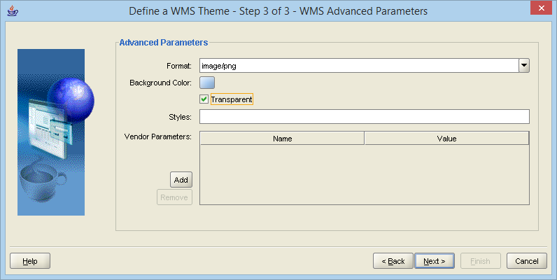

### Click on “Next >” to display a summary of the WMS Theme to be created.

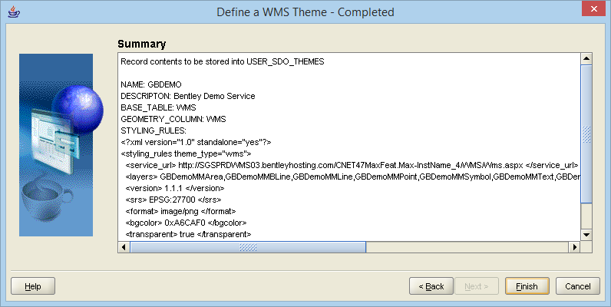

### Click on “Finish”. Map Builder will create the WMS Theme and display the details.

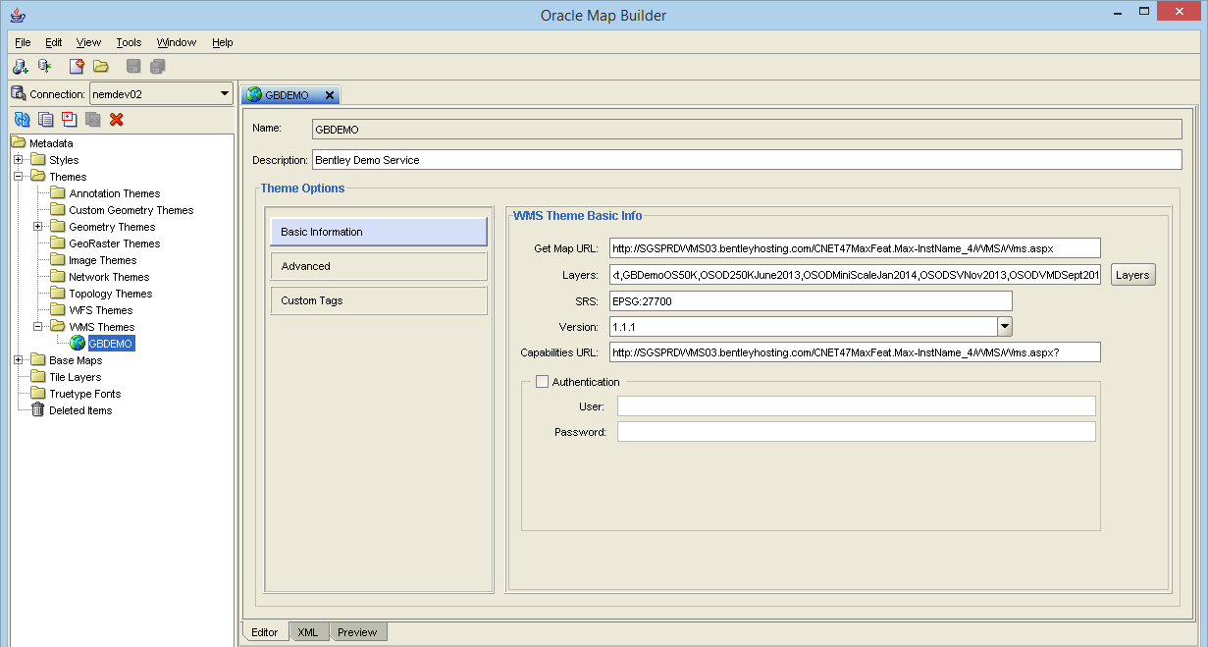

### To test the WMS Theme click on the “Preview” tab (below the WMS Theme Details), enter a point and scale to display and click on the green run button ().

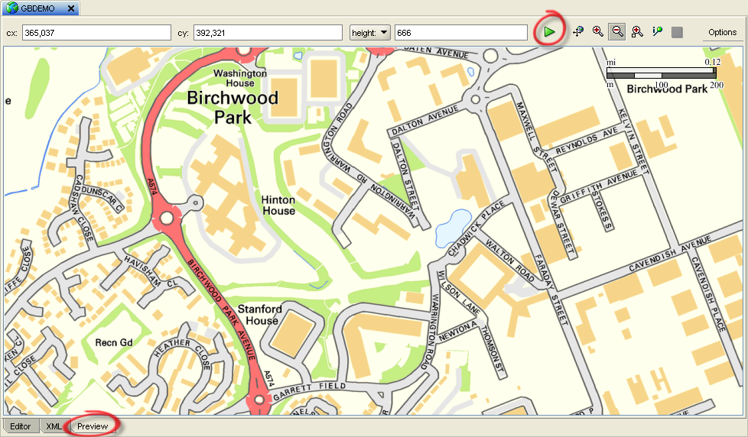

### Now that the WMS Theme has been defined it can be added to the Base Map.

Double click on the Base Map used in the exor Locator map (see Product Option “WEBMAPNAME”) to display its details and click on the “Add Theme” button ().

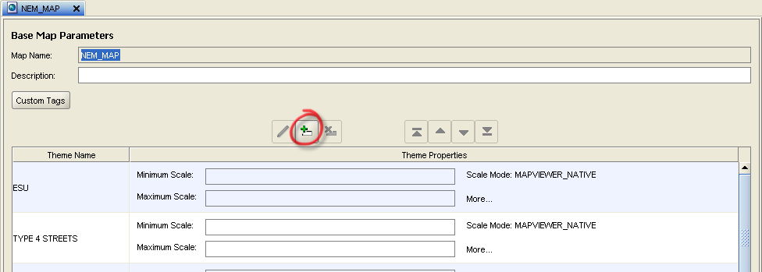

### Select the WMS Theme from the list and click “Ok”.

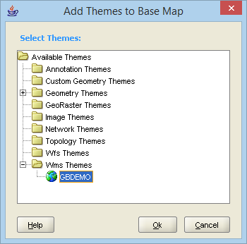

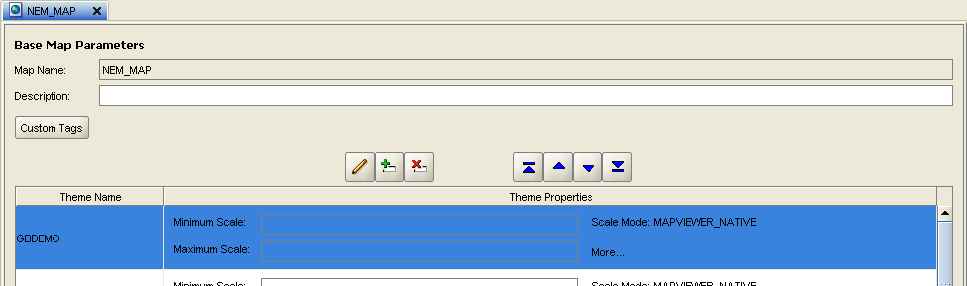

**NB. Any WMS Themes defined in the exor Locator map will be treated as Background themes and therefore displayed below the Geometry Themes defined for the map regardless of the order in which they appear in Map Builder.**

### If the WMS Theme is required to be displayed at a specific range of scales select the Theme in the Base Map details panel and click on the “Edit” button (), enter the required scale range and click on “Ok”.

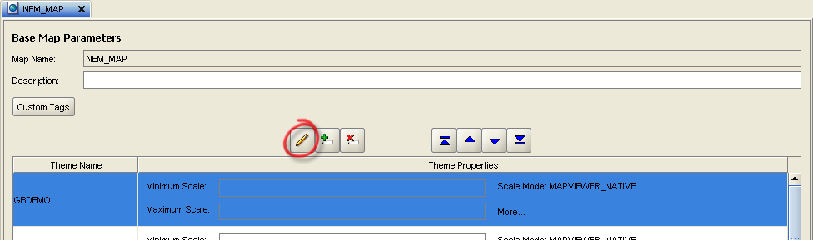

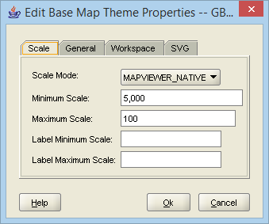

### Click on the “Save All Changes” Button in the Map Builder toolbar () to complete this part of the configuration.

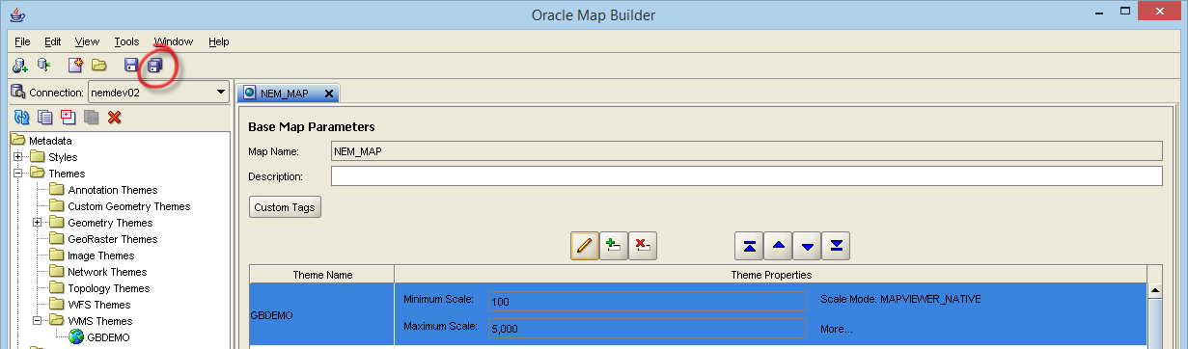

### Repeat these steps for any further WMS Themes required then close Map Builder.

**NB. There is a bug in Map Builder that means the “Duplicate” functionality does not work correctly for WMS Themes please do not use this option to create a new WMS Theme as it will not be visible to the GIS0030 form so will not be displayed in exor Locator map.**

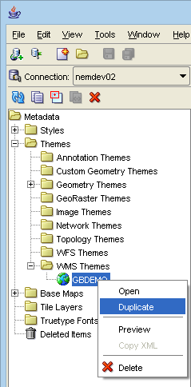

## GIS0030 – GIS WMS Themes form.

A new form has been added to the exor forms application to allow the following to be configured for WMS Themes:-

* Role based security.
* The transparency of the Theme as a whole (as opposed to the transparency of the theme’s background).
* Whether the Theme is initially displayed in the exor Locator map.

**NB. The WMS Theme must be defined in Map Builder before it can be configured in this form.**

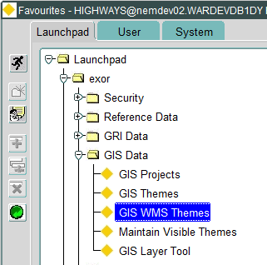

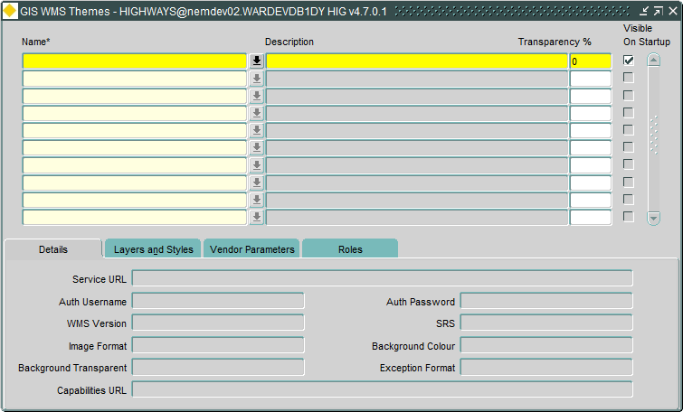

### To add a WMS Theme that has been defined in Map Builder create a new record in the main block of the form and either type the name of the WMS Theme or use the LOV to view a list of WMS Themes that have been configured in Map Builder but not yet configured in this form.

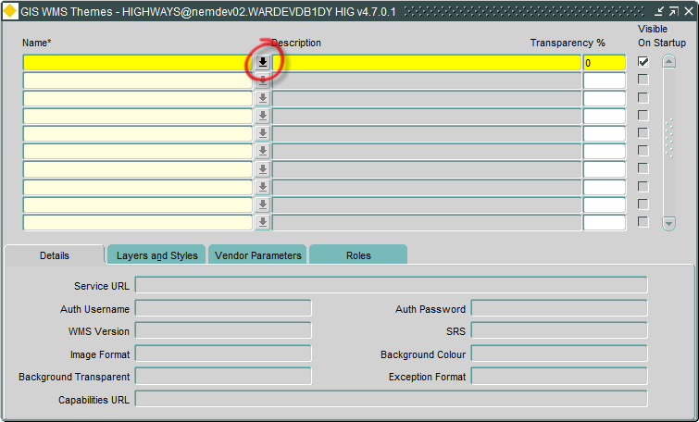

### Select the required WMS Theme from the LOV and click on “OK”.

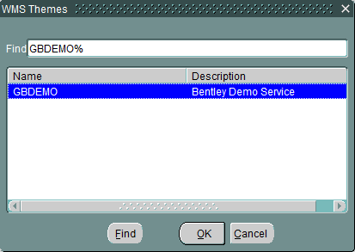

### The information that was entered during the Map Builder configuration is displayed in the “Details”, “Layers and Styles” and “Vendor Parameters” tabs.

If required alter the “Transparency %” and “Visible On Startup” fields for the WMS Theme.

Save the record.

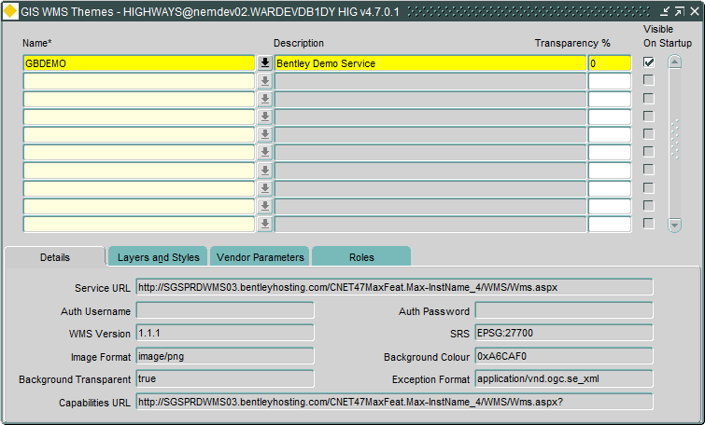

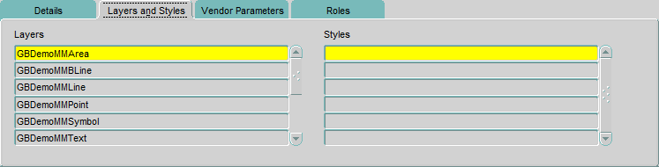

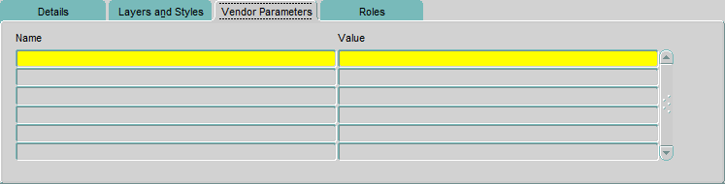

### Any WMS Themes defined in Map Builder for the exor Locator map will only be displayed if the user has one of more of the roles that is associated with the Theme. To associate the Theme with a Role click on the “Roles” tab and create a new record then either type in the name of the Role or use the LOV to view a list of Roles.

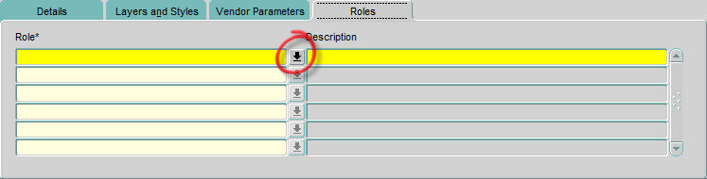

### Select the required Role from the LOV and click on “OK”.

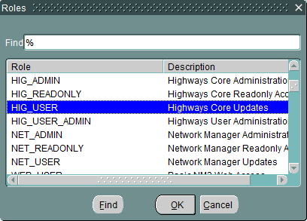

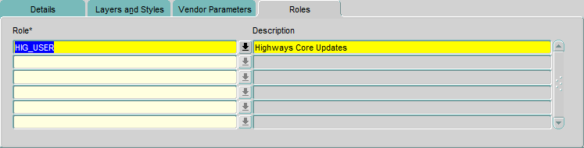

### Add any further Roles required and save the changes. This completes the configuration of the WMS Theme.

## Changes to the exor Locator map

The exor Locator map has been updated to display the WMS Themes defined in the base map (see Product Option “WEBMAPNAME”) where the logged in user has the appropriate Role based access.

When the exor Locator map is started:-

* The presence of a WMS Layer is determined by the Roles assigned to the Layer in the “GIS WMS Themes” form and the Roles assigned to the User.
* The initial order of the WMS Layers is determined by the order in which they are shown in the Map Builder base map.
* The initial transparency and visibility settings are determined by the values set in the “GIS WMS Themes” form.

The Layer Control Tool can be used to amend the order, transparency and visibility of WMS Themes at runtime.

**NB. Any WMS Themes defined in the base map will be treated as Background themes and therefore displayed below the Geometry Themes defined for the map regardless of the order in which they appear in Map Builder.**

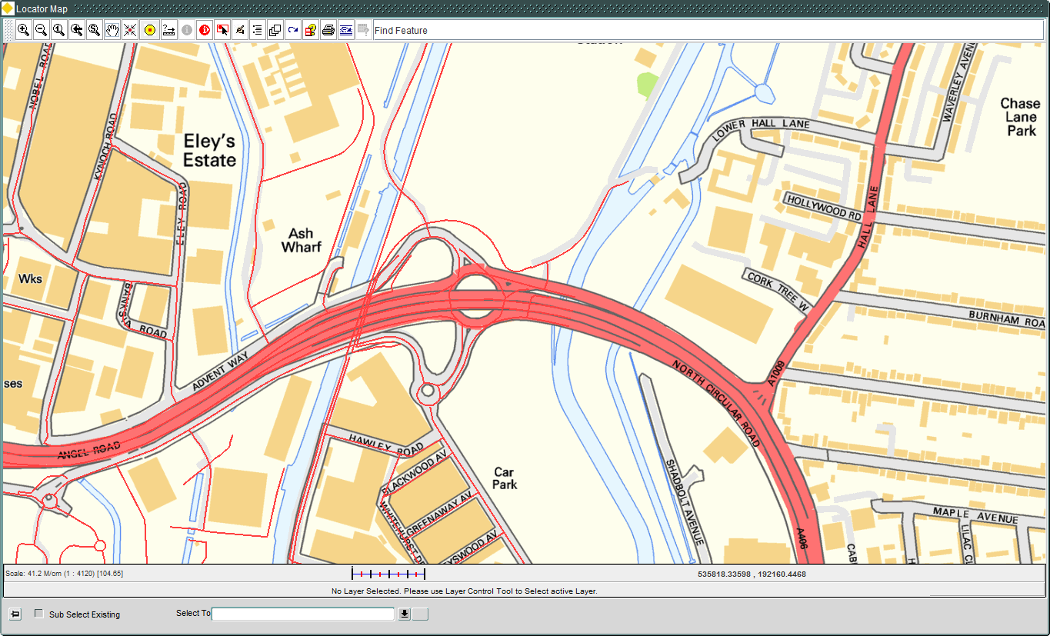

## Changes to the exor Locator Layer Control Tool

The exor Locator Layer Control Tool has been updated to include two tabs, “Geometry Layers” and “WMS Layers”.

Each tab allows reordering and the ability to switch layers on and off as with the previous version of the control, the Geometry Layers tab continues to allow the selection of an “Active Layer”.

The WMS Layers tab additionally allows the transparency of a layer to be amended.

When the exor Locator map is started:-

* The presence of a WMS Layer is determined by the Roles assigned to the Layer in the “GIS WMS Themes” form and the Roles assigned to the User.
* The initial order of the WMS Layers is determined by the order in which they are shown in the Map Builder base map.
* The initial transparency and visibility settings are determined by the values set in the “GIS WMS Themes” form.

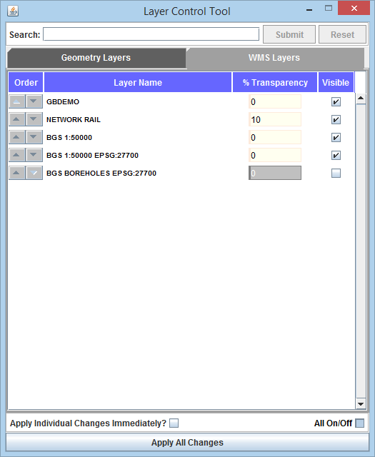

# Log No. Summary

This chapter summarises all software issues that have been addressed by this fix.

For issues raised by users, Bentley Technical Support Group (TSG) Service Request Numbers are cross referenced where applicable.

|  |  |  |
| --- | --- | --- |
| Details | Internal Reference | TSG Service Request |
| Changes to add support for Multiple OGC Compliant WMS Layers within Exor’s Locator module. | Enhancement 99553 | - |
| Defect Details: [Locator] Layer Control Tool - "Apply Individual Changes Immediately" does not apply outstanding changes when first ticked.  Fix Details: A change has been made to the Layer Control Tool in exor Locator so that any outstanding changes are applied when the user ticks the "Apply Individual Changes Immediately?" checkbox. | Defect 139685 | - |