

Network Manager

**Fix Release Notes**

Fix

Table of Contents

1. Introduction 2

2. Fix Details 2

3. List of Amended Files 2

4. Exor Menu Changes 3

5. Log No. Summary 5

# Introduction

This document defines the changes made to the Network Manager product for 4.7.0.x Fix 63 and is specifically targeted at end users.

After reading through this document, should you have any further training or consultancy requirements then please contact your Bentley account manager.

# Fix Details

|  |  |
| --- | --- |
| Fix Details Baseline Release | 4.7.0.x |
| Fix Description | Network Manager 4.7.0.x Fix 63 Patchset |
| Prerequisites | It is assumed that all fixes are applied in numerical order. |
| Implementation Instructions | The staging folder is the location of the folder that **exnm04070006en_updt63.zip** was extracted to (the folder containing this readme).  Go to the relevant exor\bin directory on the Oracle Weblogic Server and copy all .fmx, .mmx and.plx files into a backup directory of your choosing. Now copy all .fmx, .mmx and.plx files from the staging folder into the exor\bin directory on the Oracle Weblogic Server.  Log onto SQL*Plus as the Highways Owner with the staging folder as the working directory.  At the prompt type START nm_4700_fix63.sql and press return.  Exit SQL*Plus |
| Limitations |  |
| Configuration Information | None |
| How To Test | Recommend full regression test |
| Rollback Strategy | Initially implement on a test environment |

# List of Amended Files

|  |  |
| --- | --- |
| Filename | Version |
| hig.plx | 5.8 |
| form.mmx | 5.2 |
| nm_4700_fix63.sql | 1.3 |

# Exor Menu Changes

Users are experiencing multiple exceptions when opening a form, due to Oracle bug:

[BUG:12934323](https://support.oracle.com/epmos/faces/BugDisplay?parent=DOCUMENT&sourceId=1932257.1&id=12934323) - FRM-41068 : Error in Set_Menu_Item_Property. When Launching a Forms With Dynamic Menu ([Doc ID 1932257.1](https://support.oracle.com/epmos/faces/SearchDocDisplay?_adf.ctrl-state=12y4qt2o6w_4&_afrLoop=376751528996667)),

As a result, the Exor Forms menu has been modified to remove the list of historic forms used to resolve this problem. i.e. The following will no longer appear in the *File* menu:

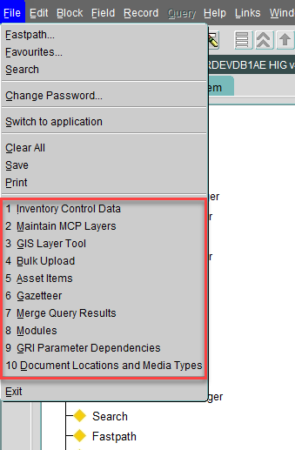

Instead, it’s advised that the *User* tab in the Favourites form (hig1807) should be used, as in the following example:

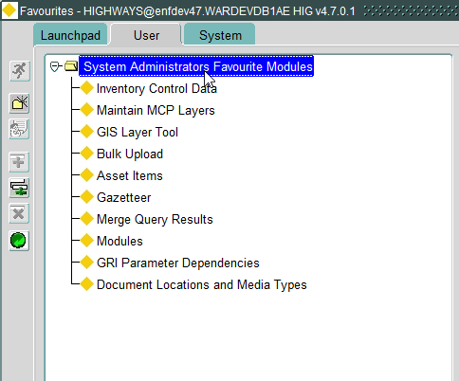

# Log No. Summary

This chapter summarises all software issues that have been addressed by this fix.

For issues raised by customers, Bentley Technical Support Group (TSG) Ticket Numbers are cross referenced where applicable.

|  |  |  |
| --- | --- | --- |
| Details | Internal Reference | TSG Ticket Number |
| On a new environment configuration, users are reporting multiple exceptions with the following message, when opening forms:  *FRM-410968: Error in Set_Menu_Item_Property* | Defect 1024971: | SR #7000909759 |