

**Fix Release Notes**

Fix

Table of Contents

1. Introduction 2

2. Fix Details 2

3. List of Amended Files 3

4. Enhancements 4

4.1 Exor Integration With IMS 4

5. Log No. Summary 8

# Introduction

This document defines the changes made to the product for Fix and is specifically targeted at end users. After reading through this document, should you have any further training or consultancy requirements then please contact your Bentley account manager.

# Fix Details

|  |  |
| --- | --- |
| Fix Details Baseline Release |  |
| Fix Description | Exor Core Enhancements for IMS Integration |
| Prerequisites | Network Manager Fix 46 and Network Manager Fix 50 should be applied prior to this fix |
| Implementation Instructions | **Note: This fix contains enhancements to allow for IMS Integration, if required.**  **Applying this fix will have no impact on the current installation but introduces the ability to configure the system to make use of Bentley IMS as an Identity Provider**  The staging folder is the location of the folder that exnm04070001en_updt53.zip was extracted to (the folder containing this readme).  Go to the relevant exor\bin directory on the Oracle Weblogic Server and rename the following files:-   hig1832.fmx to nm1832_old.fmx  hig.plx to hig_old.plx  Then copy in the following files from the staging folder to the exor\bin directory –  hig1832.fmx  hig.plx  sso.plx  higenc.fmx  higsso.fmx  Go to the relevant <ORACLE_HOME>\forms\java directory on the Oracle WebLogic Forms Server and rename the following files –  exor-mapviewer.jar to exor-mapviewer_old.jar  exor_login_util.jar to exor_login_util_old.jar  Then copy in the following jars from the staging folder\lib directory –  exor-mapviewer.jar  exor_login_util.jar  DJNativeSwing-SWT.jar  DJNativeSwing.jar  swt.jar  log4j.jar  Log onto SQL*Plus as **SYS** user with the staging folder as the working directory.  At the prompt type START nm_4700_fix53_sys.sql and press return.  Log onto SQL*Plus as the Highways Owner with the staging folder as the working directory.  At the prompt type START nm_4700_fix53.sql and press return.  Exit SQL*Plus |
| Limitations |  |
| Configuration Information | None |
| How To Test | Recommend full regression test |
| Rollback Strategy | Initially implement on a test environment |

# List of Amended Files

|  |  |
| --- | --- |
| Filename | Version |
| hig1832.fmx | 5.10 |
| hig_relationship_api.pkh | 1.1 |
| hig_sso_api.pkh | 1.0 |
| hig_relationship_api.pkw | 1.1 |
| hig_sso_api.pkw | 1.2 |
| exor-mapviewer.jar | 1.11 |
| sso.plx | 1.0 |
| higsso.fmb | 1.0 |
| higenc.fmb | 1.0 |
| hig.plx | 5.4.1.1 |
| exor-ims.war | 1.0 |
| log4j.properties | 1.0 |
| exor_login_util.jar | 1.1 |
| swt.jar | 1.0 |
| log4j.jar | 1.0 |
| DJNativeSwing-SWT.jar | 1.0 |
| DJNativeSwing.jar | 1.0 |
| migrate_users.sql | 1.0 |
| nm_4700_fix53_sys.sql | 1.0 |
| nm_4700_fix53.sql | 1.0 |

# Enhancements

## Exor Integration With IMS

This fix contains enhancements to allow integration between Exor Core and the Bentley IMS product. This means that Single Sign-On can be implemented across any applications that also integrate with Bentley IMS as an Identity Provider. When activated, user authentication will be performed using passive WS-Federation. In effect this allows Exor Core to be configured as a relying party in WS-Federation terms.

In support of this, the User definition form (HIG1832) has been amended to allow users to be configured for authentication via the external Identity Provider.

The *Exor IMS Integration Configuration Guide* document, included in this fix, details how IMS Authentication is configured. The obvious difference to the user, once this authentication method has been implemented, is that Identity Providers Login screen will replace the current login screen. The following is the login form from Bentley IMS, as an example

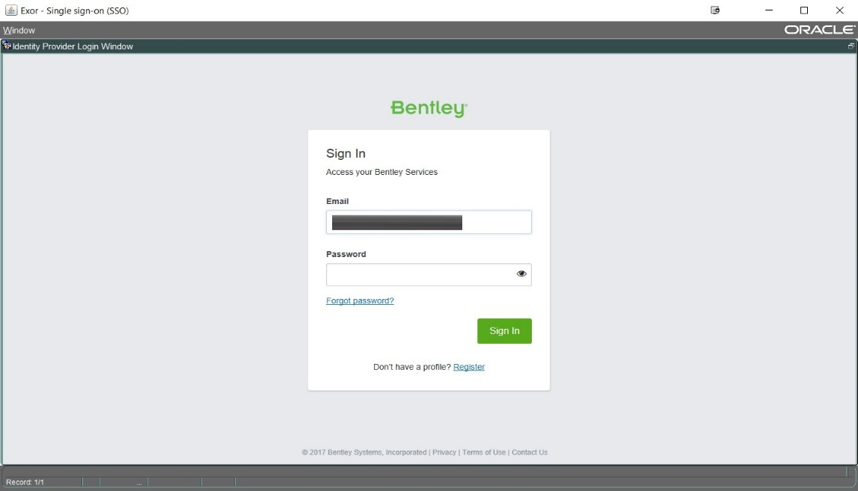

### **PROXY_OWNER Role**

User Authentication via IMS makes use of Oracle’s Proxy Authentication, where a Proxy User is defined that will connect and authenticate against the database on behalf of another database user.

To allow for this, the PROXY_OWNER Role has been created, where any user granted this role can be used as a Proxy Owner.

### **Enabling User Authentication via IMS**

A new checkbox has been introduced, and when checked will register the user for access via Single Sign-On.

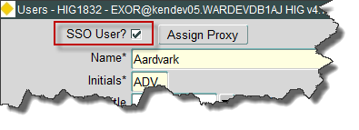

Once the *SSO User* checkbox has been checked the following dialog will be displayed:

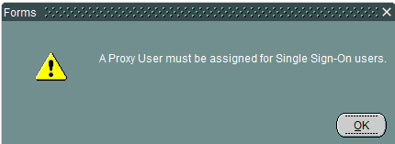

The following window will then be displayed, requiring one or more Proxy Users to be assigned (Note: Only users that have been assigned the PROXY_OWNER role will be available for selection, see section 4.1.1):

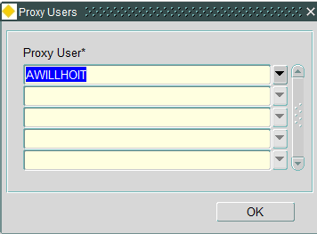

For authentication, the user’s email address will be used to identify the user. As a result, the user’s email address must be defined. Validation will ensure that a value is present.

### **Automatic Password Generation**

Once registered as a Single Sign-On User, the user’s password will be automatically generated and the Password field will be disabled. If the user also requires access to the Exor Forms Application directly (ie. As they do currently), there is an option to override the automatic password generation by use of the *Override password generation* checkbox:

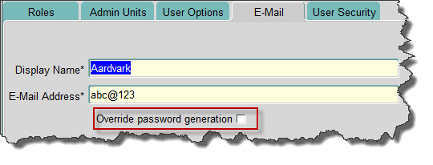

On checking this checkbox the user is prompted to enter a password.

**NB: By default all newly created users will be registered for access via Single Sign-On and will have their passwords automatically generated**

### **Auto-generated Password Reset Process**

Where users have been registered for Automatic Password management, a new process has been introduced which will allow for regular password updates. A random password will then be generated for each of these users.

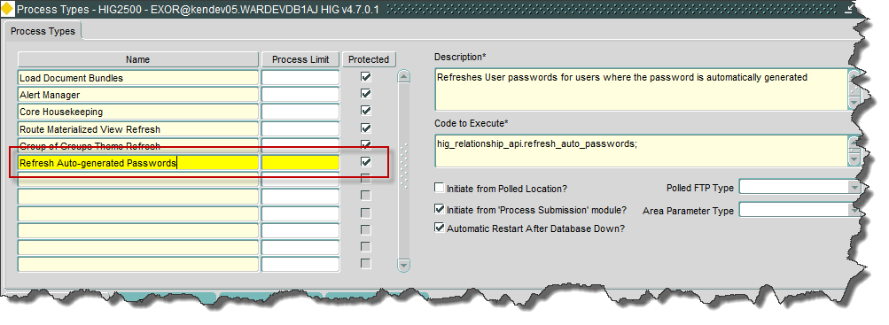

# Log No. Summary

This chapter summarises all software issues that have been addressed by this fix.

For issues raised by customers, Bentley Technical Support Group (TSG) Ticket Numbers are cross referenced where applicable.

|  |  |  |
| --- | --- | --- |
| Details | Internal Reference | TSG Ticket Number |
| Enhancement required to register a user as a Single Sign-On user.  A method for mapping an Exor Username (ie Oracle User name) to a users' IMS credentials will be required to allow for Single Sign-On access to the Exor application | Enhancement 633609 |  |

### **NB: It should be noted that applying this fix will not affect the current installation, but merely introduces the ability to configure, and make use of, Bentley IMS as an Identity Provider to access the Exor Forms Application, if required.**