

Network Manager

**Fix Release Notes**

Fix

Table of Contents

1. Introduction 2

2. Fix Details 2

3. New Roles 2

4. Java Tools 3

5. List of Amended Files 4

6. Log No. Summary 4

# Introduction

This document defines the changes made to the Network Manager product for 4.7.0.x Fix 67 and is specifically targeted at end users.

After reading through this document, should you have any further training or consultancy requirements then please contact your Bentley account manager.

# Fix Details

|  |  |
| --- | --- |
| Fix Details Baseline Release | 4.7.0.x |
| Fix Description | Network Manager 4.7.0.x Fix 67 Patch set. |
| Prerequisites |  |
| Implementation Instructions | The staging folder is the location of the folder that **exnm04070002en_updt67.zip** was extracted to (the folder containing this readme).  Log onto **SQL*Plus** as the **Highways Owner** with the staging folder as the working directory.  At the prompt type START exnm04070002en_updt67.sql and press return.  Exit **SQL*Plus** |
| Limitations |  |
| Configuration Information | None |
| How to Test | Recommend full regression test |
| Rollback Strategy | Initially implement on a test environment |

# New Roles

This fix introduces three new roles that are related to specific Java functions and these roles will need to be granted to any user that intends to use the following operations:

**EXTRACT_SHAPE_FILE**

This role is required for anyone who wishes to extract a Shapefile from the system.

**UPLOAD_SHAPE_FILE**

This role is required for anyone who wishes to upload a Shapefile into the system.

**CHECK_XSS**

This role is required for all TIG users to use the identify XSS vulnerable URLs and prevent such attacks.

# Java Tools

1. **Creation of Additional Database Objects** –

Run **mci_ldjava_11g.bat** from **Command Prompt** with staging folder as working directory.

**Usage:** mci_ldjava_11g.bat user/pass@connect

**Note** –

1. The system executing this batch file must have **loadjava** utility. This can be confirmed by running the command – loadjava –help – on a **Command Prompt** on the system, if it shows the help options, the batch file can be run. Generally, **loadjava** is available on systems with Oracle Database or Oracle Database Client or Forms & Reports Server installed.
2. In case the system has *more than one Oracle Homes*, e.g. installing Oracle Database Server, Oracle Database Client – 32 bit and Oracle Database Client – 64 bit on the same system creates three Oracle Homes, **PATH** Environment Variable needs to be set before running the batch file on the **same Command Window**. **First entry** in the **PATH** variable must be the Oracle Home directory path for the **Database Server**.

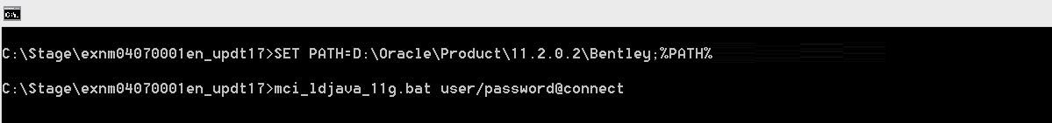

1. User must be the **Highways Owner***.*
2. **Creation of Environment Variable for MapCapture** –

A new environment variable called – SDE_UTIL_PATH will need to be created on the database server that points to the Shapefile jars (e.g. sde2shp.jar, shp2sde.jar etc.) location.

After creation the database server will need to be **restarted**.

1. **Creation of Environment Variable for TIG** –

A new environment variable called – XSS_UTIL_PATH will need to be created on the database server that points to the tig-xss.jar location (Please refer “*Transportation Intelligence Gateway Deployment Guide*” for more details on tig-xss.jar).

After creation the database server will need to be **restarted**.

# List of Amended Files

|  |  |
| --- | --- |
| Filename | Version |
| CMDUtilities.java | 1.2 |
| mci_ldjava_11g.bat | 1.0 |
| nm3_java_utils.pkh | 1.0 |
| nm3_java_utils.pkw | 1.0 |

# Log No. Summary

This chapter summaries all software issues that have been addressed by this fix. For issues raised by customers, Bentley Technical Support Group (TSG) Ticket Numbers are cross referenced where applicable.

|  |  |  |
| --- | --- | --- |
| Details | Internal Reference | TSG Ticket Number |
| Protect running of certain Java components | 1034054 |  |