

Fix Release Notes

4.7.0.0 Fix 20

Table of Contents

1. Introduction 2

2. Fix Details 2

3. List of Amended Files 3

4. New Java Shape Tool 4

4.1 SDE2SHP 4

4.2 SHP2SDE 4

4.3 New Product Options 5

4.3.1 SHPJAVASRV 5

4.3.2 SHPJAVAPRT 5

4.3.3 SHPJAVADB 5

4.3.4 SHPJAVAUP 5

4.3.5 SHPJAVAEX 5

4.3.6 SHPJAVABIN 5

4.3.7 SHPJAVARTE 6

5. New Process Type 7

6. Log No. Summary 8

# Introduction

This document defines the changes made to the Network Manager product for 4.7.0.0 Fix 20 and is specifically targeted at end users.

After reading through this document, should you have any further training or consultancy requirements then please contact your Bentley account manager.

# Fix Details

|  |  |
| --- | --- |
| Fix Details Baseline Release | 4.7.0.0 |
| Fix Description | Various modifications related to Network Edits for HA Update |
| Prerequisites |  |
| Implementation Instructions | The staging folder is the location of the folder that exnm04070004en_updt20.zip was extracted to (the folder containing this readme).  Log onto SQL*Plus as the Highways Owner with the staging folder as the working directory.  At the prompt type START nm_4700_fix20.sql and press return.  Exit SQL*Plus |
| Limitations |  |
| Configuration Information | None |
| How To Test | Recommend full regression test |
| Rollback Strategy | Initially implement on a test environment |

# List of Amended Files

|  |  |
| --- | --- |
| Filename | Version |
| get_lb_RPt_r_tab.fnw | 1.0 |
| lb_aggr.pkh | 1.0 |
| lb_aggr.pkw | 1.0 |
| v_geom_on_route.vw | 1.5 |
| v_obj_on_route.vw | 1.3 |
| lb_data_types.sql | 1.0.1.0 |

# New Java Shape Tool

Java versions of SHP2SDE and SDE2SHPE have been developed to allow for the extract and loading of shape files, rather than using the ESRI supplied modules. The following sections will detail the product options that have been introduced to support these tools, and their use.

Note: A more comprehensive description of these tools, along with a full list of mandatory and optional parameters, is contained in the Java Shape Tool documentation

## SDE2SHP

The mandatory parameters required for SHP2SDE, as specified in the installation instructions can be defined as follows, using the product options (defined in 4.3) where appropriate:

<-h>: Host machine with existing Oracle database

Defined by product option SHPJAVASRV

<-p>: Host machine's port with existing Oracle database (e.g. 1521)

Defined by product option SHPJAVAPRT

<-s>: Host machine's SID with existing Oracle database

Defined by product option SHPJAVADB

<-u>: Database user

Oracle Database User Id

<-d>: Database user's password

Oracle User Password for Database User, defined above

<-t>: Input feature table name and spatial column name (separated by COMMA only)

For example, V_MCP_EXTRACT_SPED,SHAPE

<-f>: File name of an output Shapefile WITHOUT EXTENSION

This is the output shape file name, including the file path (defined by product option SHPJAVAEX) to where the details will be extracted on the database server.

## SHP2SDE

The mandatory parameters required for SHP2SDE, as specified in the installation instructions can be defined as follows, using the product options (defined in 4.3), where appropriate:

<-h>: Host machine with existing Oracle database

Defined by product option SHPJAVASRV

<-p>: Host machine's port with existing Oracle database (e.g. 1521)

Defined by product option SHPJAVAPRT

<-s>: Host machine's SID with existing Oracle database

Defined by product option SHPJAVADB

<-u>: Database user

Oracle Database User Id

<-d>: Database user's password

Oracle User Password for Database User, defined above

<-t>: Table name for the result

Table name used in the shape file load, for example V_MCP_UPLOAD_SPED

<-f>: File name of an input Shapefile WITHOUT EXTENSION

This is the input shape file name, including the file path (defined by product option SHPJAVAUP) on the database server

## New Product Options

To support the new Java Shape Tool modules, a number of product options have been introduced:

### SHPJAVASRV

This product option specifies the server on which SDE is running, and where the Java tool will extract and load shape file details

### SHPJAVAPRT

Port Number used by Java Shape Tool

### SHPJAVADB

This product option specifies the Database SID used by Java Shape Tool

### SHPJAVAUP

This product option specifies the upload directory, on the database server, from where the Java Shape Tool will load the shape files

### SHPJAVAEX

This product option specifies the extract directory, on the database server, to where the Java Shape Tool will extract the shape files

### SHPJAVABIN

This product option specifies the directory where the Java Shape Tool executables are located on the database server

### SHPJAVARTE

This product option specifies the Route Type on which the Materialized views used in shape file production are based.

**Note: The 2 materialized views included in this release are based on this product option. Whenever the details for this product option are defined, or modified, the views will need to be refreshed. This can be achieved by submitting the ‘Route Materialized View Refresh’ process, as described in Section 5.**

# New Process Type

Two new materialized views have been introduced to allow for the aggregation of asset linear references and geometries relative to a specific route type. The views will be based on the route type specified in product option SHPJAVARTE.

For these views to be refreshed on a regular basis, a new Process Type has been specified:

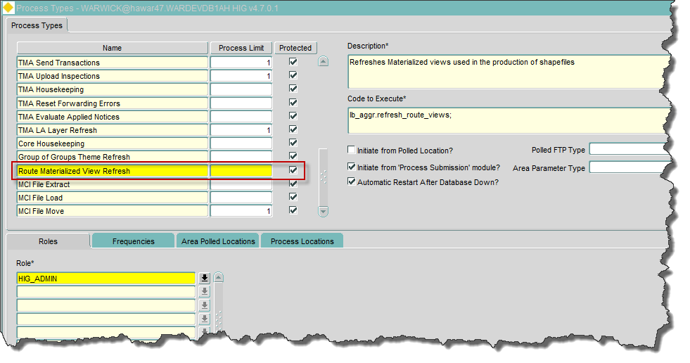

# Log No. Summary

This chapter summarises all software issues that have been addressed by this fix.

For issues raised by customers, Bentley Technical Support Group (TSG) Ticket Numbers are cross referenced where applicable.

|  |  |  |
| --- | --- | --- |
| Details | Internal Reference | TSG Ticket Number |
| A Process is required to refresh materialized views, introduced to allow for the aggregation of asset linear references and geometries relative to a specific route type | Enhancement 204151 |  |