

Network Manager

**Fix Release Notes**

4.7.0.0 Fix

Table of Contents

1. Introduction 2

2. Fix Details 2

3. List of Amended Files 3

4. Group of Groups Spatial Representation 4

5. New Process Type 5

6. Log No. Summary 6

# Introduction

This document defines the changes made to the Network Manager product for 4.7.0.0 Fix 3 and is specifically targeted at end users.

After reading through this document, should you have any further training or consultancy requirements then please contact your Bentley account manager.

# Fix Details

|  |  |
| --- | --- |
| Fix Details Baseline Release | 4.7.0.0 |
| Fix Description | Group of Groups spatial representation changes |
| Prerequisites | Network Manager 4700 Fix 13 |
| Implementation Instructions | The staging folder is the location of the folder that exnm04070005en_updt21.zip was extracted to (the folder containing this readme).  Go to the relevant exor\bin directory on the Oracle Weblogic Server and rename the following files:-  gis0020.fmx to gis0020_old.fmx  Then copy in the new versions of the files from the staging folder.  Log onto SQL*Plus as the Highways Owner with the staging folder as the working directory.  At the prompt type START nm_4700_fix21.sql and press return.  Exit SQL*Plus |
| Limitations |  |
| Configuration Information | None |
| How To Test | Recommend full regression test |
| Rollback Strategy | Initially implement on a test environment |

# List of Amended Files

|  |  |
| --- | --- |
| Filename | Version |
| v_nm_group_structure.vw | 1.0 |
| v_nm_group_hierarchy.vw | 1.1 |
| v_nm_rebuild_all_nat_sdo_join.vw | 3.6 |
| v_nm_sub_group_structure.vw | 1.0 |
| v_nm_network_themes.vw | 1.1 |
| nm3sdo.pkh | 2.10 |
| nm3sdo.pkw | 2.92 |
| nm3layer_tool.pkh | 2.14 |
| nm3layer_tool.pkw | 2.40 |
| nm3sdm.pkw | 2.77 |
| nm3invval.pkw | 2.19 |
| nm3pla.pkh | 2.4 |
| nm3pla.pkw | 2.17 |
| gis0020.fmx | 5.3 |

# Group of Groups Spatial Representation

An Enhancement has been introduced that will allow a group of groups to be given a spatial representation (theme). The spatial data is constructed from the highest possible layer of existing spatial representations which relate to a network. The changes to the software will work out the best method to build a group layer depending on its subordinates and whether they already have associated geometry.

As an example, in the following hierarchy of road groups



If the Sections are road groups that have shapes and the geometry exists for groups Grp2 and Grp3, the Grp1 group shapes will be an aggregation of the geometries of Grp2 and Grp3. If however, Grp2 and Grp3 have no spatial representation, the Grp1 shapes will be an aggregation of the shapes of the Sections.

Once created, the data will remain static, due to it being defined as a “deferred” theme, i.e. it will not work if the update-on-edit is set to ‘I’ for Immediate (If this setting is made, network edits will fail).

Modifications to the Layer Tool form (GIS0020) have been made, to allow for the creation of Group themes, and the ability to refresh these themes (currently restricted to generating only the layers for group types, which are groups of datums).

Also, a process has been introduced, see Section 5, to refresh all group-of-groups type layers allowing for the refresh to be performed at regular intervals.

# New Process Type

A new process has been introduced to allow for the refresh of Group of Groups geometry layers. This will refresh all Group of Group themes, in hierarchical order

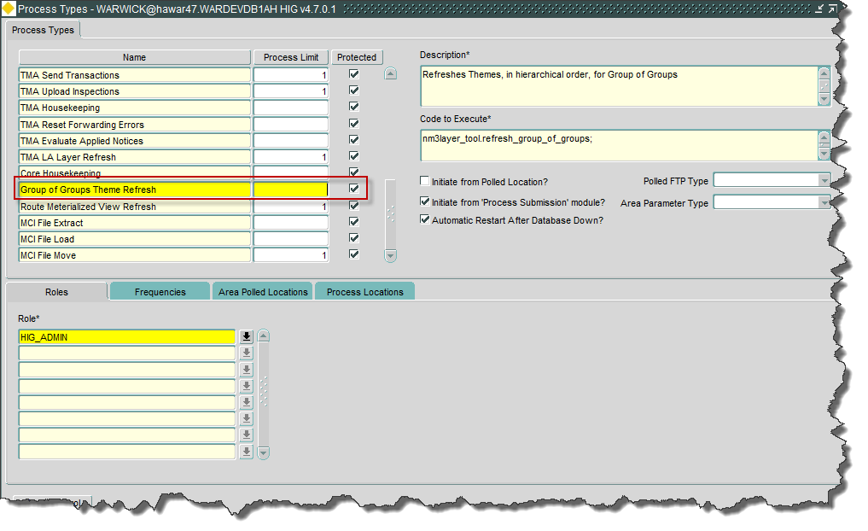

# Log No. Summary

This chapter summarises all software issues that have been addressed by this fix.

For issues raised by users, Bentley Technical Support Group (TSG) Service Request Numbers are cross referenced where applicable.

|  |  |  |
| --- | --- | --- |
| Details | Internal Reference | TSG Service Request |
| Groups of Groups spatial representation | Enhancement 147211 |  |
| When an asset has several locations on the same network element and the locations have not been added in start measure order, attempting to remove one of these locations can result in more than one location being end dated. | Defect 198837 |  |
| Attempting to split an element at a position less than that defined for product option SDOMINPROJ is permitted within Spatial Manager. Modifications have been made to prevent this | Defect 204188 |  |
| Trapping of error messages in dynamic segmentation of geometries can fail. | Defect 168043 |  |
| Spatial generation of route-based inventory layer lacks a column alias on some dynamic SQL | Defect 183452 |  |
| When trying to post a new asset from Mapcapture, an error is produced indicating a failure ‘Inserting Feature’ | Defect 168153 |  |
| When creating an Asset in Asset Items form (NM0510) where IIT_PRIMARY_KEY is defined as an attribute, an Oracle exception is produced | Defect 250757 |  |
| In Mapcapture, when attempting to load an Asset where IIT_PRIMARY_KEY is defined as an attribute, an Oracle exception is produced | Defect 202783 |  |