

Fix Release Notes

4.7.0.0 Fix 13

Table of Contents

1. Introduction 2

2. Fix Details 2

3. List of Amended Files 3

4. New Product Options 4

4.1 NODETOL 4

4.2 SDOMINPROJ 4

4.3 SDOPROXTOL 5

5. NM0200 Modifications 6

5.1 General Modifications 6

5.2 Node Selection 6

5.3 Split position corresponds with Node 6

5.4 Split position within tolerance of Node 7

5.5 Performance Enhancements for Spatial Generation of NSG Data for Large Data Volumes 7

5.6 Proximity checking – Existing Node selection 8

6. Log No. Summary 9

# Introduction

This document defines the changes made to the Network Manager product for 4.7.0.0 Fix 13 and is specifically targeted at end users.

After reading through this document, should you have any further training or consultancy requirements then please contact your Bentley account manager.

# Fix Details

|  |  |
| --- | --- |
| Fix Details Baseline Release | 4.7.0.0 |
| Fix Description | Various modifications related to Network Edits for HA Update |
| Prerequisites |  |
| Implementation Instructions | The staging folder is the location of the folder that exnm04070007en_updt13.zip was extracted to (the folder containing this readme).  Go to the relevant exor\bin directory on the Oracle Weblogic Server and rename the following files:-  nm0200.fmx to nm0200_old.fmx  Then copy in the new versions of the files from the staging folder.  Log onto SQL*Plus as the Highways Owner with the staging folder as the working directory.  At the prompt type START nm_4700_fix13.sql and press return.  Exit SQL*Plus |
| Limitations |  |
| Configuration Information | None |
| How To Test | Recommend full regression test |
| Rollback Strategy | Initially implement on a test environment |

# List of Amended Files

|  |  |
| --- | --- |
| Filename | Version |
| nm0200.fmx | 5.9 |
| nm3rvrs.pkh | 2.3 |
| nm3rvrs.pkw | 2.4 |
| nm3layer_tool.pkw | 2.37 |
| nm3rsc.pkw | 2.7.1.0 |
| nm3sdo.pkw | 2.84 |
| nm3undo.pkw | 2.22 |
| nm3split.pkw | 2.16 |
| nm3nwval.pkw | 2.12 |
| nm3sdm.pkw | 2.72 |
| nm3lrs.pkw | 2.9 |
| v_node_proximity_check.vw | 1.0 |

# New Product Options

## NODETOL

A New product option has been introduced to specify a tolerance distance within which a search will be made for Nodes, from an Offset value entered in NM0200. Any nodes within the tolerance distance specified for the product option will be displayed. See section 5.4 for more detail

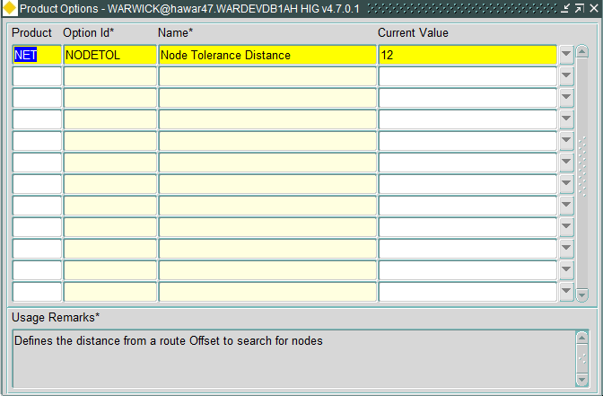

## SDOMINPROJ

A New product option has been introduced to specify the minimum measured length of a datum which may result from a split at the projection of a node onto the element geometry. This is used in the identification of nodes within a distance buffer that will be presented to the user, in NM0200, when the user requires an element to be split on an existing node. Any nodes within the distance buffer that would result in a network split smaller than the value defined for this product option will be excluded.

**Note:** The value entered will be based on the unit of length defined for the network element (i.e. If this is set at 0.5 and the unit of length is defined as Kilometres the minimum datum length will be 500 metres)

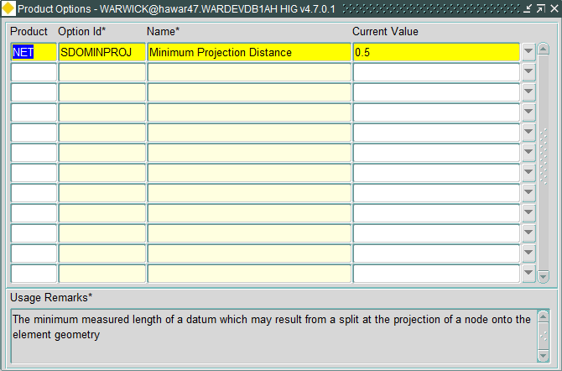

## SDOPROXTOL

A New product option has been introduced to define a distance buffer (in Metres) from a selected network element, to check for nodes that can be used for network split operations. This is used in NM0200 to identify nodes that will be presented to the user, when the user requires an element to be split on an existing node.

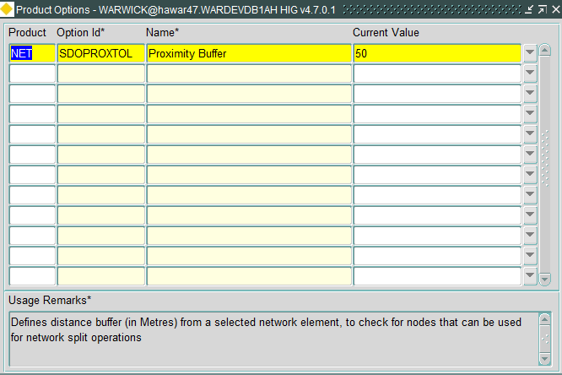

**Note**: When modifying the Product Option values, a refresh is required to ensure the Product Option change has been applied

# NM0200 Modifications

## General Modifications

* The *New Element* section of the form, ie

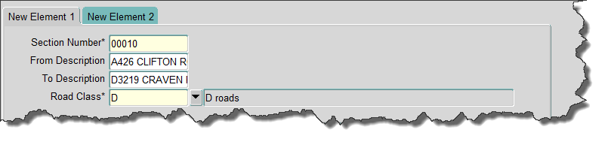

is no longer shown as default, and will only be shown once the *Select Route* checkbox has been selected.

* The *Node* Panel will be disabled if *Select Route* checkbox has been selected
* When entering a value equivalent to *Min Offset* or *Max Offset* in the *Offset* field, the following dialog will be produced:

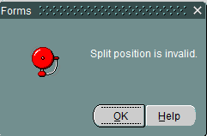

* When *Offset* radio button has been selected, the *Node* Panel will be enabled, allowing for the selection of an Existing Node. The *Node* LOV has been modified to exclude any existing Nodes along the element being split.

## Node Selection

When selecting the *Node* radio button, or if a node has been identified and selected, the *Select Route* checkbox will be set, the node details will be populated and the *New Element* section of the form will be shown. The user will be prevented from unchecking the *Select* Route checkbox until the *Offset* radio button is selected.

## Split position corresponds with Node

When entering a split position that corresponds with a Node, the following dialog is produced:

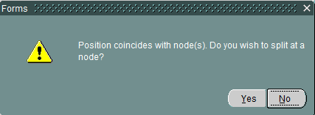

Selecting ‘Yes’ will populate the Node details, the *Node* radio button will be selected and the form will perform as described in 5.2. Selecting ‘No’ will perform no action and will return focus to the *Offset* field, allowing for modification.

## Split position within tolerance of Node

When entering a split position that is within a tolerance (defined by product option NODETOL, see section 4.), the following dialog is produced:



Selecting ‘Yes’ will result in an LOV defining the nodes within tolerance (Note: this won’t include terminating nodes):

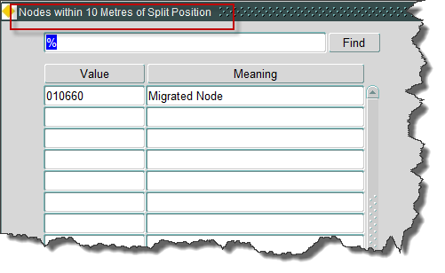

Selecting a node will perform as in 5.3, above. Selecting ‘No’ will perform no action and will return focus to the *Offset* field, allowing for modification.

## **Performance Enhancements for Spatial Generation of NSG Data for Large Data Volumes**

The code which is used to generate spatial representations of linear events has remained unchanged for many years. It was originally built for an Oracle 8 database and has few changes since it was coded. The original Oracle API had many disadvantages such as using complex geometry arguments by value as opposed to by reference. Later advances in SQL and improvements in the Oracle API make it feasible to obtain better performance.

The original code was also replicated across the NSG and the core products and code which was originally used for asset events was replicated to cater for road groups. In many cases, these event types may be very different – many road groups are configured to be sets of whole datum elements. Making use of this feature of the group type makes the spatial generation a lot more efficient and this is particularly true for NSG street types. The extra performance enhancement is critical in the production of spatial representations of group shapes over large extents such as NSG street data shapes over the whole UK.

The changes are made such that one core server procedure will perform the relevant dynamic segmentation procedure and it is referenced from within the NSG product and from within core. Any code specification within the NSG product which relate to the old method should be retired in the next major release.

These changes now mean that earlier NSG fixes to allow the generation of street shapes over large areas can be replaced by using the standard product layer tool to build and refresh themes.

## Proximity checking – Existing Node selection

When choosing to split an element at an existing node, the form will currently allow for any valid node within the system to be entered, or will present the user with a list of all the nodes within the system, excluding those that are currently defined along the route. Validation, when attempting the split, will indicate where nodes will project to the start or end of the network, preventing these from being used. However, any nodes that will project onto the network successfully can be used, irrespective of the distance from the network element.

Proximity checking has been introduced so that the list of values, for existing nodes, will only contain those nodes with a specified proximity from the element to be split (defined by product option SDOPROXTOL), and where the split will not result in nodes shorter than the minimum length (defined by product option SDOMINPROJ). Validation of any nodes entered will also take account of these product options.

# Log No. Summary

This chapter summarises all software issues that have been addressed by this fix.

For issues raised by customers, Bentley Technical Support Group (TSG) Ticket Numbers are cross referenced where applicable.

|  |  |  |
| --- | --- | --- |
| Details | Internal Reference | TSG Ticket Number |
| Split Element form (NM0200) has various issues that require resolution | Defect 146432 |  |
| Undo Split, and Undo Merge pick up end dated members from previous operations, as a result attempting an undo of the split, or merge, produces an exception due to overlapping members | Defects 150475 & 151201 |  |
| When a Route's Group Type is defined as "Reversible", no details are created during the reverse process to enable other products to identify the reversal | Defect 150513 |  |
| Currently the Core "Resize Route" functionality does not have the ability to apply resize changes to other products. New procedure calls will need to be introduced to apply these changes to affected products | Enhancement 158736 |  |
| Performance Enhancements for Spatial Generation of NSG Data for Large Data Volumes | Enhancement 99747 |  |
| This enhancement allows for network operations for routes without nodes. | Enhancement 104961 |  |
| In Split Element form (NM0200), when splitting on an existing node, the List of Values contains a list of all available nodes. Selecting a node, which may be position a long distance away from the network location can result in ORA-06530: Reference to uninitialized composite | Defect 177773 |  |
| When undoing a Network Split, if Groups of Sections form (NM0110) is produced and an attribute value contains just a space the form will translate this to a NULL value and will result in an exception when a save is attempted. | Defect 177828 |  |
| In Split Element form (NM0200), when splitting on an existing node the List of Values included end nodes for the current Network | Defect 177832 |  |
| In Split Element form (NM0200, after entering a Route Offset value, the Datum Offset will allow for 0 or negative values to be entered | Defect 177841 |  |
| In Split Element form (NM0200), when attempting to split an element where the Datum Split Position entered equals the datum length, exception NET-0358: Split position is invalid is produced | Defect 177839 |  |
| In Split Element form (NM0200), when offset corresponds with a node position node selection choice can result in no action, or an incorrect node | Defect 180411 |  |
| In Split Element form (NM0200), when offset corresponds exactly with a node position the form should automatically populate the node details | Defect 180412 |  |
| In Split Element form (NM0200), When choosing an offset on a small element, the identification of a node is not being made under certain circumstances | Defect 181362 |  |
| In Split Element form (NM0200), When changing split between Offset and Node the New Elements panel does not appear, under certain circumstances | Defect 181371 |  |
| In Split Element form (NM0200), Existing Node List of Values does not return any entries after editing New Elements details | Defect 181382 |  |
| When attempting an Undo Split (using NM0203) on an element, the undo operation is including all operations that were performed against that element on the same day, rather than just the operation being undone. | Defect 181356 |  |