Maintenance Manager
Release Notes v4.5.0.0 Fix 1

Introduction
This document defines the changes made to the Maintenance Manager product for fix release v4.5.0.0 Fix 1 and is specifically targeted at end users.

After reading through this document, should you have any further training or consultancy requirements then please contact your Bentley account manager.

Fix Details
Baseline Release | 4.5.0.0
Fix Description | Maintenance Manager 4.5.0.0 Fix 1 Patchset.  0111048 - Changes to Payment Approval form  0111604 - ensuring target date blank if UPDWOTGT = 'Y'
Prerequisites
Implementation Instructions | Unzip mai_4500_fix1.zip to a staging folder.  Go to the relevant exor\bin directory on the Oracle Weblogic Server and rename the following files:-  mai3800.fmx to mai3800_old.fmx  mai3801.fmx to mai3801_old.fmx  mai3856.fmx to mai3856_old.fmx  Then copy in the new version of this file from the staging folder.  Log onto SQL*PLUS as the Highways Owner with the staging folder as the working directory.  At the prompt type "START mai_4500_fix1.sql" and press return.  Exit SQL*PLUS.
Limitations | None known
Configuration Information | None
How To Test | Recommend full regression test
Rollback Strategy | Initially implement on a test environment

List of Amended Files
Filename | Version
log_mai_4500_fix1.sql | 3.0
mai.pkw | 2.28
mai3800.fmx | 5.7
mai3801.fmx | 5.3
mai3856.fmx | 5.3
mai_4500_fix1.sql | 3.0
mai_wo_api.pkw | 3.30

Product Option UPDWOTGT
When the product option UPDWOTGT is set to ‘Y’ the Work Order Target date in MAI3800 will not be automatically calculated, based on the Work Order Line target dates and Work Order Priority, but will allow for manual specification.

The Work Order Target date will only be populated if a Work Order Priority is entered. Otherwise, the value will be NULL requiring population before Authorisation or Instruction.

The product option will be initially set to ‘N’.

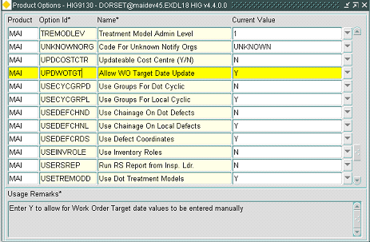

This product option has two values:-

- N = Work Order Target date is automatically populated
- Y = Work Order target date is not populated, and requires manual specification.
Log No. Summary
This chapter summarises all software changes that have been made in this release.

These changes are derived from the following sources,

- Issues raised by Customers via Bentley Support
- Issues raised internally by Bentley

Issues
Internal  Task ID | Issue | Support  Log(s)
0111048 | When executing a query in Payment Approval form (MAI3856), previously entered criteria was not being cleared under certain circumstances. The only way of resolving this was to exit the form, and re-enter the details. Also, % difference calculations being calculated incorrectly. These issues have now been resolved
0111604 | When creating a Work Order via locator, or via the Inspections form, the Work Order target date was being populated if manual entry was required (by specification of UPDWOTGT = 'Y'). Also, if Work Orders were being automatically created via the Inspection Load, the date was also being populated if the product option was set and auto-instruction had not been specified in the Work Order Automation rules. Modifications have been made to overcome these problems. | 8001212150
0111750 | When selecting a defect on to a Work Order using Works Orders form (MAI3800) error message 'Unexpected error occurred ORA-00923: FROM keyword not found where expected.' was being produced. Changes have been made to resolve this | 8001251817

