

Maintenance Manager
Fix Release Notes

4.7.0.x Fix 4

Table of Contents
1. Introduction 2
2. Fix Details 2
3. List of Amended Files 2
4. Change Details 3
5. Log No. Summary 5

Introduction
This document defines the changes made to the Maintenance Manager product for 4.7.0.x Fix 4 and is specifically targeted at end users.
After reading through this document, should you have any further training or consultancy requirements then please contact your Bentley account manager.

Fix Details
Fix Details Baseline Release | 4.7.0.x
Fix Description | Maintenance Manager 4.7.0.x Fix 4 Patchset.  This patchset will bring XSP validation in line with the XSP Integrity modifications released as Network Manager 4.7.0.x fix 7.
Prerequisites | Network Manager 4.7.0.x Fix 7 and Maintenance Manager 4.7.0.x fix 2.
Implementation Instructions | The staging folder is the location of the folder that exmai04070001en_updt4.zip was extracted to (the folder containing this readme).  - Go to the relevant exor\bin directory on the Oracle Weblogic Server and rename the following files:-  mai3800.fmx to mai3800_old.fmx  mai3806.fmx to mai3806_old.fmx  mai3808.fmx to mai3808_old.fmx  Then copy in the new versions of the files from the staging folder.  - Log onto SQL*PLUS as the Highways Owner with the staging folder as the working directory.  At the prompt type START mai_4700_fix4.sql and press return.  Exit SQL*Plus.
Limitations
Configuration Information | None
How To Test | Recommend full regression test
Rollback Strategy | Initially implement on a test environment

List of Amended Files
Filename | Version
mai3800.fmx | 5.18
mai3806.fmx | 5.7
mai3808.fmx | 5.12
mai_4700_fix4.sql | 3.0
log_mai_4700_fix4.sql | 3.0

Change Details
Prior to applying this fix the integrity of Defect XSPs could be an issue when working with maintenance sections that are groups of datum elements as a result Defect XSPs may be flagged as invalid should any validation be applied. This fix contains modifications to a number of forms that will allow them to work correctly alongside the changes made in Network Manager 4.7.0.x fix 7, please see the readme file for this fix a detailed explanation of these changes.
The following modifications are included in the fix:-

MAI3800 – Work Orders
The List Of Values for XSP in the Defect Selection – Selection Criteria window has been updated.
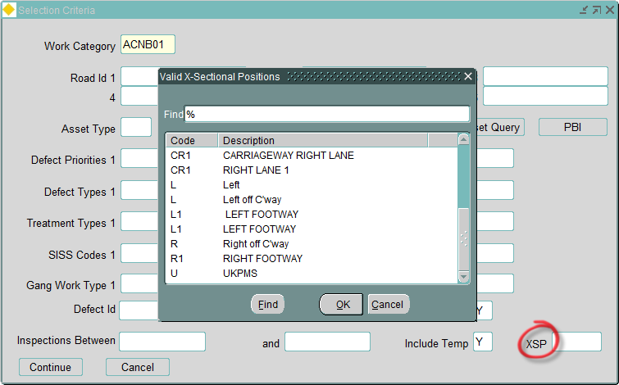

MAI3806 – Defects
The List Of Values for XSP when entering a query has been updated.
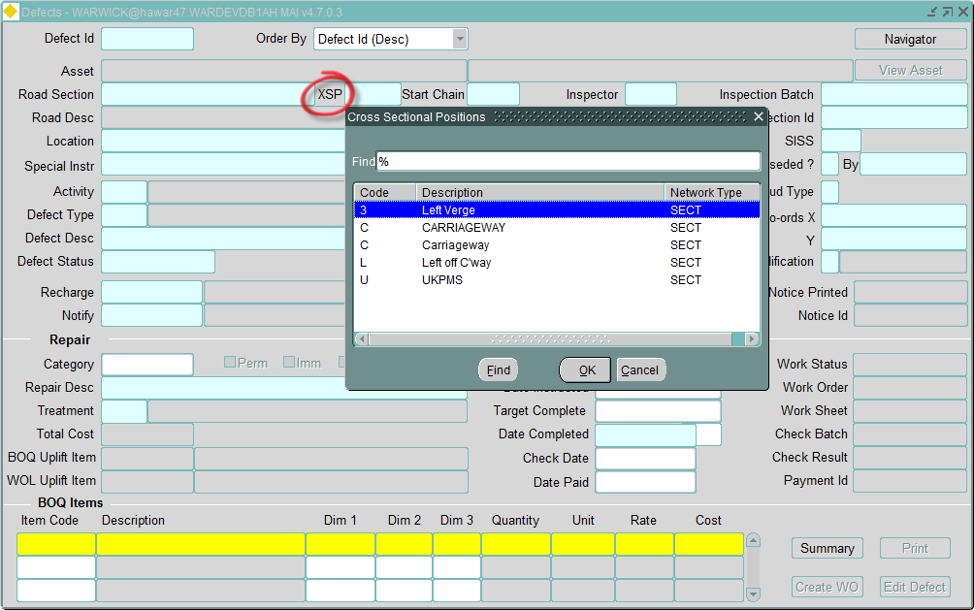
MAI3808 – Inspections
The List Of Values and validation of manually entered XSPs has been updated in the Defects on Inspection window.
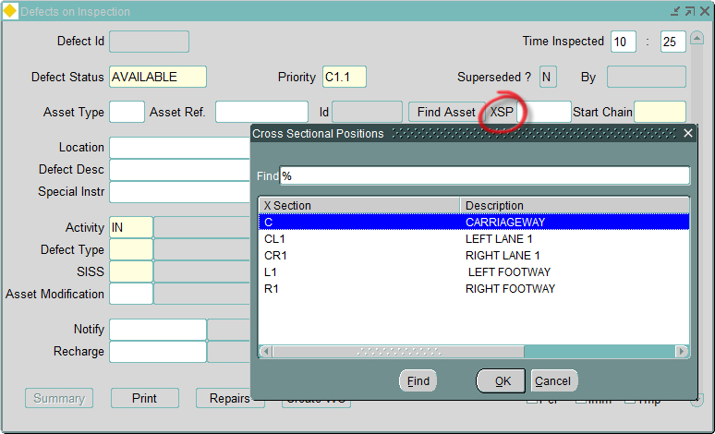

Log No. Summary
This chapter summarises all software issues that have been addressed by this fix.
For issues raised by users, Bentley Technical Support Group (TSG) Service Request Numbers are cross referenced where applicable.
Details | Internal Reference | TSG Service Request
Work Orders form (MAI3800) – Defect Selection XSP List Of Values change. | Defect 134664 | -
Defects form (MAI3806) – XSP List Of Values change. | Defect 135031 | -
Inspections form (MAI3808) – Defect XSP List Of Values and Validation change. | Defect 135011

