Maintenance Manager
Release Notes v4.6.0.0 Fix 7

Introduction
This document defines the changes made to the Maintenance Manager product for fix release v4.6.0.0 Fix 7 and is specifically targeted at end users.

After reading through this document, should you have any further training or consultancy requirements then please contact your exor account manager.

Fix Details
Baseline Release | 4.6.0.0
Fix Description | Changes to allow MapCapture to work with 4 character inventory codes.
Prerequisites
Implementation Instructions | Unzip mai_4600_fix7.zip to a staging folder.  Go to the relevant exor\bin directory on the Oracle Weblogic Server and rename the following file:-  mai2100c.exe to mai2100c_old.exe  Then copy in the new version of the file from the staging folder.  Log onto SQL*PLUS as the Highways Owner with the staging folder as the working directory.  At the prompt type "START mai_4600_fix7.sql" and press return.  Exit SQL*PLUS.
Limitations | Please apply MAI 4600 Fixes 1,4 and 6 before applying this fix.
Configuration Information | None
How To Test | Recommend full regression test
Rollback Strategy | Initially implement on a test environment

List of Amended Files
Filename | Version
mai2100c.exe | 3.2
mai_inspection_loader.pkw | 3.20
pedif.pkw | 3.6

New Product Option PED4CHRASS
When set to 'Y' this Product Option will cause a newly generated PED file to contain the translated Asset Type as defined in the “v2 Asset Type Translations” form (MAI1400) rather than the v2 Asset Type code.
The Inspection and Inventory Loaders will also allow up to 4 characters for the Asset Type in the files to be loaded when this option is set to ‘Y’. Both loaders will translate the any Asset Types given in the load file, that are more than 2 characters long, to the equivalent v2 Asset Type before processing the record.

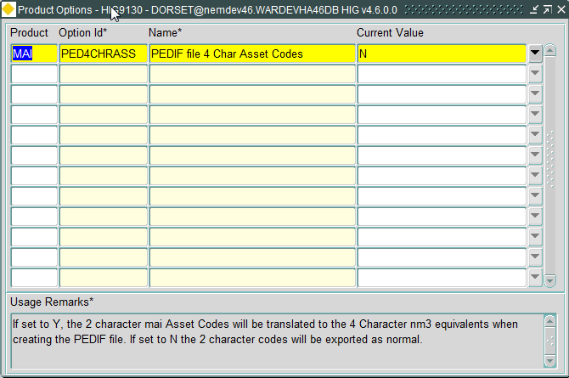

This product option has two values:-

N = Export v2 Asset Type codes in the PED file, as is the case before this fix is applied. This is the Default value.

Y = Export the nm3 Asset Type (up to 4 characters) in the PED file.
Log No. Summary
This chapter summarises all software changes that have been made in this release.

These changes are derived from the following sources,

- Issues raised by Customers via Exor Support
- Issues raised internally by Exor

Issues
Internal  Task ID | Issue | Support  Log(s)
0112303 | Changes to allow 4 character asset codes to be exported in the PED file and used in Enhanced Inspection and Invent files.

