

Maintenance Manager
Fix Release Notes

4.5.0.0 Fix 12

Table of Contents
1. Introduction 2
2. Fix Details 2
3. List of Amended Files 2
4. New Product Option CIMMULTIF 3
5. Allow Multiple Final Invoice files to be processed through CIM Interface 4
6. Log No. Summary 5

Introduction
This document defines the changes made to the Maintenance Manager product for 4.5.0.0 Fix 12 and is specifically targeted at end users.
After reading through this document, should you have any further training or consultancy requirements then please contact your Bentley account manager.

Fix Details
Fix Details Baseline Release | 4.5.0.0
Fix Description | Modification to resolve budget calculation for Final invoices, and enhancement to allow for multiple Final invoices to be processed
Prerequisites
Implementation Instructions | The staging folder is the location of the folder that exmai04050012en_updt12.exe was extracted to (the folder containing this readme).  Go to the relevant exor\bin directory on the Oracle Weblogic Server and rename the following files:-  mai3854.fmx to mai3854_old.fmx  Then copy in the new versions of the files from the staging folder.  Log onto SQL*Plus as the Highways Owner with the staging folder as the working directory.  At the prompt type START mai_4500_fix12.sql and press return.  Exit SQL*Plus
Limitations
Configuration Information | None
How To Test | Recommend full regression test
Rollback Strategy | Initially implement on a test environment

List of Amended Files
Filename | Version
interfaces.pkw | 2.40
mai3854.fmx | 5.1

New Product Option CIMMULTIF
When set to ‘Y’, CIM Final Invoice files can be processed, even though a subsequent Final invoice file has been processed ie. The product option, when set to ‘Y’, will allow for multiple Final invoice files to be processed through CIM
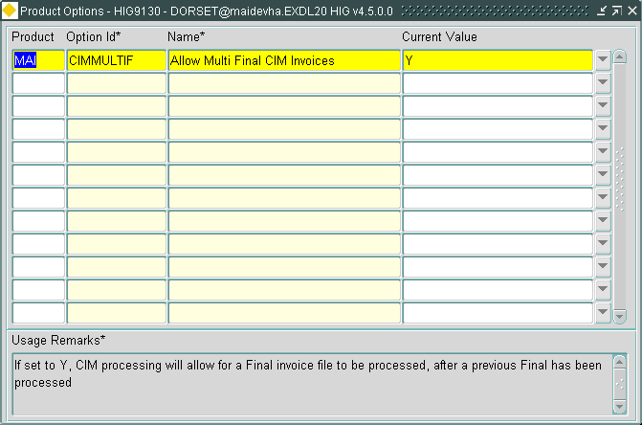
Note: When modifying the Product Option value, a refresh is required to ensure the Product Option change has been applied

Allow Multiple Final Invoice files to be processed through CIM Interface
CIM has been enhanced to allow for the processing of multiple Final Invoice files, depending on product option CIMMULTIF.
CIMMULTIF = ‘Y’: Final Invoices will be processed, even though a Final Invoice file has subsequently been processed.
CIMMULTIF = ‘N’: Processing will be performed as it is currently i.e. only a single Final Invoice is permitted
The following rules apply, for multiple Final invoice processing:
- If CIMMULTIF = ‘Y’, the Final invoices will be treated similar to the Interims. So a Final sequence number will need to be specified in the Record Type 5 (currently null for Final invoices) so that the Finals are processed in the correct order
- For each Final invoice received the Work Order line completion date will be updated according to the Date Completed on the 10 record
- The Completion Date on a Work Order will be the latest completion date received on a Final Invoice for a Work Order Line

Log No. Summary
This chapter summarises all software issues that have been addressed by this fix.
For issues raised by customers, Bentley Technical Support Group (TSG) Ticket Numbers are cross referenced where applicable.
Details | Internal Reference | TSG Ticket Number
Allow for the processing of Multiple Final Invoice files through the CIM interface | D-125250
A work order line completed through interfaces at a lower cost than the estimate does not wipe the remaining committed amount from the budget – giving a misrepresentation of monies spent in the budget | D-126107

