Maintenance Manager
Release Notes v4.3.0.0 Fix 6

Introduction
This document defines the changes made to the Maintenance Manager product for fix release v4.3.0.0 Fix 6 and is specifically targeted at end users.

After reading through this document, should you have any further training or consultancy requirements then please contact your Bentley account manager.

Fix Details
Baseline Release | 4.3.0.0
Fix Description | Maintenance Manager 4.3.0.0 Fix 6 Patchset.
Prerequisites
Implementation Instructions | Unzip mai_4300_fix6.zip to a staging folder.  Go to the relevant exor\bin directory on the Oracle Application Server and rename the following files:-  mai3856.fmx to mai3856_old.fmx  Then copy in the new version of this file from the staging folder.  Log onto SQL*PLUS as the Highways Owner with the staging folder as the working directory.  At the prompt type "START mai_4300_fix6.sql" and press return.  Exit SQL*PLUS.
Limitations | None known
Configuration Information | None
How To Test | Recommend full regression test
Rollback Strategy | Initially implement on a test environment

List of Amended Files
Filename | Version
log_mai_4300_fix6.sql | 3.0
mai3856.fmx | 4.6
mai_4300_fix6.sql | 3.0
v_mai3856_woc.vw | 3.0
v_mai3856_wol.vw | 3.0

Software Changes
Introduction
The Payment Approval form (MAI3856) has been enhanced to include additional detail, and functionality, to help users make informed decisions when carrying out the approval process.
A brief summary of the changes is as follows:
- Additional fields have been added to the Work Order Lines tab, these include
  - Road Description
  - Work Order Originator details
  - Work Order Authoriser Details
  - Original Estimate of the work
  - The percentage difference between the estimate and total value of the work.
- When querying data, the form will initially be restricted to current data by default, with an option to view all data.
- When entering a query in the either the Invoices or Work Order Lines tab, the query will apply to both tabs. For example, if the query is restricted to display details for a Work Order in one of the tabs, both tabs will be restricted to display details for that Work Order.
- Both the Invoices and Work Order Lines tabs have been modified to include ‘Order By’ buttons at the top of the main column details, allowing for data returned to be ordered by the column where the button has been pressed.
- A Navigator button has been included in both tabs to allow for the Navigator module to be called, displaying details for the currently selected Work Order.
Screen Changes
Additional Fields
Fields have been added to the Work Order Lines tab to give the user more information, but with minimum changes to the layout of the form.
The Road Description field has been added next to the Road Id fields as shown below: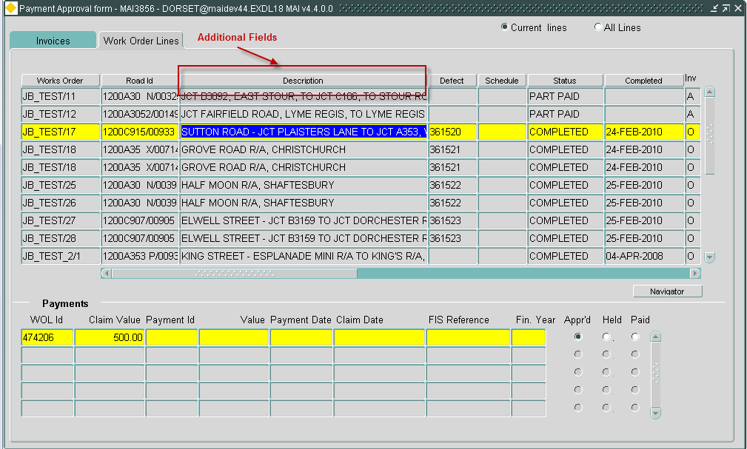
A scroll bar has been added to accommodate the remainder of the user and cost information, with the Work Order column remaining anchored for context, when scrolling through the additional details.
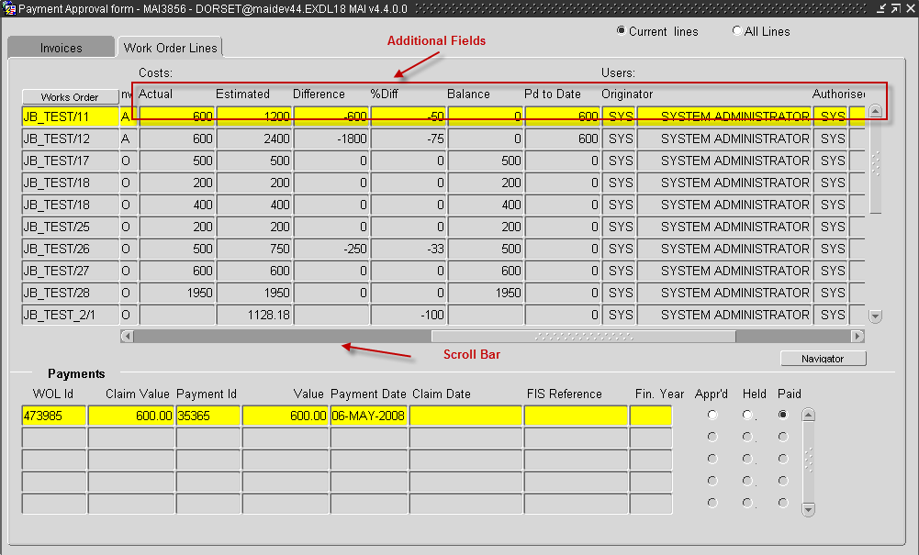
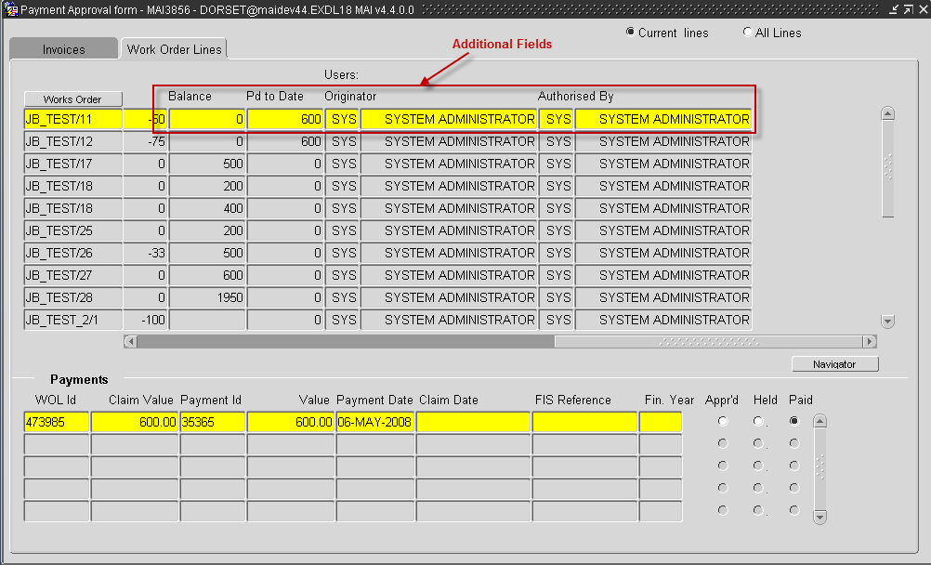
Data Retrieved
Two radio buttons have been introduced, one to display all data and one to display current data i.e. excluding works that have been ‘Paid’ or superseded and ‘Held’.

The radio buttons will apply to both the Invoices and Work Order Lines tabs.

Data Retrieved
When a query is entered into either the Invoices or Work Order Lines tabs, both tabs will be synchronised to contain the appropriate data in each tab relating to the query entered.
Ordering Data
Once some data has been queried back into the form the user may select the ‘Order By’ buttons at the top of each column to order the data either ascending or descending within the column.
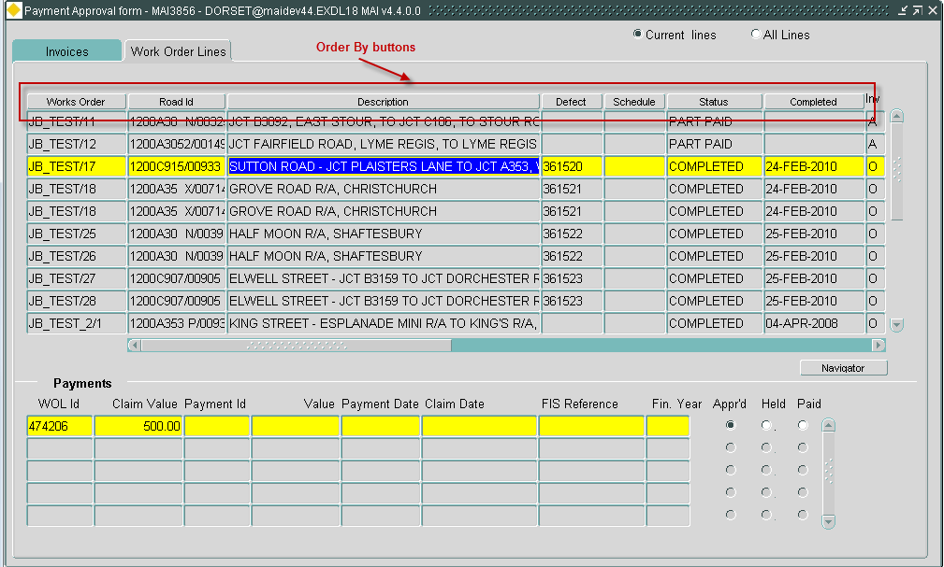
Navigator
The Navigator button
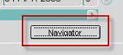
has been added to the form, to display the Work Order Line, and all associated data providing the user has the appropriate permissions. For example:
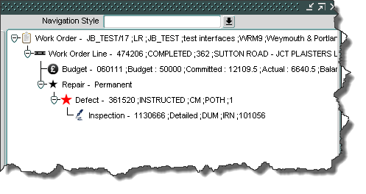
Log No. Summary
This chapter summarises all software changes that have been made in this release.

These changes are derived from the following sources,

- Issues raised by Customers via Bentley Support
- Issues raised internally by Bentley

Issues
Internal  Task ID | Issue | Support  Log(s)
0111360 | There is a requirement by the customer to add additional fields, and functionality, to the Payment Approval form (MAI3856)

