Maintenance Manager
Release Notes v4.3.0.0 Fix 4

Introduction
This document defines the changes made to the Maintenance Manager product for fix release v4.3.0.0 Fix 4 and is specifically targeted at end users.

After reading through this document, should you have any further training or consultancy requirements then please contact your exor account manager.

Fix Details
Baseline Release | 4.3.0.0
Fix Description | Maintenance Manager 4.3.0.0 Fix 4 Patchset
Prerequisites | All previous MAI 4300 Fixes (1, 2 and 3) must be applied prior to applying this fix
Implementation Instructions | Unzip mai_4300_fix4.zip to a staging folder.  Go to the relevant exor\bin directory on the Oracle Application Server and rename the following file:-  mai3800.fmx to mai3800_old.fmx  mai3807.fmx to mai3807_old.fmx  mai3808.fmx to mai3808_old.fmx  mai4405.fmx to mai4405_old.fmx  Then copy in the new versions of these files from the staging folder.  Log onto SQL*PLUS as the Highways Owner with the staging folder as the working directory.  At the prompt type "START mai_4300_fix4.sql" and press return.  A Defect/Repair data error report and an error correction script have been provided as part of this fix; please see below for details of how to run them.  Log onto SQL*PLUS as the Highways Owner with the staging folder as the working directory.  At the prompt type "START ReportDefect.sql" and press return.  If the report shows that errors exist then continue as follows:  Log onto SQL*PLUS as the Highways Owner (if not already connected) with the staging folder as the working directory.  At the prompt type "START RepairDefects.sql" and press return.  Follow the instructions given by the script regarding committing any updates.  Exit SQL*PLUS.
Limitations | None known
Configuration Information | None
How To Test | Recommend full regression test
Rollback Strategy | Initially implement on a test environment

List of Amended Files
Filename | Version
RepairDefects.sql | 1.0
ReportDefects.sql | 1.0
log_mai_4300_fix4.sql | 3.0
mai3800.fmx | 4.19.1.1
mai3807.fmx | 4.7.1.0
mai3808.fmx | 4.11.1.0
mai4405.fmx | 4.11.1.2
mai_4300_fix4.sql | 3.2
mai_4300_fix4_ddl_upg.sql | 1.1
mai_4300_fix4_metadata_upg.sql | 1.0
mai_insp_load_batches_v.vw | 3.0
mai_inspection_api.pkw | 3.23
works_func.pkw | 2.2.1.0

New Functionality
Inspection Loader Error Correction and Summary Form (Enhanced)
The Error Correction form for the Maintenance Inspection Loader has been enhanced to display more information about each Load and to allow it to act as a Load Summary form as well as Error Correction.
When run from the Process Monitor form (HIG2520) or the Process Execution Log form (HIG2540) via the “More Details...” button this form will be automatically populated with the details of the selected load process. Details will be displayed of any:-
- File validation errors
- Data validation errors
- Successfully loaded inspections

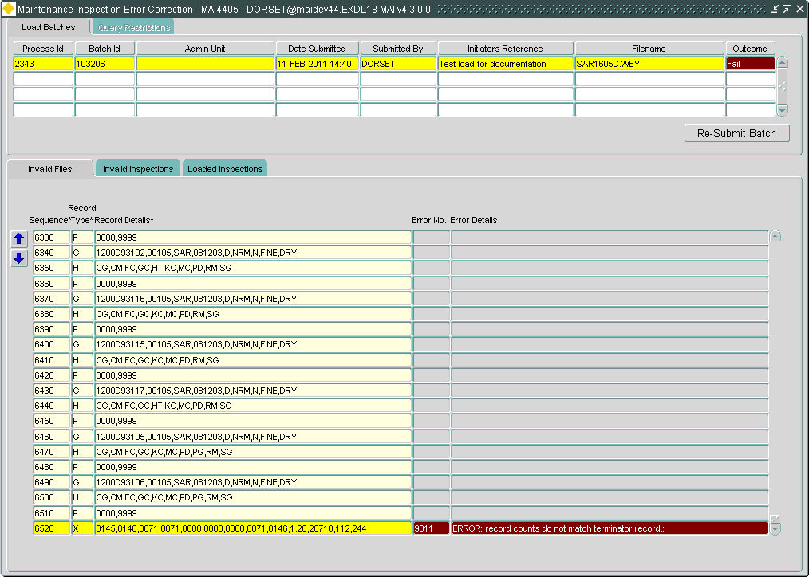

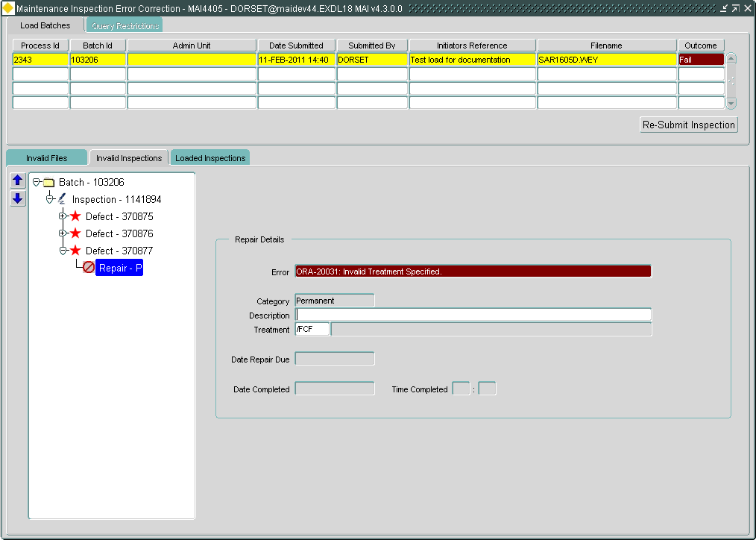

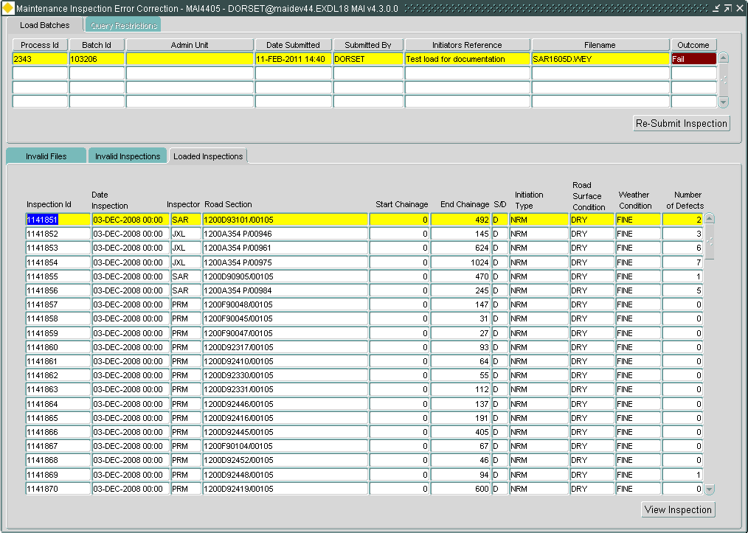

As was previously the case this form can be used to correct any errors identified and resubmit the load.
In order to help find the errors in large files buttons have been added to the error correction tabs to navigate to either the next or the previous error.
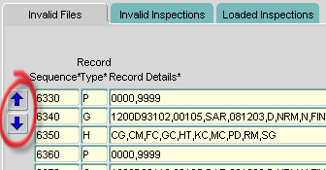

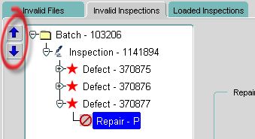

This form can also be run directly from the menu.
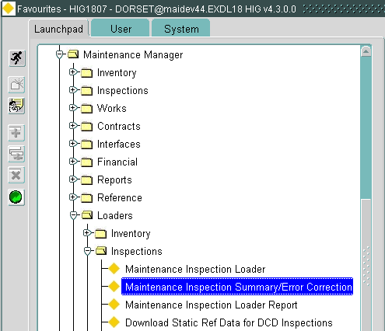

When run from the menu this form can be used to show a summary of Maintenance Inspection Loads.
The User can execute queries in the Load Batches tab in order to view the outcome of any Loads that match the query criteria entered.
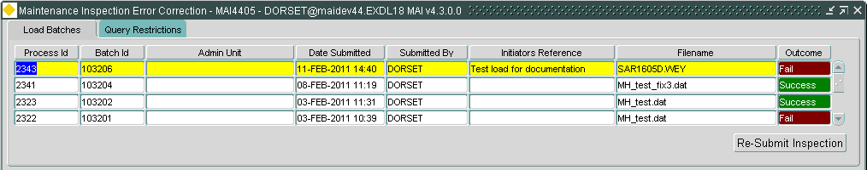
The Query Restrictions tab can be used to further restrict the results of a query.
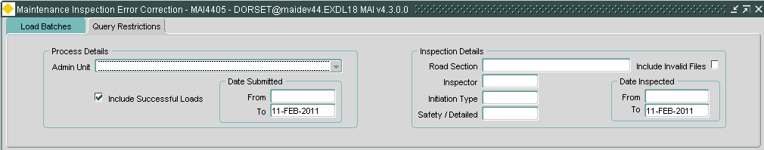

Works Order form – Instruct Works Order (Enhanced)
The Date Instructed field is no longer directly enterable; the Instruct button should be used to instruct a Works Order.
When the User presses the Instruct button they will be prompted to enter the Date Instructed (defaulted to the System Date).

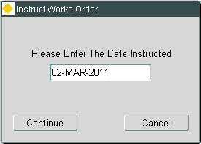

If the Continue button is pressed the Works Order is instructed using the date given, otherwise if the Cancel button is pressed the User is returned to the Works Order details and no changes are made.

Log No. Summary
This chapter summarises all software changes that have been made in this release.

These changes are derived from the following sources,

- Issues raised by Customers via Exor Support
- Issues raised internally by Exor

Issues
Internal  Task ID | Issue | Support  Log(s)
0110751 | Changes have been made to the Works Order form (MAI3800) Instruction process.  At no point is the date instructed field directly enterable, the Instruct button should be used to instruct a Works Order.  When the user presses the instruct button a popup is displayed allowing them to alter the defaulted sysdate, once continue is pressed the WO is instructed using the date given. | 729394  8001014509  8001034336
0110752 | In MAI3807entering a fractional quantity against a BOQ item was causing error indicating Total Quantity was outside range. Fractional quantities are now processed as expected. | 8001019534  8001035278
0110755 | Corrected an issue in which The Maintenance Inspection Loader Error Correction form (MAI4405) raised repeated errors (in an infinite loop) when the Batch is highlighted in the tree and the User pressed the "Re-Submit Inspection" button.  The form now asks the User to select an Inspection to be resubmitted and returns focus to the tree.  Also amended the Loader to produce a more User friendly error message when the Asset Id provided in the load file is invalid. | 8001012703  8001019779
0110786 | Increased Road Description length for Work Order Templates to resolve error when road description was over 80 chars | 8001034321
0110790 | Corrected an issue in the Maintenance Inspection Loader that was leading to:-  1, Defects being incorrectly marked as completed when one or more of their associated Repairs are not complete.  2, Defects being incorrectly marked as not completed when all of their associated Repairs are complete. | 8001026636  8001030125
0110794 | Corrected the calculation of Repair Due Dates to use the Inspection Date rather than the Load Date. | 8001036918
0110802 | Fixed the following problem in the Inspection Form (MAI3808):-  When entering a completion date for a repair in the inspections form, if the completion date is the same as the inspected date, get an error saying you're trying to enter a repair date before the inspected date. | 8001036919

