

Maintenance Manager
Fix Release Notes

4.7.0.0 Fix 5

Table of Contents
1. Introduction 2
2. Fix Details 2
3. List of Amended Files 2
4. MAI3818 Modification 3
5. Log No. Summary 4

Introduction
This document defines the changes made to the Maintenance Manager product for 4.7.0.0 Fix 5 and is specifically targeted at end users.
After reading through this document, should you have any further training or consultancy requirements then please contact your Bentley account manager.

Fix Details
Fix Details Baseline Release | 4.7.0.0
Fix Description | Modification to Work Order Automation to optionally include repairs to a Work Order, where the Repair Due date falls outside the Work Order Automation Rules Validity Period
Prerequisites | None
Implementation Instructions | The staging folder is the location of the folder that exmai04070002en_updt5.zip was extracted to (the folder containing this readme).  - Go to the relevant exor\bin directory on the Oracle Weblogic Server and rename the following files:  mai3818.fmx to mai3818_old.fmx  - Log onto SQL*PLUS as the Highways Owner with the staging folder as the working directory.  At the prompt type "START mai_4700_fix5.sql" and press return.  Exit SQL*PLUS.
Limitations
Configuration Information | None
How To Test | Recommend full regression test
Rollback Strategy | Initially implement on a test environment

List of Amended Files
Filename | Version
mai_wo_api.pkw | 3.37
mai3818.fmx | 5.4

MAI3818 Modification
When identifying Repairs to add to a Work Order, Work Order Automation rules were placing multiple repairs on separate Work Orders, even though Multiple Repairs should appear on the same Work Order. This happened when the repair due dates on each of the repairs fell between different financial years.
The Work Order Automation Rules form (MAI3818) has been modified to allow for either the Repair Due Date (Default) or Inspection Date to be used to identify the repairs to add to a Work Order, by use of a new radio button:
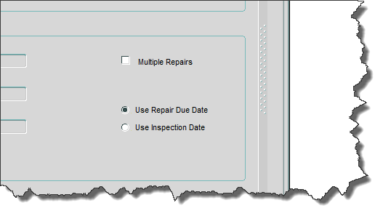

Log No. Summary
This chapter summarises all software issues that have been addressed by this fix.
For issues raised by customers, Bentley Technical Support Group (TSG) Ticket Numbers are cross referenced where applicable.
Details | Internal Reference | TSG Ticket Number
When identifying Repairs to add to a Work Order, Work Order Automation rules were placing multiple repairs on separate Work Orders, even though Multiple Repairs should appear on the same Work Order. This happened when the repair due dates on each of the repairs fell between different financial years. MAI3818 has been modified to specify whether the Repair Due Date or Inspection Date is used to identify the repairs to add  Also, date comparison has been modified to include any Work Orders where the Due Date falls on the last day of the financial year. These were being excluded under certain circumstances | Defect 81845 | SR#7000118268

