Maintenance Manager
Release Notes v4.4.0.0 Fix 3

Introduction
This document defines the changes made to the Maintenance Manager product for fix release v4.4.0.0 Fix 3 and is specifically targeted at end users.

After reading through this document, should you have any further training or consultancy requirements then please contact your Bentley account manager.

Fix Details
Baseline Release | 4.4.0.0
Fix Description | Maintenance Manager 4.4.0.0 Fix 3 Patchset.  When creating new works orders and assigning defects, the front screen is being autopopulated with the target complete date of the repair. This is being done automatically and the target date cannot be overwritten. Customer was able to overwrite this field prior to the upgrade.
Prerequisites
Implementation Instructions | Unzip mai_4400_fix3.zip to a staging folder.  Go to the relevant exor\bin directory on the Oracle Application Server and rename the following files:-  mai3800.fmx to mai3800_old.fmx  Then copy in the new version of this file from the staging folder.  Log onto SQL*PLUS as the Highways Owner with the staging folder as the working directory.  At the prompt type "START log_mai_4400_fix3.sql" and press return.  Exit SQL*PLUS.
Limitations | None known
Configuration Information | None
How To Test | Recommend full regression test
Rollback Strategy | Initially implement on a test environment

List of Amended Files
Filename | Version
log_mai_4400_fix3.sql | 3.0
mai3800.fmb | 4.32.1.0

Log No. Summary
This chapter summarises all software changes that have been made in this release.

These changes are derived from the following sources,

- Issues raised by Customers via Bentley Support
- Issues raised internally by Bentley

Issues
Internal  Task ID | Issue | Support  Log(s)
0111603 | Works Orders form (MAI3800) has been modified to allow for manual input of Work Order target dates, rather than being automatically calculated.  Product option UPDWOTGT has been introduced to allow for the manual update. Setting the product option to 'Y' will allow manual update, otherwise the Work Order target date will be calculated, as specified in the Maintenance Manger Release notes for 4.4.0.0. | 8001212150

Product Option UPDWOTGT
When the product option UPDWOTGT is set to ‘Y’ the Work Order Target date in MAI3800 will not be automatically calculated, based on the Work Order Line target dates and Work Order Priority, but will allow for manual specification.

The Work Order Target date will only be populated if a Work Order Priority is entered. Otherwise, the value will be NULL requiring population before Authorisation or Instruction.

The product option will be initially set to ‘N’.

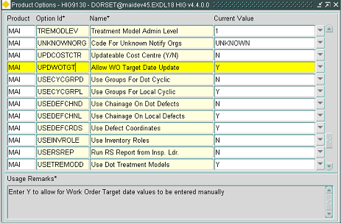

This product option has two values:-

- N = Work Order Target date is automatically populated
- Y = Work Order target date is not populated, and requires manual specification.

