Maintenance Manager
Release Notes v4.6.0.0 Fix 8

Introduction
This document defines the changes made to the Maintenance Manager product for fix release v4.6.0.0 Fix 8 and is specifically targeted at end users.

After reading through this document, should you have any further training or consultancy requirements then please contact your exor account manager.

Fix Details
Baseline Release | 4.6.0.0
Fix Description | New Product Option that determines how Date attributes are exported in the PEDIF file.
Prerequisites | Please apply MAI 4600 Fixes 1, 4, 6 and 7 before applying this fix.
Implementation Instructions | Unzip mai_4600_fix8.zip to a staging folder.  Log onto SQL*PLUS as the Highways Owner with the staging folder as the working directory.  At the prompt type "START mai_4600_fix8.sql" and press return.  Exit SQL*PLUS.
Limitations
Configuration Information | None
How To Test | Recommend full regression test
Rollback Strategy | Initially implement on a test environment

List of Amended Files
Filename | Version
pedif.pkw | 3.7

New Product Option PEDDATEATR
New Y/N Product Option "PEDDATEATR" used to determine how asset type date attributes are exported in the PEDIF file.

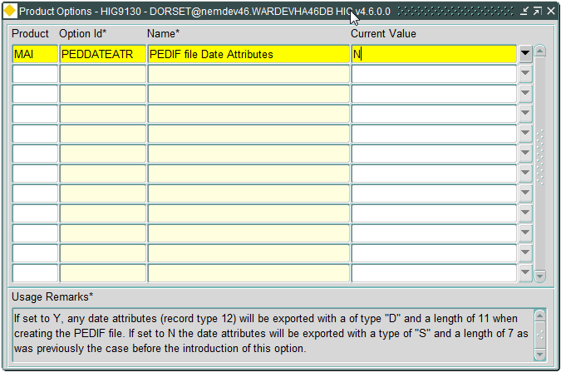

This product option has two values:-

N = Date Attributes are exported as a type “12” record with “S” as the datatype and a length of 7 as was previously the case. This is the Default value.

Y = Date Attributes are exported as a type “12” record with “D” as the datatype and a length of 11.
Log No. Summary
This chapter summarises all software changes that have been made in this release.

These changes are derived from the following sources,

- Issues raised by Customers via Exor Support
- Issues raised internally by Exor

Issues
Internal  Task ID | Issue | Support  Log(s)
D-116399 | Fixed an issue that was leading to duplicated type “5” records and duplicate attribute data on type “6” records when multiple PEDIF files are generated within a single session.
D-115691 | New Y/N Product Option "PEDDATEATR" used to determine how asset type date attributes are exported in the PEDIF file.  If the product option is set to "Y" then any type "12" record for date attribute will contain "D" for the datatype and have a length of 11 otherwise the datatype will be "S" and the length will be 7 as has previously been the case.  The default value for the new product option is "N". | 8001501691

