**cid:image001.png@01D147BB.D301C4E0**



**IAM IS**

**Highways England**

NEM to DCM Interface Deployment Guide

**Version <1.0>**

**Document Version History**

|  |  |  |  |
| --- | --- | --- | --- |
| **Version** | **Update Source** | **Date** | **Description** |
| 1.0 | Peter Bibby | 22-Sep-2016 | Initial draft. |
|  |  |  |  |
|  |  |  |  |
|  |  |  |  |
|  |  |  |  |
|  |  |  |  |
|  |  |  |  |
| **For review** | | | **For approval** |
|  | | |  |

Document last saved on 23-Sep-2016 12:04 PM

**Table of Contents**

1 Introduction 4

1.1 Prerequisites 4

2 Database Install 5

3 Configuration 6

3.1 Product Options **Error! Bookmark not defined.**

3.2 Directory 6

3.3 FTP Connection 6

3.4 Process Framework 7



# Introduction

As part of the IAMIS Managed Service an interface that allows a Delay Cost model calculation to be performed on a Network Event and the subsequent results to be visible inside the NEM application is required.

For details of the solution agreed with Highways England please refer to the document entitled “HE-DCM_Interface_Specification”

The purpose of this document is to provide instructions on how to deploy the Interface and some guidance on how to configure it.

## Prerequisites

This version of the DCM Interface has been developed to run against the 4.7.2.5 (or higher) release of Network Event Manager which should be installed and configured before following the instructions given in this document.

# Database Install

This section gives details of how to create the required objects on the exor database.

1. Unzip the exnem_dcm_Interface04070201en.zip file to a staging folder on the Database Server.
2. Start a SQL*Plus session logged in as the Highways Table Owner with the working directory set to the staging folder created in step 1.
3. Type “start install.sql” and press enter.
4. Type “start nem_dcm_interface.pkh” and press enter.
5. Type “start nem_dcm_interface.pkw” and press enter.
6. Type “start nem_dcm_actions.pkh” and press enter.
7. Type “start nem_dcm_actions.pkw” and press enter.
8. Type “start nm_inv_items_all_dcm.trg” and press enter
9. Log out of SQL*Plus.
10. Delete the staging folder created in step 1 as it is no longer needed.

# Configuration

## Directory

Two Oracle Directories needs to be setup for the Interface files to be written to, to do this create directories on the Database server then update the path for “NEM_DCM_EXPORT” and “NEM_DCM_RESULTS”, created during the install, in the Directories form (HIG1895) in the exor application.



## FTP Connection

To configure the FTP connection that should be used by the interface enter the details of the FTP Site and the folder details for both the newly created FTP types in the FTP Connections (HIG0200) form in the exor application.

These details should be entered under the “NEM_DCM_RESULTS_FILE” and “NEM_DCM_EXPORT_FILE” FTP Type that is created as part of the install.

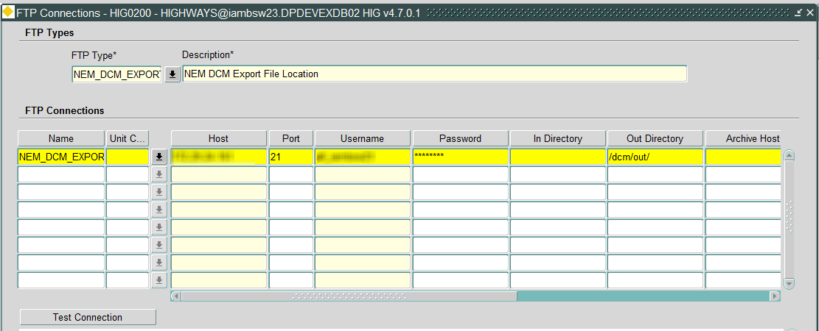



## Process Framework

This interface has been written to run under the exor Process Framework, two Process Types are created as part of the Install:

* NEM DCM Export
* NEM DCM Results File Loader

Both the processes are intended to be run on a scheduled basis under the Process Framework so as part of the deployment a job should be submitted as the Highways Owner using the Submit a Process form (HIG2510) in the exor application:

1. Select the “NEM DCM Export” from the list of Process Types and click on Next.

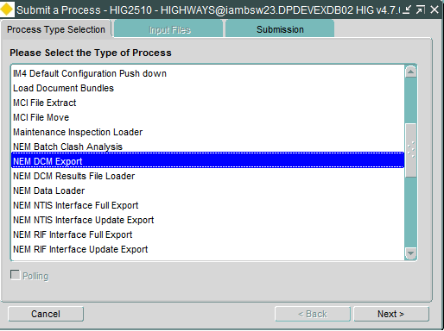

1. Select the required frequency (to be agreed with Highways England) and click on Finish.

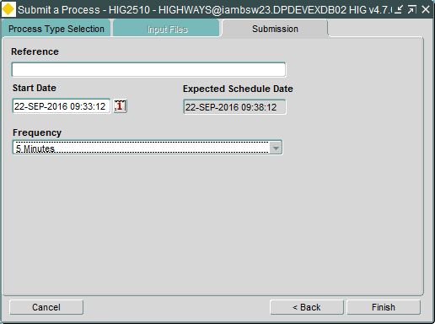

1. The process will be created, click on Exit in the confirmation dialog to complete this part of the configuration, the submitted process can be monitored in the Process Monitor form (HIG2520) in the exor application.

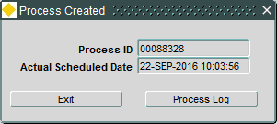

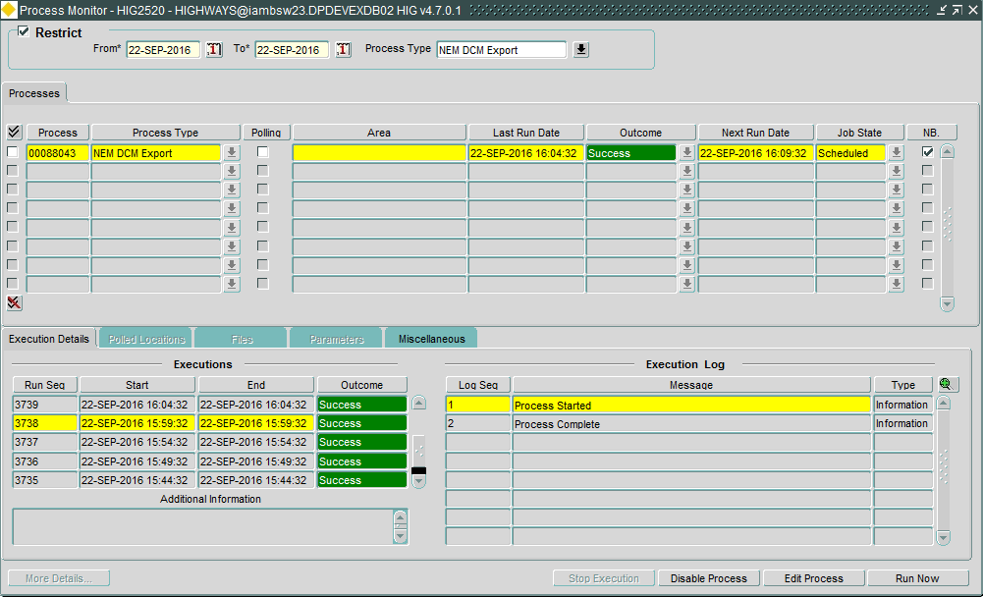

The same steps as above will need to be followed for the second process “NEM DCM Results File Loader”.