**cid:image001.png@01D147BB.D301C4E0**



**IAM IS**

**Highways England**

NEM to RIF Interface Deployment Guide

**Version <1.0>**

**Document Version History**

|  |  |  |  |
| --- | --- | --- | --- |
| **Version** | **Update Source** | **Date** | **Description** |
| 1.0 | Mike Huitson | 22-Nov-2016 | Initial version. |
|  |  |  |  |
|  |  |  |  |
|  |  |  |  |
|  |  |  |  |
|  |  |  |  |
|  |  |  |  |
| **For review** | | | **For approval** |
|  | | |  |

Document last saved on 22-Nov-2016 3:44 PM

**Table of Contents**

1 Introduction 4

1.1 Prerequisites 4

2 Database Install 5

3 Configuration 6

3.1 Product Options 6

3.2 Directory 7

3.3 FTP Connection 8

3.4 Process Framework 8



# Introduction

As part of the IAMIS Managed Service an interface from the Network Occupancy Management System (NOMS) providing an extract of Network Event data for supply to the Performance Assessment Unit (PAU) systems is required.

For details of the solution agreed with Highways England please refer to the document entitled “Initial Asset & NOMS National Stage - NEM to RIF/PAU Interface Specification”

The purpose of this document is to provide instructions on how to deploy the Interface and some guidance on how to configure it.

## Prerequisites

This version of the RIF Interface has been developed to run against the 4.7.2.5 (or higher) release of Network Event Manager which should be installed and configured before following the instructions given in this document.

# Database Install

This section gives details of how to create the required objects on the exor database.

1. Unzip the exNEM_RIF_Interface04070201en.zip file to a staging folder on the Database Server.
2. Start a SQL*Plus session logged in as the Highways Table Owner with the working directory set to the staging folder created in step 1.
3. Type “start install.sql” and press enter.
4. Type “start nem_rif_interface.pkh” and press enter.
5. Type “start nem_rif_interface.pkw” and press enter.
6. Log out of SQL*Plus.
7. Delete the staging folder created in step 1 as it is no longer needed.

# Configuration

## Product Options

A number of product options are created during the deployment of the interface and can be used to modify its behavior.

The values set during deployment are those agreed with Highways England at the time of publication, however they can be modified as required using the exor Product Options form (HIG9130):

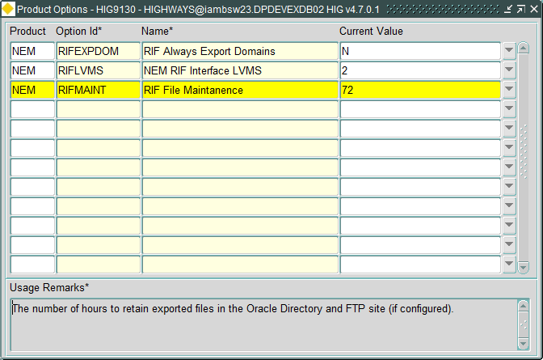

| Option Id | Description | Default Value |
| --- | --- | --- |
| RIFLVMS | The Location Viewing Methods (LVMs) to be used when exporting Event Impacted Network locations. This can be a comma separated list of one or more LVM IDs. See the Network Event Manager Admin guide for more detail on LVMs | 2 (Maintenance Sections) |
| RIFMAINT | The number of hours to retain exported files in the Oracle Directory and FTP site (if configured). | 72 |
| RIFEXPDOM | Export the Domains file every time a Full Export or Update file is produced. | N |

## Directory

An Oracle Directory needs to be setup for the Interface files to be written to, to do this create a directory on the Database server then update the path for “NEM_RIF_OUT_DIRECTORY”, created during the install, in the Directories form (HIG1895) in the exor application.

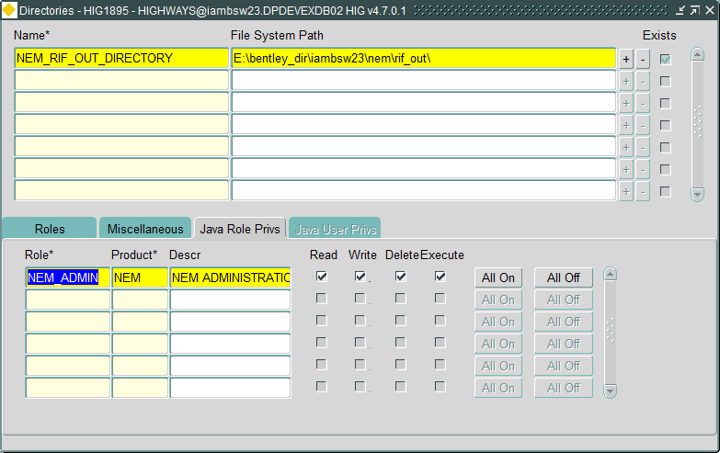

## FTP Connection

To configure the FTP connection that should be used by the interface enter the details of the FTP Site and the folder that the files should be written to (Out Directory) in the FTP Connections (HIG0200) form in the exor application.

These details should be entered under the “NEM_RIF_OUT” FTP Type that is created as part of the install.

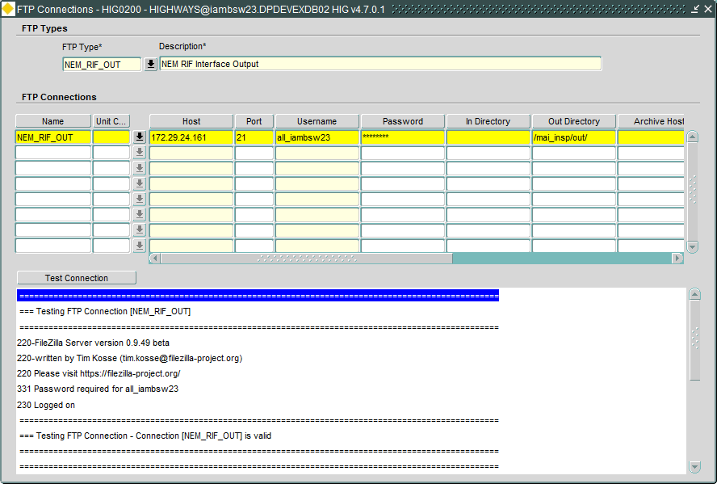

## Process Framework

This interface has been written to run under the exor Process Framework, three Process Types are created as part of the Install:

* NEM RIF Interface Full Export
* NEM RIF Interface Update Export
* NEM RIF Interface Domain Export

The “NEM NTIS Interface Full Export” and “NEM RIF Interface Domain Export” Process Types are intended to be manually executed by an Administrator as and when required by the PAU/RIF systems, by default they are restricted to users with the NEM_ADMIN role so unless Highways England require a different role to be allowed to execute it no further configuration should be required for this Process Type.

The “NEM RIF Interface Update Export” is intended to be run on a scheduled basis under the Process Framework so as part of the deployment a job should be submitted as the Highways Owner using the Submit a Process form (HIG2510) in the exor application:

1. Select the “NEM RIF Interface Update Export” from the list of Process Types and click on Next.

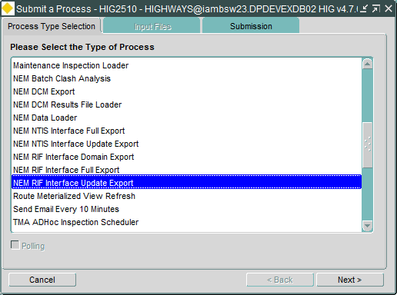

1. Select the required frequency (to be agreed with Highways England) and click on Finish.

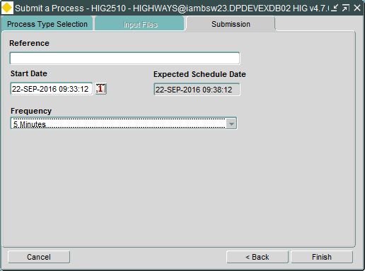

1. The process will be created, click on Exit in the confirmation dialog to complete this part of the configuration, the submitted process can be monitored in the Process Monitor form (HIG2520) in the exor application.

