This informal document is intended to clarify how we imagine the node intersection logic to function.

CHANGE ONLY NO_NAME FIELD!

In nm_nodes_all we have 2 fields of interest, no_node_name and no_purpose

Joe’s understanding of the last meeting is that would use no_node_name to indicate which items were part of a specific intersection. This column would have 2 possible values:

1. I[Intersection ID]-[no_node_number]
   1. Where intersection id and no_node_numbers are numbers
2. As is gets populated now, with the node number

If this column gets an intersection ID this is determined by an after insert trigger that looks at the no_purpose column.

The no_purpose column is the one that the user interacts with. If the column contains (and these values have not been agreed on or discussed in detail) the value: INA (for intersection Not Assigned) the trigger well ignore it until an intersection ID is assigned. If the Column Contains: I[Intersection ID] then the trigger is fired to update the no_node_name field. If the column was changed but does not contain INA or I[Intersection ID] then the trigger will see if no_node_name has I[Intersection ID] and change it if necessary.

Assigning of Intersection IDs can be done manually in network manager (form NM0101) or in spatial manager.

This can be done using the general methods in Spatial manager or a new execute command can be created for assigning new intersection IDs:

This is best done but creating a new Exor theme ‘Node New Intersection Assign’. This Theme would have an oracle procedure attached to it. When Ran this procedure would take the selected Nodes and assign a new Intersection ID to them. If a node contained an intersection ID, or the node was not marked INA, then we would have to decide what we wanted to happen.

The general work flow for this would be:

1. Turn on the node layer with the procedure attached
   1. In this case z_node_exe_test_theme_1
      1. 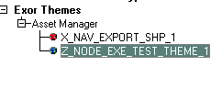
2. Select the Intersection Nodes Using the select Exor Features Tool
   1. 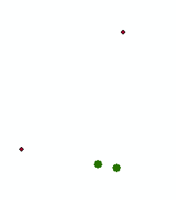
3. On the exor Groups tab right click on the Theme and select Execute
   1. 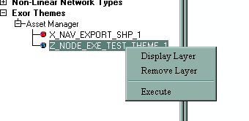
4. A window will pop up allowing the user to pick a procedure
   1. 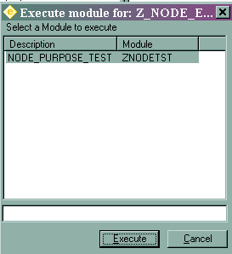
5. Once Execute is ran, the procedure will be ran on the selected Nodes.