附件4-6：外文翻译
华南理工大学广州学院
本科毕业设计（论文）外文翻译

外文原文名 Design of DC Motor Speed Regulation System Based on ARM

中文译名 基于ARM的直流电机调速系统设计

学 院 计算机工程学院
专业班级 16级计算机科学与技术4班
学生姓名 关嘉道
学生学号 201610089175
指导教师 卢 珍
填写日期 2019.12.25

外文原文版出处：He Chun-hong. Design of DC Motor Speed Regulation System Based on ARM[C].Proceedings of the 2018 2nd International Workshop on Renewable Energy and Development (IWRED 2018).

译文成绩： 指导教师（导师组长）签名： 卢珍

译文：
基于ARM的直流电机调速系统设计
摘要:本文主要研究基于ARM的直流电机转速控制系统的设计。利用STM32单片机设计了相应的硬件外围电路，并对单片机进行了编程，用硬件电路实现了相应的功能。采用速度闭环PID控制算法，可以调整直流电机的转速，改善电机的动态特性。实际运行结果表明，本课题的设计是满足电机控制的要求，如启动与停止、正反转、加减速、无稳态误差。

1.介绍
近年来，直流电机的调速越来越智能化、全数字化、高度集成。与由模拟离散元件组成的控制系统相比，采用微控制器的直流电机速度控制系统具有许多优点。例如微控制器的控制方式更加灵活，可以通过软件控制的方式快速改变控制方式。而且微控制器内部处理的信号是数字信号，因此其抗干扰能力、控制精度、速度、可靠性和稳定性比模拟速度控制系统要好得多。
为了满足系统对直流电机快速响应和速度精度的要求，本文主要研究了微处理器用PID控制算法来控制电机转速。

2.有刷直流电机的工作原理及控制方法
2.1有刷直流电机工作原理及调速方法
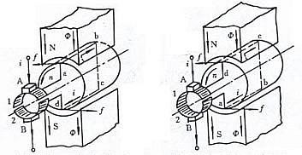

- (b)
图1直流电动机工作原理

如图1所示(a),直流电源的电流流入刷A .自刷和整流板1相互接触,整流板2的电流通过线圈abcd整流板1、2联系,最后从电刷B流出。从电磁感应定律可以看出，线圈一侧的导体ab和导体cd会受到电磁力和方向的影响,电磁力的大小可以用左手定则来判断。导体两端的力形成一个逆时针的扭矩，使电机的转子逆时针旋转。
虽然电源是直流电，但由于电刷和换相的相互作用，电机线圈中的电流是交替的。通电线圈在磁场中产生的转矩方向不变，将电机旋转到给定的旋转方向。

电机电压平衡方程 : 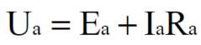 （1）
电枢绕组中的反电动势: 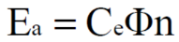 （2）
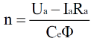
电机转速计算公式： （3）

n:电机转速，单位:r/min; Ua:电机电枢供电电压，单位:V; A:电枢电流，单位:A; Ra: 电枢的内阻,单位:Ω; Ce:电机电动势常数; Φ:电动机磁通,单位:Wb。

2.2 PID控制器设计

2.2.1 PID控制原理
本文通过软件编程实现PID控制器的控制算法，传统的模拟控制器必须离散化。因此，我们需要用离散差分方程来代替连续微分方程。假设采样时间短，可以用一阶差分代替一阶微分，用累加代替积分。
PID参数的主要作用如下:
(1) Kp:比例参数的作用是加快系统响应速度，提高系统调节精度。
(2) Ki:积分参数Ki的作用是消除系统的稳态误差。Ki的值越大，系统的静态错误消除得越快。Ki值需要根据实际系统调试，直到达到满意的控制效果。
(3) Kd:微分参数的作用是提高系统的动态性能。如果Kd值过大，将提前停止响应过程，这将导致响应时间延迟
延长了系统的调整时间，降低了系统的抗干扰性能。
总之，在调整PID参数时，要注意各个参数在系统响应过程中的作用以及它们之间的内在关系，在实际应用中根据实际系统进行不断的调试和验证，最终才能满足控制效果。

2.2.2抗积分饱和PID控制器设计
由于PID控制器的积分功能，当系统在一个方向上发生偏差时，PID控制器的输出将继续增大，使电机转速达到极限值。如果控制器的输出继续增加，且电机的转速已达到极限，不随控制器的输出增加而增加，则控制器的输出进入饱和区。然后，如果系统出现相反方向的偏差，控制器的输出将逐渐退出饱和区。控制器的输出进入饱和区越深，退出饱和区的时间越长。制动器(电机)的输出不会立即产生相应的变化与反向偏差，使系统控制性能恶化，这是积分饱和的现象。本设计采用反积分PID控制算法。

3.硬件电路设计

3.1硬件电路设计总体框图
系统整体硬件电路设计如图2所示，主要由电源电路、液晶电路、电机驱动电路、下载调试电路、编码器速度电路组成。
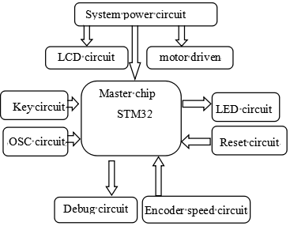

图2系统硬件设计示意图

3.2系统模块电路设计

3.2.1主芯片选择
本项目使用的主芯片为STM32F103RCT6。该芯片的功能包括:2个基本定时器，256KB FLASH, 4个通用定时器，2个DMA控制器，2个高级定时器，3个SPIs, 5个串口，1个12位DAC, 3个12位adc, 51个通用IO端口，1个SDIO接口。

3.2.2晶体及复位电路设计
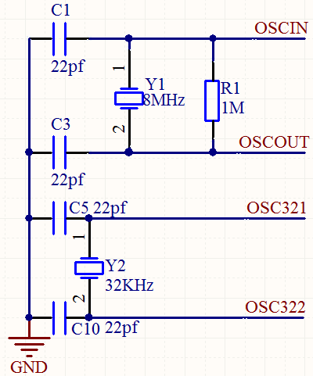
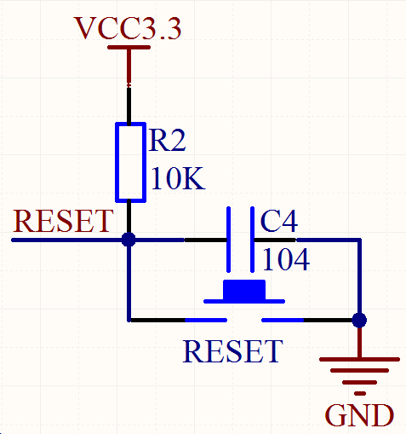

图3晶体振荡电路 图4复位电路
本设计的系统晶体振荡器电路如图3所示，主频率晶体振荡器用8M，用C1、C2和一个并联的1M电阻为系统提供一个稳定的时钟源。时钟采用32.678KHZ晶体振荡器，主要用于定时、系统待机或低功耗。

图4是系统复位电路, 系统刚上电时，电源VCC3.3通过电阻R2向电容C4充电，RESET点处的电压逐渐升高，直到电压达到芯片工作电压为止，系统复位，系统开始执行程序 ，此后RESET点的电压继续上升，直到3.3V。当复位按钮被按下时，RESET点电位降低，电容C4也释放储存的电荷，然后释放复位按钮，C4充电，RESET点逐渐增加到3.3V，系统手动复位完成。

3.2.3系统电源电路设计

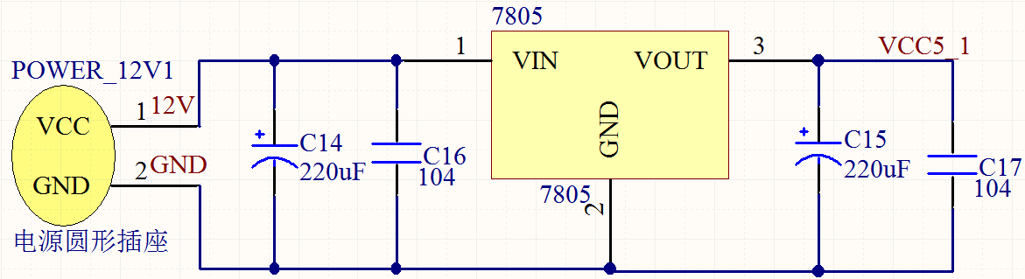

图5 12V至5V电路

在图5的电路中，12V电源来自电源适配器。12V电源除了为电机驱动电路供电外，还利用LM7805稳压芯片将12V电压降至5V，为系统中的其他电路模块供电。铝电解电容C14、C15、陶瓷电容C16、C17主要作用是降低电源纹波，滤除杂波，为系统提供更优质的电源。
在图6的电路中，5V电源主要来自于USB接口电源，12V后转换为5V。系统切换后，使用AMS1117-3.3稳压芯片和系统其他电路模块将5V电源降至3.3V电源。铝电解电容C19、C21、陶瓷电容C20、C22的作用与上述铝电解电容和陶瓷电容的作用一致，都是为系统提供更高质量的电源。

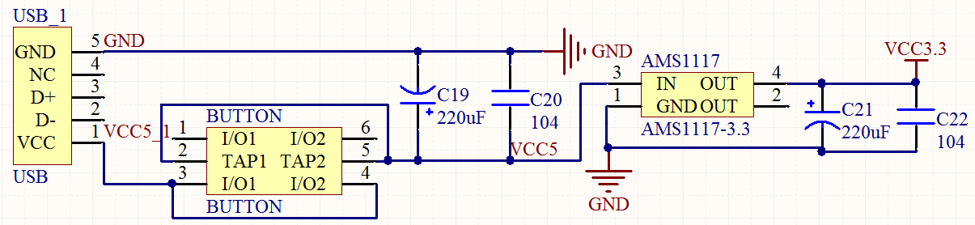

图6 5V至3.3 v电路
3.2.4编码器电路设计
图7是编码器的电路板接口电路，通过引脚将STM32F103RCT6编码器接口对应的IO端口引出。假设的两个输入信号频道编码器TI1 TI2, 分别启动计数器，并通过每个TI1或TI2上的有效转换驱动计数器，根据两个输入信号信号的转换顺序生成计数脉冲和方向。根据两个输入信号的顺序，计数器可以向上或向下计数。同时，硬件在TIM_CR1寄存器中设置DIR位。当编码器的输入信号路径改变时，DIR位将被重新计算。
为了提高编码器的精度，可以采用编码器软件4倍频的技术，使编码器的精度提高4倍。图8是软件4倍频率技术的简单示意图。
通常情况下，我们使用M方法的速度，仅通过测量每单位时间A相的输出脉冲数来获取速度信息。 根据常规方法，仅测量A相（或B相）的上升沿或下降沿，对应于图3中的数字1234中的任何一个。 因此，在图10所示的测量周期中，如图10所示。 而软件的4x频率方法是测量A和B相位编码器的上升沿和下降沿，因此在图10所示的测量周期内，您可以计数12次，这是软件4倍频率的基本原理。
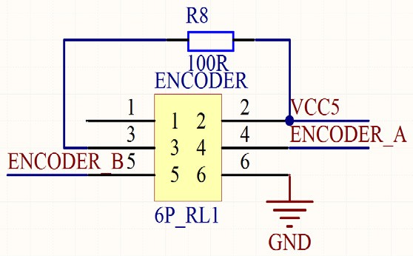
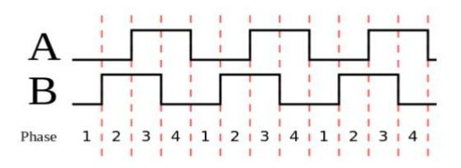

图7编码器接口电路 软件4倍频图
3.2.5电机驱动电路设计
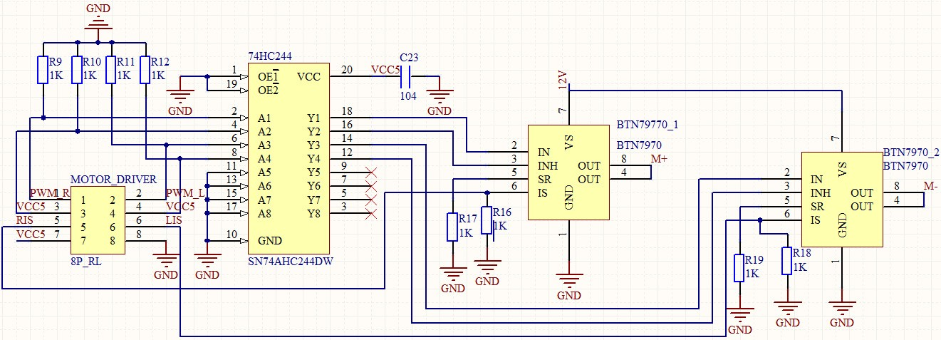

图9电机驱动电路
驱动电路主要由一个74HC244芯片和两个BTN7970芯片组成，两个BTN7970驱动芯片分别控制电机的正反转。设计电路中的R9、R10、R11、R12为下拉电阻，保证输入74HC244电平稳定。当存在不确定的电平时，该电平被拉低。

4.软件编程

4.1系统初始化
软件部分的设计框图如图10所示。系统开机后，程序开始初始化系统中的各个模块。对于设计,模块初始化:系统时钟,USART波特率,LED灯,PID控制器,tft - lcd液晶显示器、外部中断,PWM输出,计时器和编码器接口, 在此过程中，实现了每个模块参数的初始设置，并完成了系统分配任务。

4.2速度设定
齿轮分为10档，每档速度增加1 r / min，最小为0 r / min，最大为10 r / min。当按下加(减)速按钮时，速度设定值将在当前基础上加减当前齿轮值。齿轮设定的主要功能是方便快速的加减速度。如果没有齿轮设定功能，加减速需要多次按下加减速键。如果将每次按键的增加（减少）值设置为Setting（设置），则无法在电动机速度范围内进行任何速度调节。

4.3编码器速度
编码器速度由主芯片编码器接口电路来完成，STM32自带编码器接口电路，经过一定的配置，利用这个功能可以很容易地测量电机转速。
用于计算速度设计的方法为M方法。在这个设计中,电机旋转一圈，霍尔编码器输出脉冲为390，经过软件乘法器4，实际测得脉冲数为1560，系统采样周期为100ms，在两次测量之前和之后设置TIM-> CNT的值之差为ΔCNT，计算M方法速度公式为：


将此值与设置的速度值进行比较，得到速度偏差，将偏差发送到PID控制器进行适当的处理。

4.4 PID控制算法设计
本设计的PID控制采用位置控制算法，采样周期为100ms。PID位置控制算法公式为:

控制器对偏差进行处理后，根据正反转的控制要求，将得到的值分配给不同的PWM通道。在本设计中，两个PWM通道分别是通道1和计时器1的通道4, 通过更改TIM1-> CCR1或TIM1-> CCR4的值可以更改相应通道输出PWM的占空比，从而达到控制电机转速和速度的目的。

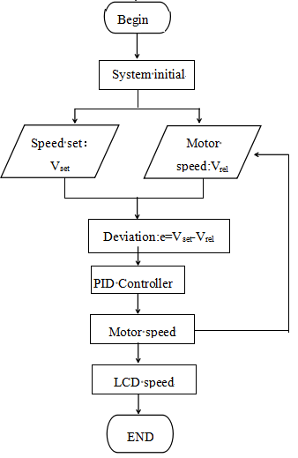

图10软件设计流程图

5.系统参数调试及结果分析
本设计采用的电机为有刷直流齿轮电机，减速比为30，额定电压为12V，额定电流360mA，功率4.32W，空载转速366RPM，原转速为11000RPM，额定转矩1kgf.cm

5.1 PID参数调整步骤
PID参数调节的基本步骤:
(1)确定比例参数Kp:令Ti和Td为0，则PID为纯比例调节。从0开始逐渐增大Kp，直到系统振荡，然后从此时的Kp逐渐减小Kp，直到系统振荡消失。记录Kp，完成比例系数的调整。
(2)确定积分时间常数Ti:在确定比例系数后，设置较大的积分时间常数Ti的初值，然后逐渐减小Ti的值，直到系统振荡，并逐渐增加，从这个值增大Ti值，直到系统振荡消失。完成积分时间常数Ti的调试。
(3)确定微分时间常数Td:微分时间常数一般为0。如果要设置，则使用上述确定比例参数和积分时间常数的方法，在无振荡时取该值的30％。
5.2 PID参数的确定

5.2.1比例参数Kp的确定:
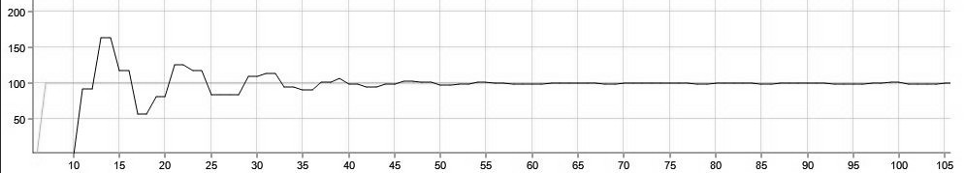
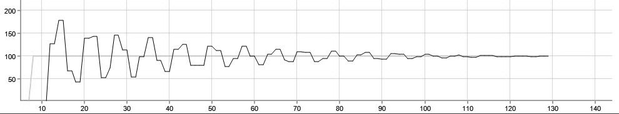

图.11 Kp=300,Ki=0,Kd=0 图.12 Kp=400,Ki=0,Kd=0
从图11到图13可以看出，当KP = 450时系统振荡;当Kp = 400时，系统收敛，但需要很长时间才能使系统稳定在设定值附近;当Kp =300，系统收敛，使系统稳定在设定值所需的较短时间内，Kp值可以加快调整速度，Kp=300也可以满足调整时间的要求，所以取Kp=300, Kp调试完成。
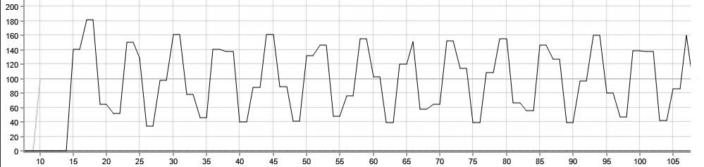

图.13 Kp = 450, Ki=0,Kd=0
5.2.2积分参数Ki的确定
从图14到图16可以看出，当积分系数较大时，系统响应曲线超调量也较大，响应曲线达到稳态值所需时间也较长。最后，Ki的这三个值最终可以使系统达到控制要求而无稳态误差，考虑超调和调整时间，取Ki的值为1。

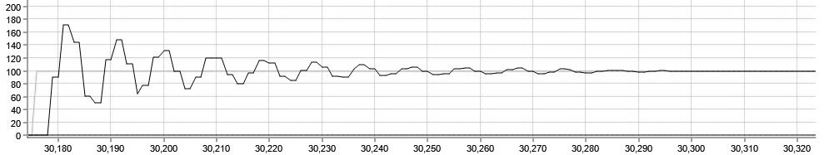
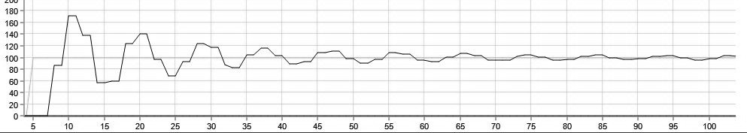

图14 Kp=300, Ki=20, Kd=0 图15 Kp =300 Ki=10 Kd=0

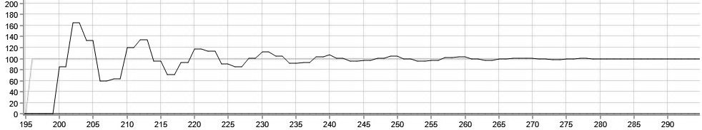

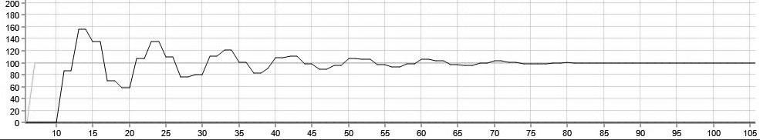
图16 Kp=300, Ki=1, Kd=0 图17 Kp=300 Ki=1 Kd=0.5

5.2.3微分参数Kd的确定
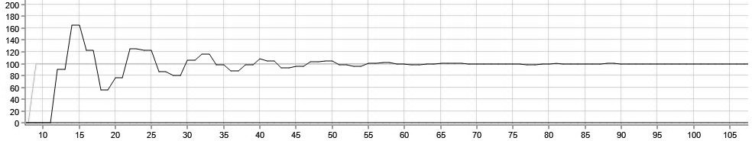
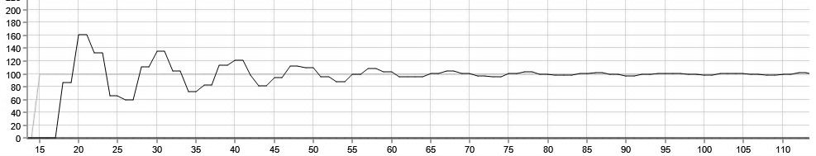

图18 Kp=300, Ki=1, Kd=1.5 图19 Kp = 300, Ki = 1, Kd = 10
从图17到图19可以看出，当Kd值较小时，微分作用较弱，看不到微分分量的差异，Kd值逐渐增大。当Kd = 1.5时，微分分量对系统调节时间的作用变小。Kd值继续增加到10和30，可以看出系统调整时间变长，系统动态性能恶化。

6.结论
通过观察系统的实际运行情况，本设计可以实现对电机的正向、反向、启动、停止、无稳态误差控制的要求。同时通过液晶显示屏了解电机转速设定值、实际值、电机转速状态和转速曲线等信息，可以非常直观地了解电机的实时运行信息。

参考文献
[1] Qiu Tie. ARM embedded system architecture and programming. Beijing: Tsinghua University
Press, 2013
[2] Song Yue. Single-chip microcomputer principle and interface technology. Beijing: Electronic
Industry Press, 2015.8
[3] Chen L., Yan Zhian, Liu Xinzheng. Control motor. Xi'an:Xidian University Press, 2013.4
[4] Ruan Yi, Chen Bo Shi. Electric Drive Automatic Control System: Motion Control System. Beijing: Mechanical Industry Press, 2009.8
[5] Gu Shengu. Motor and drag on the book. Beijing: Mechanical Industry Press, 2007.10

原文：
Design of DC Motor Speed Regulation System Based on ARM

He Chun-hong1, Ren Bin2*
1Research and Development Department, Guangdong somens Technology Group Co., Ltd, Dongguan, China
2School of Electronic Engineering and Intelligent, Dongguan University of
Technology Dongguan, China

*Corresponding author, Email: renbin@dgut.edu.cn

Abstract：This paper mainly studies the design of DC motor speed control system based on ARM. The STM32 micro controller is used to design the corresponding hardware peripheral circuit, and the microcontroller programming, with the hardware circuit to achieve the corresponding function. Using the speed closed-loop PID control algorithm, the speed of the DC motor can be adjusted to improve the dynamic characteristics of the motor. The actual operation results show that the design of this topic is to meet the requirements of the control of the motor, such as start and stop, forward and reverse, acceleration and deceleration, and no steady state error.

1. Introduction
In recent years，the adjustment of the speed of the DC motor is more and more towards intelligent,
fully digital, highly integrated direction. Compared with the control system composed of analog discrete components, there are many advantages of the DC motor speed control system using micro controllers. For example, the control method of the micro controller is more flexible, and the way of software control can be used to quickly change the control mode. Moreover, Micro controller internal processing signal is a digital signal, so its anti-interference ability, the control accuracy, speed, reliability and stability than the analog speed control system is much better.
In order to meet the requirements of the system for the rapid response and speed accuracy of DC motor, this paper mainly studies the micro processor with PID control algorithm to control the motor speed.

2. Brushed DC motor working principle and control methods

2.1 Brushed DC motor working principle and speed control method

(a) (b) Fig.1 DC motor working principle
As shown in FIG. 1 (a), the current of the DC power source flows in from the brush A. Since the brush A and the commutation plate 1 are in contact with each other, the current flows from the commutation plate 2 through the coil abcd of the commutation plate 1, 2 contact, the last current from the brush B outflow. We can see from the law of electromagnetic induction that the conductor ab and the conductor cd on one side of the coil will be affected by the electromagnetic force and the direction
of the electromagnetic force can be judged by the left hand rule. The force on both ends of the
conductor forms a counterclockwise torque, causing the motor's rotor to rotate counterclockwise.
Although the power supply is a direct current power supply, the current flowing in the motor coil is alternating due to the interaction between the brush and the commutation. The direction of the torque generated by the energized coil in the magnetic field is invariable, Rotate the motor in the given direction of rotation.
The voltage balance equation by the motor： （1）
Back EMF in armature windings： （2）
Know the motor speed calculation formula： （3）

n:motor speed,unit:r / min; Ua: motor armature power supply voltage,unit:V; Ia: armature current, unit: A; Ra: internal resistance of the armature,unit: Ω ; Ce: motor electromotive force constant; Φ : Motor flux, ,unit: Wb.

2.2 PID controller design

2.2.1 PID control principle
In this paper, the PID controller is programmed by software to realize its control algorithm, so the traditional analog controller must be discretized. Therefore, we need to use discrete difference equations instead of continuous differential equations. Assuming a short sampling time, you can use first-order differences instead of first-order differentials and accumulate instead of integrals.
The main role of PID parameters are as follows:
(1) Kp: The role of the ratio parameter is to speed up the system response speed and improve the system regulation accuracy.
(2) Ki: The integral parameter Ki's role is to eliminate the system's steady-state error. The larger the value of Ki, the faster the system's static error will be removed. Ki values need to be based on the actual system debugging, until it reaches a satisfactory control effect.
(3) Kd: The function of the differential parameter is to improve the dynamic performance of the system. If the Kd value is too large, the response process will be braked in advance, which will
prolong the adjustment time of the system and reduce the anti-interference performance of the system.
In short, the adjustment of PID parameters, we should pay attention to the role of each parameter in the system response process and the inherent relationship between them, in practical applications based on the actual system for continuous debugging and verification, and ultimately can be satisfied with the control effect.
2.2.2 anti-integral saturation PID controller design
Due to the integral function of the PID controller, when the system has a deviation in one direction, the PID controller output will continue to increase, causing the motor speed to reach the limit value. If the output of the controller continues to increase, and the motor Of the speed has reached the limit, does not increase with the controller output increases, then the controller output into the saturation zone. Afterwards, if the system shows the deviation in the opposite direction, the output of the controller will gradually exit the saturation area. The deeper the output of the controller enters the saturation area, the longer it takes to exit the saturation area. , The actuator (motor) output does not produce the corresponding change immediately with the reverse deviation, so that the system control performance deterioration, which is the phenomenon of integral saturation. This design uses anti-integral PID control algorithm.

3. Hardware circuit design

3.1 Hardware Circuit Design overall block diagram
The system overall hardware circuit design shown in Figure 2, mainly by the power circuit, liquid crystal circuits, motor drive circuit, download debug circuit, encoder speed circuit built.

Fig.2 System hardware design diagram

3.2 system module circuit design

3.2.1 master chip selection
The main chip used in this project is STM32F103RCT6. The functions of this chip include: 2 basic timers, 256KB FLASH, 4 general purpose timers, 2 DMA controllers, 2 advanced timers, 3 SPIs , Five serial ports, one 12-bit DAC, three 12-bit ADCs, 51 general purpose IO ports, and an SDIO interface.

3.2.2 Crystal and Reset Circuit Design

Fig.3 Crystal oscillator circuit FIg.4 Reset Circuit
This design of the system crystal oscillator circuit shown in Figure 3, the main frequency crystal oscillator with 8M quartz, with C1, C2 and a parallel 1M resistor for the system to provide a stable clock source. Clock using 32.678KHZ crystal oscillator, mainly for timing, the system standby or low power consumption.
Figure 4 is the system reset circuit, the system just power-up, the power VCC3.3 through the resistor R2 to the capacitor C4 charge, the voltage at the RESET point gradually increased until the voltage reaches the chip high low, the system reset , The system began to implement the program, after which the voltage at the RESET point continued to rise until about 3.3V. When the reset button is pressed RESET, the potential of the RESET point goes low, the capacitor C4 also releases the stored charge, then release the reset button, the C4 is recharged, the RESET point gradually increases to 3.3V, and the system finishes manually Reset.

3.2.3 system power supply circuit design

Power circular socket
Fig.5 12V to 5V circuit

In the circuit of Fig. 5, the 12V power supply comes from the power adapter. In addition to the power supply to the motor drive circuit, the 12V power supply utilizes the LM7805 voltage regulator chip to reduce the 12V voltage to 5V to supply other circuit modules in the system. Aluminum electrolytic capacitors C14, C15, ceramic capacitors C16, C17 main role to reduce the power supply ripple and filter out the power clutter for the system to provide a more high-quality power supply.
In the circuit of Fig. 6, 5V power mainly comes from the USB interface power supply and the power that is converted to 5V after 12V. After the system switch, the 5V power supply is stepped down to 3.3V power supply by using the AMS1117-3.3 voltage regulator chip and the system Other circuit modules to use. Aluminum electrolytic capacitors C19, C21, ceramic capacitors C20, C22 role and the aforementioned aluminum electrolytic capacitors and ceramic capacitors consistent role, are designed to provide higher quality system power supply.

Fig.6 5V to3.3V circuit
3.2.4 Encoder circuit design
Figure 7 is the circuit board encoder interface circuit, through the pin will STM32F103RCT6 encoder interface corresponding IO port leads. Assuming that the two input signal channels of the encoder are TI1 and TI2, respectively, the counter has been started and the counter is driven by a valid transition on each TI1 or TI2, the count pulse and direction are generated according to the transition order of the two input signals signal. According to the order of the two input signals, the counter counts up or down. At the same time, the hardware sets the DIR bit in the TIM_CR1 register. The DIR bit will be
recalculated when the input signal path of the encoder changes.
In order to improve the accuracy of the encoder, you can use encoder software 4 times frequency technology, the encoder accuracy of 4 times. Figure 8 is a simple schematic of the software 4x frequency technique.
Under normal circumstances we use M method speed, only by measuring the number of output pulses per unit time A phase to get speed information. According to the conventional method, only the rising edge or the falling edge of the A phase (or B phase) is measured, corresponding to any one of the numbers 1234 in FIG. 10, so that in the measurement cycle shown in FIG. 8, , And the software 4x frequency method is to measure the A and B phase encoder rising and falling edge, so that in the
measurement period shown in Figure 10, you can count 12 times, this is the software 4 times the frequency Fundamental.

Fig.7 Encoder interface circuit Fig.8 Software 4 times frequency diagram
3.2.5 motor drive circuit design

Fig.9 Motor drive circuit
The driver circuit mainly consists of a 74HC244 chip and two BTN7970 chip set up, two BTN7970 driver chip respectively control the motor forward and reverse. The R9, R10, R11 and R12 in the design circuit are pull-down resistors, ensuring the input 74HC244 level is stable. When there is an indefinite level, the level is pulled low.

4. software programming

4.1 system initialization
The design of the software part of the block diagram shown in Figure 10. System power, the program began to initialize the various modules in the system. For the design, the modules to be initialized are: the system clock, USART baud rate, LED lights, PID controller, TFT-LCD liquid crystal display, external interrupt, PWM output, timer and encoder interface, In this process, the initial setting of each module parameter is realized and the task of system allocation is completed.

4.2 speed setting
Gear is divided into ten files, each file speed increase 1 r / min, the minimum is 0 r / min, the maximum is 10 r / min. When the acceleration (deceleration) button is pressed, the speed setpoint will add (subtract) the current gear value on the current basis. The main function of the gear setting is to facilitate rapid addition and subtraction of the speed. If there is no gear setting function, the acceleration and deceleration will need to press the acceleration / deceleration key several times. If the value of increase (decrease) of each key press is set as Setting, it is impossible to achieve any speed
adjustment within the motor speed range.

4.3 encoder speed
Encoder speed by the master chip encoder interface circuit to complete, STM32 comes with encoder
interface circuit, after a certain configuration, the use of this feature can be very easily measured motor speed.
The method used to calculate the speed of the design for the M method speed. In this design, the motor rotates one circle, the Hall encoder output pulse is 390, after the software multiplier 4, the actual number of pulses measured 1560, the system sampling period of 100ms, set before and after the two measurements The difference between the values of TIM-> CNT is ΔCNT , then the calculation
formula of the speed of M method is:

This value is compared with the set speed value to get the speed deviation, the deviation sent to the
PID controller for the appropriate treatment.

4.4 PID control algorithm design
The design of the PID control using position control algorithm, the sampling period of 100ms. PID
position control algorithm formula is:

After the deviation is processed by the controller, the obtained value is assigned to different PWM channels according to the control requirements of forward and reverse rotation. In the present design, the two PWM channels are the channel 1 and the channel of the timer 1 respectively 4, ie, TIM1-> CCR1 and TIM1-> CCR4, the duty cycle of the corresponding channel output PWM can be changed by changing the value of TIM1-> CCR1 or TIM1-> CCR4 to achieve the purpose of controlling the motor rotation and speed.

Fig.10 Software design flow chart

5. System parameter debugging and result analysis
The design of the motor used for the brush DC gear motor, the reduction ratio of 30, rated voltage of
12V, rated current of 360mA, power of 4.32W, no-load speed of 366RPM, the original speed of
11000RPM, rated torque of 1kgf.cm .
5.1 PID parameter adjustment steps
PID parameters to adjust the basic steps:
(1) Determine the proportional parameter Kp: Let Ti and Td be equal to 0, then PID is pure proportional adjustment. Gradually increase the Kp from 0 until the system oscillates, and then gradually reduce the value of Kp from Kp at this time until the system oscillation disappears. Record the Kp and complete the adjustment of the proportional coefficient.
(2) Determine the integral time constant Ti: Set a larger initial value of the integral time constant Ti after determining the proportional coefficient, and then gradually reduce the value of Ti until the
system oscillates, and gradually increase from this value Large Ti value until the system oscillation
disappears. Complete the integral time constant Ti debugging.
(3) determine the differential time constant Td: differential time constant is generally 0. If you want to set, then with the above-mentioned method of determining the proportional parameters and integral time constant, take 30% of the value when no oscillation.

5.2 Determination of PID parameter

5.2.1 Determination of the proportional parameter Kp:

Fig.11 Kp=300,Ki=0,Kd=0 Fig. Fig.12 Kp=400,Ki=0,Kd=0
From Fig.11 to Fig.13,it can be seen that the system oscillates when KP = 450; when Kp = 400, the system converges, but it takes a long time to make the system stable around the set value; when Kp =
300 , The system converges, and make the system stable in the setting value of the shorter time required, Kp value can speed up adjustment speed, Kp=300 also can meet the adjustment time requirements, so take Kp =300, Kp debugging completed .
Fig.13 Kp=450,Ki=0,Kd=0

5.2.2 Determination of the integral parameter Ki
As can be seen from Figures 14 to 16, when the integral coefficient is large, the overshoot of the system response curve is also large, and the time required for the response curve to reach the steady-state value is also relatively long. Finally, these three values of Ki can eventually So that the system reaches the control requirements without steady-state error, taking into account the overshoot and adjustment time, take the value of Ki is 1.

Fig.14 Kp=300, Ki=20, Kd=0 Fig.15 Kp=300, Ki=10, kd=0

Fig.16 Kp=300, Ki=1, Kd=0 Fig.17 Kp=300, Ki=1, Kd=0.5
5.2.3 Determination of the differential parameter Kd

Fig.18 Kp=300, Ki=1, Kd=1.5 Fig. 19 Kp=300,Ki=1,Kd=10
As can be seen from Figs. 17 to 19, when the value of Kd is small, the differential action is weak, and the difference of the differential component can not be seen and the value of Kd is gradually increased. When Kd = 1.5, the differential component The role of the system to adjust the time smaller. Continue to increase the value of Kd to 10 and 30, we can see that the system adjustment time becomes larger, the system dynamic performance deterioration.

6. Conclusion
By observing the actual operation of the system, the design can be achieved on the motor forward, reverse, start, stop, no steady-state error control requirements. At the same time through the LCD screen to understand the motor speed setpoint, the actual value, the motor rotation status and speed curve and other information, you can very intuitively understand the real-time motor running information.

Acknowledgment
This research was supported by the Science and Technology Project of Guang-dong Province under
Grand No.2015B090922014、No.2016B090918132、No.2017B020240001

References
[1] Qiu Tie. ARM embedded system architecture and programming. Beijing: Tsinghua University
Press, 2013
[2] Song Yue. Single-chip microcomputer principle and interface technology. Beijing: Electronic
Industry Press, 2015.8
[3] Chen L., Yan Zhian, Liu Xinzheng. Control motor. Xi'an:Xidian University Press, 2013.4
[4] Ruan Yi, Chen Bo Shi. Electric Drive Automatic Control System: Motion Control System. Beijing: Mechanical Industry Press, 2009.8
[5] Gu Shengu. Motor and drag on the book. Beijing: Mechanical Industry Press, 2007.10

