Student Data EDA
Christopher Douglas, cdouglas@bellarmine.edu

ABSTRACT

This project explores student performance factors to understand which variables are the most predictive of exam success. Using a dataset containing demographic, behavioral, and academic performance indicators, the aim is to identify key contributors to high or low exam scores. The project focuses on predicting whether a student’s final exam score is above or below average. Initial data exploration reveals correlations between study time, previous scores, internet access, and exam results as well as others.

- INTRODUCTION

This project investigates the factors that influence student performance by analyzing a dataset containing 6,607 student records. The data include both numerical variables (such as Hours_Studied, Sleep_Hours, Attendance, and Tutoring_Sessions) and categorical variables (such as Gender, Parental_Education_Level, and Motivation_Level). Two central research questions guide this study: (1) a regression question—“How do hours studied and previous scores predict a student's exam score?” and (2) a classification question—“Can we accurately classify whether a student scores above average based on study habits and socioeconomic factors?”

- BACKGROUND

Student academic performance is an area of intense research because of its direct implications for educational policy, resources, and individualized student support programs. This data is invaluable to many to better the daily lives of students and give them the best outcomes possible. The data is very organized with a lot of categorical data to look over which will be the most challenging part of my analysis.

EXPLORATORY ANALYSIS

Table 1: Data Types
Variable Name | Data Type
Hours_Studied | Numeric
Attendance | Numeric
Parental_Involvement | Character
Access_to_Resources | Character
Extracurricular_Activities | Character
Sleep_Hours | Numeric
Previous_Scores | Numeric
Motivation_Level | Character
Internet_Access | Character
Tutoring_Sessions | Numeric
Family_Income | Character
Teacher_Quality | Character
School_Type | Character
Peer_Influence | Character
Physical_Activity | Numeric
Learning_Disabilities | Character
Parental_Education_Level | Character
Distance_from_Home | Character
Gender | Character
Exam_Score | Numeric
PerformanceGap | Numeric

- METHODS

  - Data Preparation

There were no missing values and overall, it was pretty clean, however I did make a new variable Performance Gap and the target variable for classification above average by comparing each student’s Exam_Score to the overall mean.

  - Experimental Design

Table X: Experiment Parameters
Experiment Number | Parameters
1 | Previous_Scores + Hours_Studied + Attendance + Sleep_Hours for linear regression 80/20 split for train, and test
2 | Sleep_Hours + Hours_Studied for linear regression with 80/20 split for train, and test
3 | All categorical features for logistic regression with 80/20 split for train, and test
4 | Selected categorical features for logistic regression with 80/20 split for train, and test

  - Tools Used

The following tools were used for this analysis: RStudio, dplyr for data manipulation, ggplot2 for visualization, ggcorrplot for correlation plots, caret for model training, validation, and testing, stats (base R functions for regression modeling).

- RESULTS
  - Classification Measures/ Accuracy measure

For the logistic regression model predicting AboveAverage, performance was evaluated using a confusion matrix and accuracy statistics. The full model yielded a confusion matrix that detailed the number of true positives, true negatives, false positives, and false negatives. Table 1 shows the results for the first experiment where all Categorical variables were used to predict exam score. In table 2 you will see Distance_from_Home, Internet_Access and School_Type due to the lack of significance in the summary of the original model. Metrics such as accuracy (approximately 63%–65% accuracy, depending on the experiment) were computed. For the linear regression model predicting Exam_Score, evaluation included R-squared and could see a visual trend. In table 3 we have our initial experiment we have Previous_Scores + Hours_Studied + Attendance + Sleep_Hours. In table 4 we dropped Attendance and Previous_Scores to see the effect it would have on your predictions.

Table 1: Logistics experiment 1 Table 2: Logistics experiment 2, reduced
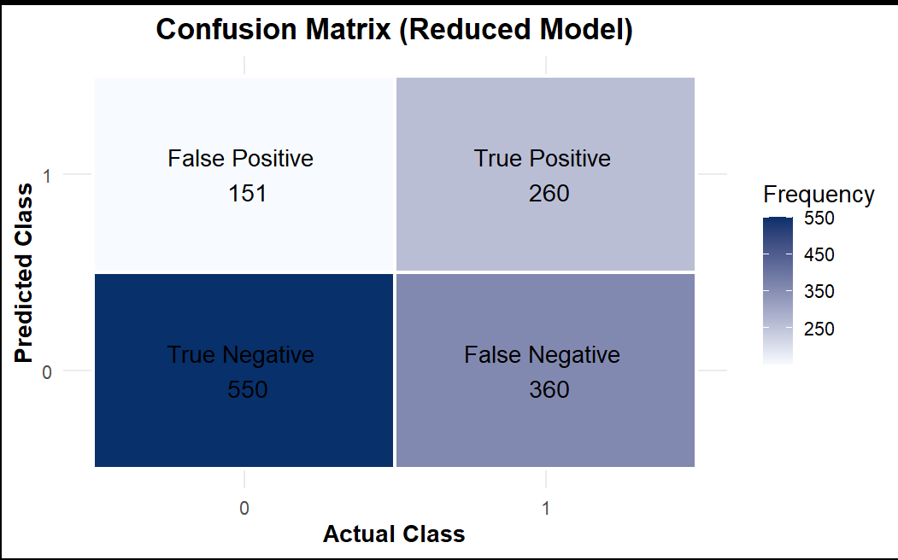
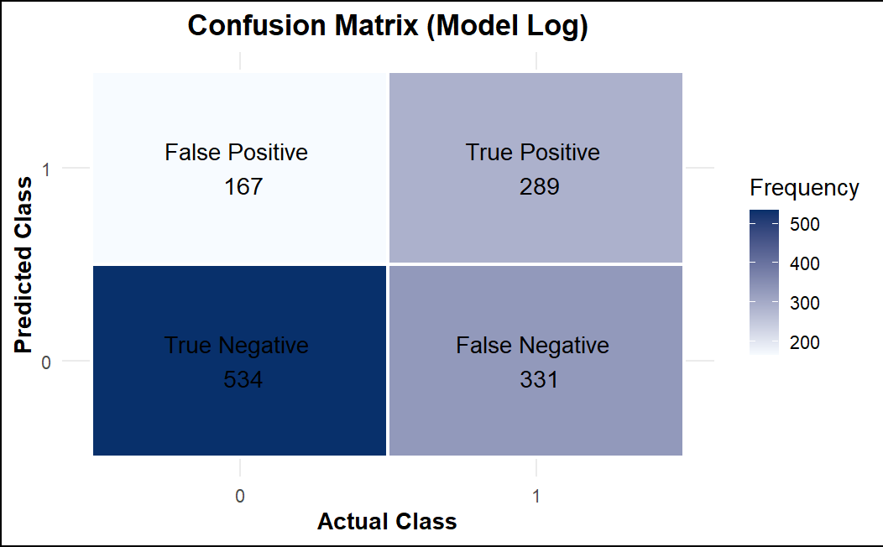

Table 3: Actual vs Predicted Liner Regression. Table 4: Actual vs Predicted Liner Regression reduced.
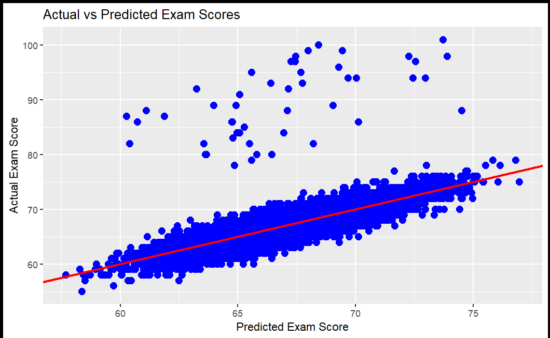
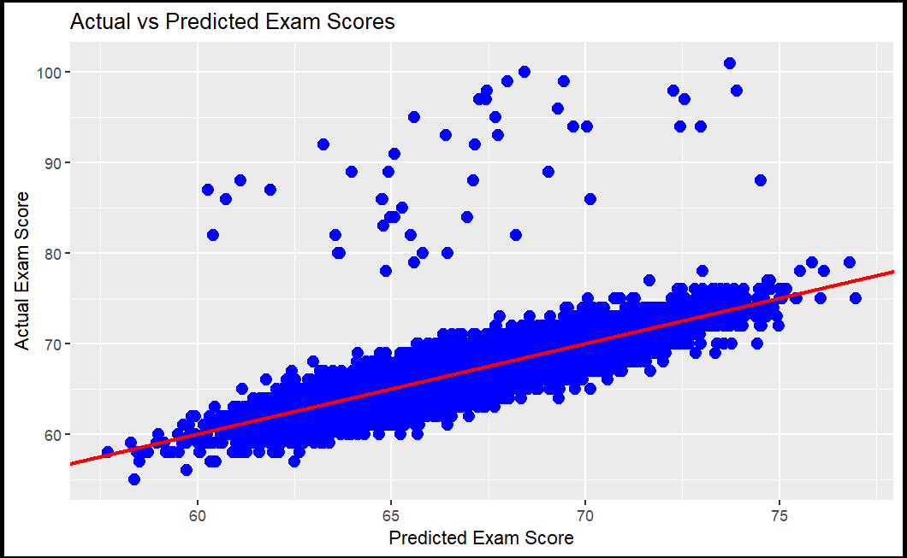

  - Discussion of Results

The experiments revealed that increased study hours and higher previous scores are significant parts of better exam outcomes making a R^2 of 19.89 or making up about 20 of the variability in the data while the numerical data almost makes up 60% of the variability. We can also see that both are pretty close to the line of best fit besides the few outliners.
In the classification model, features such as motivation level, Peer influence, and family income were strong indicators of whether a student scored above average, however for the initial experiment it has a high residual deviance: 6910.3 and a AIC of 6952.3 and for the reduced it has a residual deviance: 7011.3 and AIC: 7043.3 showing by removing some variables the fit becomes even worse however it still have above a 60% accuracy rate despite this .

  - Problems Encountered

The data was clean overall however the hardest part was trying to find the right logistical model to use that yielded good results.

  - Limitations of Implementation

The models implemented here have some limitations. Linear regression assumes a linear relationship that may oversimplify the complex interactions between study habits and exam scores. Logistic regression, while useful for classification, the results were underwhelming in the end and while gave good insight, to depend on the prediction would be a risky gamble.

  - Improvements/Future Work

Future work could extend this project by incorporating additional variables that I didn’t think of at the time or utilizing more complex models that could better pull apart the fine details of the categories.

- CONCLUSION

In conclusion, the analysis of over 6,600 student records revealed that study habits and academic performance are significant indicators of exam success. Our linear regression model confirmed that increased study hours and higher previous scores are predictors of better exam outcomes, while the logistic regression model, despite yielding moderate to weak classification accuracy, it showed how factors such as motivation level, Peer influence, and family income and others are important when classifying above-average performers. However, these models also highlighted limitations due to the complexity of student performance, suggesting that more sophisticated modeling techniques and additional variables may be necessary.

REFERENCES

Student Dataset

