Tam Chi Ka 210133669 SE2C

1. The assumption made during analysis and design of the application

Analysis: the current system is developed without a good design pattern. It would be hard to maintain or implement new function for the current design of the system. Therefore, we need to use the new design pattern to increase the extensibility maintainability of the system.

Design: The new design will adopt the Open Close Principle, since the new system should add new function, which are the undo/redo function. If we don’t adopt with the Open Close Principle, the system would be hard to maintain, and so the Command pattern, Abstract Factory Pattern, Memento pattern will be use in the system, to attain a better structure of system.

Open Close Principle: The Open Closed Principle let us to implement the new function without changing the existing code in the system. Therefore, the old system function will not be interrupt by adding the new code into system.

1. System design on your application with class diagram

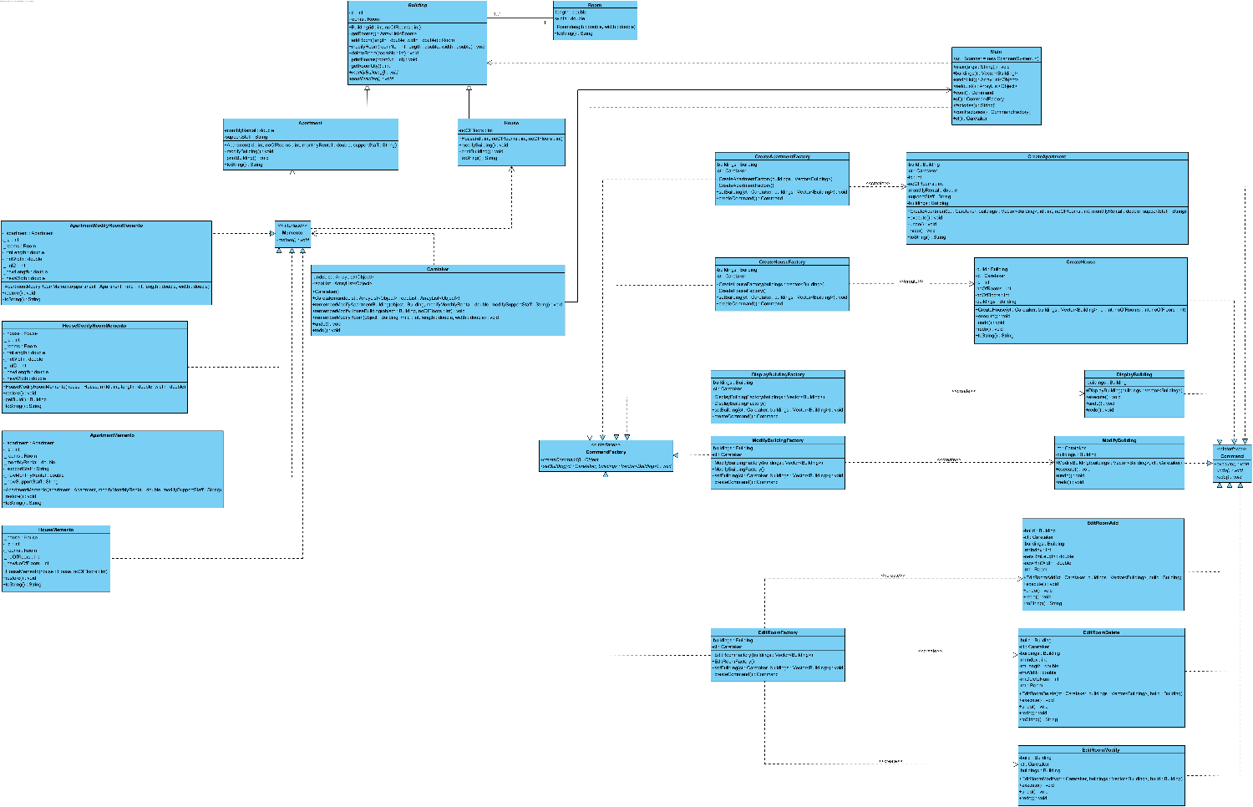

Command Pattern:

The Command Pattern uses four actor classes, Invoker, Receiver, Command, ConcreteCommand. In our case, the Invoker receive the command from user, and they can decide which command to execute a request by calling the execute method and store the executed command into the undo list. After that, the ConcreteCommand call the corresponding command to create a command. Then, the Command will create an object or execute the command. The receiver is responsible to deal with each request.

Memento pattern

Memento pattern uses three actor classes, Memento, Originator and Caretaker. In our case, the Memento classes store the data of apartment and house object and consist with a restore function. The Originator creates and stores states in Memento objects. Also, the Caretaker consist with an undo list and redo list, and the Caretaker object is responsible to restore object state from Memento class object.

Undo/Redo Function

Once the undo/redo function is called in the Invoker, the undo list will take the latest object from the undo list, and check whether it is command or memento class. If it is a command/memento class, it will call undo function in the command object / call the restore function in the memento object, and the data is restored. If it is a memento class, it will call restore function in the memento object, so the data will restore to the data of the Originator object.

D)

|  |  |  |  |  |  |
| --- | --- | --- | --- | --- | --- |
| Test ID | Description | Expected Results | Expected Result | Actual Results | P/F |
| 1. | Add building record (Apartment)(a) | Add new Apartment | New Apartment message displayed | New Apartment message displayed | P |
| 2. | Add building record (House)(h) | Add new House | New House message displayed | New House message displayed | P |
| 3. | Display one Building record (d) | Display specific building | Display specific building | Display specific building | P |
| 4. | Display one Building record (d)(*) | Display all building info. | Display all building info. | Display all building info. | P |
| 5. | Modify Building (Apartment)(m) | Modify Apartment | Modify Apartment message displayed | Modify Apartment message displayed | P |
| 6. | Modify Building (House)(m) | Modify House | Modify House message displayed | Modify House message displayed | P |
| 7. | Edit rooms (e) and then add room (a) | Add new room | Add new room message displayed | Add new room message displayed | P |
| 8. | Edit rooms (e) and then modify room (m) | Modify room | Modify room message displayed | Modify room message displayed | P |
| 9. | Edit rooms (e) and then delete room (d) | Delete room | Delete room message displayed | Delete room message displayed | P |
| 10. | Display the Undo/Redo List (l) | Display undo/redo list | Display undo/redo list | Display undo/redo list | P |
| 11. | Undo the last command in the Undo List (u) | Undo the last command | Undo the last command | Undo the last command | P |
| 12. | Redo the last command in the Redo List (r) | Redo the last command | Redo the last command | Redo the last command | P |

Test Plan:

Test ID.1.

Description: Add building record (Apartment)

Test ID.2.

Description: Add building record (House)

Test ID.3.

Description: Display one Building record (d)

Test ID.4.

Description: Display one Building record (d)(*)

Test ID.5.

Description: Modify Building (Apartment)(m)

Test ID.6.

Description: Modify Building (House)(m)

Test ID.7.

Description: Edit rooms (e) and then add room (a)

Test ID.8.

Description: Edit rooms (e) and then modify room (m)

Test ID.9.

Description: Edit rooms (e) and then delete room (d)

Test ID.10.

Description: Display the Undo/Redo List (l)

Test ID.11.

Description: Undo the last command in the Undo List (u)

Undo => Delete Room: Building No: 1001 Room No.1 Length: 15.0 Width:20.0

(d) =>(u) =>(d) =>(l)

Test ID.11.

Description: Undo the last command in the Undo List (u)

Undo => Modify Room: Building No: 1001 Room No.2 Length: 9.0 Width:18.0

(d) =>(u) =>(d) =>(l)

Test ID.11.

Description: Undo the last command in the Undo List (u)

Undo => Add Room: Building No: 1001 Room No.3 Length: 12.0 Width: 14.0

(d) =>(u) =>(d) =>(l)

Test ID.12.

Description: Redo the last command in the Redo List (r)

Redo => Delete Room: Building No: 1001 Room No.1 Length: 15.0 Width:20.0

(l)=>(d) =>(r) =>(d) =>(l)

Test ID.12.

Description: Redo the last command in the Redo List (r)

Redo => Modify Room: Building No: 1001 Room No.2 Length: 9.0 Width:18.0

(l)=>(d) =>(r) =>(d) =>(l)

Test ID.12.

Description: Redo the last command in the Redo List (r)

Redo => Add Room: Building No: 1001 Room No.3 Length: 12.0 Width: 14.0

(l)=>(d) =>(r) =>(d) =>(l)

