TCS2411/TSE2101 Software Engineering Fundamentals

Tutorial 10
Part A: Discussion
Topic (Lecture 10): Software Testing Techniques

- Two main approaches in testing are white box testing and black box testing. Explain white box and black box testing approaches and contrast these two testing approaches.
- Black box testing: a software testing method in which internal structure/ design of the item being tested is not known the test, can be functional or not functional.
- White box testing: glass box testing, method of testing software that test internal structure or workings of application, as opposed and as functionality.
Difference:
- Black box:
  - testing carried out by tester
  - implementation knowledge not required
  - programming knowledge not required
  - testing applicable on higher level of testing
  - primarily on testing functionality
- White box:
  - testing by software developer
  - implementation knowledge required
  - programming knowledge required
  - testing applicable on low level of testing
  - primarily on testing program code.
- Given the following program:

A input (mark)
B if mark < 45
C then print “Fail”
D else print “Pass”
E if mark > 80
F then print “With Distinction”
G end

- Draw the flowgraph for this program.

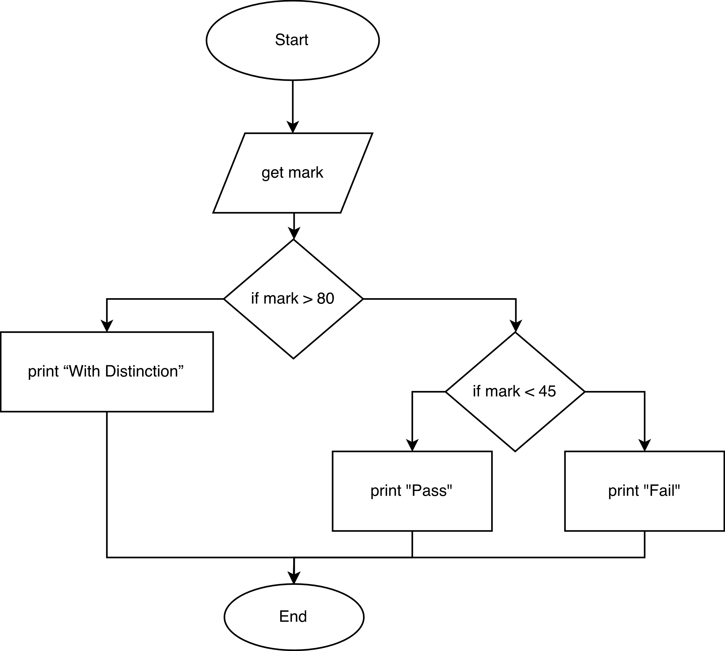

- Based on the flowgraph, determine the cyclomatic complexity of this program.
3.

- How many test cases are required to completely test all the paths of this program?
3
path 1: A, E, F, G
path 2: A, E, B, C, G
path 3: A, E, B, D, G

- How does unit testing differ for object-oriented testing as compared to conventional software unit testing?
Conventional testing is the traditional approach to testing mostly done when water fall life cycle is used for development, while object oriented testing is used when object oriented analysis and design is used for developing enterprise software. Conventional testing focuses more on decomposition and functional approaches as opposed to object oriented testing, which uses composition. The three levels of testing (system, integration, unit) used in conventional testing is not clearly defined when it comes to object oriented testing. The main reason for this is that OO development uses incremental approach, while traditional development follows a sequential approach. In terms of unit testing, object oriented testing looks at much smaller units compared to conventional testing.

- What is scenario-based testing?
The user tasks described in the use-cases are used to construct the test cases. It is used to uncover errors that occur when actors interact with the software (focus is on user behavior, not product behavior). Generally it is better to spend more time reviewing the use cases as they are created than spending more time on testing.

- Describe the how test cases are derived from behavior models to facilitate interclass testing?
Test cases must cover all states in the state transition diagram
Breadth first traversal of the state model can be used (test one transition at a time and only make use of previously tested transitions when testing a new transition)
Test cases can also be derived to ensure that all behaviors for the class have been adequately exercised.

