TCS2411/TSE2101 Software Engineering Fundamentals

Tutorial 2
Part A: Discussion
Topic (Lecture 2): Software Process

- Describe the Generic Process Model, as schematically shown in Figure 1

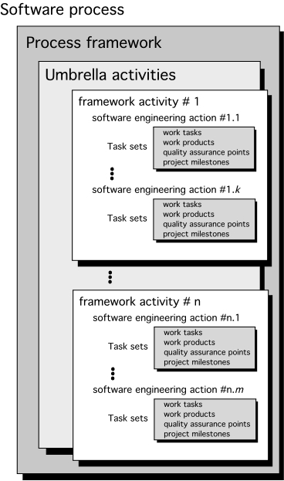

Figure 1: A software process framework

- Read the journal article authored by Tore Dyba and Torgeir Dingsoyr entitled; Empirical studies of agile software development: a systematic review

Discuss the answers for the following questions:

- What do the article define “Agility”?
Agility is a set of principles and values of helping people work in a more efficient way.

- What are the advantages of Agile Development?
-Customer satisfaction by rapid, continuous delivery of useful software.
-Working software is delivered frequently Regular adaptation to changing circumstances.
-Requirements can be changed at any time.

- What are the main agile development methods and how have they been described?
Scrum is one of the main agile development method.
With Scrum methodology, the “Product Owner” has a great cooperation with the team to identify system functionality in a form of “Product Backlog” . It consists features of fixing bugs, non-functional requirements and etc. Scrum process framework requires the use of development cycles called Sprints. The Product Backlog will be analyzed and re-prioritized once a Sprint has been delivered.

- In terms of what aspects do the traditional and agile development being differentiated?
Agile developers have higher flexibility through thier iterative style of work, and the users are often involved, suggesting ideas to them. Somehow, agile development only suitable to small to medium sized system compared to traditional development.

- Agile development do has several disadvantages which have been denoted in the article. Describe.
- Difficulty of introducing in a complex organization
- Inefficient pair programming
- Difficult test-first development
- Less interchangeable in agile teams

Part B: Exploration

- The following URL discusses about the Software Development Process:

http://en.wikipedia.org/wiki/Software_development_process#Software_development_models

- Identify the types of projects that may be suitable for each model.

Focus is on risk assessment and on minimizing project risk

- Discuss the advantages and disadvantages of using each model for a software project.
Advantages of Spiral model:
- Flexibility while having a risk and high avoidance
- Suitable for larger projects
- Additional Functionality can be added at a later date.
- Software can be created early
Disadvantages of Spiral model:
- A higher cost can’t be avoided
- Higher demand for the specific experts
- Smaller projects have a higher difficulty

- Discuss whether a combination of models can be used in a software project.
Yes, the combination of models is possible but adequate planning is needed as not all combination of models are effective. For example, apiral model is a model that combines some key espect of the waterfall model and rapid prototyping methodologies.

Tore Dybå, Torgeir Dingsøyr, Empirical studies of agile software development: A systematic review, Information and Software Technology, Volume 50, Issues 9–10, August 2008, Pages 833-859, ISSN 0950-5849, http://dx.doi.org/10.1016/j.infsof.2008.01.006. (http://www.sciencedirect.com/science/article/pii/S0950584908000256)

