

**TIS1101 Database Fundamentals / TDB2111 Database System**

**Group Project**

**Title: Concert Ticketing System**

**Prepared by:**

|  |  |  |
| --- | --- | --- |
| GOH KUN SHUN | 1151101980 | kunshun225@gmail.com |
| JOHN CHRISTIAN GONZALES ESCOBIA | 1132701350 | escobiajohn@gmail.com |
| CHRISTOPHER TOO WEI BIN | 1151101473 | christopher_two@hotmail.com |
| NG JING KEONG | 1151100169 | james0523njk@gmail.com |



|  |  |  |  |  |  |  |  |  |
| --- | --- | --- | --- | --- | --- | --- | --- | --- |
| **Data Dictionary** | | | | | | | | |
| **TABLE NAME** | **ATTRIBUTE NAME** | **CONTENTS** | **TYPE** | **FORMAT** | **RANGE** | **REQUIRED** | **PK OR FK** | **FK REFERENCED TABLE** |
| THEATRE | Theatre_ID | Theatre identification code | CHAR( 6 ) | Xx9999 | TT0000 - TT9999 | Y | PK |  |
|  | Theatre_Name | Theatre name | VARCHAR( 20 ) | Xxxxxxxx |  | Y |  |  |
|  | Theatre_Venue | Theatre venue | VARCHAR( 20 ) | Xxxxxxxx |  | Y |  |  |
|  | Seat_Capacity | Number of seats | INTEGER | 9999 | 50 - 125000 | Y |  |  |
|  | VIP_Count | Number of VIP seats. | INTEGER | 9999 | 0 - Seat_Capacity | Y |  |  |
|  | Zone_Count | Number of zones in theatre. | INTEGER | 99 | 1 - 5 | Y |  |  |
| CONCERT | Con_ID | Concert identification code | CHAR( 6 ) | Xx9999 | CN0000 - CN9999 | Y | PK |  |
|  | Con_Title | Concert title | VARCHAR( 20 ) | Xxxxxxxx |  | Y |  |  |
|  | Con_Artist | Concert artist | VARCHAR( 20 ) | Xxxxxxxx |  |  |  |  |
|  | Con_Date | Date of the concert | DATE | YYYY-MM-DD |  | Y |  |  |
|  | Con_TimeStart | Concert starting time | TIME | HH-MM | 0000 - 2359 | Y |  |  |
|  | Con_TimeEnd | Concert ending time | TIME | HH-MM | 0000 - 2359 | Y |  |  |
|  | VIP_Price | VIP ticket price | DECIMAL( 6, 2 ) | 9999.99 | 0.00 - 9999.99 | Y |  |  |
|  | Normal_Price | Normal ticket price | DECIMAL( 6, 2 ) | 9999.99 | 0.00 - 9999.99 | Y |  |  |
|  | Theatre_ID | Theatre identification code | CHAR( 6 ) | T9999 | TT0000 - TT9999 | Y | FK | THEATRE |
| CUSTOMER | Cus_ID | Customer identification code | CHAR( 6 ) | Xx9999 | CS0000 - CS9999 | Y | PK |  |
|  | Cus_FName | Customer first name | VARCHAR( 15 ) | Xxxxxxxx |  | Y |  |  |
|  | Cus_LName | Customer last name | VARCHAR( 15 ) | Xxxxxxxx |  | Y |  |  |
|  | Cus_Age | Customer age | INTEGER | 99 |  |  |  |  |
|  | Cus_Gender | Customer gender | CHAR( 1 ) | X |  | Y |  |  |
| AGENT | Agent_ID | Agent identification code | CHAR( 6 ) | Xx9999 | AG0000 - AG9999 | Y | PK |  |
|  | Agent_FName | Agent first name | VARCHAR( 15 ) | Xxxxxxxx |  | Y |  |  |
|  | Agent_LName | Agent last name | VARCHAR( 15 ) | Xxxxxxxx |  | Y |  |  |
|  | Agent_Age | Agent age | INTEGER | 99 |  |  |  |  |
|  | Agent_Gender | Agent gender | CHAR( 1 ) | X |  | Y |  |  |
| BOOKING | Booking_ID | Booking identification code | CHAR( 6 ) | Xx9999 | BK0000 - BK9999 | Y | PK |  |
|  | Cus_ID | Customer identification code | CHAR( 6 ) | Xx9999 | CS0000 - CS9999 | Y | PK, FK1 | CUSTOMER |
|  | Agent_ID | Agent identification code | CHAR( 6 ) | Xx9999 | AG0000 - AG9999 | Y | PK, FK2 | AGENT |
|  | Booking_Time | Booking time | TIMESTAMP | YYYY-MM-DD HH24:MI:SS |  | Y |  |  |
|  | Total_Price | Total price for the booking | decimal( 8, 2 ) | 99999999.99 | 0.00 - 999999.99 |  |  |  |
| TICKET | Ticket_ID | Ticket identification code | CHAR( 6 ) | Xx9999 | TK0000 - TK9999 | Y | PK |  |
|  | Con_ID | Concert identification code | CHAR( 6 ) | Xx9999 | CN0000 - CN9999 | Y | PK, FK1 | CONCERT |
|  | Ticket_Price | Ticket price | DECIMAL( 6, 2 ) | 9999.99 | 0.00 - 9999.99 | Y |  |  |
|  | Ticket_Type | Ticket type | VARCHAR( 6 ) | Xxxxxx |  | Y |  |  |
|  | Booking_ID | Booking identification code | CHAR( 6 ) | Xx9999 | BK0000-BK9999 |  | FK2 | BOOKING |
| VIP_TICKET | Ticket_ID | Ticket identification code | CHAR( 6 ) | Xx9999 | TK0000 - TK9999 | Y | PK, FK1 | TICKET |
|  | Con_ID | Concert identification code | CHAR( 6 ) | Xx9999 | CN0000 - CN9999 | Y | PK, FK2 | CONCERT |
|  | Seat_No | Seat number | CHAR( 5 ) | X9999 | V0000 - V9999 | Y |  |  |
| NORMAL_TICKET | Ticket_ID | Ticket identification code | CHAR( 6 ) | Xx9999 | TK0000 - TK9999 | Y | PK, FK1 | TICKET |
|  | Con_ID | Concert identification code | CHAR( 6 ) | Xx9999 | CN0000 - CN9999 | Y | PK, FK2 | CONCERT |
|  | Zone_No | Zone number | CHAR( 1 ) | X | A - F | Y |  |  |

# Entities and Business Rules

## Entities

1. Agent
2. Booking
3. Theatre
4. Customer
5. Ticket
6. VIP Ticket
7. Normal Ticket
8. Concert

## Business Rules

1. One concert has one to many tickets, but one ticket must have only one concert.
2. One theatre can have many concerts, but one concert must only have one

## theatre.

## Every ticket must be either a normal ticket or a VIP ticket.

## Every ticket may have only one booking, but every booking may have many tickets.

## One booking must have only one agent and only one customer, but one agent and one customer can have many bookings.

## The number of tickets for each concert is depended on the number of seats in the theatre.

# Relationships

## One concert has one to many tickets, but one ticket must have only one concert.



## One theatre may have many concerts, but one concert must only have one

## theatre.



## Every ticket must be either a normal ticket or a VIP ticket.



## Every ticket may have only one booking, but every booking may have many tickets.



## One booking must have only one agent and only one customer, but one agent and one customer can have many bookings.

## 

# Data Definition Command (DDL)

*We have initialized our IBM DB2 with ‘@’ as the termination character.

## Table Creation

*CREATE TABLE THEATRE*

*(*

*Theatre_ID CHAR( 6 ) NOT NULL CHECK ( Theatre_ID BETWEEN 'TT0000' AND*

*'TT9999' ),*

*Theatre_Name VARCHAR( 20 ) NOT NULL,*

*Theatre_Venue VARCHAR( 20 ) NOT NULL,*

*Seat_Capacity INTEGER NOT NULL CHECK ( Seat_Capacity BETWEEN 50*

*AND 125000 ),*

*VIP_Count INTEGER NOT NULL,*

*Zone_Count INTEGER NOT NULL CHECK ( Zone_Count BETWEEN 1 AND*

*6 ),*

*PRIMARY KEY ( Theatre_ID )*

*)@*

*CREATE TABLE CONCERT*

*(*

*Con_ID CHAR( 6 ) NOT NULL CHECK ( Con_ID BETWEEN 'CN0000'*

*AND 'CN9999' ),*

*Con_Title VARCHAR( 20 ) NOT NULL,*

*Con_Artist VARCHAR( 20 ),*

*Con_Date DATE NOT NULL,*

*Con_TimeStart TIME NOT NULL,*

*Con_TimeEnd TIME NOT NULL,*

*VIP_Price DECIMAL( 6, 2 ) NOT NULL,*

*Normal_Price DECIMAL( 6, 2 ) NOT NULL,*

*Theatre_ID CHAR( 6 ) NOT NULL,*

*PRIMARY KEY ( Con_ID ),*

*FOREIGN KEY ( Theatre_ID ) REFERENCES THEATRE( Theatre_ID ) ON DELETE CASCADE*

*)@*

*CREATE TABLE CUSTOMER*

*(*

*Cus_ID CHAR( 6 ) NOT NULL CHECK ( Cus_ID BETWEEN 'CS0000' AND*

*'CS9999' ),*

*Cus_FName VARCHAR( 15 ) NOT NULL,*

*Cus_LName VARCHAR( 15 ) NOT NULL,*

*Cus_Age INTEGER,*

*Cus_Gender CHAR( 1 ) NOT NULL,*

*PRIMARY KEY ( Cus_ID )*

*)@*

*CREATE TABLE AGENT*

*(*

*Agent_ID CHAR( 6 ) NOT NULL CHECK ( Agent_ID BETWEEN 'AG0000'*

*AND 'AG9999' ),*

*Agent_FName VARCHAR( 15 ) NOT NULL,*

*Agent_LName VARCHAR( 15 ) NOT NULL,*

*Agent_Age INTEGER,*

*Agent_Gender CHAR( 1 ) NOT NULL,*

*PRIMARY KEY ( Agent_ID )*

*)@*

*CREATE TABLE BOOKING*

*(*

*Booking_ID CHAR( 6 ) NOT NULL CHECK ( Booking_ID BETWEEN 'BK0000'*

*AND 'BK9999' ),*

*Cus_ID CHAR( 6 ) NOT NULL,*

*Agent_ID CHAR( 6 ) NOT NULL,*

*Booking_Time TIMESTAMP NOT NULL,*

*Total_Price DECIMAL( 8, 2 ) NOT NULL DEFAULT 0.0,*

*PRIMARY KEY ( Booking_ID ),*

*FOREIGN KEY ( Cus_ID ) REFERENCES CUSTOMER( Cus_ID ),*

*FOREIGN KEY ( Agent_ID ) REFERENCES AGENT( Agent_ID )*

*)@*

*CREATE TABLE TICKET*

*(*

*Ticket_ID CHAR( 6 ) NOT NULL CHECK ( Ticket_ID BETWEEN 'TK0000'*

*AND 'TK9999' ),*

*Con_ID CHAR( 6 ) NOT NULL,*

*Ticket_Price DECIMAL( 6, 2 ) NOT NULL CHECK ( Ticket_Price BETWEEN 0 AND*

*9999.99 ),*

*Ticket_Type VARCHAR( 6 ) NOT NULL,*

*Booking_ID CHAR( 6 ),*

*PRIMARY KEY ( Ticket_ID, Con_ID ),*

*FOREIGN KEY ( Con_ID ) REFERENCES CONCERT ( Con_ID ) ON DELETE CASCADE,*

*FOREIGN KEY ( Booking_ID ) REFERENCES BOOKING ( Booking_ID ) ON DELETE CASCADE*

*)@*

*CREATE TABLE VIP_TICKET*

*(*

*Ticket_ID CHAR( 6 ) NOT NULL CHECK ( Ticket_ID BETWEEN 'TK0000'*

*AND 'TK9999' ),*

*Con_ID CHAR( 6 ) NOT NULL CHECK ( Con_ID BETWEEN 'CN0000'*

*AND 'CN9999' ),*

*Seat_No CHAR( 5 ) NOT NULL CHECK ( Seat_No BETWEEN 'V0000'*

*AND 'V9999' ),*

*PRIMARY KEY ( Ticket_ID, Con_ID ),*

*FOREIGN KEY ( Ticket_ID, Con_ID ) REFERENCES TICKET ( Ticket_ID, Con_ID ) ON DELETE CASCADE*

*)@*

*CREATE TABLE NORMAL_TICKET*

*(*

*Ticket_ID CHAR( 6 ) NOT NULL CHECK ( Ticket_ID BETWEEN 'TK0000'*

*AND 'TK9999' ),*

*Con_ID CHAR( 6 ) NOT NULL CHECK ( Con_ID BETWEEN 'CN0000'*

*AND 'CN9999' ),*

*Zone_No CHAR( 1 ) NOT NULL CHECK ( Zone_No BETWEEN 'A' AND*

*'F' ),*

*PRIMARY KEY ( Ticket_ID, Con_ID ),*

*FOREIGN KEY ( Ticket_ID, Con_ID ) REFERENCES TICKET ( Ticket_ID, Con_ID ) ON DELETE*

*CASCADE*

*)@*

# Data Definition Command (DDL)

## Data Insertion

*INSERT INTO THEATRE VALUES ( 'TT0000','Stadium Merdeka', 'Bukit Jalil', 50, 10, 6 )@*

*INSERT INTO THEATRE VALUES ( 'TT0001','Stadium Arena', 'Genting Highland', 100, 30, 4 )@*

*INSERT INTO THEATRE VALUES ( 'TT0002','Grand Hall', 'MMU Cyberjaya', 50, 55, 6 )@*

*SELECT * FROM THEATRE@*

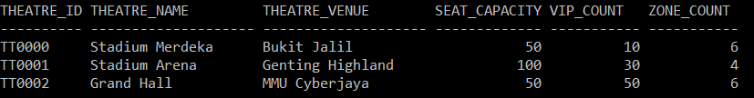

*INSERT INTO CONCERT VALUES ( 'CN0000', 'The Invincible', 'Jay Chou', '2017-01-27', '20:00:00', '23:00:00', 5000.00, 1000.0, 'TT0000' )@*

*INSERT INTO CONCERT VALUES ( 'CN0001', 'Maroon 5 Genting', 'Maroon 5', '2017-12-31', '20:00:00', '23:00:00', 200.00, 100.0, 'TT0001' )@*

*INSERT INTO CONCERT VALUES ( 'CN0002', 'Party Rock!', '-KHUN-', '2017-05-22', '20:00:00', '23:00:00', 200.00, 100.0, 'TT0002' )@*

*SELECT * FROM CONCERT@*

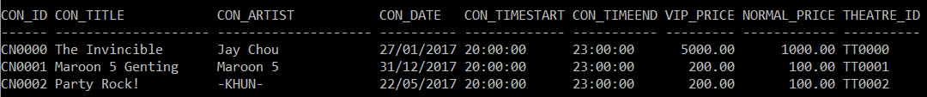

*INSERT INTO CUSTOMER VALUES ( 'CS0000', 'GOH', 'KUN SHUN', 19, 'M' )@*

*INSERT INTO CUSTOMER VALUES ( 'CS0001', 'CHRISTOPHER', 'TOO WEI BIN', 19, 'M' )@*

*INSERT INTO CUSTOMER VALUES ( 'CS0002', 'JOHN', 'ESCOBIA', 19, 'M' )@*

*INSERT INTO CUSTOMER VALUES ( 'CS0003', 'NG', 'JING KEONG', 19, 'M' )@*

*INSERT INTO CUSTOMER VALUES ( 'CS0004', 'ONG', 'SHU YU', 19, 'F' )@*

*INSERT INTO CUSTOMER VALUES ( 'CS0005', 'CHEW', 'PEI SHAN', 19, 'F' )@*

*INSERT INTO CUSTOMER VALUES ( 'CS0006', 'TEE', 'WEI WEI', 19, 'F' )@*

*INSERT INTO CUSTOMER VALUES ( 'CS0007', 'ABBY', 'LOW', 20, 'F' )@*

*SELECT * FROM CUSTOMER@*

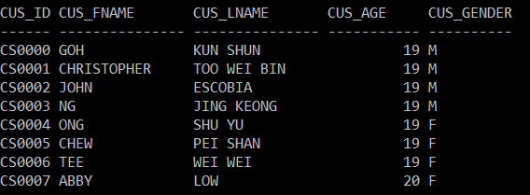

*INSERT INTO AGENT VALUES ( 'AG0000', 'ELON', 'MUSK', 45, 'M' )@*

*INSERT INTO AGENT VALUES ( 'AG0001', 'BILL', 'GATES', 61, 'M' )@*

*INSERT INTO AGENT VALUES ( 'AG0002', 'NEIL', 'TYSON', 58, 'M' )@*

*INSERT INTO AGENT VALUES ( 'AG0003', 'STEPHEN', 'HAWKING', 75, 'M' )@*

*INSERT INTO AGENT VALUES ( 'AG0004', 'WARREN', 'BUFFET', 86, 'M' )@*

*INSERT INTO AGENT VALUES ( 'AG0005', 'OPRAH', 'WINFREY', 62, 'F' )@*

*INSERT INTO AGENT VALUES ( 'AG0006', 'HEDY', 'LAMARR', 85, 'F' )@*

*SELECT * FROM AGENT@*

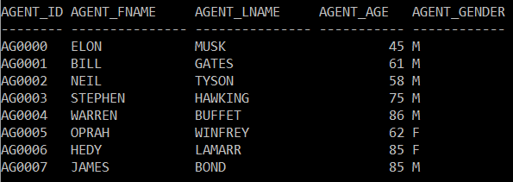

*INSERT INTO BOOKING ( Booking_ID, Cus_ID, Agent_ID ) VALUES ( 'BK0000', 'CS0000', 'AG0000' )@*

*INSERT INTO BOOKING ( Booking_ID, Cus_ID, Agent_ID ) VALUES ( 'BK0001', 'CS0004', 'AG0006' )@*

*INSERT INTO BOOKING ( Booking_ID, Cus_ID, Agent_ID ) VALUES ( 'BK0002', 'CS0005', 'AG0006' )@*

*INSERT INTO BOOKING ( Booking_ID, Cus_ID, Agent_ID ) VALUES ( 'BK0003', 'CS0004', 'AG0003' )@*

*INSERT INTO BOOKING ( Booking_ID, Cus_ID, Agent_ID ) VALUES ( 'BK0004', 'CS0003', 'AG0005' )@*

*INSERT INTO BOOKING ( Booking_ID, Cus_ID, Agent_ID ) VALUES ( 'BK0005', 'CS0007', 'AG0002' )@*

*INSERT INTO BOOKING ( Booking_ID, Cus_ID, Agent_ID ) VALUES ( 'BK0006', 'CS0006', 'AG0005' )@*

*INSERT INTO BOOKING ( Booking_ID, Cus_ID, Agent_ID ) VALUES ( 'BK0007', 'CS0003', 'AG0004' )@*

*INSERT INTO BOOKING ( Booking_ID, Cus_ID, Agent_ID ) VALUES ( 'BK0008', 'CS0002', 'AG0001' )@*

*INSERT INTO BOOKING ( Booking_ID, Cus_ID, Agent_ID ) VALUES ( 'BK0009', 'CS0001', 'AG0002' )@*

*INSERT INTO BOOKING ( Booking_ID, Cus_ID, Agent_ID ) VALUES ( 'BK0010', 'CS0004', 'AG0006' )@*

*SELECT * FROM BOOKING@*

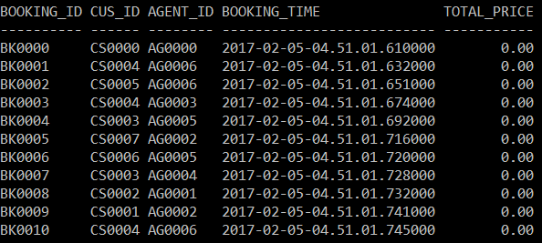

## Data Update

### Trying to book one expired concert’s ticket, and one available ticket

*UPDATE TICKET*

*SET Booking_ID = 'BK0000'*

*WHERE Ticket_ID = 'TK0049' AND Con_ID = 'CN0000' OR -- Expired concert*

*Ticket_ID = 'TK0050' AND Con_ID = 'CN0001'@ -- Okay concert*

*SELECT * FROM TICKET*

*WHERE Ticket_ID = 'TK0049' AND Con_ID = 'CN0000' OR*

*Ticket_ID = 'TK0050' AND Con_ID = 'CN0001'@*

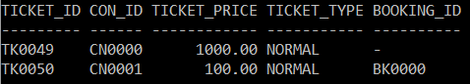

### Trying to book different ticket types

*UPDATE TICKET*

*SET Booking_ID = 'BK0001'*

*WHERE Ticket_ID = 'TK0029' AND Con_ID = 'CN0001' OR -- VIP ticket*

*Ticket_ID = 'TK0030' AND Con_ID = 'CN0001'@ -- Normal ticket*

*SELECT * FROM TICKET*

*WHERE Ticket_ID = 'TK0029' AND Con_ID = 'CN0001' OR*

*Ticket_ID = 'TK0030' AND Con_ID = 'CN0001'@*

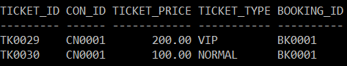

### Trying to book 2 invalid tickets

*UPDATE TICKET*

*SET Booking_ID = 'BK0002'*

*WHERE Ticket_ID = 'TK0029' AND Con_ID = 'CN0001' OR -- Booked ticket*

*Ticket_ID = 'TK9999' AND Con_ID = 'CN0001'@ -- Invalid ticket ID*

*SELECT * FROM TICKET*

*WHERE Ticket_ID = 'TK0029' AND Con_ID = 'CN0001' OR*

*Ticket_ID = 'TK9999' AND Con_ID = 'CN0001'@*

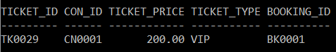

### Booking multiple tickets with BETWEEN

*UPDATE TICKET*

*SET Booking_ID = 'BK0003'*

*WHERE Con_ID = 'CN0001' AND*

*Ticket_ID BETWEEN 'TK0010' AND 'TK0025'@*

*SELECT * FROM TICKET*

*WHERE Con_ID = 'CN0001' AND*

*Ticket_ID BETWEEN 'TK0010' AND 'TK0025'@*

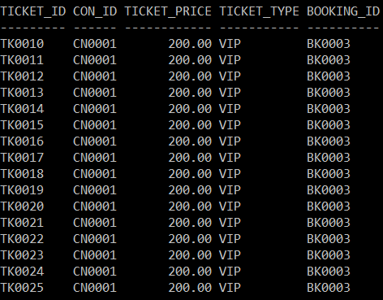

### Booking using subquery

*UPDATE TICKET*

*SET Booking_ID = 'BK0004'*

*WHERE Ticket_ID = 'TK0000' AND*

*Con_ID IN ( SELECT Con_ID*

*FROM CONCERT*

*WHERE Con_Date > '2017-06-01' )@*

*SELECT * FROM TICKET*

*WHERE Ticket_ID = 'TK0000' AND*

*Con_ID IN ( SELECT Con_ID*

*FROM CONCERT*

*WHERE Con_Date > '2017-06-01' )@*



### Booking using multi-level subqueries and LIKE

*UPDATE TICKET*

*SET Booking_ID = 'BK0005'*

*WHERE Ticket_ID = 'TK0001' AND*

*Con_ID IN ( SELECT Con_ID*

*FROM CONCERT*

*WHERE Theatre_ID IN ( SELECT Theatre_ID*

*FROM THEATRE*

*WHERE Theatre_Name LIKE*

*'Stadium%' ) )@*

*SELECT * FROM TICKET*

*WHERE Ticket_ID = 'TK0001' AND*

*Con_ID IN ( SELECT Con_ID*

*FROM CONCERT*

*WHERE Theatre_ID IN ( SELECT Theatre_ID*

*FROM THEATRE*

*WHERE Theatre_Name LIKE*

*'Stadium%' ) )@*

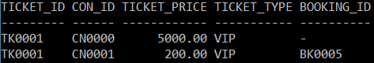

### Book all VIP within a range

*UPDATE TICKET*

*SET Booking_ID = 'BK0006'*

*WHERE Con_ID = 'CN0002' AND*

*Ticket_ID BETWEEN 'TK0000' AND 'TK0005' AND*

*Ticket_Type = 'VIP'@*

*SELECT * FROM TICKET*

*WHERE Con_ID = 'CN0002' AND*

*( Ticket_ID BETWEEN 'TK0000' AND 'TK0005' ) AND*

*Ticket_Type = 'VIP'@*

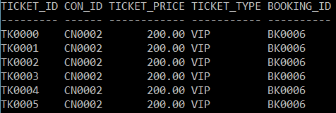

### Book normal ticket only

*UPDATE TICKET*

*SET Booking_ID = 'BK0007'*

*WHERE Con_ID = 'CN0001' AND*

*Ticket_ID BETWEEN 'TK0025' AND 'TK0035' AND*

*TICKET_TYPE = 'NORMAL'@*

*SELECT * FROM TICKET*

*WHERE Con_ID = 'CN0001' AND*

*Ticket_ID BETWEEN 'TK0025' AND 'TK0035' AND*

*TICKET_TYPE = 'NORMAL'@*

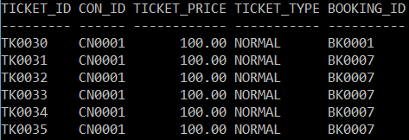

### Booking ticket based on ticket’s price

*UPDATE TICKET*

*SET Booking_ID = 'BK0008'*

*WHERE Con_ID = 'CN0001' AND*

*Ticket_ID BETWEEN 'TK0025' AND 'TK0035' AND*

*Ticket_Price > 100.0@*

*SELECT * FROM TICKET*

*WHERE Con_ID = 'CN0001' AND*

*Ticket_ID BETWEEN 'TK0025' AND 'TK0035' AND*

*Ticket_Price > 100.0@*

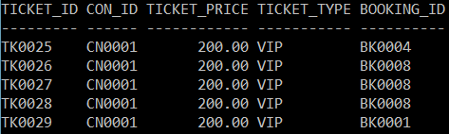

### Booking ticket based on ticket’s price with aggregate function

*UPDATE TICKET*

*SET Booking_ID = 'BK0009'*

*WHERE ( Con_ID = 'CN0001' OR Con_ID = 'CN0002' ) AND*

*( Ticket_ID BETWEEN 'TK0040' AND 'TK0044' ) AND*

*Ticket_Price < ( SELECT AVG( Ticket_Price )*

*FROM TICKET*

*GROUP BY Con_ID*

*HAVING Con_ID = 'CN0002' )@*

*SELECT * FROM TICKET*

*WHERE ( Con_ID = 'CN0001' OR Con_ID = 'CN0002' ) AND*

*( Ticket_ID BETWEEN 'TK0040' AND 'TK0044' ) AND*

*Ticket_Price < ( SELECT AVG( Ticket_Price )*

*FROM TICKET*

*GROUP BY Con_ID*

*HAVING Con_ID = 'CN0002' )@*

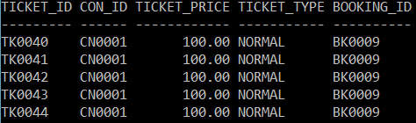

# Data Manipulation Language (DML):

## Triggers

### TRG_CHECK_SEATCAP

*CREATE TRIGGER TRG_CHECK_SEATCAP*

*BEFORE INSERT ON THEATRE*

*REFERENCING NEW AS N*

*FOR EACH ROW MODE DB2SQL*

*BEGIN*

*IF N.VIP_Count > N.Seat_Capacity*

*THEN*

*SET N.VIP_Count = N.Seat_Capacity;*

*END IF;*

*END@*

*The trigger above will check if user try to input VIP_Count with a value greater than Seat_Capacity of a THEATRE. If it is detected, the trigger will set the VIP_Count to the Seat_Capacity, which means the CONCERTs held on this THEATRE will not have NORMAL_TICKETs.*

*Inserting this line of code:*

*INSERT INTO THEATRE VALUES ( 'TT0002', 'Grand Hall', 'MMU Cyberjaya', 50, 55, 6 )@*

*The output:*

*SELECT * FROM THEATRE WHERE Theatre_ID = 'TT0002'@*



Notice how the VIP_Count is set to 50 instead of 55 because the trigger

detected the invalid input and automatically set it to Seat_Capacity’s value.

### TRG_GEN_CONCERT_TICKET

*CREATE TRIGGER TRG_GEN_CONCERT_TICKET*

*AFTER INSERT ON CONCERT*

*REFERENCING NEW AS N*

*FOR EACH ROW MODE DB2SQL*

*BEGIN*

*-- Declare variables*

*DECLARE I INTEGER; -- Counter = 0*

*DECLARE ID CHAR( 6 ); -- Ticket ID*

*DECLARE VIP_ID CHAR( 5 ); -- VIP ticket ID*

*DECLARE T_TYPE CHAR( 6 ); -- Ticket type*

*DECLARE T_ZONE CHAR( 1 ); -- Ticket zone*

*DECLARE NO_SEATS INTEGER; -- Number of seats*

*DECLARE NO_VIP INTEGER; -- Number of VIP_TICKETS*

*DECLARE NO_NORM INTEGER; -- Number of NORMAL_TICKETS*

*DECLARE VIP_P DECIMAL( 6, 2 ); -- VIP ticket price*

*DECLARE NORM_P DECIMAL( 6, 2 ); -- Normal ticket price*

*DECLARE NO_ZONE INTEGER; -- Number of zones*

*-- Initialize vairables*

*SET I = 0;*

*SET VIP_P = ( SELECT VIP_PRICE FROM CONCERT WHERE N.CON_ID =*

*CONCERT.CON_ID );*

*SET NORM_P = ( SELECT NORMAL_PRICE FROM CONCERT WHERE N.CON_ID =*

*CONCERT.CON_ID );*

*SET NO_SEATS = ( SELECT SEAT_CAPACITY FROM THEATRE WHERE N.THEATRE_ID =*

*THEATRE.THEATRE_ID );*

*SET NO_VIP = ( SELECT VIP_COUNT FROM THEATRE WHERE N.THEATRE_ID =*

*THEATRE.THEATRE_ID );*

*SET NO_NORM = NO_SEATS - NO_VIP;*

*SET NO_ZONE = ( SELECT ZONE_COUNT FROM THEATRE WHERE N.THEATRE_ID =*

*THEATRE.THEATRE_ID );*

*WHILE I < NO_SEATS*

*DO*

*-- Determine TICKET_ID*

*SET ID = ( 'TK' || LPAD( I, 4, 0 ) );*

*SET VIP_ID = ( 'V' || LPAD( I, 4, 0 ) );*

*-- Determine TICKET_TYPE*

*IF I < NO_VIP*

*THEN*

*SET T_TYPE = 'VIP';*

*-- Insert the generated VIP_TICKET into TICKET*

*INSERT INTO TICKET VALUES ( ID, N.CON_ID, VIP_P,*

*T_TYPE, NULL );*

*-- Insert the generated VIP_TICKET into VIP_TICKET*

*INSERT INTO VIP_TICKET VALUES ( ID, N.CON_ID, VIP_ID );*

*ELSE*

*SET T_TYPE = 'NORMAL';*

*IF I <= ( NO_VIP + ( NO_NORM / NO_ZONE ) )*

*THEN*

*SET T_ZONE = 'A';*

*ELSEIF I <= ( NO_VIP + ( 2 * NO_NORM / NO_ZONE ) )*

*THEN*

*SET T_ZONE = 'B';*

*ELSEIF I <= ( NO_VIP + ( 3 * NO_NORM / NO_ZONE ) )*

*THEN*

*SET T_ZONE = 'C';*

*ELSEIF I <= ( NO_VIP + ( 4 * NO_NORM / NO_ZONE ) )*

*THEN*

*SET T_ZONE = 'D';*

*ELSEIF I <= ( NO_VIP + ( 5 * NO_NORM / NO_ZONE ) )*

*THEN*

*SET T_ZONE = 'E';*

*ELSEIF I <= ( NO_VIP + ( 6 * NO_NORM / NO_ZONE ) )*

*THEN*

*SET T_ZONE = 'F';*

*END IF;*

*-- Insert the generated NORMAL_TICKET into TICKET*

*INSERT INTO TICKET VALUES ( ID, N.CON_ID, NORM_P, T_TYPE,*

*NULL );*

*-- Insert the generated NORMAL_TICKET into NORMAL_TICKET*

*INSERT INTO NORMAL_TICKET VALUES ( ID, N.CON_ID, T_ZONE );*

*END IF;*

*-- Increase counter by 1*

*SET I = I + 1;*

*END WHILE;*

*END@*

The above trigger will be triggered when user insert a CONCERT. The trigger will automatically generate the TICKETs based on the THEATRE the CONCERT will be held on. For example, this trigger will generate VIP_TICKETs based on the VIP_Count. The rest of the non-VIP_TCIKETs will be generated as NORMAL_TICKETs. For the NORMAL_TICKETs, the Zone_No is also automatically generated based on Zone_Count of the THEATRE, and they will be divided equally.

Inserting this line of code:

*INSERT INTO CONCERT VALUES ( 'CN0000', 'The Invincible', 'Jay Chou', '2017-01-27', '20:00:00', '23:00:00', 5000.00, 1000.0, 'TT0000' )@*

The output:

*SELECT * FROM TICKET WHERE Con_ID = ‘CN0000’@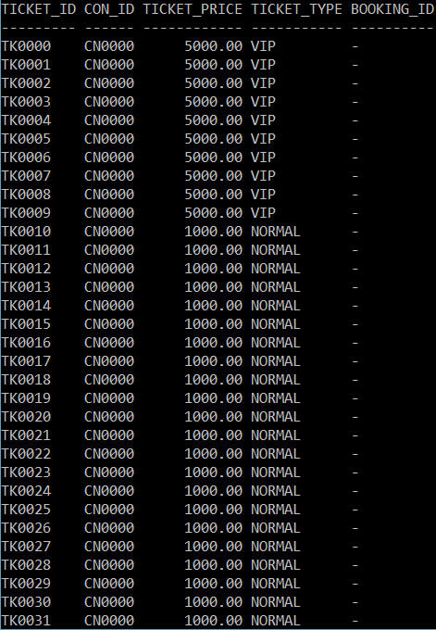*

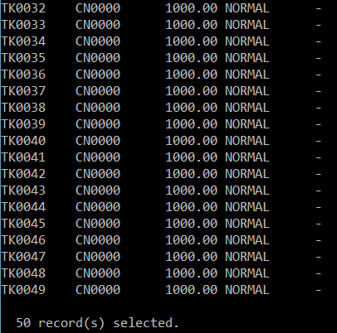

*SELECT * FROM VIP_TICKET WHERE Con_ID = ‘CN0000’@*

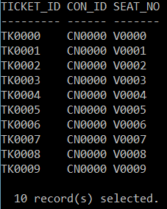

*SELECT * FROM NORMAL_TICKET WHERE Con_ID = ‘CN0000’@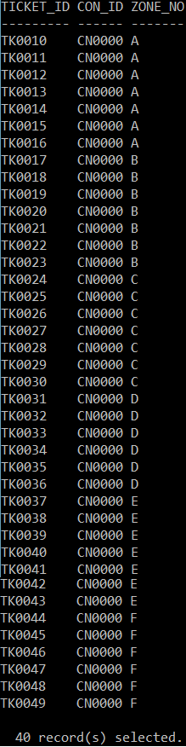*

### TRG_BOOKING

*CREATE TRIGGER TRG_BOOKING*

*BEFORE INSERT ON BOOKING*

*REFERENCING NEW AS N*

*FOR EACH ROW MODE DB2SQL*

*BEGIN*

*SET N.BOOKING_TIME = CURRENT TIMESTAMP;*

*END@*

The above trigger will be triggered when user create a BOOKING. It will automatically set the Booking_Time to the current time using the CURRENT TIMESTAMP keyword in IBM DB2.

Inserting this line of code:

*INSERT INTO BOOKING ( Booking_ID, Cus_ID, Agent_ID ) VALUES ( 'BK0000', 'CS0000', 'AG0000' )@*

The output:

*SELECT * FROM BOOKING WHERE Booking_ID = ‘BK0000’@*



### TRG_BOOK_TICKET

*CREATE TRIGGER TRG_BOOK_TICKET*

*BEFORE UPDATE OF BOOKING_ID ON TICKET*

*REFERENCING OLD AS O NEW AS N*

*FOR EACH ROW MODE DB2SQL*

*BEGIN*

*DECLARE CONCERT_BEGIN TIMESTAMP; -- Concert begin time*

*DECLARE BOOKTIME TIMESTAMP; -- Booking time*

*-- Convert date to timestamp*

*SET CONCERT_BEGIN = ( SELECT TIMESTAMP_ISO( DATE( Con_Date ) )*

*FROM CONCERT C*

*WHERE N.CON_ID = C.CON_ID );*

*SET BOOKTIME = ( SELECT Booking_Time*

*FROM BOOKING B*

*WHERE N.BOOKING_ID = B.BOOKING_ID );*

*IF ( O.BOOKING_ID IS NOT NULL ) OR ( BOOKTIME > CONCERT_BEGIN )*

*THEN*

*SET N.BOOKING_ID = O.BOOKING_ID;*

*END IF;*

*END@*

The above trigger will be triggered when user create a BOOKING. It will automatically set the Booking_Time to the current time using the CURRENT TIMESTAMP keyword in IBM DB2.

Inserting this line of code:

*UPDATE TICKET*

*SET Booking_ID = 'BK0002'*

*WHERE Ticket_ID = 'TK0029' AND Con_ID = 'CN0001' OR -- Booked ticket*

*Ticket_ID = 'TK0000' AND Con_ID = 'CN0000'@ -- Invalid ticket ID*

The output:

*SELECT * FROM TICKET*

*WHERE Ticket_ID = 'TK0029' AND Con_ID = 'CN0001' OR*

*Ticket_ID = 'TK0000' AND Con_ID = 'CN0000'@*

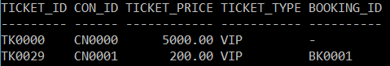

Notice how the and Booking_ID of TK0000 is still null because the CONCERT it is associated is already expired ( refer to the Data Insertion section ) and Booking_ID of TK0029 is not updated because it is previously booked by BK0001.

### TRG_CALC_BOOKING_PRICE

*CREATE TRIGGER TRG_CALC_BOOKING_PRICE*

*AFTER UPDATE OF BOOKING_ID ON TICKET*

*REFERENCING NEW AS N*

*FOR EACH ROW MODE DB2SQL*

*UPDATE BOOKING B*

*SET TOTAL_PRICE = ( SELECT SUM( TICKET_PRICE )*

*FROM TICKET*

*WHERE TICKET.BOOKING_ID = N.BOOKING_ID )*

*WHERE N.BOOKING_ID = B.BOOKING_ID@*

The above trigger will be triggered when user update the Booking_ID of a TICKET. It will automatically calculate the Total_Price of a booking by getting the sum of all the Ticket_Price that have the same Booking_ID .

The output:

*SELECT * FROM BOOKING@*

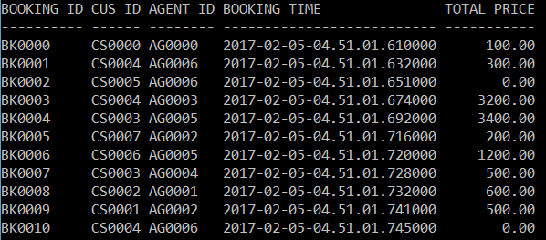

## Views

### AGENT_SOLD

*CREATE VIEW AGENT_SOLD AS*

*SELECT AGENT_FNAME,*

*AGENT_LNAME,*

*COUNT(NT.TICKET_ID) AS NORMAL_SOLD,*

*COUNT(VT.TICKET_ID) AS VIP_SOLD,*

*COUNT(NT.TICKET_ID) + COUNT(VT.TICKET_ID) AS TOTAL_SOLD*

*FROM TICKET TK*

*LEFT OUTER JOIN NORMAL_TICKET NT*

*ON TK.TICKET_ID = NT.TICKET_ID*

*AND TK.CON_ID = NT.CON_ID*

*LEFT OUTER JOIN VIP_TICKET VT*

*ON TK.TICKET_ID = VT.TICKET_ID*

*AND TK.CON_ID = VT.CON_ID*

*LEFT OUTER JOIN BOOKING BK*

*ON BK.BOOKING_ID = TK.BOOKING_ID*

*LEFT OUTER JOIN AGENT AG*

*ON BK.AGENT_ID = AG.AGENT_ID*

*WHERE TK.BOOKING_ID IS NOT NULL*

*GROUP BY ( AGENT_FNAME, AGENT_LNAME )@*

AGENT_SOLD view is to show the number VIP ticket, normal ticket and total amount of ticket sold by an agent.

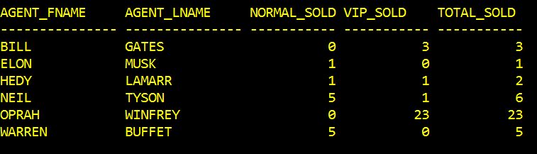

### CUSTOMER_PURCHASE

*CREATE VIEW CUSTOMER_PURCHASE AS*

*SELECT CUS_FNAME,*

*CUS_LNAME,*

*COUNT(NT.TICKET_ID) AS NORMAL_BOUGHT,*

*COUNT(VT.TICKET_ID) AS VIP_BOUGHT,*

*COUNT(NT.TICKET_ID) + COUNT(VT.TICKET_ID) AS TOTAL_TICKET_BOUGHT*

*FROM TICKET TK*

*LEFT OUTER JOIN NORMAL_TICKET NT*

*ON TK.TICKET_ID = NT.TICKET_ID*

*AND TK.CON_ID = NT.CON_ID*

*LEFT OUTER JOIN VIP_TICKET VT*

*ON TK.TICKET_ID = VT.TICKET_ID*

*AND TK.CON_ID = VT.CON_ID*

*LEFT OUTER JOIN BOOKING BK*

*ON BK.BOOKING_ID = TK.BOOKING_ID*

*LEFT OUTER JOIN CUSTOMER CS*

*ON BK.CUS_ID = CS.CUS_ID*

*WHERE TK.BOOKING_ID IS NOT NULL*

*GROUP BY ( CUS_FNAME, CUS_LNAME )@*

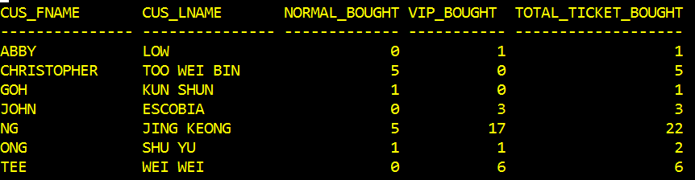

CUSTOMER_PURCHASE view is to show the amount of VIP ticket, normal ticket and total amount of ticket purchase by a customer.

### SEAT_AVAILABLE

*CREATE VIEW SEAT_AVAILABLE AS*

*SELECT CON_TITLE,*

*COUNT(NT.TICKET_ID) AS NORMAL_AVAILABLE,*

*COUNT(VT.TICKET_ID) AS VIP_AVAILABLE*

*FROM TICKET T*

*LEFT OUTER JOIN CONCERT C*

*ON C.CON_ID = T.CON_ID*

*LEFT OUTER JOIN NORMAL_TICKET NT*

*ON T.TICKET_ID = NT.TICKET_ID*

*AND T.CON_ID = NT.CON_ID*

*LEFT OUTER JOIN VIP_TICKET VT*

*ON T.TICKET_ID = VT.TICKET_ID*

*AND T.CON_ID = VT.CON_ID*

*WHERE T.BOOKING_ID IS NULL*

*GROUP BY ( CON_TITLE )@*

SEAT_AVAILABLE view is to show the number of VIP ticket and normal ticket available for a concert.

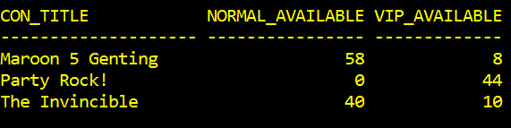

### N0_TICKET_SOLD

*CREATE VIEW N0_TICKET_SOLD AS*

*SELECT CON_TITLE,*

*COUNT( TICKET_ID ) AS TICKETS_SOLD,*

*SEAT_CAPACITY,*

*( CAST( ( ( ( CAST( COUNT( TICKET_ID ) AS DECIMAL ( 7, 3 ) ) ) / SEAT_CAPACITY ) * 100) AS DECIMAL ( 5, 2 ) ) ) AS SOLD_PERCENT*

*FROM TICKET T*

*LEFT OUTER JOIN CONCERT C*

*ON C.CON_ID = T.CON_ID*

*LEFT OUTER JOIN THEATRE TT*

*ON C.THEATRE_ID = TT.THEATRE_ID*

*WHERE T.BOOKING_ID IS NOT NULL*

*GROUP BY ( CON_TITLE, SEAT_CAPACITY )@*

N0_TICKET_SOLD view is to show the amount of ticket sold, seat capacity and the percentage of ticket sold for a concert, this view only shows ticket that are sold, therefore “The Invincible” won’t be listed because the concert did not sell any ticket.

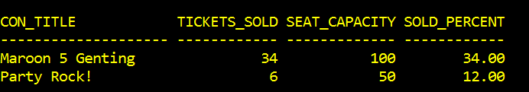

### NORM_TICKET_SOLD

*CREATE VIEW NORM_TICKET_SOLD AS*

*SELECT CON_TITLE,*

*COUNT( NT.TICKET_ID ) AS NORMAL_SOLD,*

*SEAT_CAPACITY - VIP_COUNT AS NORMAL_CAPACITY,*

*( CAST( ( ( ( CAST( COUNT( NT.TICKET_ID ) AS DECIMAL ( 7, 3 ) ) ) / (SEAT_CAPACITY - VIP_COUNT) ) * 100) AS DECIMAL ( 5, 2 ) ) ) AS SOLD_PERCENT*

*FROM NORMAL_TICKET NT*

*LEFT OUTER JOIN CONCERT C*

*ON C.CON_ID = NT.CON_ID*

*LEFT OUTER JOIN THEATRE TT*

*ON C.THEATRE_ID = TT.THEATRE_ID*

*LEFT OUTER JOIN TICKET T*

*ON NT.TICKET_ID = T.TICKET_ID*

*AND NT.CON_ID = T.CON_ID*

*WHERE T.BOOKING_ID IS NOT NULL*

*GROUP BY ( CON_TITLE, SEAT_CAPACITY, VIP_COUNT )@*

NORM_TICKET_SOLD view show the normal ticket sold by a concert, with their percentage and capacity for a concert. “Party Rock!” is not listed here because it does not have normal ticket allocated, while “The Invincible” is not listed because it did not sell any ticket.

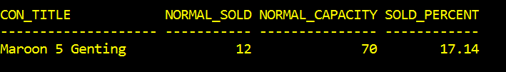

### VIP_TICKET_SOLD

*CREATE VIEW VIP_TICKET_SOLD AS*

*SELECT CON_TITLE,*

*COUNT( VT.TICKET_ID ) AS VIP_SOLD,*

*VIP_COUNT AS VIP_CAPACITY,*

*( CAST( ( ( ( CAST( COUNT( VT.TICKET_ID ) AS DECIMAL ( 7, 3 ) ) ) / (VIP_COUNT) ) * 100) AS DECIMAL ( 5, 2 ) ) ) AS SOLD_PERCENT*

*FROM VIP_TICKET VT*

*LEFT OUTER JOIN CONCERT C*

*ON C.CON_ID = VT.CON_ID*

*LEFT OUTER JOIN THEATRE TT*

*ON C.THEATRE_ID = TT.THEATRE_ID*

*LEFT OUTER JOIN TICKET T*

*ON VT.TICKET_ID = T.TICKET_ID*

*AND VT.CON_ID = T.CON_ID*

*WHERE T.BOOKING_ID IS NOT NULL*

*GROUP BY ( CON_TITLE, VIP_COUNT )@*

VIP_TICKET_SOLD view show the VIP ticket sold by a concert, with their percentage and capacity for a concert. “The Invincible” is not listed because it did not sell any ticket.

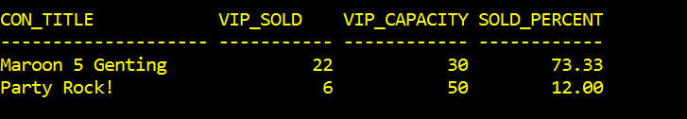

## Stored Procedures

### spTop5Customers

Displays five customers with the most purchased tickets within two concert dates – parameters.

Creation:

*CREATE PROCEDURE spTop5Customers( IN startDate DATE, endDate DATE )*

*BEGIN*

*DECLARE c cursor with return for*

*SELECT CUSTOMER.CUS_FNAME, CUSTOMER.CUS_LNAME,*

*COUNT(TICKET.TICKET_ID) AS TICKETS_BOUGHT*

*FROM CUSTOMER, TICKET, BOOKING, CONCERT*

*WHERE CONCERT.CON_DATE BETWEEN startDate AND endDate*

*AND BOOKING.BOOKING_ID = TICKET.BOOKING_ID*

*AND CUSTOMER.CUS_ID = BOOKING.CUS_ID*

*AND CONCERT.CON_ID = TICKET.CON_ID*

*GROUP BY CUSTOMER.CUS_FNAME, CUSTOMER.CUS_LNAME*

*ORDER BY COUNT(TICKET.TICKET_ID) DESC*

*LIMIT 5;*

*OPEN c;*

*END@*

Call and output:

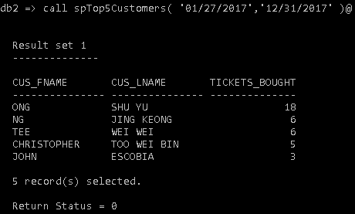

### spTop5Agents

Displays five agents who sold most tickets within two concert dates – parameters.

Creation:

*CREATE PROCEDURE spTop5Agents( IN startDate DATE, endDate DATE )*

*BEGIN*

*DECLARE c cursor with return for*

*SELECT AGENT.AGENT_FNAME, AGENT.AGENT_LNAME,*

*COUNT(TICKET.TICKET_ID) AS TICKETS_SOLD*

*FROM AGENT, TICKET, BOOKING, CONCERT*

*WHERE CONCERT.CON_DATE BETWEEN startDate AND endDate*

*AND BOOKING.BOOKING_ID = TICKET.BOOKING_ID*

*AND AGENT.AGENT_ID = BOOKING.AGENT_ID*

*AND CONCERT.CON_ID = TICKET.CON_ID*

*GROUP BY AGENT.AGENT_FNAME, AGENT.AGENT_LNAME*

*ORDER BY COUNT(TICKET.TICKET_ID) DESC*

*LIMIT 5;*

*OPEN c;*

*END@*

Call and output:

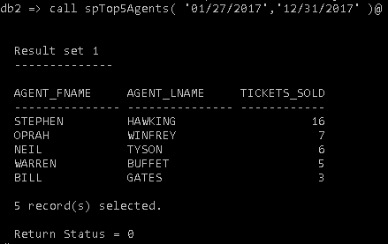

### spTop5Concerts

Displays five concerts with the most tickets sold within two concert dates – parameters.

Creation:

*CREATE PROCEDURE spTop2Concerts( IN startDate DATE, endDate DATE )*

*BEGIN*

*DECLARE c cursor with return for*

*SELECT CONCERT.CON_TITLE, COUNT(TICKET.TICKET_ID) AS*

*TICKETS_SOLD*

*FROM CONCERT, TICKET, BOOKING*

*WHERE CONCERT.CON_DATE BETWEEN startDate AND endDate*

*AND BOOKING.BOOKING_ID = TICKET.BOOKING_ID*

*AND CONCERT.CON_ID = TICKET.CON_ID*

*GROUP BY CONCERT.CON_TITLE*

*ORDER BY COUNT(TICKET.TICKET_ID) DESC*

*LIMIT 2;*

*OPEN c;*

*END@*

Call and output:

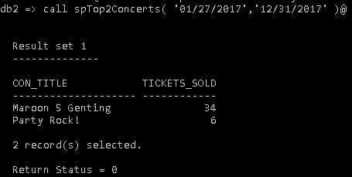

### spTheatreSchedule

Displays the concert(s) detail(s) – title, time start and time end for a specific theatre and date.

Creation:

*CREATE PROCEDURE spTheatreSchedule( IN theatreID CHAR( 6 ),*

*concertDate DATE )*

*BEGIN*

*DECLARE c cursor with return for*

*SELECT DISTINCT CONCERT.CON_TITLE, CONCERT.CON_TIMESTART,*

*CONCERT.CON_TIMEEND*

*FROM CONCERT, THEATRE*

*WHERE theatreID = THEATRE.THEATRE_ID*

*AND theatreID = CONCERT.THEATRE_ID*

*AND concertDate = CONCERT.CON_DATE*

*ORDER BY CONCERT.CON_TIMESTART;*

*OPEN c;*

*END@*

Call and output:

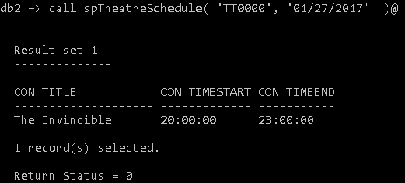

### spAvailableTickets

Displays the tickets available for a certain concert.

Creation:

*CREATE PROCEDURE spAvailableTickets( IN concertID CHAR( 6 ) )*

*BEGIN*

*DECLARE c cursor with return for*

*SELECT DISTINCT TICKET.TICKET_ID AS AVAILABLE_TICKETS,*

*TICKET.TICKET_TYPE, TICKET.TICKET_PRICE*

*FROM TICKET, BOOKING, CONCERT*

*WHERE TICKET.BOOKING_ID IS NULL*

*AND concertID = CONCERT.CON_ID*

*AND concertID = TICKET.CON_ID*

*ORDER BY TICKET.TICKET_ID;*

*OPEN c;*

*END@*

Call and output:

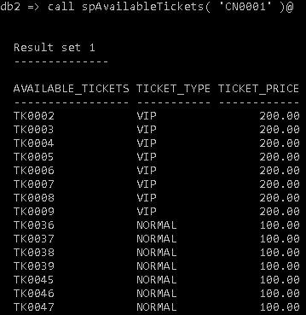

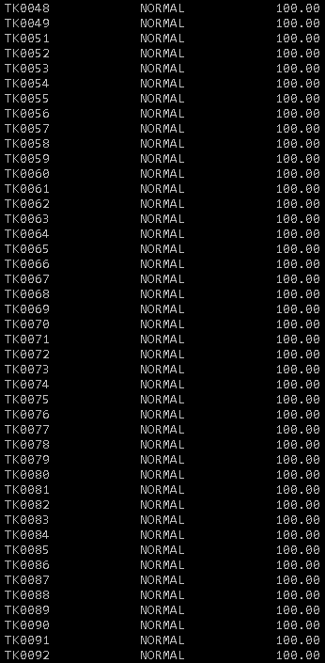

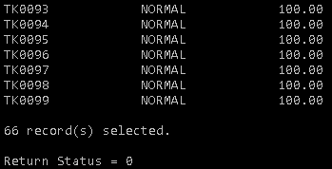

“66 record(s)” indicates there are 66 tickets available for concert CN0001.