

**TIS1101 Database Fundamentals / TDB2111 Database System**

**Group Project**

**Title: Concert Ticketing System**

**(Concert Ticketing System)**

**Members:**

|  |  |  |
| --- | --- | --- |
| GOH KUN SHUN | 1151101980 | kunshun225@gmail.com |
| JOHN CHRISTIAN | 1132701350 |  |
| CHRISTOPHER TOO WEI BIN | 1151101473 |  |
| NG JING KEONG | 1151100169 |  |

# Entities and Business Rules

## Entities

1. Agent
2. Booking
3. Theatre
4. Customer
5. Ticket
6. VIP Ticket
7. Normal Ticket
8. Concert

## Business Rules

1. One concert has one to many tickets, but one ticket must have only one concert.

## One theatre can have many concerts, but one concert must only have one

## theatre.

## Every ticket must be either a normal ticket or a VIP ticket.

## Every ticket may have only one booking, but every booking may have many

## tickets.

## One booking must have only one agent and only one customer, but one agent and one customer can have many bookings.

## The number of tickets for each concert is depended on the number of seats in

## the theatre.

# Relationships

## One concert has one to many tickets, but one ticket must have only one concert.



## One theatre may have many concerts, but one concert must only have one

## theatre.



## Every ticket must be either a normal ticket or a VIP ticket.

 

## Every ticket may have only one booking, but every booking may have many

## tickets.



## One booking must have only one agent and only one customer, but one agent and one customer can have many bookings.

## 

# Data Definition Command (DDL)

*We have initialized our IBM DB2 with ‘@’ as termination character.

## Table Creation

CREATE TABLE THEATRE

(

Theatre_ID CHAR( 6 ) NOT NULL CHECK ( Theatre_ID BETWEEN 'TT0000' AND

'TT9999' ),

Theatre_Name VARCHAR( 20 ) NOT NULL,

Theatre_Venue VARCHAR( 20 ) NOT NULL,

Seat_Capacity INTEGER NOT NULL CHECK ( Seat_Capacity BETWEEN 50 AND

125000 ),

VIP_Count INTEGER NOT NULL,

Zone_Count INTEGER NOT NULL CHECK ( Zone_Count BETWEEN 1 AND 6 ),

PRIMARY KEY ( Theatre_ID )

)@

CREATE TABLE CONCERT

(

Con_ID CHAR( 6 ) NOT NULL CHECK ( Con_ID BETWEEN 'CN0000' AND

'CN9999' ),

Con_Title VARCHAR( 20 ) NOT NULL,

Con_Artist VARCHAR( 20 ),

Con_Date DATE NOT NULL,

Con_TimeStart TIME NOT NULL,

Con_TimeEnd TIME NOT NULL,

VIP_Price DECIMAL( 6, 2 ) NOT NULL,

Normal_Price DECIMAL( 6, 2 ) NOT NULL,

Theatre_ID CHAR( 6 ) NOT NULL,

PRIMARY KEY ( Con_ID ),

FOREIGN KEY ( Theatre_ID ) REFERENCES THEATRE( Theatre_ID ) ON DELETE CASCADE

)@

CREATE TABLE CUSTOMER

(

Cus_ID CHAR( 6 ) NOT NULL CHECK ( Cus_ID BETWEEN 'CS0000' AND

'CS9999' ),

Cus_FName VARCHAR( 15 ) NOT NULL,

Cus_LName VARCHAR( 15 ) NOT NULL,

Cus_Age INTEGER,

Cus_Gender CHAR( 1 ) NOT NULL,

PRIMARY KEY ( Cus_ID )

)@

CREATE TABLE AGENT

(

Agent_ID CHAR( 6 ) NOT NULL CHECK ( Agent_ID BETWEEN 'AG0000' AND

'AG9999' ),

Agent_FName VARCHAR( 15 ) NOT NULL,

Agent_LName VARCHAR( 15 ) NOT NULL,

Agent_Age INTEGER,

Agent_Gender CHAR( 1 ) NOT NULL,

PRIMARY KEY ( Agent_ID )

)@

CREATE TABLE BOOKING

(

Booking_ID CHAR( 6 ) NOT NULL CHECK ( Booking_ID BETWEEN 'BK0000'

AND 'BK9999' ),

Cus_ID CHAR( 6 ) NOT NULL,

Agent_ID CHAR( 6 ) NOT NULL,

Booking_Time TIMESTAMP NOT NULL,

Total_Price DECIMAL( 8, 2 ) NOT NULL DEFAULT 0.0,

PRIMARY KEY ( Booking_ID ),

FOREIGN KEY ( Cus_ID ) REFERENCES CUSTOMER( Cus_ID ),

FOREIGN KEY ( Agent_ID ) REFERENCES AGENT( Agent_ID )

)@

CREATE TABLE TICKET

(

Ticket_ID CHAR( 6 ) NOT NULL CHECK ( Ticket_ID BETWEEN 'TK0000' AND

'TK9999' ),

Con_ID CHAR( 6 ) NOT NULL,

Ticket_Price DECIMAL( 6, 2 ) NOT NULL CHECK ( Ticket_Price BETWEEN 0 AND

9999.99 ),

Ticket_Type VARCHAR( 6 ) NOT NULL,

Booking_ID CHAR( 6 ),

PRIMARY KEY ( Ticket_ID, Con_ID ),

FOREIGN KEY ( Con_ID ) REFERENCES CONCERT ( Con_ID ) ON DELETE CASCADE,

FOREIGN KEY ( Booking_ID ) REFERENCES BOOKING ( Booking_ID ) ON DELETE CASCADE

)@

CREATE TABLE VIP_TICKET

(

Ticket_ID CHAR( 6 ) NOT NULL CHECK ( Ticket_ID BETWEEN 'TK0000' AND

'TK9999' ),

Con_ID CHAR( 6 ) NOT NULL CHECK ( Con_ID BETWEEN 'CN0000' AND

'CN9999' ),

Seat_No CHAR( 5 ) NOT NULL CHECK ( Seat_No BETWEEN 'V0000' AND

'V9999' ),

PRIMARY KEY ( Ticket_ID, Con_ID ),

FOREIGN KEY ( Ticket_ID, Con_ID ) REFERENCES TICKET ( Ticket_ID, Con_ID ) ON DELETE CASCADE

)@

CREATE TABLE NORMAL_TICKET

(

Ticket_ID CHAR( 6 ) NOT NULL CHECK ( Ticket_ID BETWEEN 'TK0000' AND

'TK9999' ),

Con_ID CHAR( 6 ) NOT NULL CHECK ( Con_ID BETWEEN 'CN0000' AND

'CN9999' ),

Zone_No CHAR( 1 ) NOT NULL CHECK ( Zone_No BETWEEN 'A' AND 'F' ),

PRIMARY KEY ( Ticket_ID, Con_ID ),

FOREIGN KEY ( Ticket_ID, Con_ID ) REFERENCES TICKET ( Ticket_ID, Con_ID ) ON DELETE CASCADE

)@

# Data Definition Command (DDL)

## Data Insertion

INSERT INTO THEATRE VALUES ( 'TT0000','Stadium Merdeka', 'Bukit Jalil', 50, 10, 6 )@

INSERT INTO THEATRE VALUES ( 'TT0001','Stadium Arena', 'Genting Highland', 100, 30, 4 )@

INSERT INTO THEATRE VALUES ( 'TT0002','Grand Hall', 'MMU Cyberjaya', 50, 55, 6 )@

SELECT * FROM THEATRE@

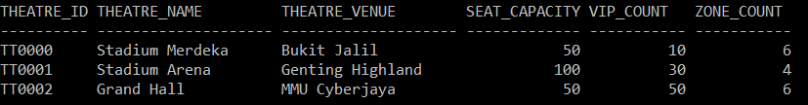

INSERT INTO CONCERT VALUES ( 'CN0000', 'The Invincible', 'Jay Chou', '2017-01-27', '20:00:00', '23:00:00', 5000.00, 1000.0, 'TT0000' )@

INSERT INTO CONCERT VALUES ( 'CN0001', 'Maroon 5 Genting', 'Maroon 5', '2017-12-31', '20:00:00', '23:00:00', 200.00, 100.0, 'TT0001' )@

INSERT INTO CONCERT VALUES ( 'CN0002', 'Party Rock!', '-KHUN-', '2017-05-22', '20:00:00', '23:00:00', 200.00, 100.0, 'TT0002' )@

SELECT * FROM CONCERT@

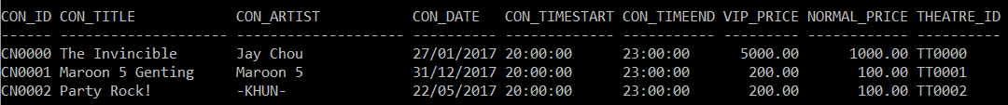

INSERT INTO CUSTOMER VALUES ( 'CS0000', 'GOH', 'KUN SHUN', 19, 'M' )@

INSERT INTO CUSTOMER VALUES ( 'CS0001', 'CHRISTOPHER', 'TOO WEI BIN', 19, 'M' )@

INSERT INTO CUSTOMER VALUES ( 'CS0002', 'JOHN', 'ESCOBIA', 19, 'M' )@

INSERT INTO CUSTOMER VALUES ( 'CS0003', 'NG', 'JING KEONG', 19, 'M' )@

INSERT INTO CUSTOMER VALUES ( 'CS0004', 'ONG', 'SHU YU', 19, 'F' )@

INSERT INTO CUSTOMER VALUES ( 'CS0005', 'CHEW', 'PEI SHAN', 19, 'F' )@

INSERT INTO CUSTOMER VALUES ( 'CS0006', 'TEE', 'WEI WEI', 19, 'F' )@

INSERT INTO CUSTOMER VALUES ( 'CS0007', 'ABBY', 'LOW', 20, 'F' )@

SELECT * FROM CUSTOMER@

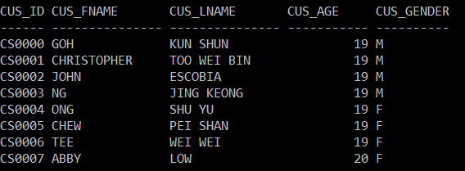

INSERT INTO AGENT VALUES ( 'AG0000', 'ELON', 'MUSK', 45, 'M' )@

INSERT INTO AGENT VALUES ( 'AG0001', 'BILL', 'GATES', 61, 'M' )@

INSERT INTO AGENT VALUES ( 'AG0002', 'NEIL', 'TYSON', 58, 'M' )@

INSERT INTO AGENT VALUES ( 'AG0003', 'STEPHEN', 'HAWKING', 75, 'M' )@

INSERT INTO AGENT VALUES ( 'AG0004', 'WARREN', 'BUFFET', 86, 'M' )@

INSERT INTO AGENT VALUES ( 'AG0005', 'OPRAH', 'WINFREY', 62, 'F' )@

INSERT INTO AGENT VALUES ( 'AG0006', 'HEDY', 'LAMARR', 85, 'F' )@

SELECT * FROM AGENT@

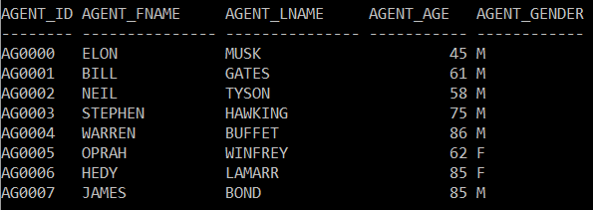

INSERT INTO BOOKING ( Booking_ID, Cus_ID, Agent_ID ) VALUES ( 'BK0000', 'CS0000', 'AG0000' )@

INSERT INTO BOOKING ( Booking_ID, Cus_ID, Agent_ID ) VALUES ( 'BK0001', 'CS0004', 'AG0006' )@

INSERT INTO BOOKING ( Booking_ID, Cus_ID, Agent_ID ) VALUES ( 'BK0002', 'CS0005', 'AG0006' )@

INSERT INTO BOOKING ( Booking_ID, Cus_ID, Agent_ID ) VALUES ( 'BK0003', 'CS0004', 'AG0003' )@

INSERT INTO BOOKING ( Booking_ID, Cus_ID, Agent_ID ) VALUES ( 'BK0004', 'CS0003', 'AG0005' )@

INSERT INTO BOOKING ( Booking_ID, Cus_ID, Agent_ID ) VALUES ( 'BK0005', 'CS0007', 'AG0002' )@

INSERT INTO BOOKING ( Booking_ID, Cus_ID, Agent_ID ) VALUES ( 'BK0006', 'CS0006', 'AG0005' )@

INSERT INTO BOOKING ( Booking_ID, Cus_ID, Agent_ID ) VALUES ( 'BK0007', 'CS0003', 'AG0004' )@

INSERT INTO BOOKING ( Booking_ID, Cus_ID, Agent_ID ) VALUES ( 'BK0008', 'CS0002', 'AG0001' )@

INSERT INTO BOOKING ( Booking_ID, Cus_ID, Agent_ID ) VALUES ( 'BK0009', 'CS0001', 'AG0002' )@

INSERT INTO BOOKING ( Booking_ID, Cus_ID, Agent_ID ) VALUES ( 'BK0010', 'CS0004', 'AG0006' )@

SELECT * FROM BOOKING@

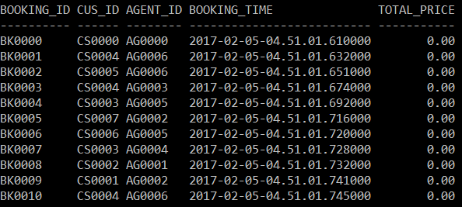

## Data Update

### Trying to book one expired concert’s ticket, and one available ticket

UPDATE TICKET

SET Booking_ID = 'BK0000'

WHERE Ticket_ID = 'TK0049' AND Con_ID = 'CN0000' OR -- Expired concert

Ticket_ID = 'TK0050' AND Con_ID = 'CN0001'@ -- Okay concert

SELECT * FROM TICKET

WHERE Ticket_ID = 'TK0049' AND Con_ID = 'CN0000' OR

Ticket_ID = 'TK0050' AND Con_ID = 'CN0001'@

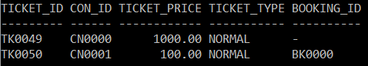

### Trying to book different ticket types

UPDATE TICKET

SET Booking_ID = 'BK0001'

WHERE Ticket_ID = 'TK0029' AND Con_ID = 'CN0001' OR -- VIP ticket

Ticket_ID = 'TK0030' AND Con_ID = 'CN0001'@ -- Normal ticket

SELECT * FROM TICKET

WHERE Ticket_ID = 'TK0029' AND Con_ID = 'CN0001' OR

Ticket_ID = 'TK0030' AND Con_ID = 'CN0001'@

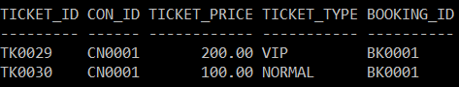

### Trying to book 2 invalid tickets

UPDATE TICKET

SET Booking_ID = 'BK0002'

WHERE Ticket_ID = 'TK0029' AND Con_ID = 'CN0001' OR -- Booked ticket

Ticket_ID = 'TK9999' AND Con_ID = 'CN0001'@ -- Invalid ticket ID

SELECT * FROM TICKET

WHERE Ticket_ID = 'TK0029' AND Con_ID = 'CN0001' OR

Ticket_ID = 'TK9999' AND Con_ID = 'CN0001'@

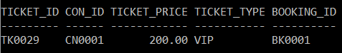

### Booking multiple tickets with BETWEEN

UPDATE TICKET

SET Booking_ID = 'BK0003'

WHERE Con_ID = 'CN0001' AND

Ticket_ID BETWEEN 'TK0010' AND 'TK0025'@

SELECT * FROM TICKET

WHERE Con_ID = 'CN0001' AND

Ticket_ID BETWEEN 'TK0010' AND 'TK0025'@

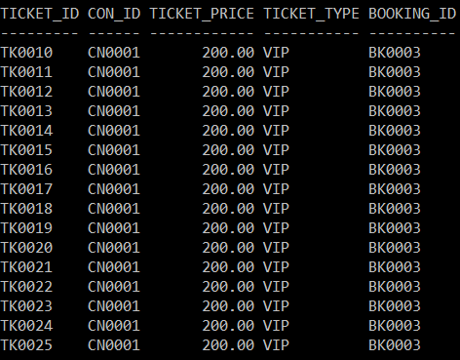

### Booking using subquery

UPDATE TICKET

SET Booking_ID = 'BK0004'

WHERE Ticket_ID = 'TK0000' AND

Con_ID IN ( SELECT Con_ID

FROM CONCERT

WHERE Con_Date > '2017-06-01' )@

SELECT * FROM TICKET

WHERE Ticket_ID = 'TK0000' AND

Con_ID IN ( SELECT Con_ID

FROM CONCERT

WHERE Con_Date > '2017-06-01' )@



### Booking using multi-level subqueries and LIKE

UPDATE TICKET

SET Booking_ID = 'BK0005'

WHERE Ticket_ID = 'TK0001' AND

Con_ID IN ( SELECT Con_ID

FROM CONCERT

WHERE Theatre_ID IN ( SELECT Theatre_ID

FROM THEATRE

WHERE Theatre_Name LIKE

'Stadium%' ) )@

SELECT * FROM TICKET

WHERE Ticket_ID = 'TK0001' AND

Con_ID IN ( SELECT Con_ID

FROM CONCERT

WHERE Theatre_ID IN ( SELECT Theatre_ID

FROM THEATRE

WHERE Theatre_Name LIKE

'Stadium%' ) )@

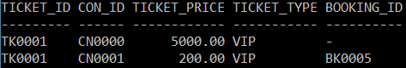

### Book all VIP within a range

UPDATE TICKET

SET Booking_ID = 'BK0006'

WHERE Con_ID = 'CN0002' AND

Ticket_ID BETWEEN 'TK0000' AND 'TK0005' AND

Ticket_Type = 'VIP'@

SELECT * FROM TICKET

WHERE Con_ID = 'CN0002' AND

( Ticket_ID BETWEEN 'TK0000' AND 'TK0005' ) AND

Ticket_Type = 'VIP'@

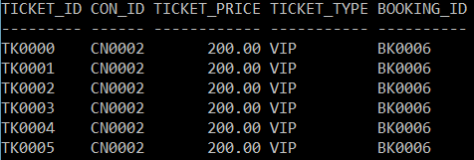

### Book normal ticket only

UPDATE TICKET

SET Booking_ID = 'BK0007'

WHERE Con_ID = 'CN0001' AND

Ticket_ID BETWEEN 'TK0025' AND 'TK0035' AND

TICKET_TYPE = 'NORMAL'@

SELECT * FROM TICKET

WHERE Con_ID = 'CN0001' AND

Ticket_ID BETWEEN 'TK0025' AND 'TK0035' AND

TICKET_TYPE = 'NORMAL'@

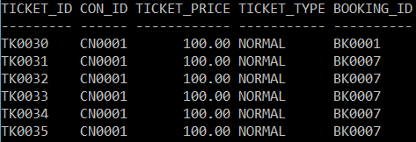

### Booking ticket based on ticket’s price

UPDATE TICKET

SET Booking_ID = 'BK0008'

WHERE Con_ID = 'CN0001' AND

Ticket_ID BETWEEN 'TK0025' AND 'TK0035' AND

Ticket_Price > 100.0@

SELECT * FROM TICKET

WHERE Con_ID = 'CN0001' AND

Ticket_ID BETWEEN 'TK0025' AND 'TK0035' AND

Ticket_Price > 100.0@

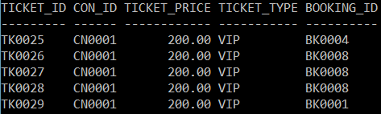

### Booking ticket based on ticket’s price with aggregate function

UPDATE TICKET

SET Booking_ID = 'BK0009'

WHERE ( Con_ID = 'CN0001' OR Con_ID = 'CN0002' ) AND

( Ticket_ID BETWEEN 'TK0040' AND 'TK0044' ) AND

Ticket_Price < ( SELECT AVG( Ticket_Price )

FROM TICKET

GROUP BY Con_ID

HAVING Con_ID = 'CN0002' )@

SELECT * FROM TICKET

WHERE ( Con_ID = 'CN0001' OR Con_ID = 'CN0002' ) AND

( Ticket_ID BETWEEN 'TK0040' AND 'TK0044' ) AND

Ticket_Price < ( SELECT AVG( Ticket_Price )

FROM TICKET

GROUP BY Con_ID

HAVING Con_ID = 'CN0002' )@

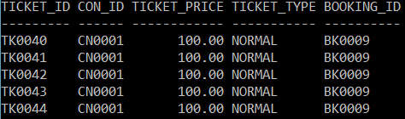

# Data Manipulation Language (DML):

## Triggers

### TRG_CHECK_SEATCAP

CREATE TRIGGER TRG_CHECK_SEATCAP

BEFORE INSERT ON THEATRE

REFERENCING NEW AS N

FOR EACH ROW MODE DB2SQL

BEGIN

IF N.VIP_Count > N.Seat_Capacity

THEN

SET N.VIP_Count = N.Seat_Capacity;

END IF;

END@

The trigger above will check if user try to input VIP_Count with a value greater than Seat_Capacity of a THEATRE. If it is detected, the trigger will set the VIP_Count to the Seat_Capacity, which means the CONCERTs held on this THEATRE will not have NORMAL_TICKETs.

Inserting this line of code:

INSERT INTO THEATRE VALUES ( 'TT0002', 'Grand Hall', 'MMU Cyberjaya', 50, 55,

6 )@

The output:



Notice how the VIP_Count is set to 50 instead of 55.

### TRG_GEN_CONCERT_TICKET

CREATE TRIGGER TRG_GEN_CONCERT_TICKET

AFTER INSERT ON CONCERT

REFERENCING NEW AS N

FOR EACH ROW MODE DB2SQL

BEGIN

-- Declare variables

DECLARE I INTEGER; -- Counter = 0

DECLARE ID CHAR( 6 ); -- Ticket ID

DECLARE VIP_ID CHAR( 5 ); -- VIP ticket ID

DECLARE T_TYPE CHAR( 6 ); -- Ticket type

DECLARE T_ZONE CHAR( 1 ); -- Ticket zone

DECLARE NO_SEATS INTEGER; -- Number of seats

DECLARE NO_VIP INTEGER; -- Number of VIP_TICKETS

DECLARE NO_NORM INTEGER; -- Number of NORMAL_TICKETS

DECLARE VIP_P DECIMAL( 6, 2 ); -- VIP ticket price

DECLARE NORM_P DECIMAL( 6, 2 ); -- Normal ticket price

DECLARE NO_ZONE INTEGER; -- Number of zones

-- Initialize vairables

SET I = 0;

SET VIP_P = ( SELECT VIP_PRICE FROM CONCERT WHERE N.CON_ID =

CONCERT.CON_ID );

SET NORM_P = ( SELECT NORMAL_PRICE FROM CONCERT WHERE N.CON_ID =

CONCERT.CON_ID );

SET NO_SEATS = ( SELECT SEAT_CAPACITY FROM THEATRE WHERE N.THEATRE_ID =

THEATRE.THEATRE_ID );

SET NO_VIP = ( SELECT VIP_COUNT FROM THEATRE WHERE N.THEATRE_ID =

THEATRE.THEATRE_ID );

SET NO_NORM = NO_SEATS - NO_VIP;

SET NO_ZONE = ( SELECT ZONE_COUNT FROM THEATRE WHERE N.THEATRE_ID =

THEATRE.THEATRE_ID );

WHILE I < NO_SEATS

DO

-- Determine TICKET_ID

SET ID = ( 'TK' || LPAD( I, 4, 0 ) );

SET VIP_ID = ( 'V' || LPAD( I, 4, 0 ) );

-- Determine TICKET_TYPE

IF I < NO_VIP

THEN

SET T_TYPE = 'VIP';

-- Insert the generated VIP_TICKET into TICKET

INSERT INTO TICKET VALUES ( ID, N.CON_ID, VIP_P,

T_TYPE, NULL );

-- Insert the generated VIP_TICKET into VIP_TICKET

INSERT INTO VIP_TICKET VALUES ( ID, N.CON_ID, VIP_ID );

ELSE

SET T_TYPE = 'NORMAL';

IF I <= ( NO_VIP + ( NO_NORM / NO_ZONE ) )

THEN

SET T_ZONE = 'A';

ELSEIF I <= ( NO_VIP + ( 2 * NO_NORM / NO_ZONE ) )

THEN

SET T_ZONE = 'B';

ELSEIF I <= ( NO_VIP + ( 3 * NO_NORM / NO_ZONE ) )

THEN

SET T_ZONE = 'C';

ELSEIF I <= ( NO_VIP + ( 4 * NO_NORM / NO_ZONE ) )

THEN

SET T_ZONE = 'D';

ELSEIF I <= ( NO_VIP + ( 5 * NO_NORM / NO_ZONE ) )

THEN

SET T_ZONE = 'E';

ELSEIF I <= ( NO_VIP + ( 6 * NO_NORM / NO_ZONE ) )

THEN

SET T_ZONE = 'F';

END IF;

-- Insert the generated NORMAL_TICKET into TICKET

INSERT INTO TICKET VALUES ( ID, N.CON_ID, NORM_P, T_TYPE,

NULL );

-- Insert the generated NORMAL_TICKET into NORMAL_TICKET

INSERT INTO NORMAL_TICKET VALUES ( ID, N.CON_ID, T_ZONE );

END IF;

-- Increase counter by 1

SET I = I + 1;

END WHILE;

END@

The above trigger will be triggered when user insert a CONCERT. The trigger will automatically generate the TICKETs based on the THEATRE the CONCERT will be held on. For example, this trigger will generate VIP_TICKETs based on the VIP_Count. The rest of the non-VIP_TCIKETs will be generated

## Views

### AGENT_SOLD

CREATE VIEW AGENT_SOLD AS

SELECT AGENT_FNAME,

AGENT_LNAME,

COUNT(NT.TICKET_ID) AS NORMAL_SOLD,

COUNT(VT.TICKET_ID) AS VIP_SOLD,

COUNT(NT.TICKET_ID) + COUNT(VT.TICKET_ID) AS TOTAL_SOLD

FROM TICKET TK

LEFT OUTER JOIN NORMAL_TICKET NT

ON TK.TICKET_ID = NT.TICKET_ID

AND TK.CON_ID = NT.CON_ID

LEFT OUTER JOIN VIP_TICKET VT

ON TK.TICKET_ID = VT.TICKET_ID

AND TK.CON_ID = VT.CON_ID

LEFT OUTER JOIN BOOKING BK

ON BK.BOOKING_ID = TK.BOOKING_ID

LEFT OUTER JOIN AGENT AG

ON BK.AGENT_ID = AG.AGENT_ID

WHERE TK.BOOKING_ID IS NOT NULL

GROUP BY ( AGENT_FNAME, AGENT_LNAME )@

AGENT_SOLD view is to show the number VIP ticket, normal ticket and total amount of ticket sold by an agent.

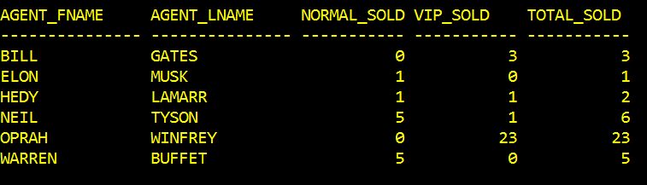

### CUSTOMER_PURCHASE

CREATE VIEW CUSTOMER_PURCHASE AS

SELECT CUS_FNAME,

CUS_LNAME,

COUNT(NT.TICKET_ID) AS NORMAL_BOUGHT,

COUNT(VT.TICKET_ID) AS VIP_BOUGHT,

COUNT(NT.TICKET_ID) + COUNT(VT.TICKET_ID) AS TOTAL_TICKET_BOUGHT

FROM TICKET TK

LEFT OUTER JOIN NORMAL_TICKET NT

ON TK.TICKET_ID = NT.TICKET_ID

AND TK.CON_ID = NT.CON_ID

LEFT OUTER JOIN VIP_TICKET VT

ON TK.TICKET_ID = VT.TICKET_ID

AND TK.CON_ID = VT.CON_ID

LEFT OUTER JOIN BOOKING BK

ON BK.BOOKING_ID = TK.BOOKING_ID

LEFT OUTER JOIN CUSTOMER CS

ON BK.CUS_ID = CS.CUS_ID

WHERE TK.BOOKING_ID IS NOT NULL

GROUP BY ( CUS_FNAME, CUS_LNAME )@

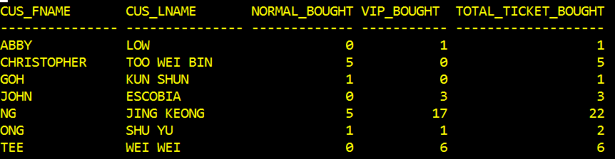

CUSTOMER_PURCHASE view is to show the amount of VIP ticket, normal ticket and total amount of ticket purchase by a customer.

### SEAT_AVAILABLE

CREATE VIEW SEAT_AVAILABLE AS

SELECT CON_TITLE,

COUNT(NT.TICKET_ID) AS NORMAL_AVAILABLE,

COUNT(VT.TICKET_ID) AS VIP_AVAILABLE

FROM TICKET T

LEFT OUTER JOIN CONCERT C

ON C.CON_ID = T.CON_ID

LEFT OUTER JOIN NORMAL_TICKET NT

ON T.TICKET_ID = NT.TICKET_ID

AND T.CON_ID = NT.CON_ID

LEFT OUTER JOIN VIP_TICKET VT

ON T.TICKET_ID = VT.TICKET_ID

AND T.CON_ID = VT.CON_ID

WHERE T.BOOKING_ID IS NULL

GROUP BY ( CON_TITLE )@

SEAT_AVAILABLE view is to show the number of VIP ticket and normal ticket available for a concert.

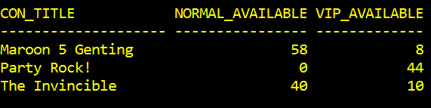

### N0_TICKET_SOLD

CREATE VIEW N0_TICKET_SOLD AS

SELECT CON_TITLE,

COUNT( TICKET_ID ) AS TICKETS_SOLD,

SEAT_CAPACITY,

( CAST( ( ( ( CAST( COUNT( TICKET_ID ) AS DECIMAL ( 7, 3 ) ) ) / SEAT_CAPACITY ) * 100) AS DECIMAL ( 5, 2 ) ) ) AS SOLD_PERCENT

FROM TICKET T

LEFT OUTER JOIN CONCERT C

ON C.CON_ID = T.CON_ID

LEFT OUTER JOIN THEATRE TT

ON C.THEATRE_ID = TT.THEATRE_ID

WHERE T.BOOKING_ID IS NOT NULL

GROUP BY ( CON_TITLE, SEAT_CAPACITY )@

N0_TICKET_SOLD view is to show the amount of ticket sold, seat capacity and the percentage of ticket sold for a concert, this view only shows ticket that are sold, therefore “The Invincible” wont be listed because the concert did not sold any ticket.

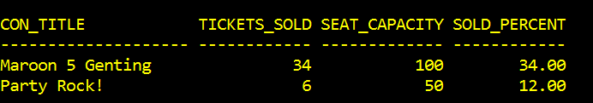

### NORM_TICKET_SOLD

CREATE VIEW NORM_TICKET_SOLD AS

SELECT CON_TITLE,

COUNT( NT.TICKET_ID ) AS NORMAL_SOLD,

SEAT_CAPACITY - VIP_COUNT AS NORMAL_CAPACITY,

( CAST( ( ( ( CAST( COUNT( NT.TICKET_ID ) AS DECIMAL ( 7, 3 ) ) ) / (SEAT_CAPACITY - VIP_COUNT) ) * 100) AS DECIMAL ( 5, 2 ) ) ) AS SOLD_PERCENT

FROM NORMAL_TICKET NT

LEFT OUTER JOIN CONCERT C

ON C.CON_ID = NT.CON_ID

LEFT OUTER JOIN THEATRE TT

ON C.THEATRE_ID = TT.THEATRE_ID

LEFT OUTER JOIN TICKET T

ON NT.TICKET_ID = T.TICKET_ID

AND NT.CON_ID = T.CON_ID

WHERE T.BOOKING_ID IS NOT NULL

GROUP BY ( CON_TITLE, SEAT_CAPACITY, VIP_COUNT )@

NORM_TICKET_SOLD view show the normal ticket sold by a concert, with their percentage and capacity for a concert. “Party Rock!” is not listed here because it does not have normal ticket allocated, while “The Invincible” is not listed because it did not sold any ticket.

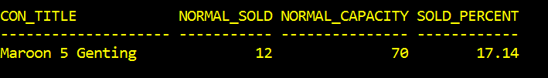

### VIP_TICKET_SOLD

CREATE VIEW VIP_TICKET_SOLD AS

SELECT CON_TITLE,

COUNT( VT.TICKET_ID ) AS VIP_SOLD,

VIP_COUNT AS VIP_CAPACITY,

( CAST( ( ( ( CAST( COUNT( VT.TICKET_ID ) AS DECIMAL ( 7, 3 ) ) ) / (VIP_COUNT) ) * 100) AS DECIMAL ( 5, 2 ) ) ) AS SOLD_PERCENT

FROM VIP_TICKET VT

LEFT OUTER JOIN CONCERT C

ON C.CON_ID = VT.CON_ID

LEFT OUTER JOIN THEATRE TT

ON C.THEATRE_ID = TT.THEATRE_ID

LEFT OUTER JOIN TICKET T

ON VT.TICKET_ID = T.TICKET_ID

AND VT.CON_ID = T.CON_ID

WHERE T.BOOKING_ID IS NOT NULL

GROUP BY ( CON_TITLE, VIP_COUNT )@

VIP_TICKET_SOLD view show the VIP ticket sold by a concert, with their percentage and capacity for a concert. “The Invincible” is not listed because it did not sold any ticket.

