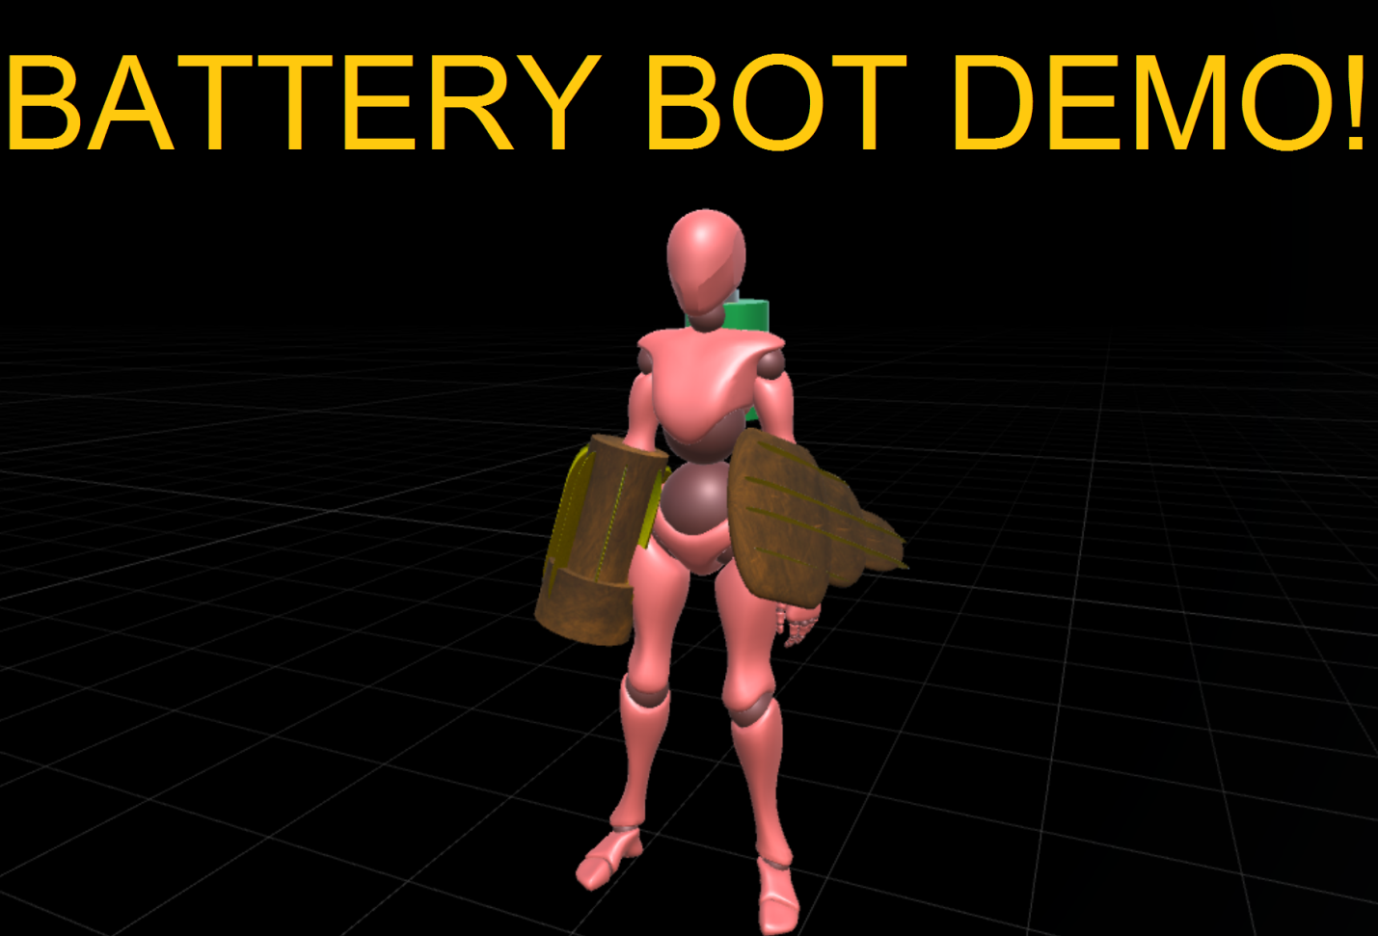

By Christopher Di Conza

-Midterm Project

-Dave Horachek

**SUMMARY:**

Your robot is running out of power! The objective is to survive as long as possible. Consume green batteries for more power, and consume red batteries for more ammunition. Use your cannon to defeat power-draining enemies while collecting the batteries which spawn from the four pipes in each corner of the arena. As you run out of power, you’ll run slower and your lights will grow dimmer. Try to stay above 200% for super speed and extra damage! Batteries become less plentiful and enemies become more numerous as the game progresses.

**CONTROLS:**

Space: Jump

Mouse: Camera

WASD: Movement

CTRL: Shoot

Enter: Accept

Escape: Quit game

**EXTRA FEATURES**

-Projectile cannon with laser sight

-3 Enemy types with tracking, Caster shoots projectiles

-Enemies spawn more frequently as time goes on

-Functioning Elevator & logic

-Special effect GameObjects chosen randomly and instantiated after battery is consumed

-Score and high score tracking

-Scene management instead of UI splash screen

**REFERENCES:**

**Music:**

Storm Signals by Mbius

**Sounds:**

http://www.soundjay.com

**Mouse Look Script**

http://answers.unity3d.com/questions/29741/mouse-look-script.html