# Battery Bot Adventures

**Version 1.0**

**By Christopher Di Conza**

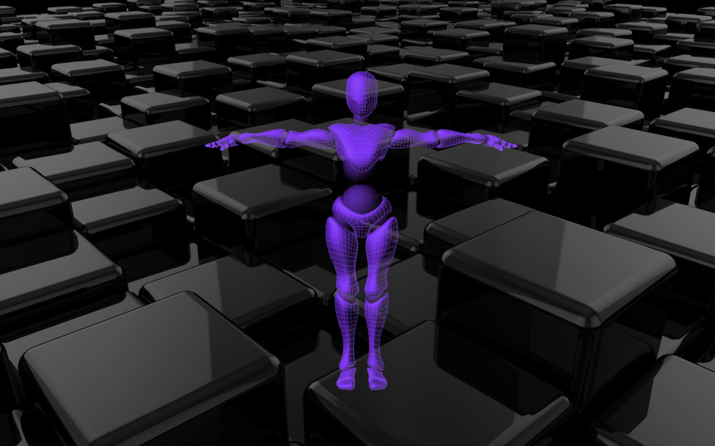

**CONTENTS**:

SUMMARY: 3

Arena Mode 3

Exploration Mode 3

CONTROLS: 4

(default setup) 4

SAVE SYSTEM: 5

BATTERIES: 5

GREEN 5

RED 5

SUPER 5

GEAR-UP 5

WEAPONS: 6

AXE 6

GUN 6

GREATSWORD 6

SHIELD 6

JETBOOSTER 6

WEAPON POWER-UPS: 7

ARMOUR: 7

GEARS: 7

PORTALS: 8

ENEMIES: 8

Vampire 8

BOSSES: 9

3rd Party Components: 10

MUSIC: 10

SOUNDS 10

PREMADE ASSETS: 10

SCRIPTS: 10

Mouse Look Script 10

# SUMMARY:

# 

## 

## Arena Mode

Your robot is running out of power! The objective is to survive as long as possible. Consume green batteries for more power, and consume red batteries for more ammunition. Use your cannon to defeat power-draining enemies while collecting the batteries which spawn from the four pipes in each corner of the arena. As you run out of power, you’ll run slower and your lights will grow dimmer. Try to stay above 200% for super speed and extra damage! Batteries become less plentiful and enemies become more numerous as this game mode progresses.

## 

## Exploration Mode

In this mode you’ll be able to explore an Overworld with portals to 4+ unique levels that contain platforming, collecting and action gameplay elements. Each level completed grants a key to unlock the next level and access to more power-ups. In addition to normal enemies there are also very interesting and complicated boss battles! This mode uses a save system to keep track of your progress.

# CONTROLS: C:\Users\Chris\AppData\Local\Microsoft\Windows\INetCache\Content.Word\tempgear.png

## 

## (default setup)

|  |  |
| --- | --- |
| Space: | Jump |
| Mouse: | Camera movement |
| WASD: | Movement |
| 1,2,3,4,5 | Select weapon |
| CTRL: | Main-hand weapon normal attack |
| L-Shift: | Powerful shot (Gun only) |
| F: | Interact |
| X: | Main-hand weapon special attack |
| V: | Off-hand weapon normal attack |
| C: | Off-hand special attack |
| H: | Heal. Consumes some energy from ammunition. |
| Enter: | Accept |
| P or Escape: | Pause |
| Dash - | Toggle camera view |
| Numpad + | Increase mouse sensitivity |
| Numpad - | Decrease mouse sensitivity |

# SAVE SYSTEM: C:\Users\Chris\AppData\Local\Microsoft\Windows\INetCache\Content.Word\tempgear.png

All relevant information about your battery bot hero is stored in a text file on your computer.

|  |
| --- |
| WARNING: C:\Users\Chris\AppData\Local\Microsoft\Windows\INetCache\Content.Word\temp.png  As of version 1.0, only one save is allowed per computer so starting a new game will overwrite any existing data. Multiple save slots is a feature currently being developed for release version 1.1. |

There are 1-2 save points per level, so be sure to interact with them as you see them! If you die, you’ll respawn there. If you run out of lives, you’ll lose all of your armour, weapons and items and be brought back to the overworld. Level completion is retained, though!

# BATTERIES:

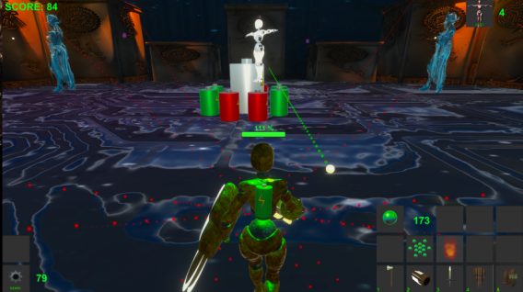

## GREEN

This is a regular battery that restores your charge. If your battery life reaches 0, your robot will die and have to respawn.

## RED

While these batteries also restore a small amount of charge, their primary use is to increase ammunition for your gun.

## SUPER

A powerful battery found in hard-to-reach locations or rarely dropped after killing a monster. This will greatly increase your charge.

## GEAR-UP

Restores your charge to normal levels, gives you access to basic weapons and if your ammunition is below 300 it’ll raise it.

# WEAPONS:

In order to protect yourself from the battery draining enemies you encounter, you’ll need some weapons! They can be obtained from vending machines, enemies, or by finding them around the world.

## AXE

C:\Users\Chris\AppData\Local\Microsoft\Windows\INetCache\Content.Word\Axe.png This is a simple yet effective melee range weapon. It is very fast, but lacks range and power. It can be upgraded with electric elemental energy.

## GUN

C:\Users\Chris\AppData\Local\Microsoft\Windows\INetCache\Content.Word\Gun.png Your primary ranged weapon. It is the most versatile as well since it offers various firing modes and elemental power-ups that affect the strength and attributes of your projectiles. Each shot consumes ammunition that can be replenished through Red Batteries.

## GREATSWORD

C:\Users\Chris\AppData\Local\Microsoft\Windows\INetCache\Content.Word\GS.PNG This is a slow but powerful melee weapon. It can be upgraded with fire elemental energy.

## SHIELD

C:\Users\Chris\AppData\Local\Microsoft\Windows\INetCache\Content.Word\KiteShield.png A shield increases your passive defense and will also occasionally block ranged projectiles if positioned right. It has similar attack power to the axe if you use it offensively, although it is much slower. It can be upgraded with ice elemental energy for a more active form of defense.

## JETBOOSTER

C:\Users\Chris\AppData\Local\Microsoft\Windows\INetCache\Content.Word\JetBooster.png Activating the jet booster gives your robot a temporary boost in speed, which is great for avoiding boss attacks or collecting batteries. It can be updated with arcane elemental energy to increase your mobility even further.

# WEAPON POWER-UPS:

  

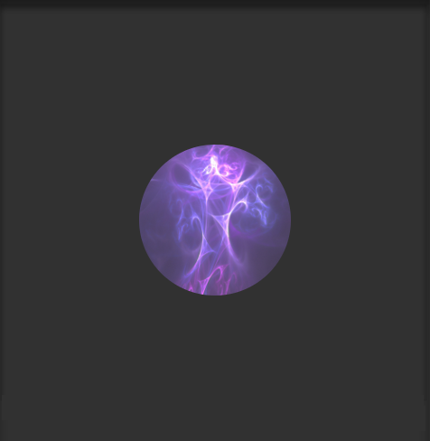

 



When killing an enemy there is a chance it will drop a cube containing elemental energy. This will upgrade the corresponding weapon that is attuned to that energy. These power-ups can also be found in obscure locations so keep an eye out for them!

# ARMOUR:

Battery bot’s armour can be modified to have increased passive defense and some other features (including thorns damage to enemies on hit, higher jumps, and immunity to fall damage). Be sure to look carefully in exploration mode to find an upgrade to your boots, legs, body and helmet!

# GEARS: C:\Users\Chris\AppData\Local\Microsoft\Windows\INetCache\Content.Word\GEARS.PNG

Gears are a form of currency in this world. Small steel ones are worth less than the large electric gold ones. They’re used in vending machines to exchange for all sorts of pickups, batteries, weapons and upgrades.

# PORTALS:

In single-player exploration mode, from the Overworld you can interact with the portals to enter new worlds. Upon completing a world, you’ll be awarded a portal back to the Overworld and a key to the next level. Press the interact key (default – “F”) while aiming at the purple cube to enter one.

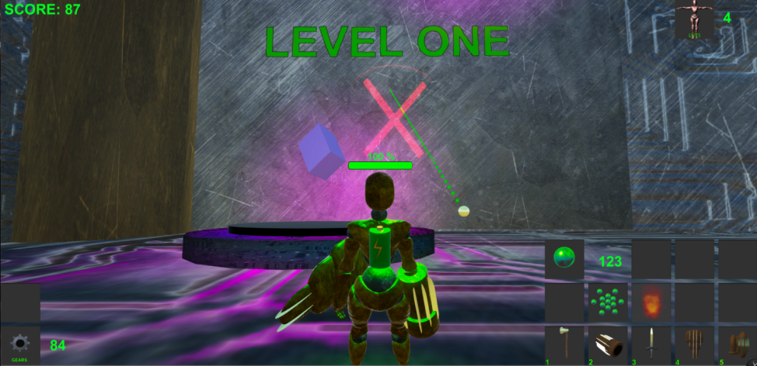

# ENEMIES:

There are Non-Player Characters (NPC’s) that want to steal your battery charge. Use your weapons to destroy them. Here are a few of the basic enemies you’ll encounter early on:

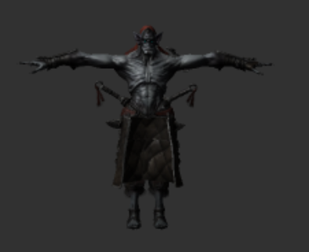

Vampire

This is a basic melee enemy that will walk around until you get too close. It will then attempt to chase you, only attacking once you get in attack range. They are easily dispatched with a ranged weapon in a few hits. There are fire, arcane and poison varieties.

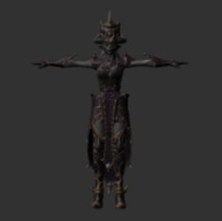Caster

These enemies conjure magical attacks from a medium distance. There are fire, arcane and poison varieties.

# BOSSES:

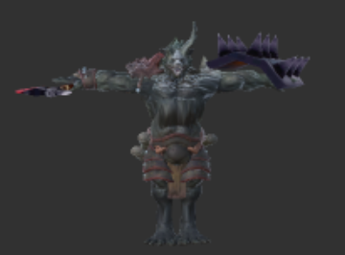

These enemies are usually found guarding portals at the end of a level. They are extremely powerful and have much more complicated behaviour patterns. There are also positional and terrain elements, for example the boss at the end of level 3 will use the platform beneath you to shoot projectiles in various patterns.

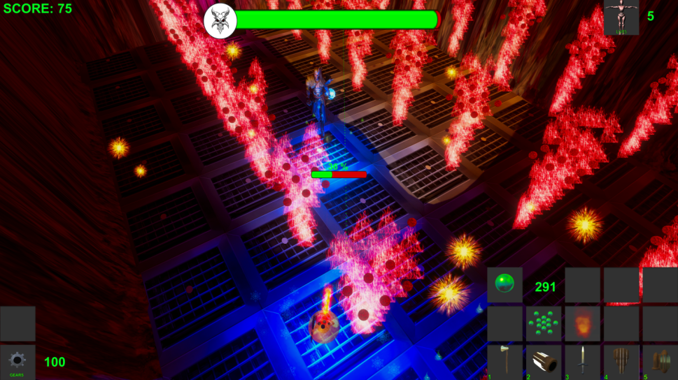

# 3rd Party Components:

## MUSIC:

* Storm Signals by Mbius
* RoleMusic (several tracks)

SOUNDS**:**

* [www.soundjay.com](http://www.soundjay.com)
* [www.soundbible.com](http://www.soundbible.com)

## PREMADE ASSETS:

* [www.mixamo.com](http://www.mixamo.com)
* [www.Turbosquid.com](http://www.Turbosquid.com)
* [www.Free3d.com](http://www.Free3d.com)
* Simple Lightning Bolt (Digital Ruby)
* Skybox Volume 2
* Rain & weather from Unity asset store

## SCRIPTS:

## Mouse Look Script

* <http://answers.unity3d.com/questions/29741/mouse-look-script.html>