**Abstract**

*Facebook post performance measures how well a post performs in terms of engagement and interaction, such as likes, shares, comments, and reach. Analyzing post performance helps to understand what content is effective and preferred by the audience, and improve social media strategy accordingly. It's important for businesses and individuals looking to optimize their online presence and increase engagement with their audience.*

**Bar Chart**

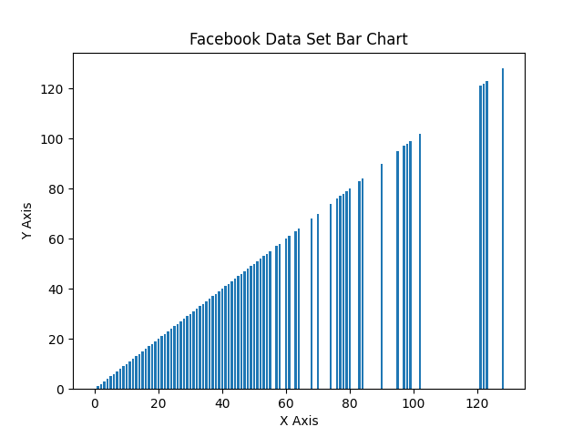

. Facebook Shares

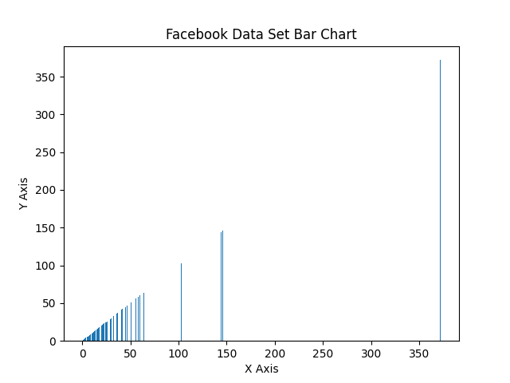

. Facebook Likes

**Analysis**

**Facebook Likes**

There are several descriptive measures that can provide useful insights. The first measure is the frequency or count of likes for each category in the bar chart. This gives us an idea of the popularity of different types of content or topics. By examining the frequency of likes across different categories, we can identify the most and least popular types of content and adjust our social media strategy accordingly.

**Facebook Shares**

A bar chart that displays the number of Facebook Shares, there are several descriptive measures that can provide useful insights. The first measure is the frequency or count of shares for each category in the bar chart. This gives us an idea of the relative popularity of different types of content or topics. By examining the frequency of shares across different categories, we can identify the most and least popular types of content and adjust our social media strategy accordingly.

**Scatterplots**

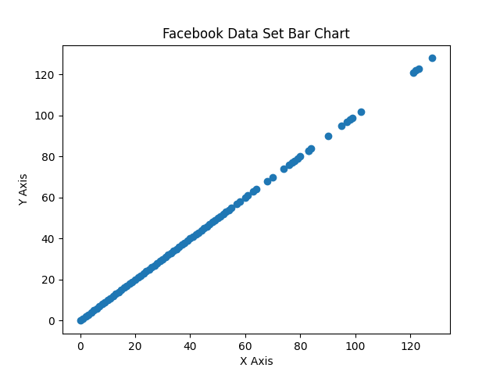

. Facebook Shares

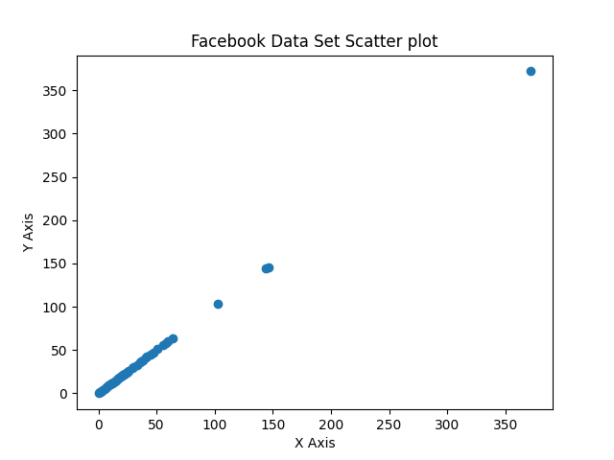

**4**. Facebook Likes

**Analysis**

**Facebook Likes**

Which measures the amount of variation or spread in the data. A higher standard deviation indicates that the data points are more spread out, while a lower standard deviation indicates that the data points are more tightly clustered around the mean. Understanding the standard deviation can help us interpret the range of Facebook Likes and assess the degree of variability in popularity.

**Facebook Shares**

The first measure is the mean, which represents the average number of shares. The mean can give us an idea of the typical level of engagement a post or page receives. However, the data point can greatly affect the mean, making it less reliable. In this case, it may be better to use the median, which represents the middle value in the dataset. The median is less sensitive to the data point and provides a more accurate measure.

**Box Chart**

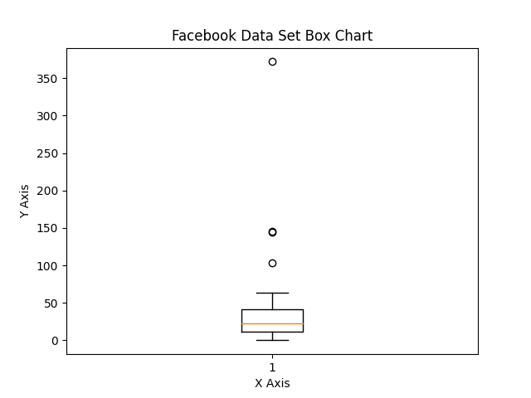

. Facebook Shares



. Facebook Likes

**Analysis**

**Facebook Likes**

A box chart is the interquartile range (IQR), which represents the spread of the distribution of likes. A larger IQR indicates a greater variability in the number of likes, while a smaller IQR indicates a more consistent number of likes. By watching the IQR, we can gain a better understanding of how much variability there is in the number of likes for different types of content.

**Facebook Shares**

The first measure is the mean, which represents the average number of shares. The mean can give us an idea of the typical level of engagement a post or page receives. However, outliers can greatly affect the mean, making it less reliable. In this case, it may be better to use the median, which represents the middle value in the dataset. The median is less sensitive to the data point (outliers) and provides a more accurate measure of central tendency.