Varoun Hanooman

ATIM  UWI

ATIM PRogress Report

# Hough Transform Progress

3 different methods were used to detect lines using the images from the drone test. The 3 methods will be noted below.

The first method is a standard hough transform. This method yields mediocre results.

The second method is a probabilistic hough transform which yields much better results, but earth surface creates a lot of unnecessary lines.

The third method is a probabilistic hough transform where the image is thresholded before using the canny edge detector. This yields the best results by filtering the lines of the earth surface.

Below are the images of the results:

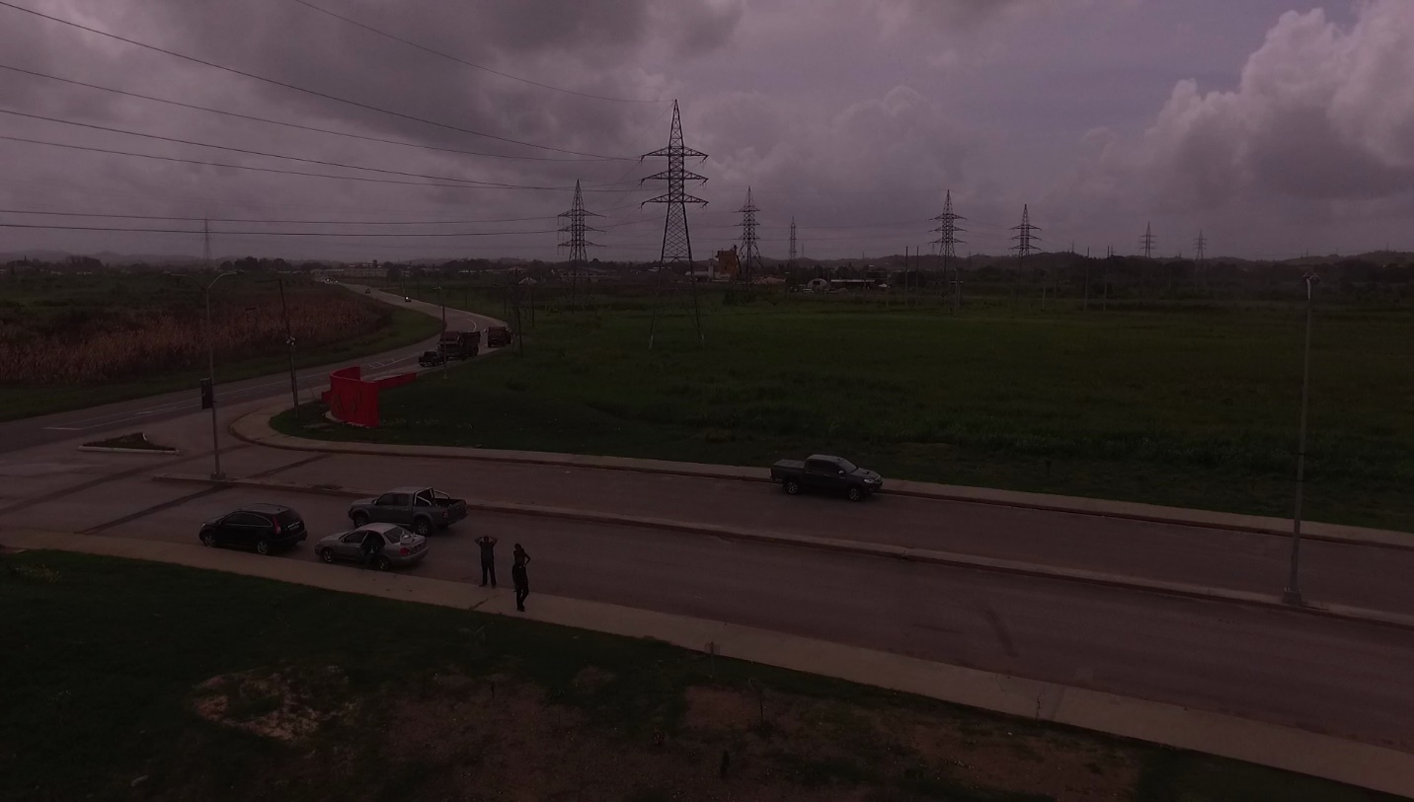

Figure : Original Image before any visual processing

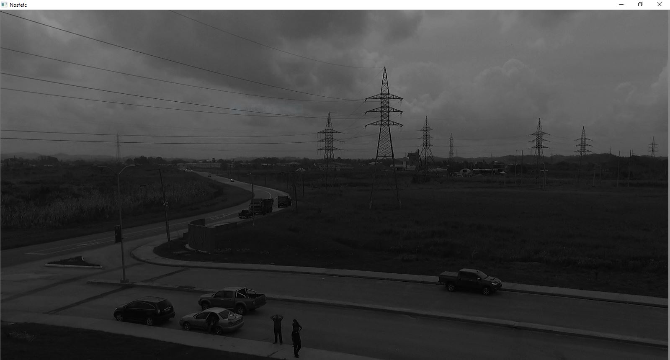

Figure : Original Image greyscaled

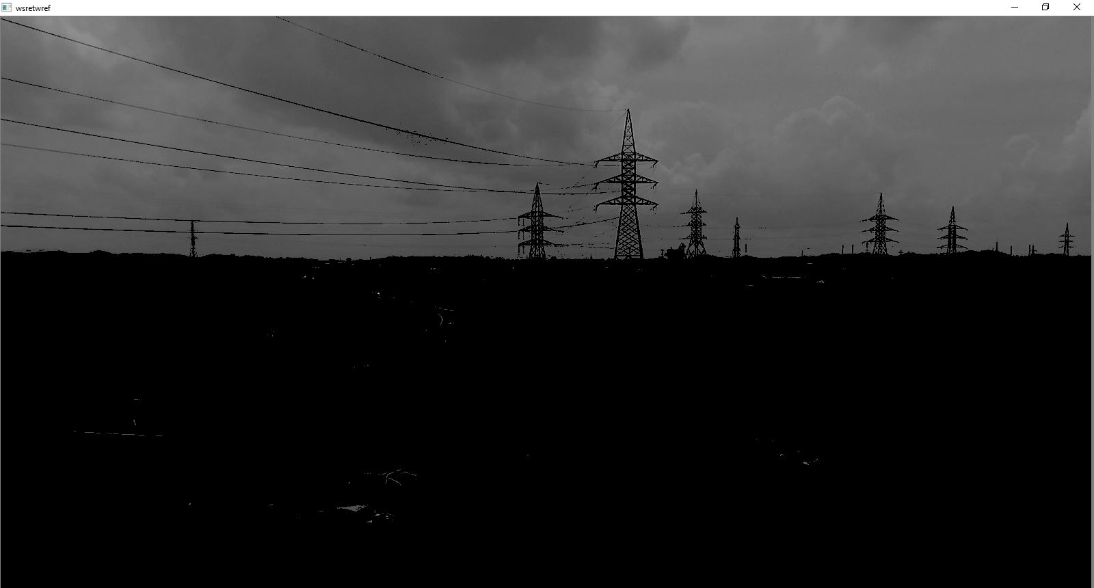

Figure :Greyscaled image thresholded

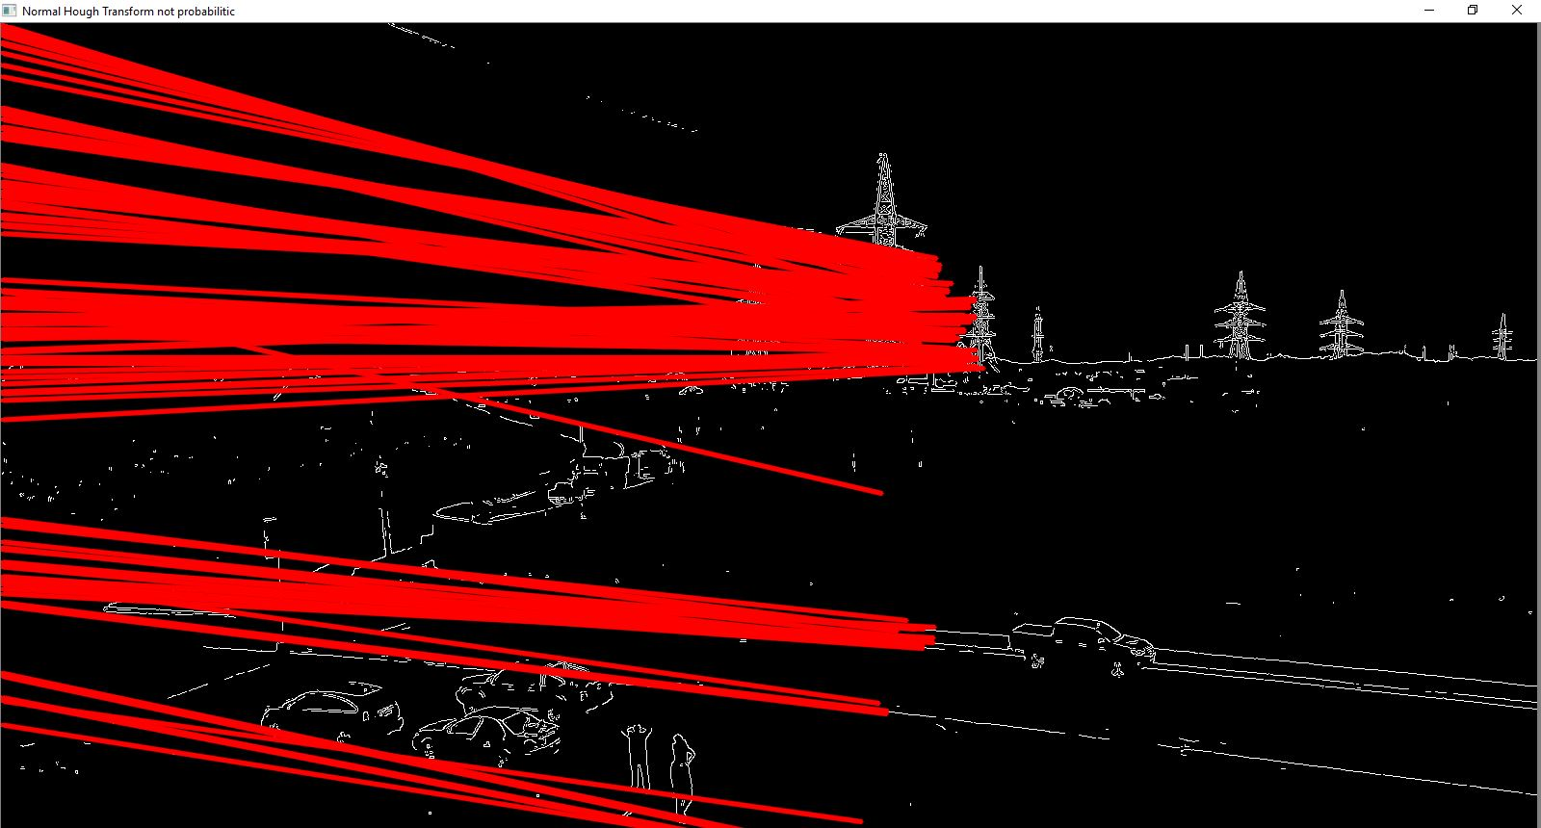

Figure : Normal Hough Transform

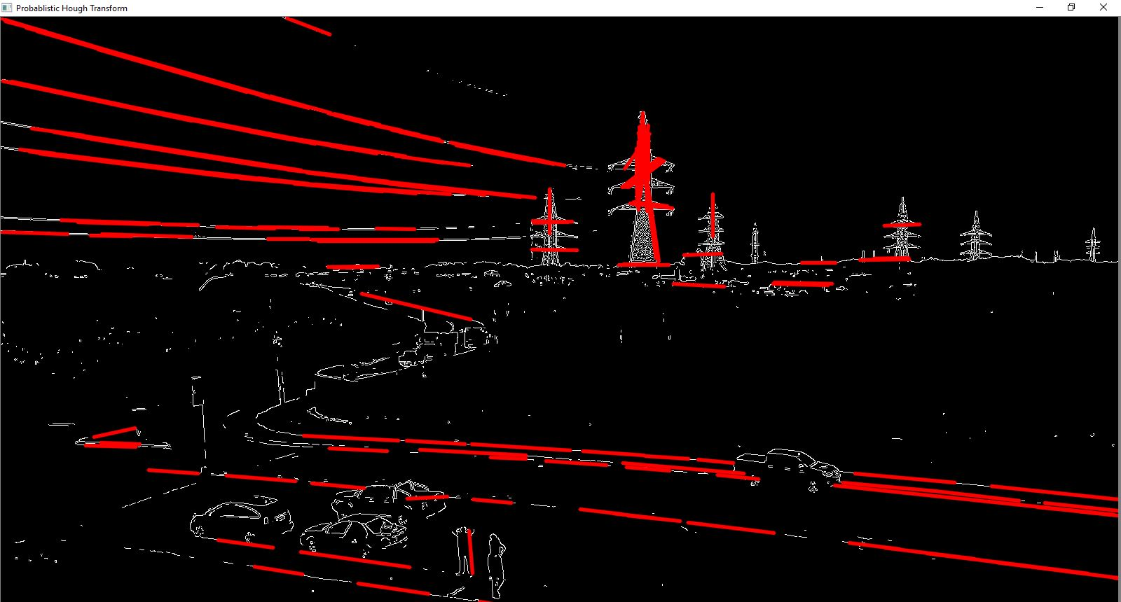

Figure : Probabilistic Hough Transform

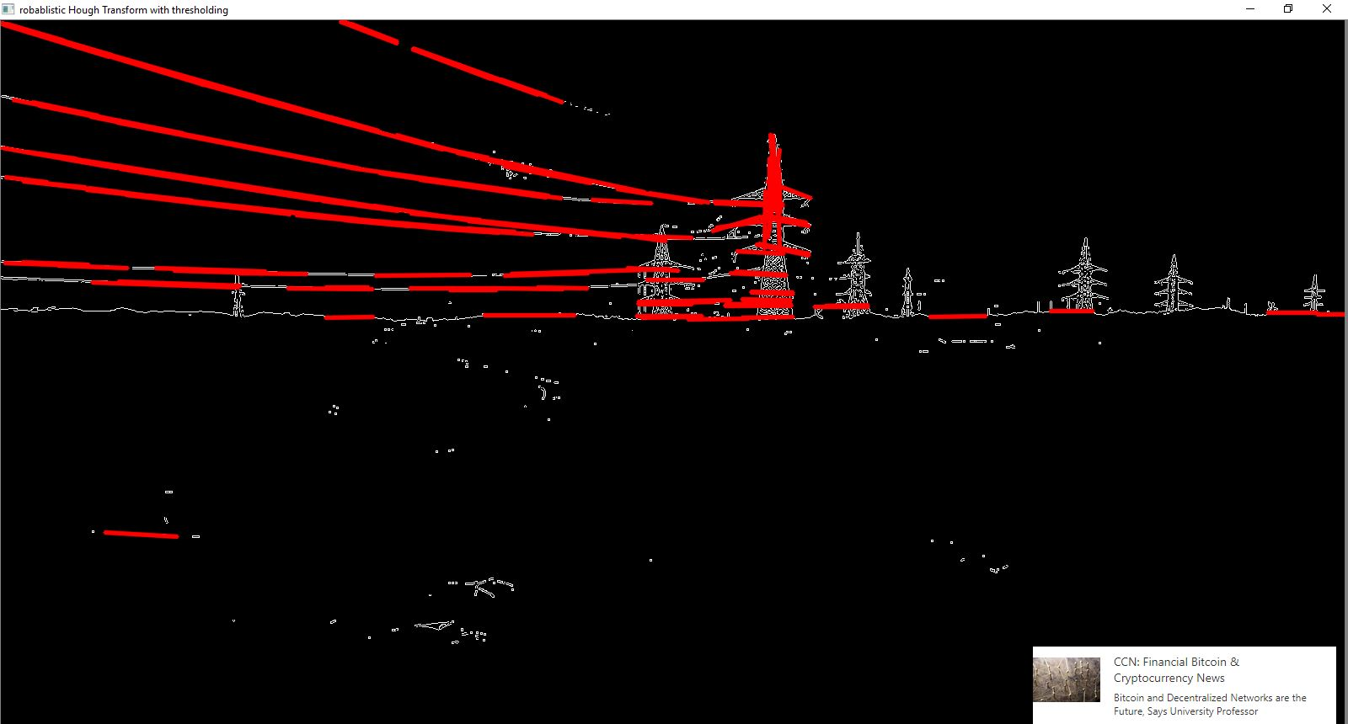

Figure : Probabilistic Hough Transform with Thresholding

The probabilistic hough transform was applied to the webcam and a powerline was tested. Results are shown below.

The Video below shows real time line detection using OpenCV

<https://youtu.be/bzgEKzGXpMk>