Christopher Badolato

Experiment 3 Three-Bit Binary Adder

EEE 3342 LAB 0014

10/7/2018

**Objective:**

* We will design a Thee-Bit Binary adder using discrete gates
* Using a one-bit half adder and two one-bit full adders we will create this three-bit adder.

Block Diagram:

Hand draw

Apparatus List:

Procedure and/or Design Methodology:

Design Specification Plan:

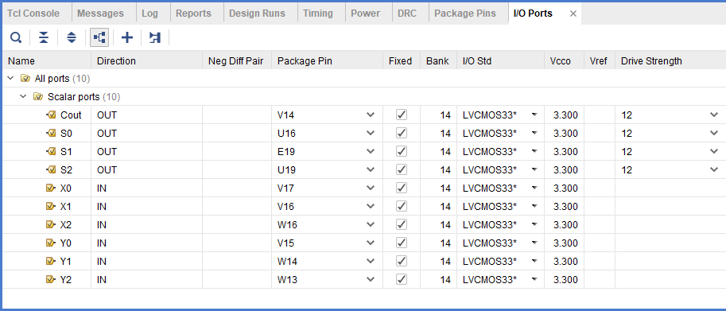

Detailed Schematic Diagram:

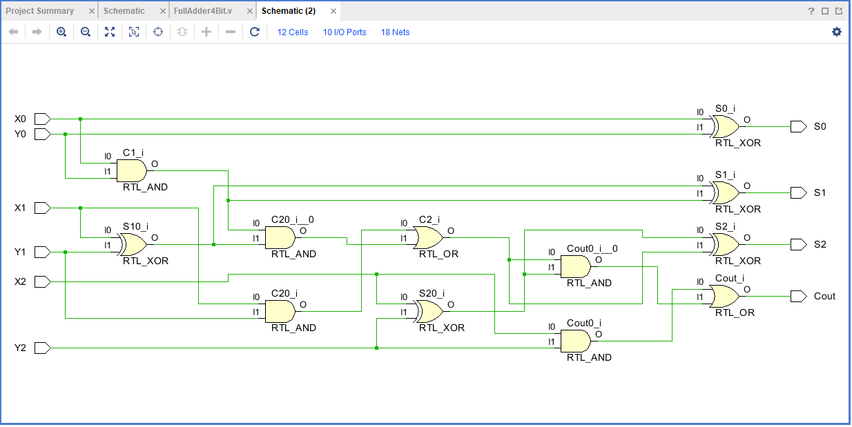

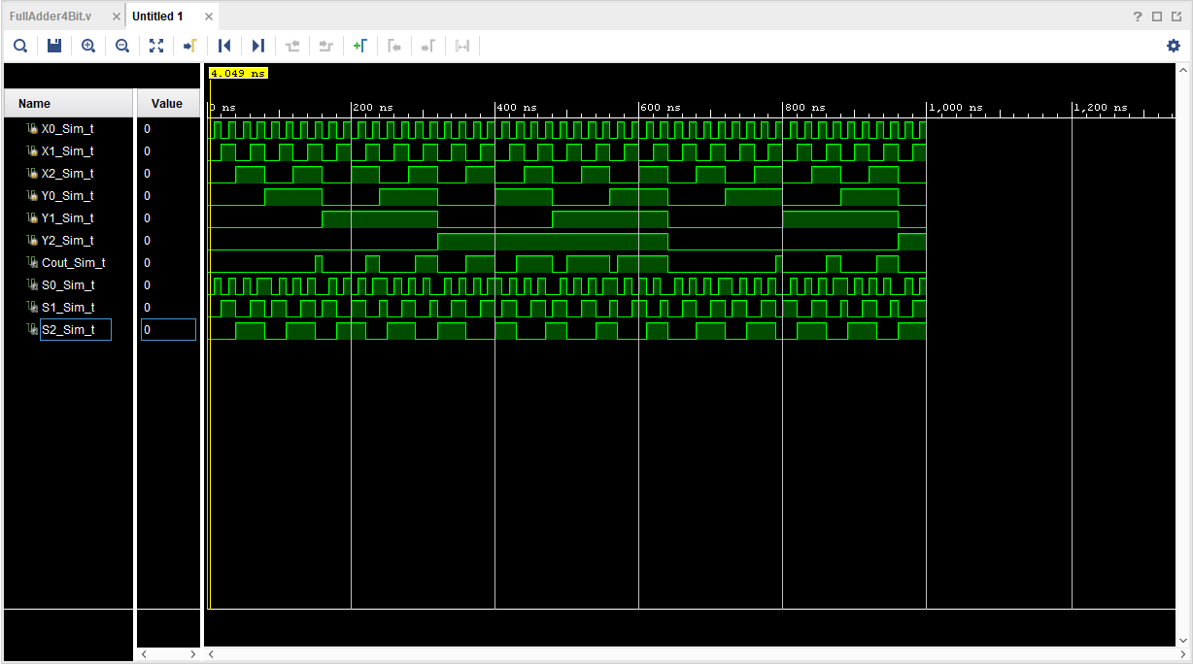

Test Plan:

Results:

Conclusion

Questions:

(To be incorporated in the Conclusion section of your laboratory report.)

1. Using full adder and half adder block diagrams, draw an 8-bit adder diagram.
2. Comment on the feasibility of designing an 8-bit adder using the brute force method.
3. Identify the advantages and disadvantages of the brute force method.
4. Identify the advantages and disadvantages of the iterative cell method.
5. Have you met all the requirements of this lab (Design Specification Plan)?
6. How should your design be tested (Test Plan)?