**Lab # 1 DC MEASUREMENT**

# Objective

* To understand the basics of DC (direct current) circuits.
* To use a digital multimeter (DMM) to measure DC voltage, current and resistance.
* To verify the valid measurement condition for a digital multimeter.

# Equipment

* Breadboard
* DC Power supply
* Digital multimeter x 2

# Simulation

***Circuit 1-6 A***

RabWe are simulating the resistance of R2 or from our nodes A to B

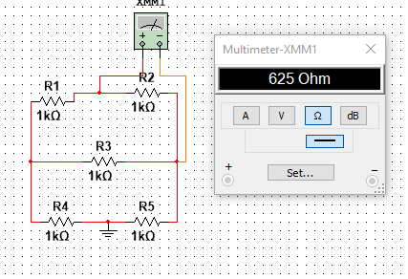

RBD  We are finding the resistance between nodes B and D 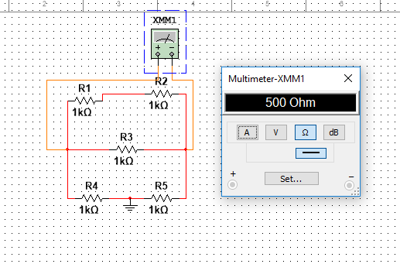

RAC We are finding the resistance between Nodes A and C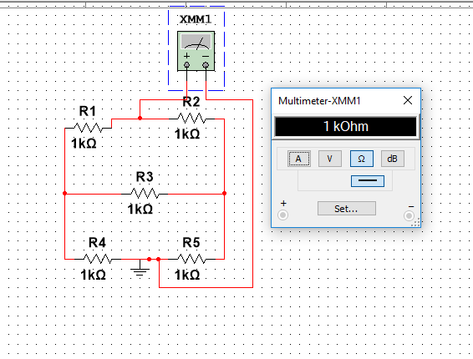

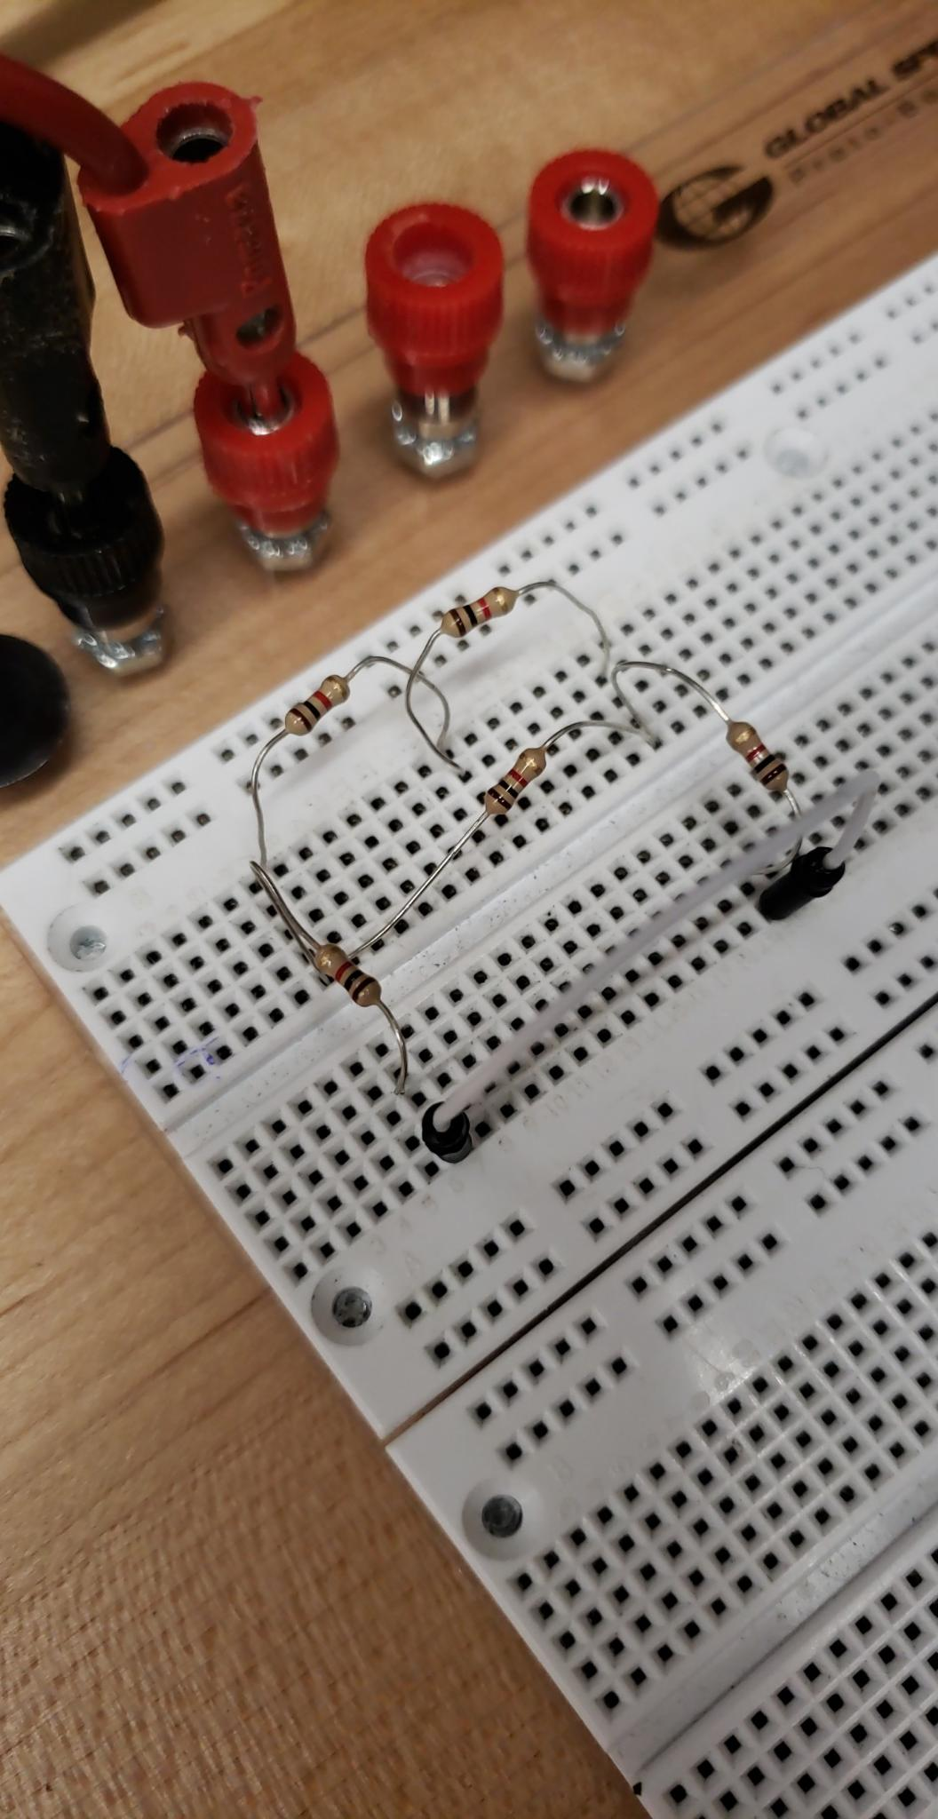

### **A.    Resistance Measurement**

1. Measure the resistance of each resistor used in this experiment using a DMM. Compare the nominal value with the measured value. The nominal value of a resistor can also be obtained from its color bands or color code.

|  |  |  |
| --- | --- | --- |
| Resistor | Nominal Value | Measured Value |
| R1 | 1k Ω | 0.9773 k Ω |
| R2 | 1k Ω | 0.9846 k Ω |
| R3 | 1k Ω | 1.0066 k Ω |
| R4 | 1k Ω | 0.9817 k Ω |
| R5 | 1k Ω | 0.9752 k Ω |

1. Construct the circuit in Figure 1 – 6 (a) on a breadboard and measure the equivalent resistances RAB, RBD and RAC. LEAVE THIS CIRCUIT IN PLACE for additional measurements.

|  |  |  |
| --- | --- | --- |
| Resistor | Simulated Value | Measured Value |
| RAB | 0.625 kΩ | 0.6129 k Ω |
| RBD | 0.500 kΩ | 0.4914 k Ω |
| RAC | 1.0 k Ω | 0.9869k Ω |

### **B.    Voltage and Current Measurement**

1. For the circuit in Figure 1 – 6 (a), perform the following steps.
   1. Measure the equivalent resistance RAB again using one DMM. At the same time, use a second DMM to measure the voltage across the first DMM (between nodes A & B). Then, use the second DMM to measure the current supplied by the first DMM.
   2. Repeat all the steps in Part a for RBD and RAC.

|  |  |
| --- | --- |
| Resistor | Measured current values supplied |
| RAB | .003 µA |
| RBD | .003 µA |
| RAC | .003 µA |
| VAB | 1.8378 x 10-6 V |
| VBD | 1.474 x 10-6 V |
| VAC | 2.9607 x 10-6 V |

* 1. For all three cases, determine the ratio of the measured voltage to the measured current. What observations or conclusions can be made based on the ratios?

A conclusion we can draw from the ratios of measured voltage to measured current, is that the current being supplied by the first DMM is negligible to the value of our voltage. This is because the value of the current is so small.

***Circuit 1-6 B***

Since these resistors are in series to find the current across the circuit we must put our multimeter in series as well.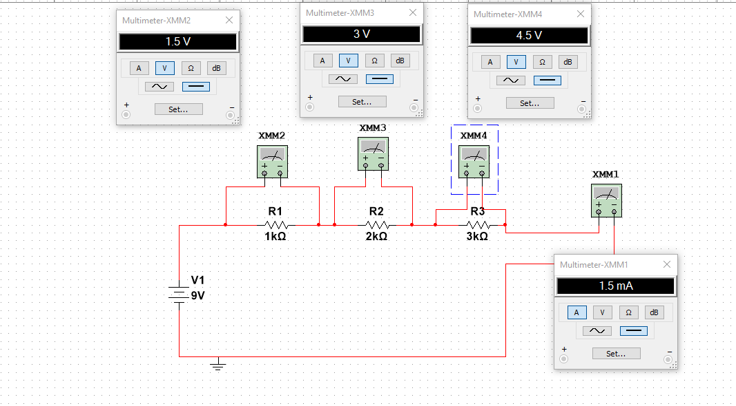

1. For the circuit in Figure 1 – 6 (b), measure V1, V2, V3 and IS.

|  |  |  |
| --- | --- | --- |
| Resistor | Nominal Value | Measured Resistance |
| R1 | 1 kΩ | 0.9825 kΩ |
| R2 | 2 kΩ | 1.9711 kΩ |
| R3 | 3 kΩ | 2.9568 kΩ |

|  |  |  |
| --- | --- | --- |
|  | Simulated values | Measured Value |
| V1 | 1.5 V | 1.49521 V |
| V2 | 3.0 V | 3.00068 V |
| V3 | 4.5 V | 4.50069 V |
| is | 1.5 mA | 1.5231 mA |

***Circuit 1-6 C***

In these two circuits we will change the resistance of each resistor to notice the change in voltage due to the internal resistor on the multimeter

10k ohm resistors

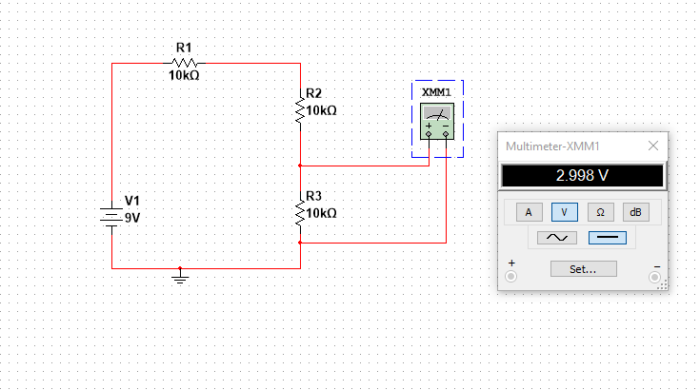

10M ohm resistor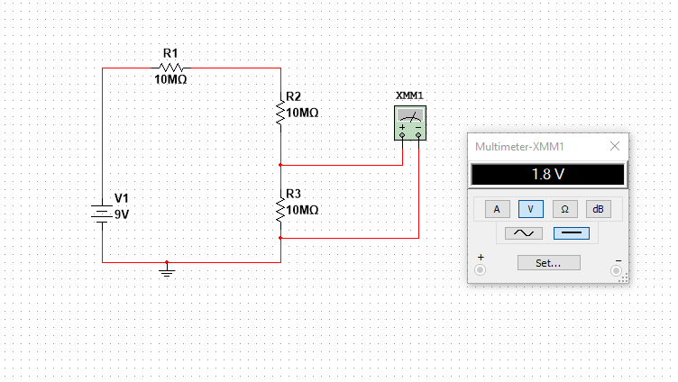

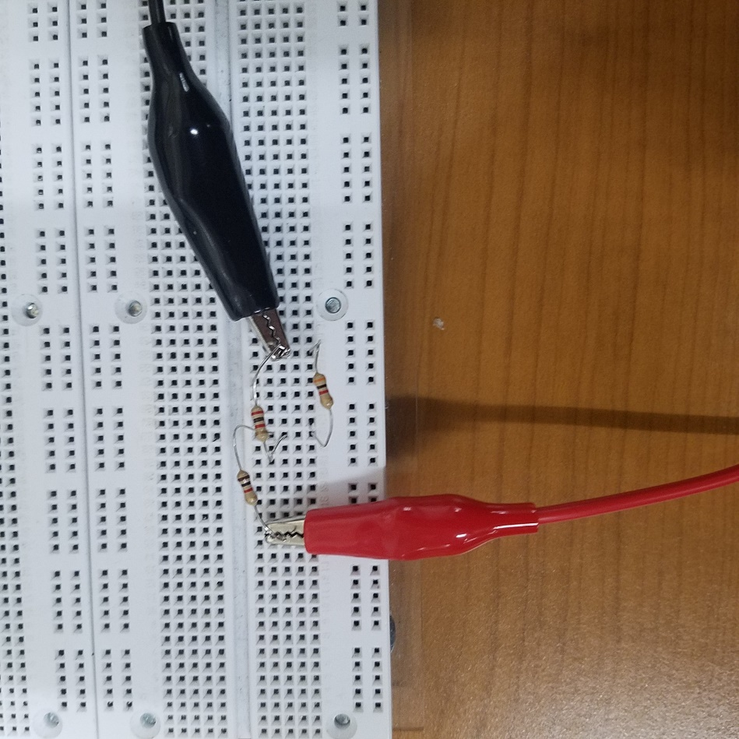

1. For the circuit in Figure 1 – 6 (c), measure VOfor both cases considered in PREPARATION.

|  |  |  |
| --- | --- | --- |
| Resistors | Simulated Value (Vo) | Measured Value |
| 10 MΩ | 1.8 V | 1.9425 V |
| 10 kΩ | 2.998 V | 3.0078 V |

***Circuit 1-6 D***

To find each current we must put our multimeters in series with the resistors as so

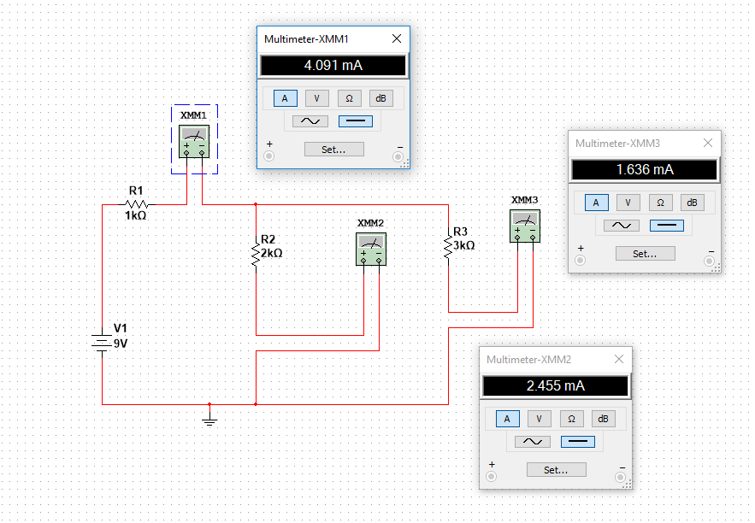

1. For the circuit in Figure 1 – 6 (d), measure I1, I2, and I3.

|  |  |  |
| --- | --- | --- |
| Resistor | Simulated Values | Measured Values |
| R1 | 1 kΩ | 0.9825 kΩ |
| R2 | 2 kΩ | 1.9711 kΩ |
| R3 | 3 kΩ | 2.9568 kΩ |
| Req | 2.2 kΩ | 2.16507 kΩ |

|  |  |  |
| --- | --- | --- |
| Current | Simulated Vale | Measured Value |
| i1 | 4.091mA | 4.1364mA |
| i2 | 2.445mA | 2.4881 mA |
| i3 | 1.636mA | 1.6628mA |

**Test of Knowledge**

Using the 10 rows of holes between the 6 screws on either the top or bottom half of the breadboard, perform the following experiments. Adjust the range of values of the DMM if a measured value displayed on the DMM is out of range or has insufficient precision.

1. Measure the resistance between any two holes on the 1st and 2nd row that are on the **same** column.

.100 Ω

The resistance is very low because we are just touching two metal plates with high conductivity

1. Measure the resistance between any two holes on the 1st and 5th row that are on the **same** column.

.100 Ω

The resistance is very low because we are just touching two metal plates with high conductivity

1. Measure the resistance between any two holes on the 1st and 6th row that are on the **same** column.

.100 Ω

‘There is no metal between the two probes so we can conclude that this is like an open circuit with no added elements

1. Measure the resistance between any two holes that are on two **different** columns.

.090 Ω

There is a slight resistance when measuring the resistance between any two holes on different columns

1. Measure the resistance of a 10kΩ resistor without having it placed on the breadboard.

9.98 kΩ

The value varies from the actually numerical value on the resistor because there is no true value resistor. There will always be a little bit of error with the resistors

1. Insert the two terminals of a 10kΩ resistor into any two holes that are on two **different** columns. Measure the resistance of the resistor.

10 kΩ

Although they are in different columns the resistance of the resistor is 10 kΩ, since the resistor is the only element in the circuit.

1. Insert the two terminals of a 10kΩ resistor into any two holes on the 1st and 5th row that are on the **same**column. Measure the resistance of the resistor.

10 kΩ

Although they are in same columns the resistance of the resistor is 10 kΩ, since the resistor is the only element in the circuit, we are still connecting two nodes.