# **#5: Second Order Circuits**

Christopher Badolato

Yajaira Varillas Perez

EEL3123C-0013

2/27/2019

## **Objectives**

* To study the step response of second order circuits.
* To understand the difference between overdamped, critically damped and underdamped responses.
* To determine theoretically and experimentally the damped natural frequency in the underdamped case.

## **Equipment**

* Breadboard
* Function generator
* Oscilloscope
* Digital multimeter (DMM)
* Resistor Box (For variable resistors)

### 

### 

### 

### 

### 

### 

### **Simulations**

Figure 5-3 (a)

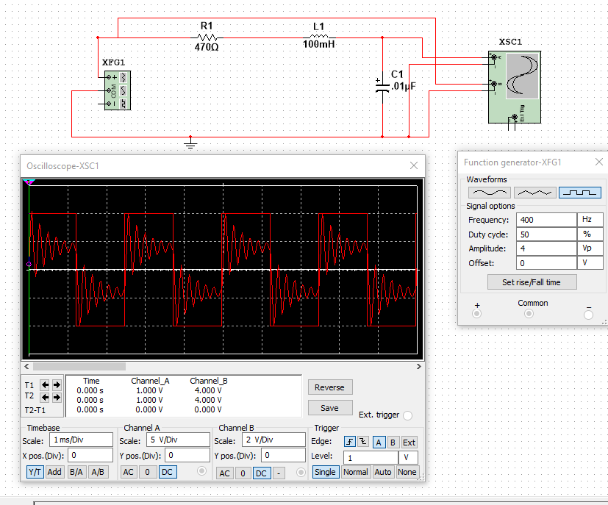

Figure 5-3 (b)

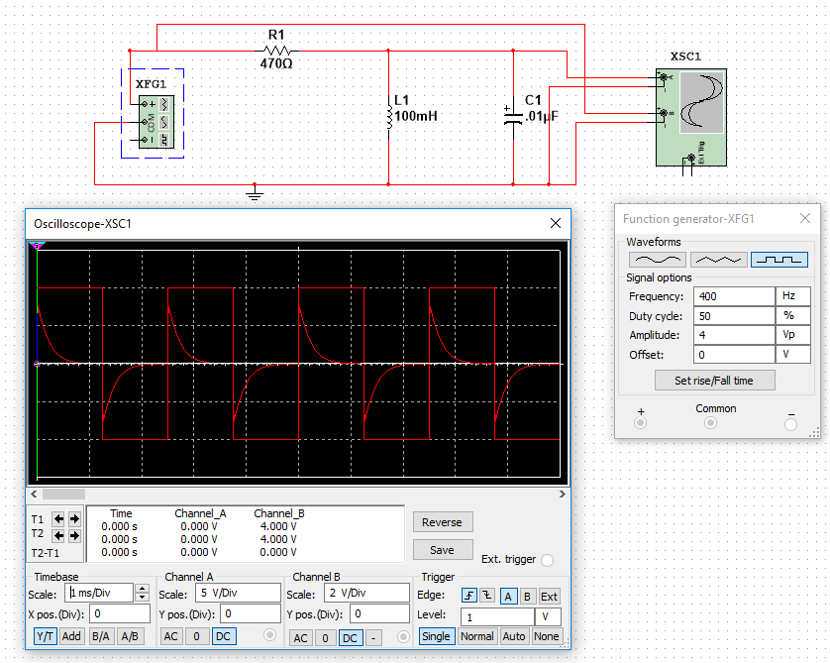

### 

The expected values shown above match the results from the preparation part of this lab. This simulations match the sketches as well from the preparation. The accountable error could be due to the graph not being to a certain scale and therefore not appearing as it should.

### 

### **A. Natural responses**

1. Use a resistor box, and set R at the values given below. Use the DMM to check the resistance values before connecting them into the circuit.

For Figure 5 – 3 (a)

1. R = 22 kΩ,

Overdamped takes off very slowly, hence the very high rise time. It will never rise above the function generator’s control graph.There are two real and distinct roots.

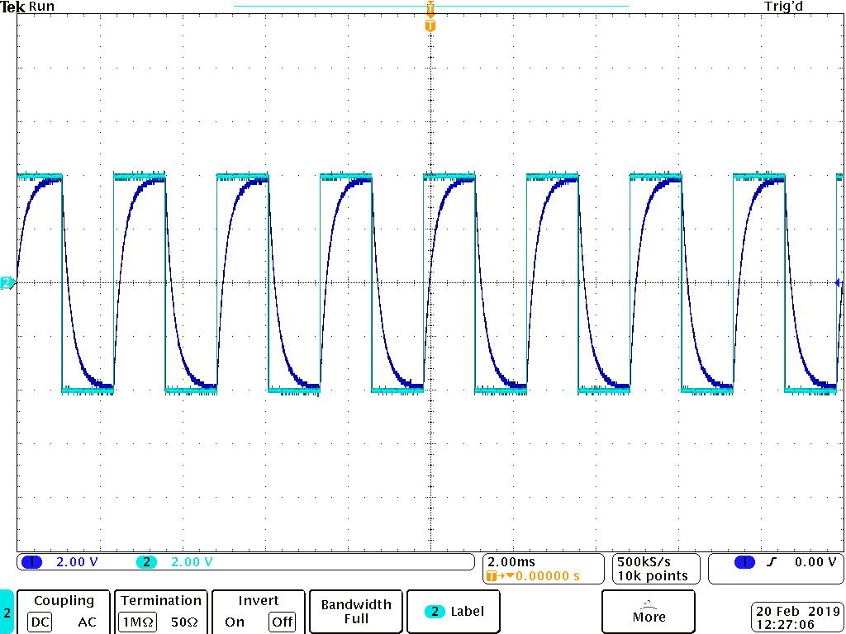

1. R = 6.3 kΩ

For Critically Damped, the graph reaches the steady state very quickly, faster than that of the overdamped graph.For critically damped there are two real equal roots

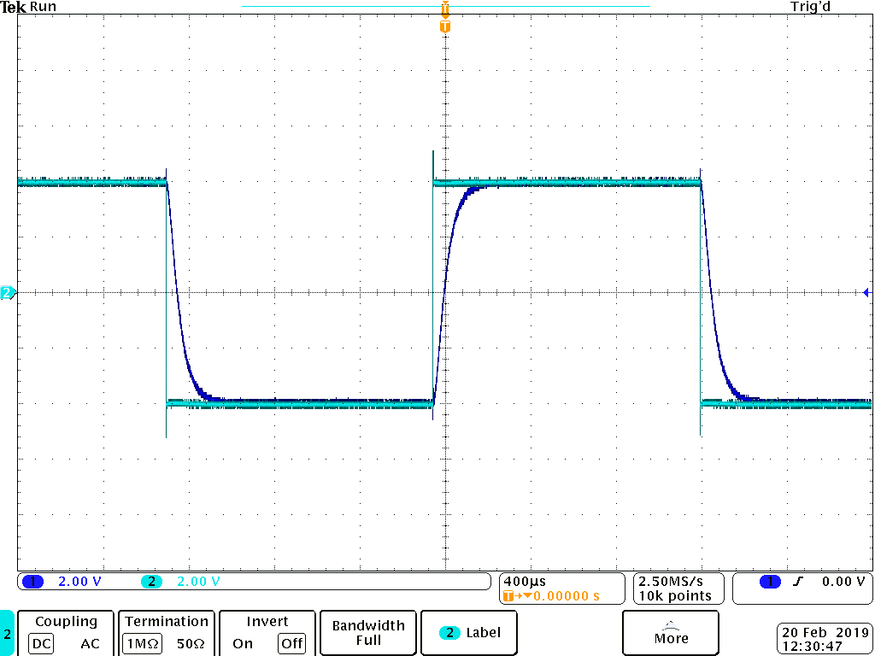

1. R = 2.2 kΩ.

Underdamped is very enthusiastic exceeding the control graph, and doing so very quickly, much faster than overdamped and critically damped, but fluxuates below the control after this overshot. For underdamped there are two complex roots

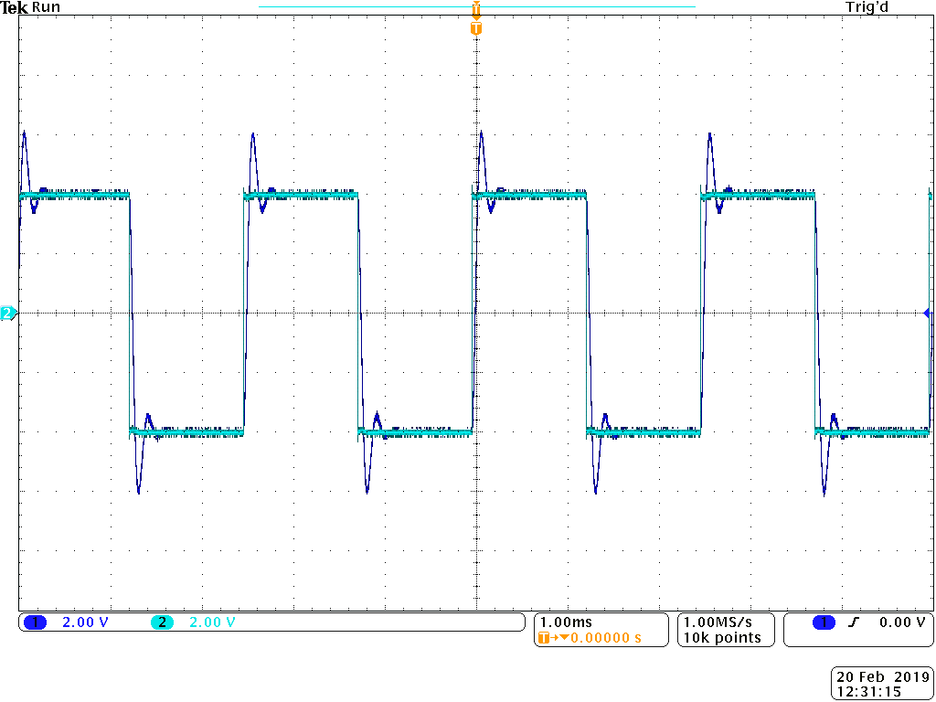

1. R = 680 Ω,

Overdamped

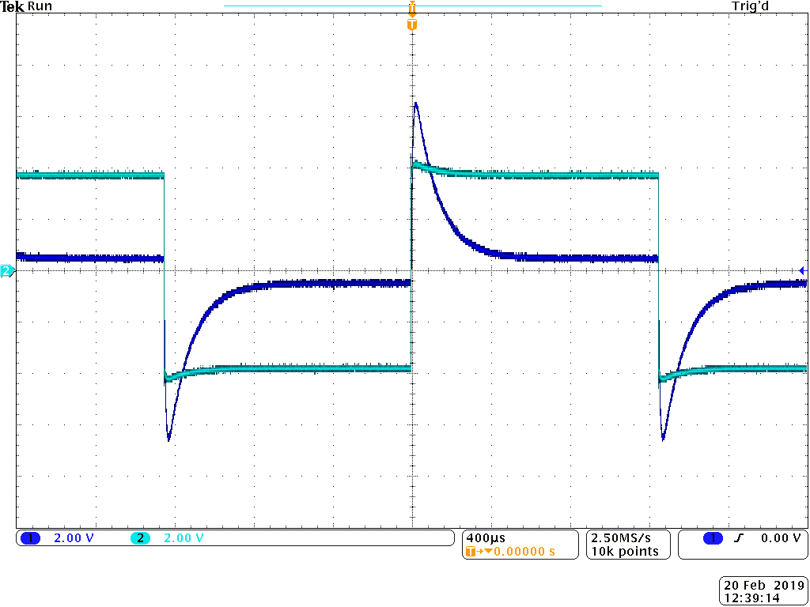

1. R = 1.6 kΩ,

Critically damped, the function generators control graph should have been moved up again, but as you can infer from the boxes the voltage graph will not exceed the control.

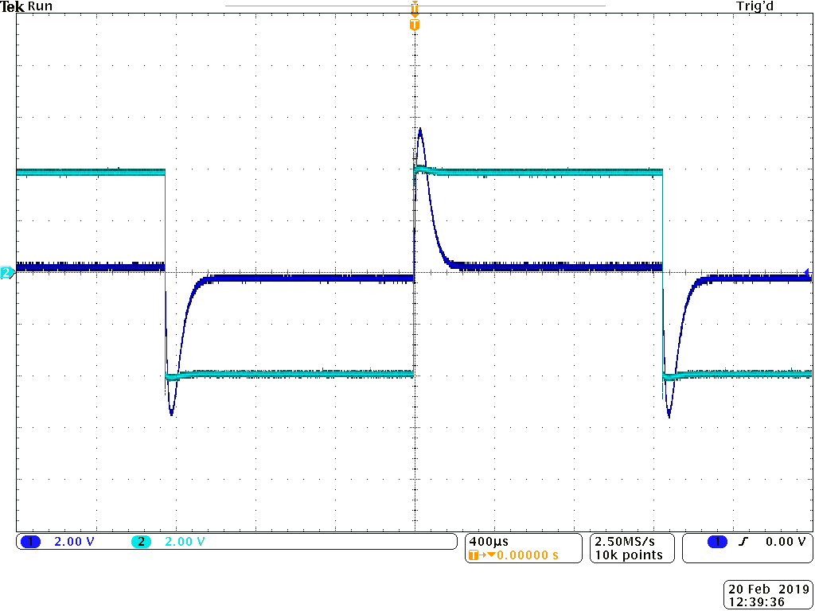

R = 4.7 kΩ.

Underdamped, at first we will exceed our control and will need time to “settle” before its next rise.

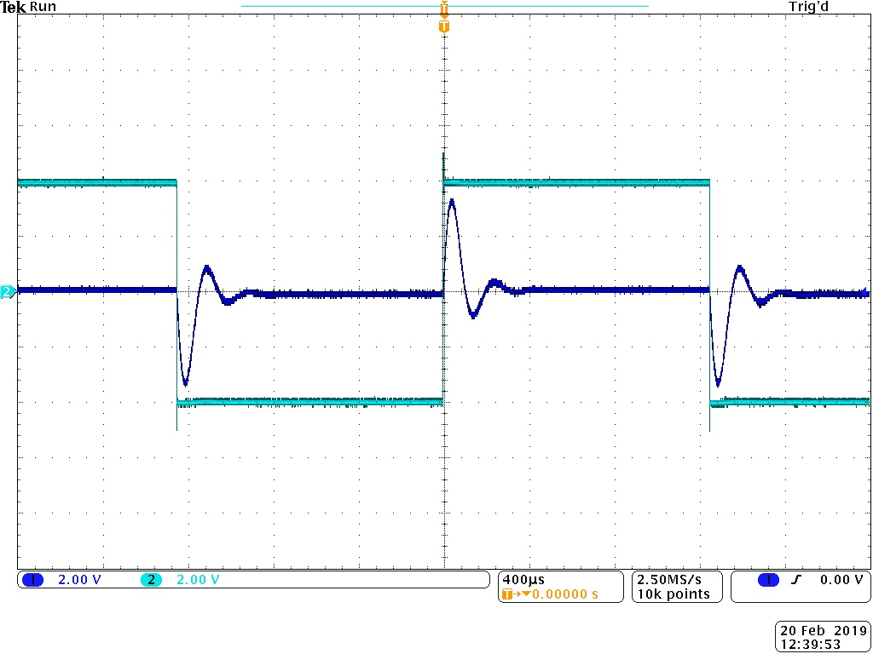

1. On the oscilloscope, connect Ch1 to the input and Ch2 to the output so that both the input and the output are displayed on the screen.
2. For each case, save the screen image with the associated measurements for both the input and the output on to a USB drive. (Follow the steps as explained in Experiment #4 to do this.)
3. For each case, indicate if the output response is overdamped, critically damped or underdamped.

### **B. Damped natural frequency measurement**

1. Set R = 470 Ω for the circuit in Figure 5 – 3 (a) or R = 22 kΩ for the circuit in Figure 5 – 3 (b), save the screen image for both the input and the output, and compare it with the results from PREPARATION and SIMULATION.

This is an underdamped response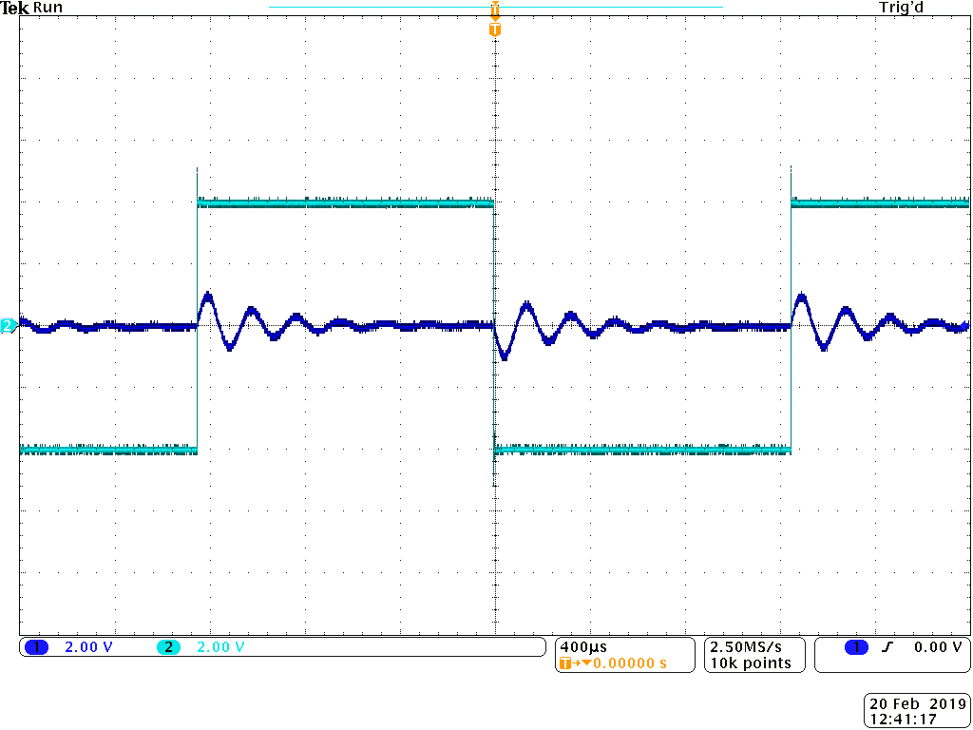

1. Zoom in on the output curve so that at least two whole oscillations (ripples) of the output from the beginning of an output cycle are displayed. Use the cursors to measure the time period Td between the first two peaks (or between two zero phases). ωd is calculated using:

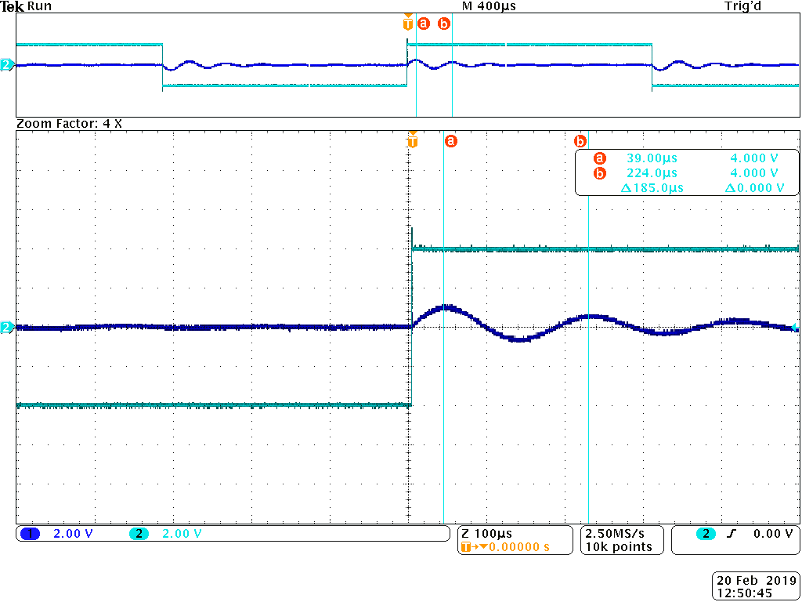

= = 33963.16 rads/s

Conclusion

In this experiment using RCL circuits that contain two energy storage elements, we are trying to study the step response of these second order circuits. Changing the resistance of R we will create different natural responses of the circuit. Doing so will help us understand the difference between, overdamped, critically damped, and underdamped responses. Finally we determined the damped natural frequency for an underdamped response.