# **#4: First Order Circuits**

Christopher Badolato

Yajaira Varillas Perez

EEL3123C-0013

2/20/2019

## 

## 

## 

## 

## 

## 

## 

## 

## 

## 

## 

## 

## **Objectives**

* To study the step response of first order circuits.
* To understand the concept of the time constant.

## **Equipment**

* Breadboard
* Function generator
* Oscilloscope
* Digital multimeter (DMM)

**Simulation**

Build and simulate the circuits in Figure 4 – 3 using Multisim. Set the input voltage to +- 5 with a frequency of 1 kHz. Display Vout(t) on the oscilloscope. Compare this result with the plot from PREPARATION step B.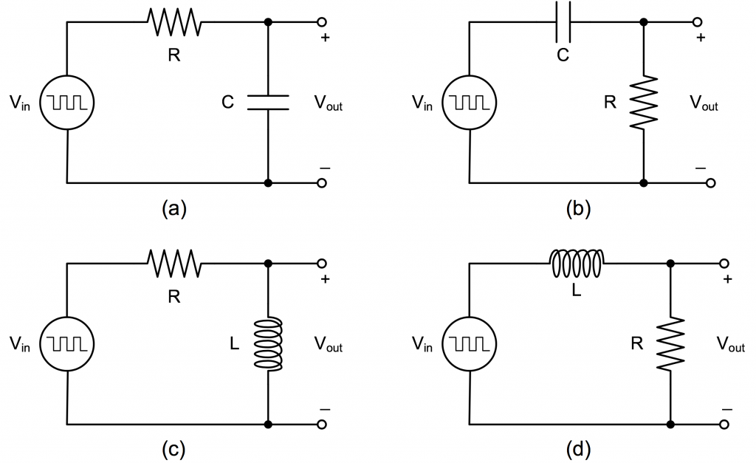

**Circuit A**

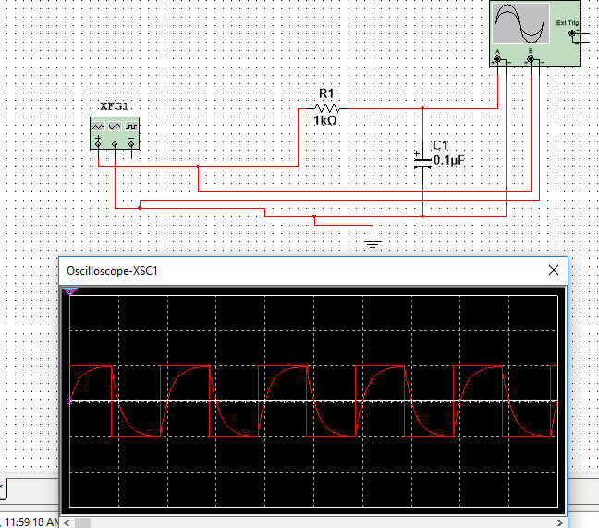

**Circuit B**

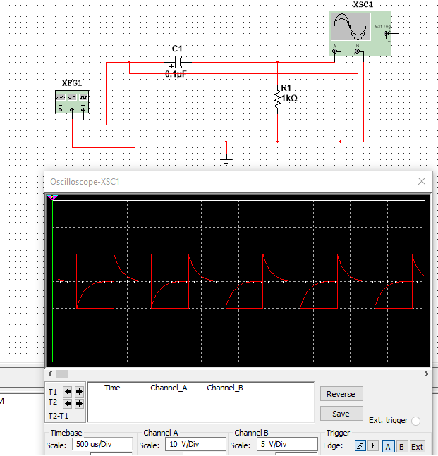

**Circuit C**

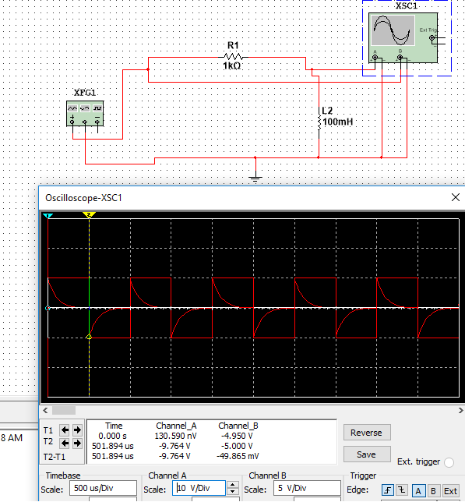

**Circuit D**

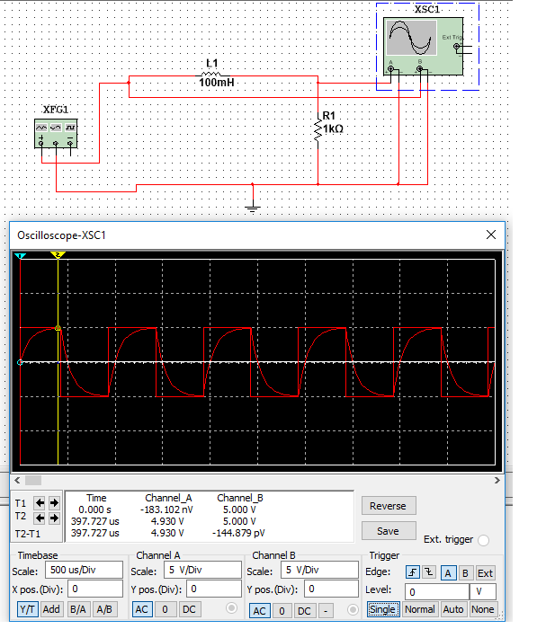

## As expected, the simulations above are the same as the plots that were plotted for the square wave input function for circuit A-D. Each wave goes from -5V to 5V just as expected from the plots that were sketched in preparation.

## **Experiment**

Use the same component values as in the PREPARATION and the same input settings used in the SIMULATION, and build the circuits shown in Figure 4 – 3 (a) – (d). Complete the measurements described below. Refer to Experiment #2 for how to use function generator and oscilloscope.

### **A. Square wave output**

On the oscilloscope, connect Ch1 to the input and Ch2 to the output so that both the input and the output are displayed on the screen. Save the screen image for both the input and the output, preferably to a USB drive. Use the ‘Menu’ button on the ‘Save/Recall’ section on the bottom of the oscilloscope screen, then use ‘File Utilities’ to select or create a folder to save the image. Press the ‘Save Screen Image’ button and use the associated buttons next to the screen to select the format or edit file name etc. Compare these waveforms with the results from PREPARATION and SIMULATION.

As shown in the previous simulations, our waveforms resulting from our measurements match up exactly!

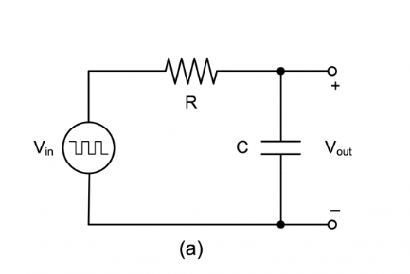

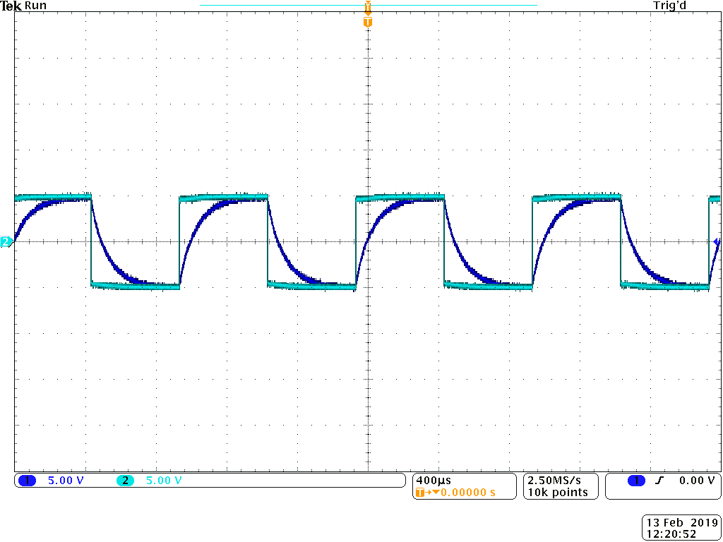

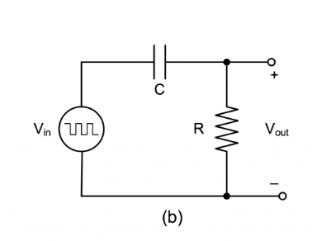

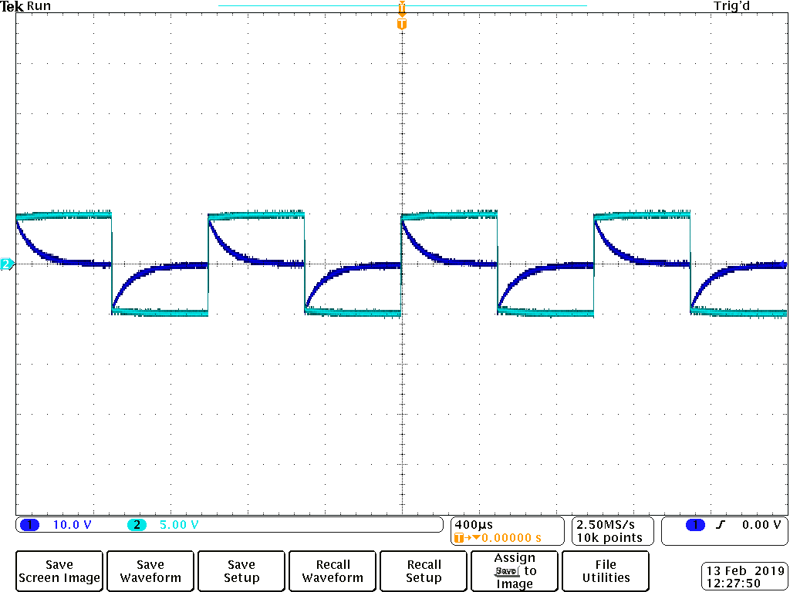

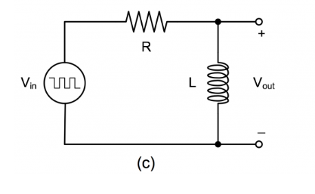

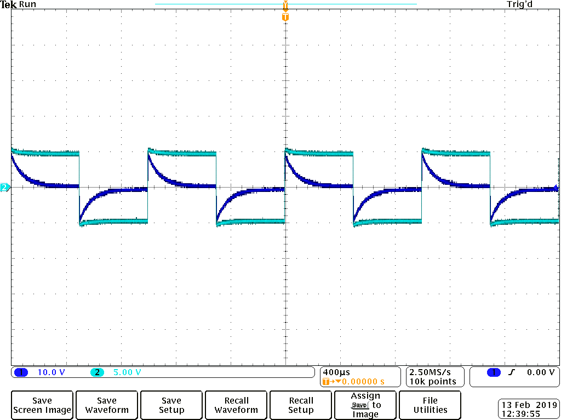

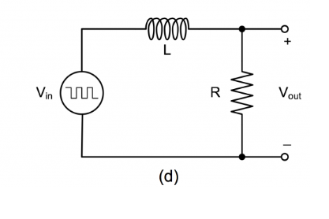

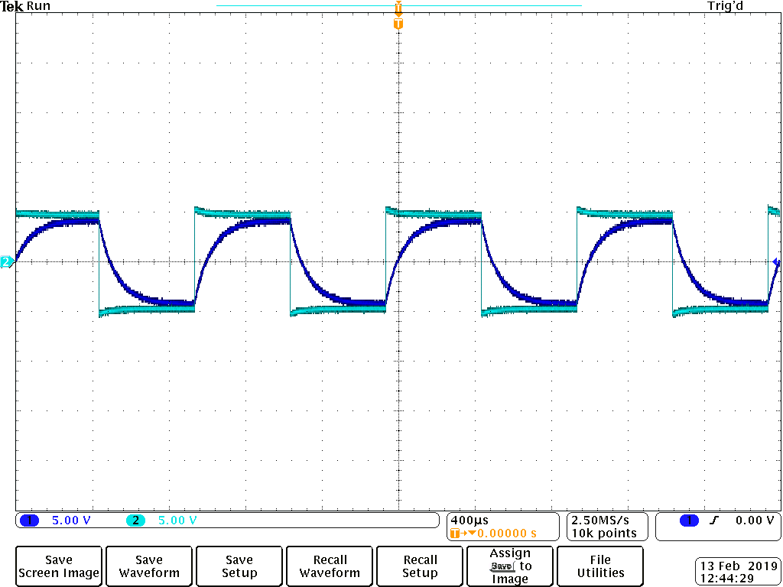

### **B. Time constant measurement**

1. Turn off the input (Channel 1) by pressing the channel number button. Now only the output is displayed on the screen.
2. Zoom in on the output curve on the oscilloscope such that a large portion (at least half a cycle) of the rise/drop of a cycle is displayed on the screen. Consider the rise and drop over one half cycle only for each circuit. Use cursors to determine the maximum voltage difference E for the output. The time it takes for the output to rise from the minimum value to 63% of E or to drop from the maximum to 37% of E is the time constant 𝜏 of the circuit. Record this time constant 𝜏 for each circuit.

**Circuit A**

|  |
| --- |
| 𝜏 = 97.00μs |

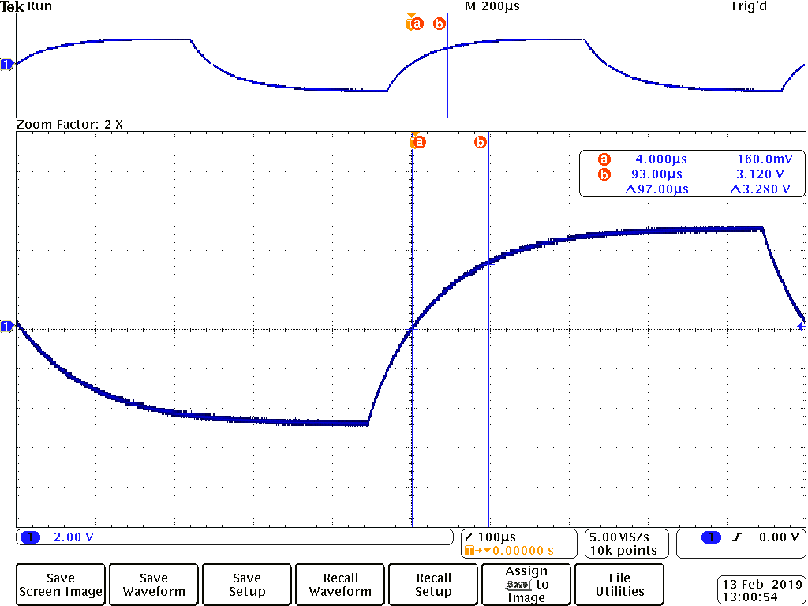

**Circuit B**

|  |
| --- |
| 𝜏 = 153.0μs |

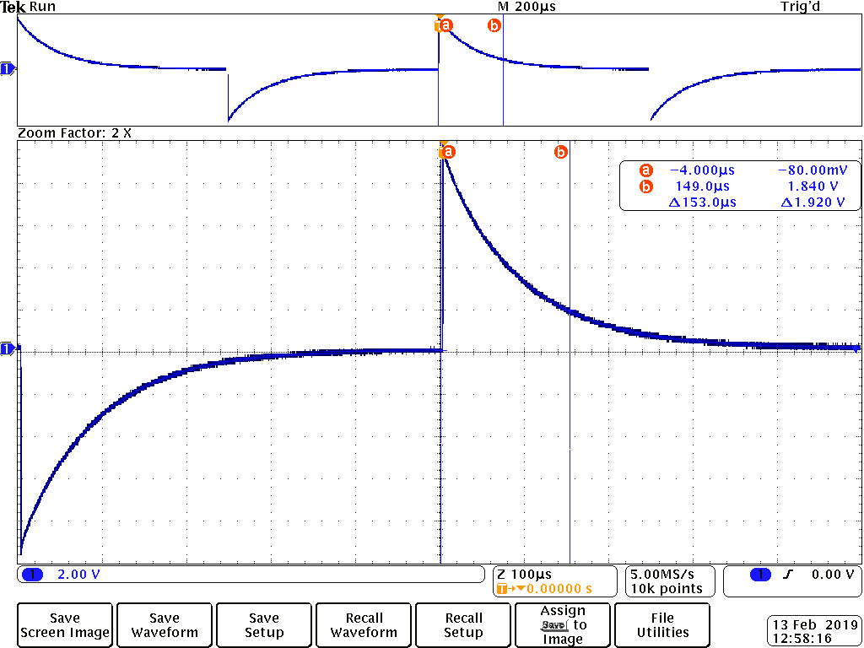

**Circuit C**

|  |
| --- |
| 𝜏 = 166.0μs |

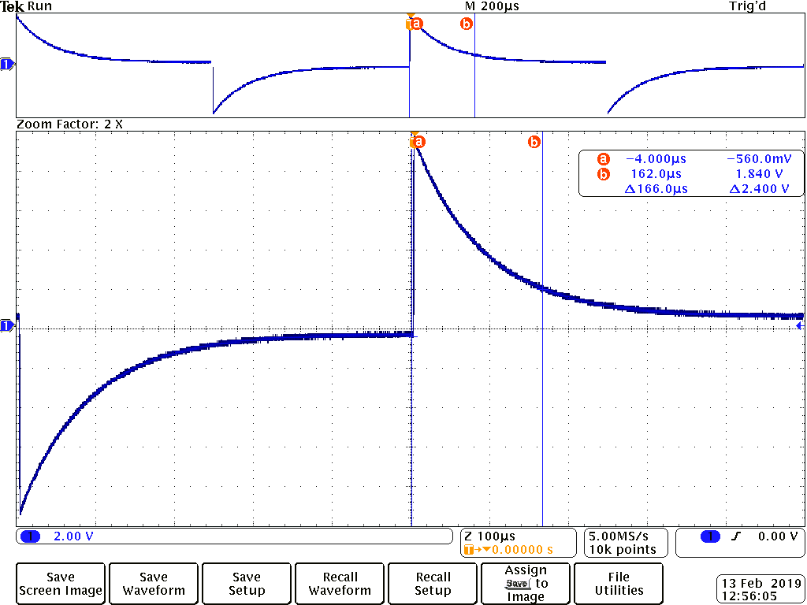

**Circuit D**

|  |
| --- |
| 𝜏 = 120.0μs |

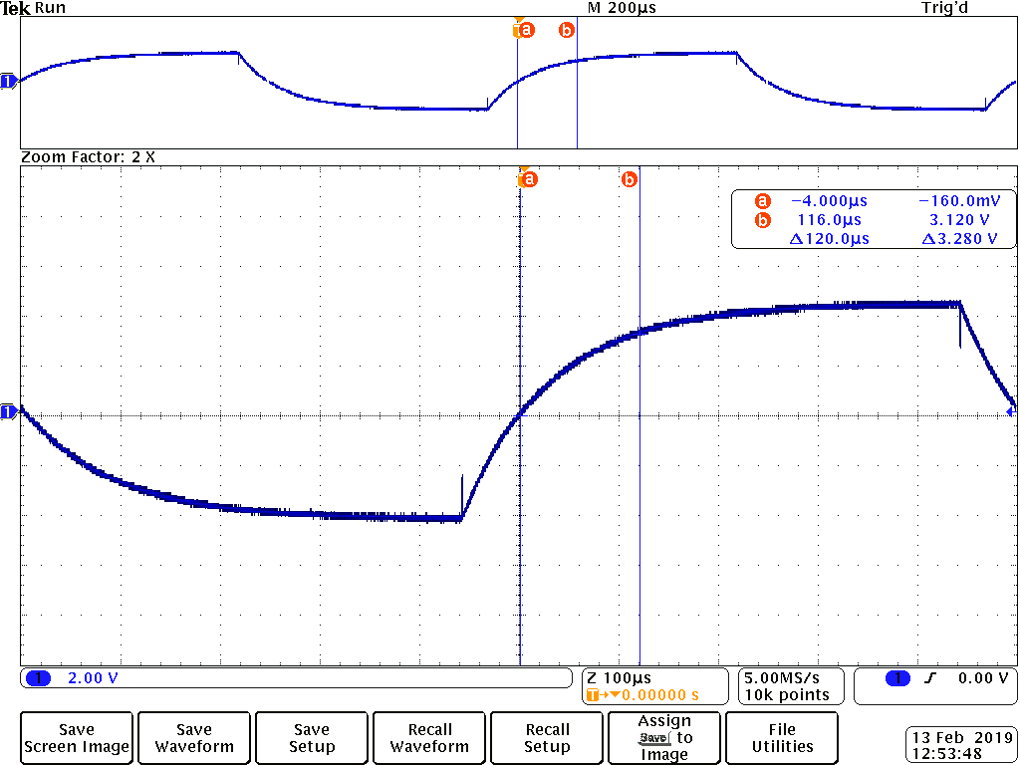

Conclusion

In this experiment, we supplied an AC voltage () using the function generator to First-Order transient circuits. We then, observed the waveforms produced from our output voltages () response across each inductor and capacitor. As well we measured the time constant for each circuit or, the amount of time it takes for the output to rise from the minimum value (0V) to 63% of its input voltage (3.120V). Or to drop from the maximum (5V) to 37% of the input voltage (1.840V).