**Project 1 Report**

Christopher Badolato

[badolato.christopher@knights.ucf.edu](mailto:badolato.christopher@knights.ucf.edu)

EEL 3801-0011: Computer Organization

2/25/2019

1. Project Description

The objective of this assignment is to create the given function in Mips code, we will take user inputs and conduct some mathematics with them. We are limited in our use of instructions (No use of the mult function), therefore we must create our multiplication and divisions using loops. We have combined project part A and Part B into one Mips program that will calculate F and G (part A) and use that output to solve for h_quotient, h_remainder, i_quotient, i_remainder, and finally j_remainder.

F = (A x A) – (B x D)

G = (A x D) + (6 x C)

h = (F / G);

i = (F + G) / h_quotient;

j = (F– G) % i_quotient;

1. Program Design
2. Symbol Table

|  |  |
| --- | --- |
| Register | Assignment |
| $t0-$t7 | Used to store temporary values throughout the program such as our inputs from the user, as well as out loop iterators. |
| $t0-$t3 | Stores input from user represents A, B, C and D in our C program |
| $s0 | STORES our value that represents F in our C program |
| $s1 | STORES our value that represents G in out C program |
|  |  |
|  |  |
|  |  |

1. Learning Coverage
2. Prototype in C
3. Test Plan

To test our Mips code, we have applied various test cases to ensure our output is correct. Each case corresponds to the results shown below in the images.

1. Test Results

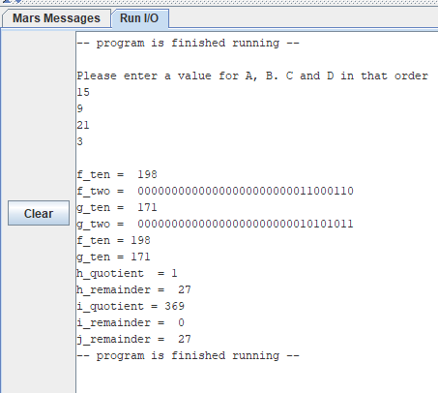

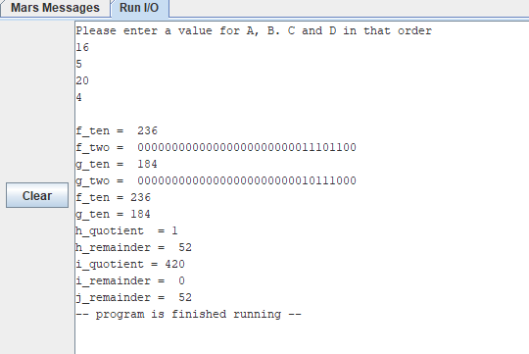

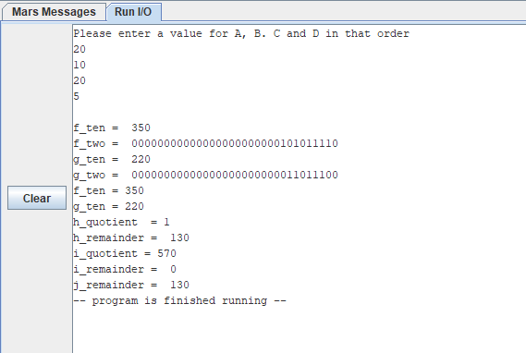

1. References

|  |  |
| --- | --- |
| Register | Assignment value |
| $t0 |  |
| $t1 |  |
| $t2 |  |
| $t3 |  |
| $t4 |  |
| $t5 |  |
| $t6 |  |
| $t7 |  |
| $s0 | STORES our value for f for the second half of the program |
| $s1 | STORES our value for f for the second half of the program |
|  |  |
|  |  |
|  |  |

Label Table