***Tabla 1. Ubicación geográfica de las estaciones de muestreo.***

|  |  |  |  |  |  |
| --- | --- | --- | --- | --- | --- |
| Estación | Latitud_De | Longitud | Latitud | Longitud_H | Código Estación |
| 1 | 2.8492999 | -78.2226028 | 2° 50' 57.483"" N | 78° 13' 21.223"" W | A01 |
| 2 | 2.8167701 | -78.2225037 | 2° 49' 0.383"" N | 78° 13' 20.965"" W | A02 |
| 3 | 2.78422 | -78.2225037 | 2° 47' 3.199"" N | 78° 13' 20.862"" W | A03 |
| 4 | 2.7516699 | -78.2223969 | 2° 45' 6.015"" N | 78° 13' 20.761"" W | A04 |
| 5 | 2.71912 | -78.2223969 | 2° 43' 8.831"" N | 78° 13' 20.661"" W | A05 |
| 6 | 2.6865699 | -78.2223969 | 2° 41' 11.647"" N | 78° 13' 20.561"" W | A06 |
| 1 | 2.78403 | -78.4004974 | 2° 47' 2.513"" N | 78° 24' 1.902"" W | G01 |
| 2 | 2.7514999 | -78.4004974 | 2° 45' 5.391"" N | 78° 24' 1.688"" W | G02 |
| 3 | 2.71895 | -78.4003983 | 2° 43' 8.213"" N | 78° 24' 1.573"" W | G03 |
| 4 | 2.6863999 | -78.4003983 | 2° 41' 11.034"" N | 78° 24' 1.459"" W | G04 |
| 5 | 2.6538501 | -78.4003983 | 2° 39' 13.855"" N | 78° 24' 1.346"" W | G05 |
| 6 | 2.6213 | -78.4002991 | 2° 37' 16.676"" N | 78° 24' 1.235"" W | G06 |
| 1 | 2.8329401 | -78.3197021 | 2° 49' 58.568"" N | 78° 19' 10.763"" W | S01 |
| 2 | 2.8004 | -78.319603 | 2° 48' 1.457"" N | 78° 19' 10.531"" W | S02 |
| 3 | 2.7678499 | -78.319603 | 2° 46' 4.276"" N | 78° 19' 10.422"" W | S03 |
| 4 | 2.7353001 | -78.3195038 | 2° 44' 7.094"" N | 78° 19' 10.314"" W | S04 |
| 5 | 2.70275 | -78.3195038 | 2° 42' 9.912"" N | 78° 19' 10.208"" W | S05 |
| 6 | 2.6702001 | -78.3195038 | 2° 40' 12.731"" N | 78° 19' 10.102"" W | S06 |

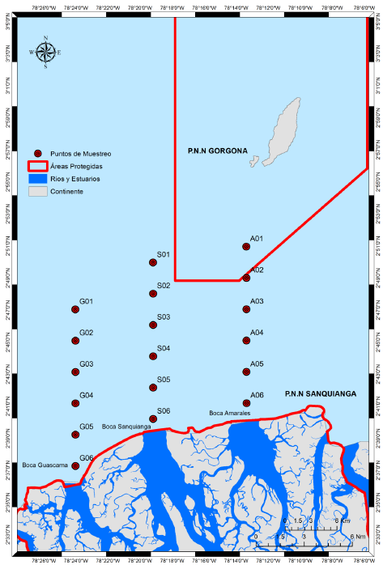

Figura 1. Distribución de las estaciones de muestreo en el área de estudio